Pancake Tuesday

(13/02/18)

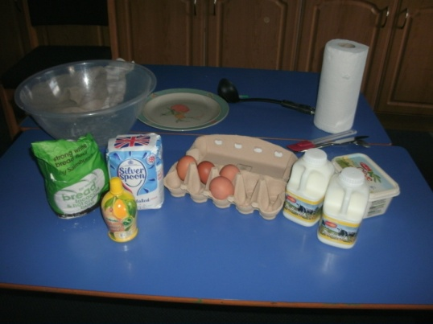

Gather ingredients and equipment.

Gather ingredients and equipment.

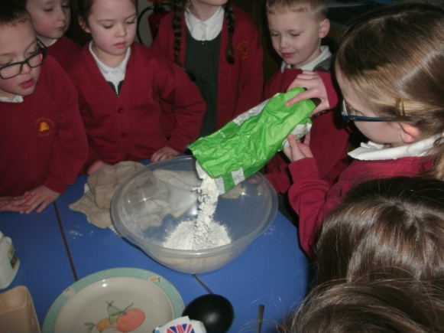

Pour some flour and sugar into a bowl.

Gather ingredients and equipment.

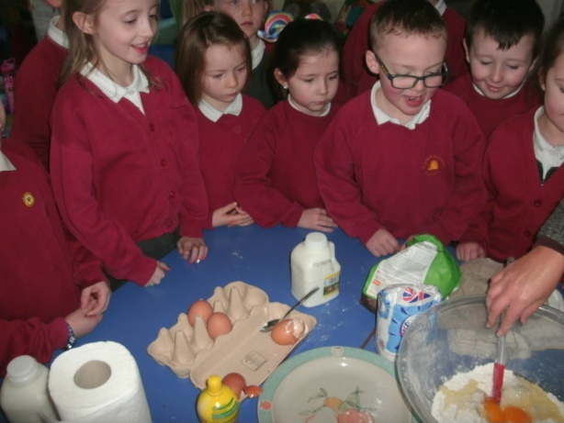

Crack open an egg and add to the mixture.

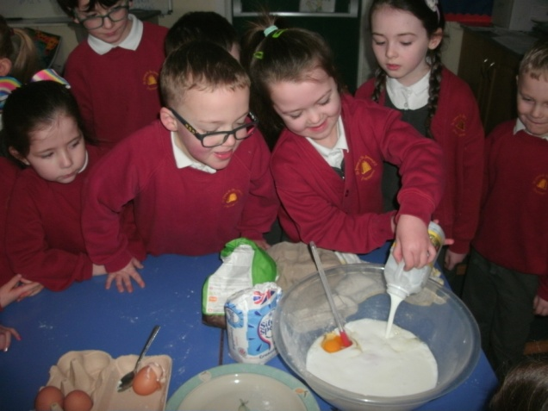

Pour buttermilk into the bowl.

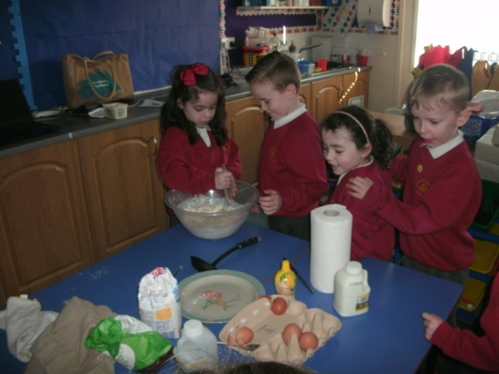

Mix the ingredients together.

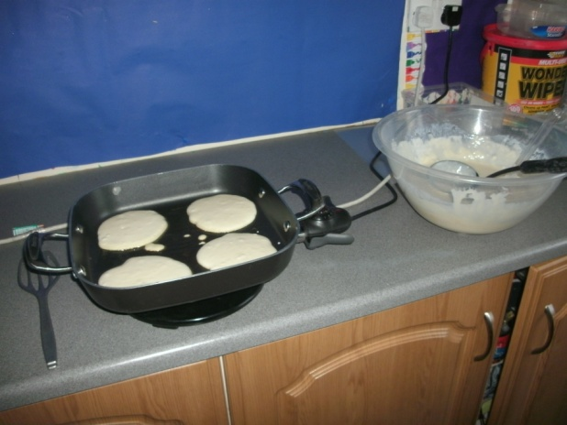

Cook the pancake mixture.

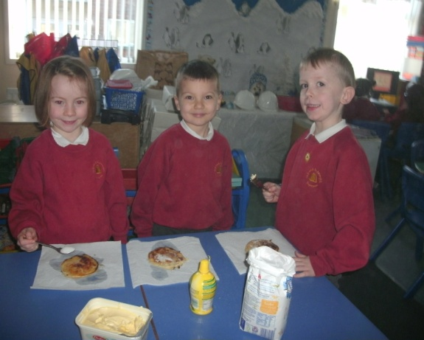

Add toppings, eat and enjoy!