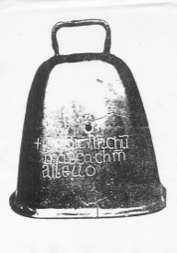
St. Joseph and St. James’s Primary School

34 Chapel Street
Poyntzpass
BT35 6SY
Tel: 028 3831 8261
Email: pmcevoy893@c2kni.net
Website : www.stjosephandstjames.com

16th April 2019

Dear Parent(s)/Guardian(s) of Primary 4 pupils,

We have just been informed today, that due to circumstances beyond our control, the Parish Hall in Mullaghbrack is unavailable for tea after First Holy Communion.

Photographs will be taken in the chapel as planned. We will try to get some photography completed before the ceremony begins and finish the photographs once the ceremony is over.

It is now necessary to change our plans for after the ceremony. Only two options remain. We did discuss the possiblility of a marquee but as this is weather dependent, it would prove too problematic and may also be too expensive.

Therefore our choices are to return to Poyntzpass Parish Hall once the ceremony and photographs have ended or for families to leave to follow their own plans at this point. If parents choose to leave straightaway, we will have a celebration for the children in school the following day.

We are sorry for this inconvenience but we are unable to legislate for all of the various factors involved.

Please indicate below your preferred choice given the new circumstances.

Yours sincerely,

Pauline McEvoy
Principal
…………………………………………………………………………………………………………………………………………………..

We would prefer to return to Poyntzpass Parish Hall : -

We would prefer to leave after the ceremony and photographs : -

Signed : ………………………………………………………………………………….

