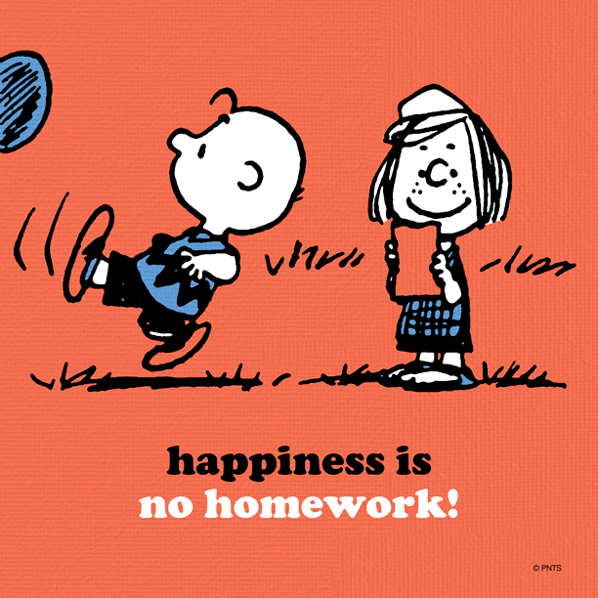

From Monday 3rd June there will be no more homework!!!!!!

