Accessing c2k Schools from home
In order to access NewsDesk and emails from the teachers, the children will have to log in to their ‘My School’ account. They first of all must go to www.c2kschools.net which will bring up the following log in screen. The children must then log in with their school username and password (sent by text to parents). If they have forgotten their name or password please email your teacher and these can be confirmed.
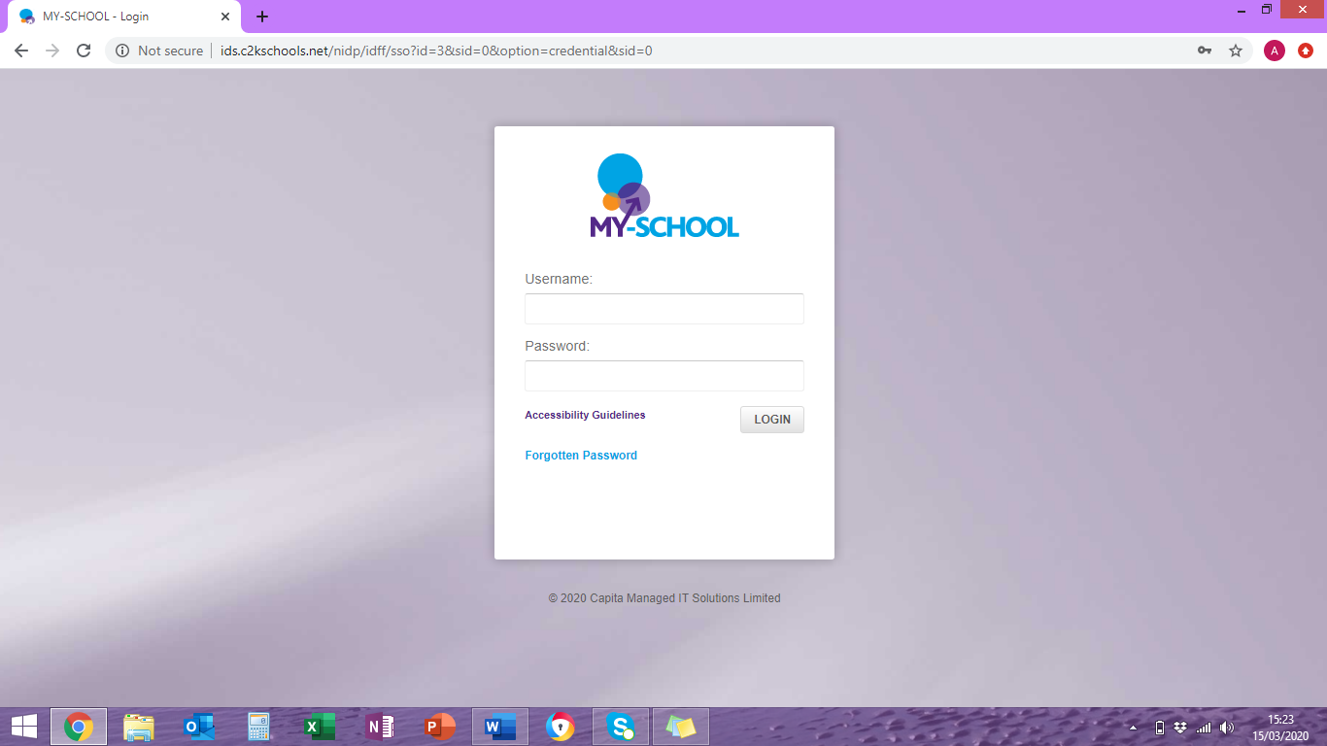
When the children successfully log in their home screen should look similar to the picture below. The office 365 tab to the bottom left is where any emails sent by the staff should have been sent.
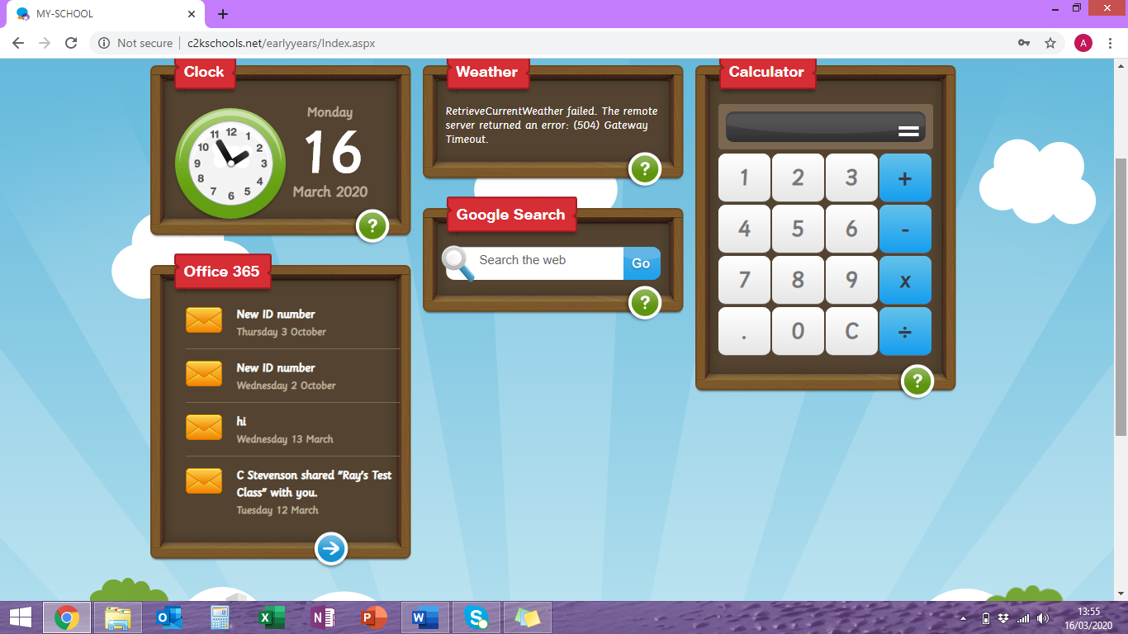
If the children do not have the Office 365 tab as above they must click on the ‘My links’ button towards the top of the page.
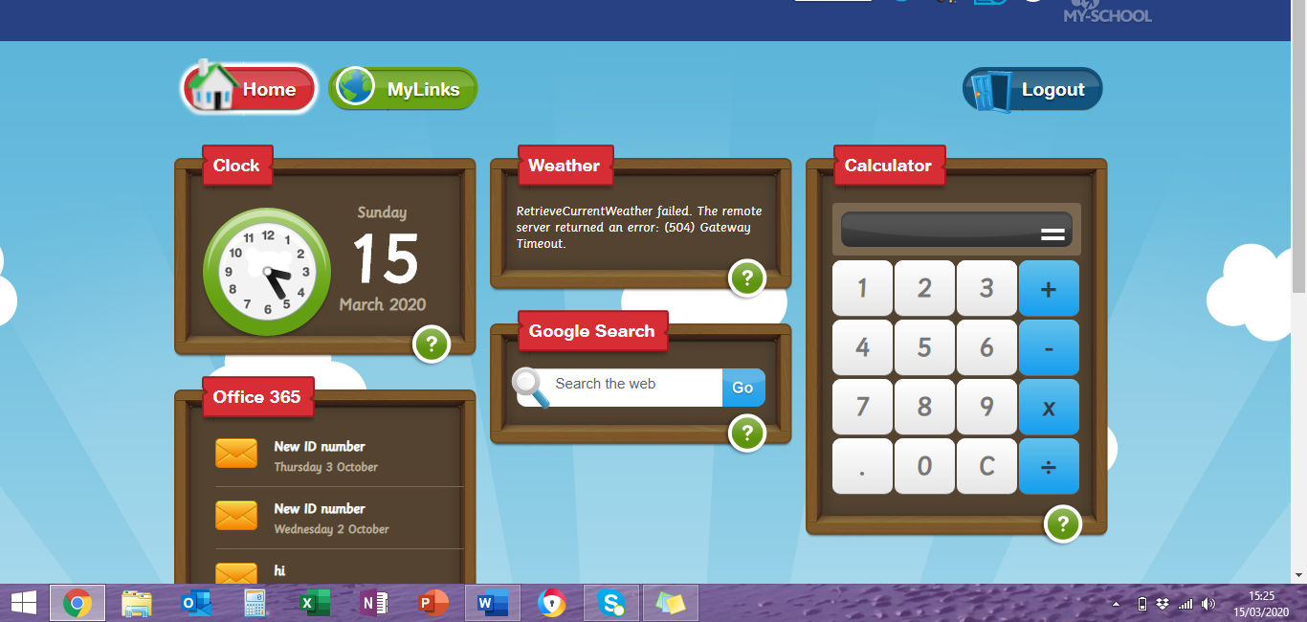

Once they have clicked ‘My Links’ it will bring them to a screen that looks like the picture below. From here, click on the Office 365 icon.
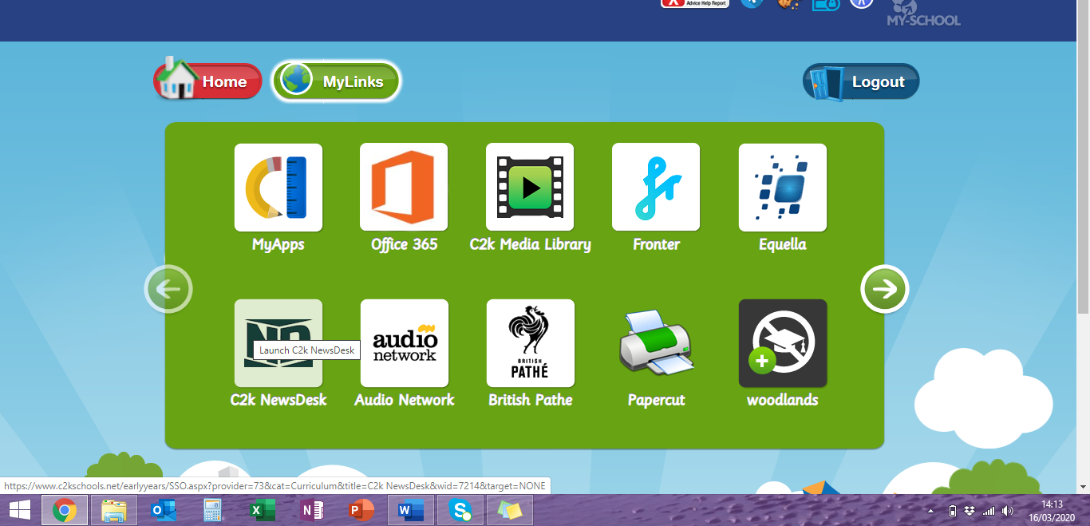
There may be an interim screen – click ‘continue’ and this will hopefully open office 365 as shown below. They can now click on the outlook icon which will open the child’s email.
