How to make a Poyntzpass viewfinder

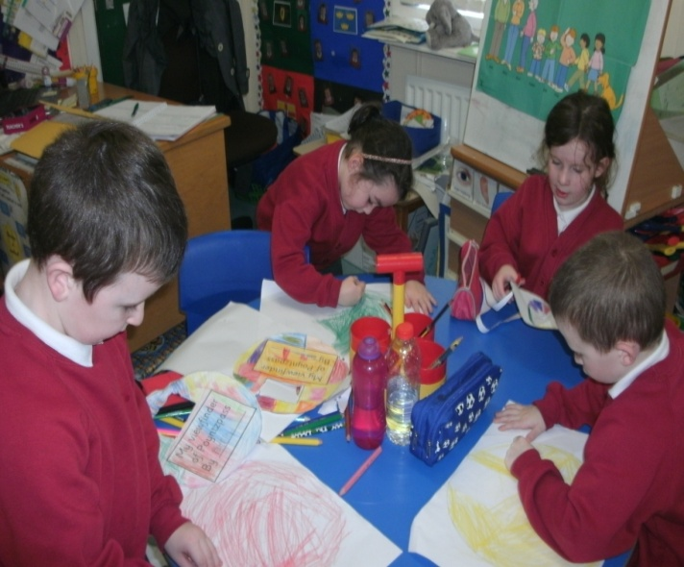

Colour two paper circles.

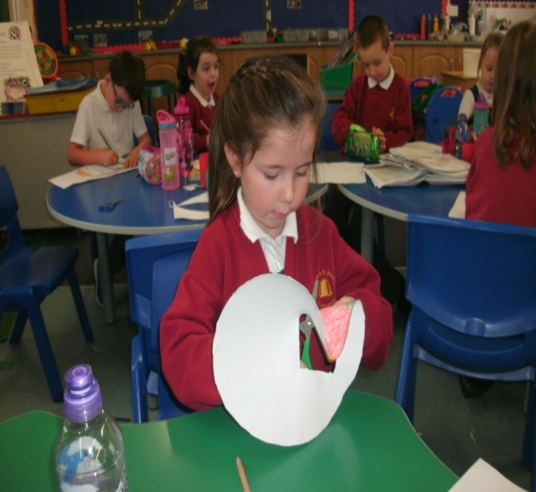

Carefully cut the circles out.

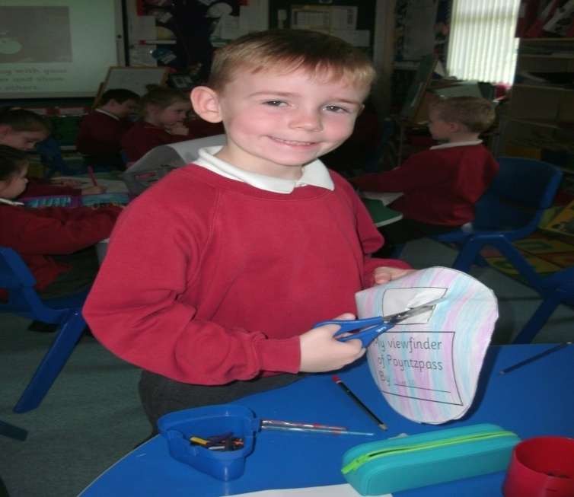

Now cut out the viewfinder

window.

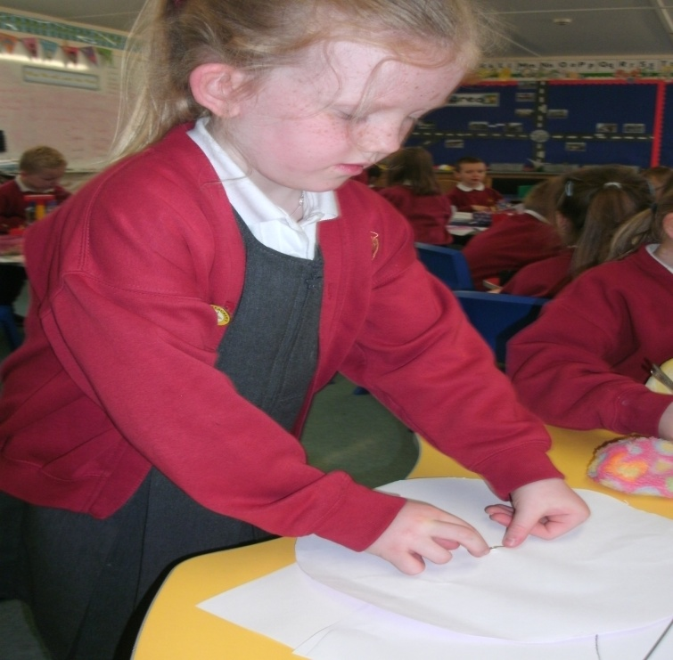

Push the paper fastener through the centre of the two circles.

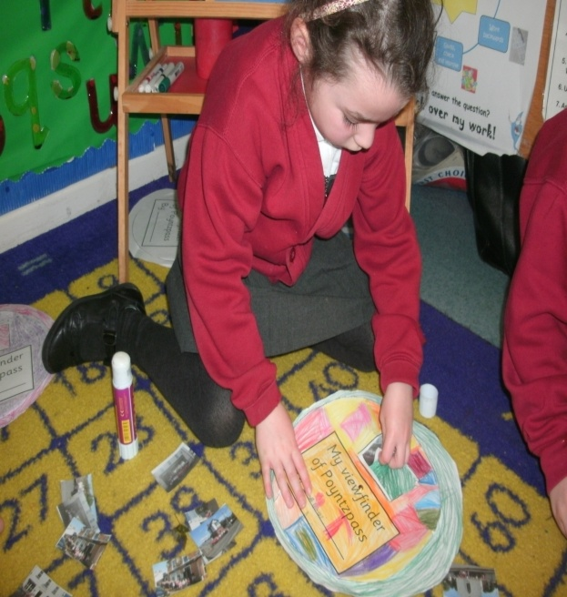

Choose three photographs and glue in place on the 2nd circle. cut the circles out.

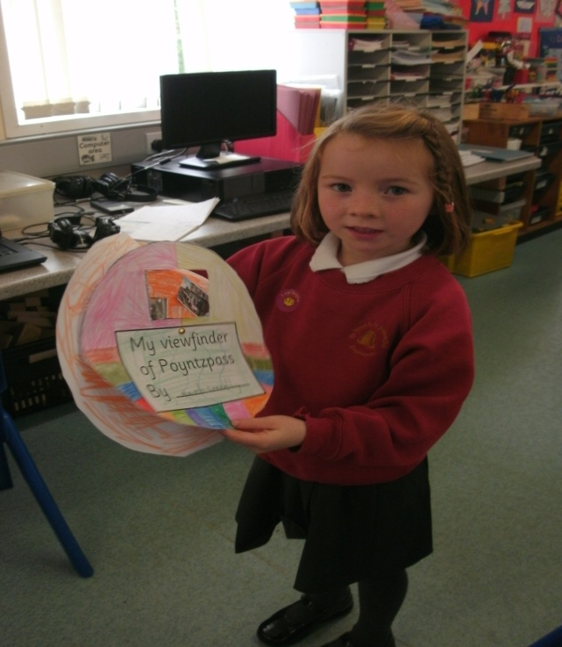

Turn the viewfinder wheel to play and demonstrate to friends and family.

By Primary 2 & 3