Measurement
(length and height)

HERE’S THE MATHS
Learning to measure accurately takes practice, so ideally work with your child to measure small lengths (less than 30 cm) to the nearest centimetre around the house.

< means ‘less than’ > means ‘greater than’ = means ‘equals’ or ‘is equal to’

The wider part of < and > belongs next to the larger number and the narrow point belongs next to the smaller number, e.g. 2 < 4 (two is less than four) and 4 > 2 (four is greater than two).
MATHS TOPICS
These are the maths topics your child will be working on during the next three weeks:
- Addition and subtraction
- Measurement (length and height)

KEY MATHEMATICAL IDEAS
During these three weeks your child will be learning to:
- recognise and use patterns of similar calculations, e.g. 4 + 0 = 4, 3 + 1 = 4,
2 + 2 = 4, 1 + 3 = 4, 0 + 4 = 4 and 4 − 0 = 4, 4 − 1 = 3, 4 − 2 = 2, 4 − 3 = 1,
4 − 4 = 0
- solve addition and subtraction problems with missing numbers
- estimate and measure length and height in centimetres
- compare measurements and record the results using <, > and =.

TIPS FOR GOOD HOMEWORK HABITS
Choose a quiet place to work, preferably sitting at a table, where your child can work comfortably without being disturbed.

ACTIVITY
What to do
You will need:
- pencil and paper
- 30 cm ruler
- objects less than 30 cm in length, height or width
- Together, measure (to the nearest cm) the length of
10 items each less than 30 cm (e.g. length of a toy car, length of your foot) and write the name of the item and its length/height on a piece of paper.
- Say two of the objects and ask your child to write a statement using the two lengths and the correct symbol in between them (<, > or =).
- Repeat for more pairs of the objects to create as many different statements as possible.
Variation
- Write 10 different length measurements each less than 30 cm and then complete the rest of the activity as described.

QUESTIONS TO ASK
Which measurement is the shortest/longest? How do you know?
What does this symbol mean?
(Point to <, > or =)
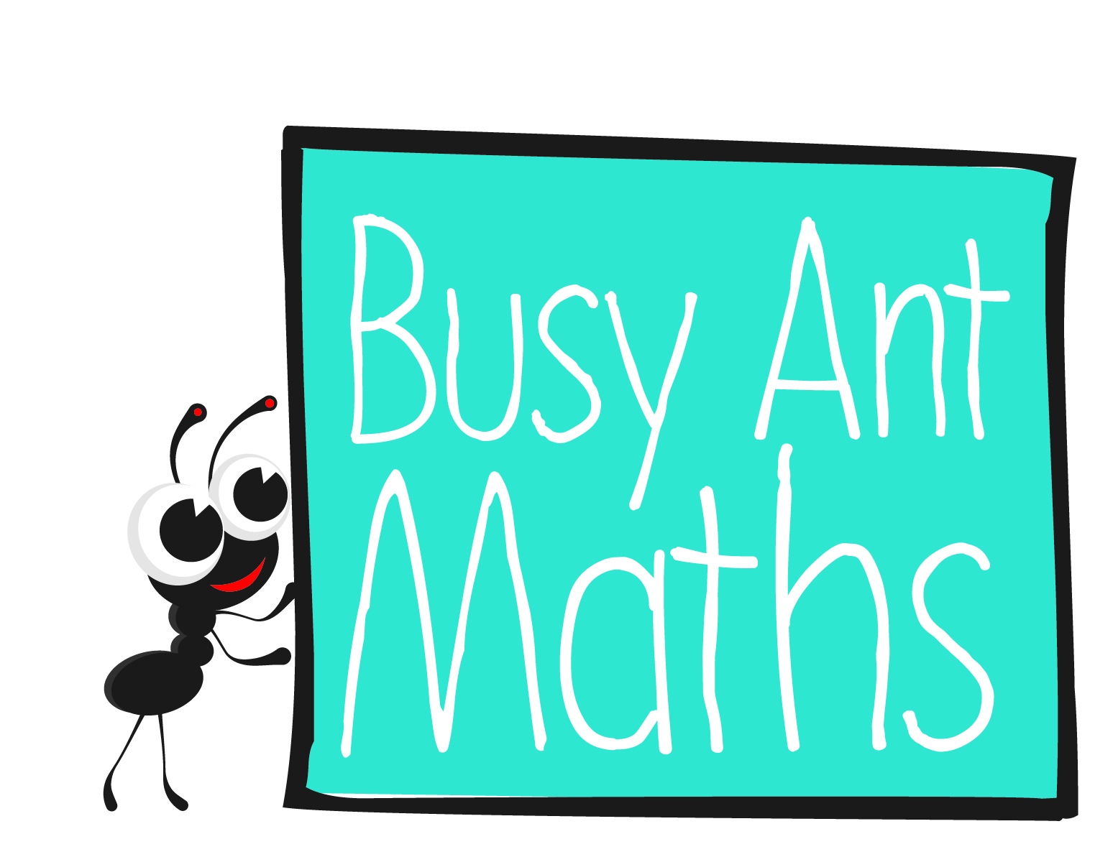
Primary 3
Maths
Newsletter 2
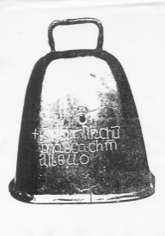
How do you know which symbol is the correct one to use? (Point to < and >)
Which symbol means ‘is less than’/’is greater than’/’is equal to’?
Date: ______________________ Name: ______________________

Addition and subtraction

HERE’S THE MATHS
Patterns of similar calculations help your child to use known or given number facts to work out unknown number facts. Knowing 2 + 2 = 4 could help them work out 3 + 1.
4 + 0 = 4 4 − 0 = 4
3 + 1 = 4 4 − 1 = 3
2 + 2 = 4 4 − 2 = 2
1 + 3 = 4 4 − 3 = 1
0 + 4 = 4 4 − 4 = 0
Your child has been learning about patterns of similar calculations for numbers up to 20, i.e. 20 + 0 = 20, 19 + 1 = 20, and 20 − 0 = 20, 20 − 1 = 19.

ACTIVITY

What to do
You will need:
- pencil and paper
- 2 counters
- 1–6 dice
- On a plain piece of paper, draw a simple zigzag game board with approximately 20–25 numbered squares as shown below.
- Put both counters at the beginning of the board.
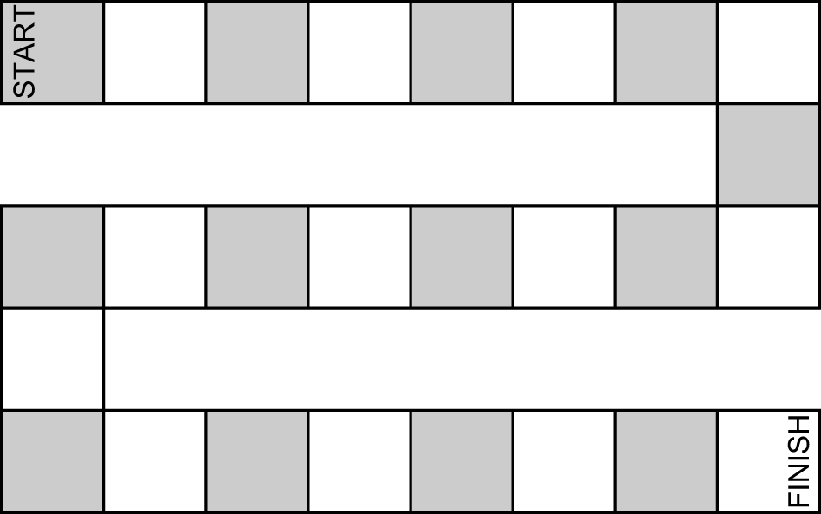
- Work together to write a set of similar subtraction calculations on small pieces of paper.
- Shuffle the question cards and put them face down in front of you.
- Take turns to take the top card and work out the answer, using a known similar calculation if needed. For correct answers only, roll the dice and move your counter that number of squares.
- The winner is the first player to reach the finish. Reshuffle the question cards, if needed.
QUESTIONS TO ASK
How do you know which calculation comes next?
How can you use these facts to answer addition and subtraction calculations involving multiples of 10?
What patterns can you see in your lists of calculations?

Addition and subtraction

HERE’S THE MATHS
Your child has been learning to use inverse operations to solve missing number addition and subtraction calculations. Addition is the inverse of subtraction. Subtraction is the inverse of addition.
To solve 4 + = 19 use 19 − 4 = .
To solve − 13 = 2 use 2 + 13 = .
To solve 16 − = 5 use 16 − 5 = .

ACTIVITY

What to do
You will need:
- two pencils and two pieces of paper
- timer – optional
- Both write a set of 10 missing-number calculations using numbers up to 20 (addition and/or subtraction). Use a
to indicate the missing number, for example, − 5 = 11.
- Remind your child to check that the missing number in each of their questions is 20 or less.
- Swap questions and challenge each other to answer the questions as quickly as possible.
- Swap back to mark each other’s answers.

Variation
- Write a list of questions and challenge your child to answer as many as they can
in a given amount of time.

QUESTIONS TO ASK
What is the something in 14 take away something equals 9? (Ask a variety of addition and subtraction questions.)
How did you write your missing-number questions?

How would/did you work out the missing number
in this addition/subtraction calculation?
Is the missing number less than or greater than X? (X should be one
of the two numbers given in the question.)

