Position and direction
HERE’S THE MATHS
The position of objects on a grid can be given using letter and number references
to specific rows and columns.

4 |  |  |  | × | For example, the star is in position C3.  The arrow is in position B4.  ‘Along the hall and up the stairs’ can be a useful way to  help children remember which part of the grid reference  to give first.
3
2
1
 | A | B | C | D
ACTIVITY
What to do
You will need:
- pencil and paper
- colouring pencils
- Both players need two grids like the ones above to play
a game similar to battleships.
6
5
4
3
2
1
 | A | B | C | D | E | F
- On the first grid, each player colours in squares to show
a school building (4 squares), playground (3 squares), football pitch (3 squares), swimming pool (2 squares), garden (2 squares). All squares for an individual object should be next to each other and in a horizontal or vertical line.
- Take turns to say a letter and number to check whether the other player has an object in that square. Colour the square if there is something there, otherwise put a cross in the square.
- The winner is the first player to find all five objects on the other person’s grid.

QUESTIONS TO ASK
What is/are the grid reference(s) of the X?
How do you know which part of the grid reference to give first?
Where is the X?

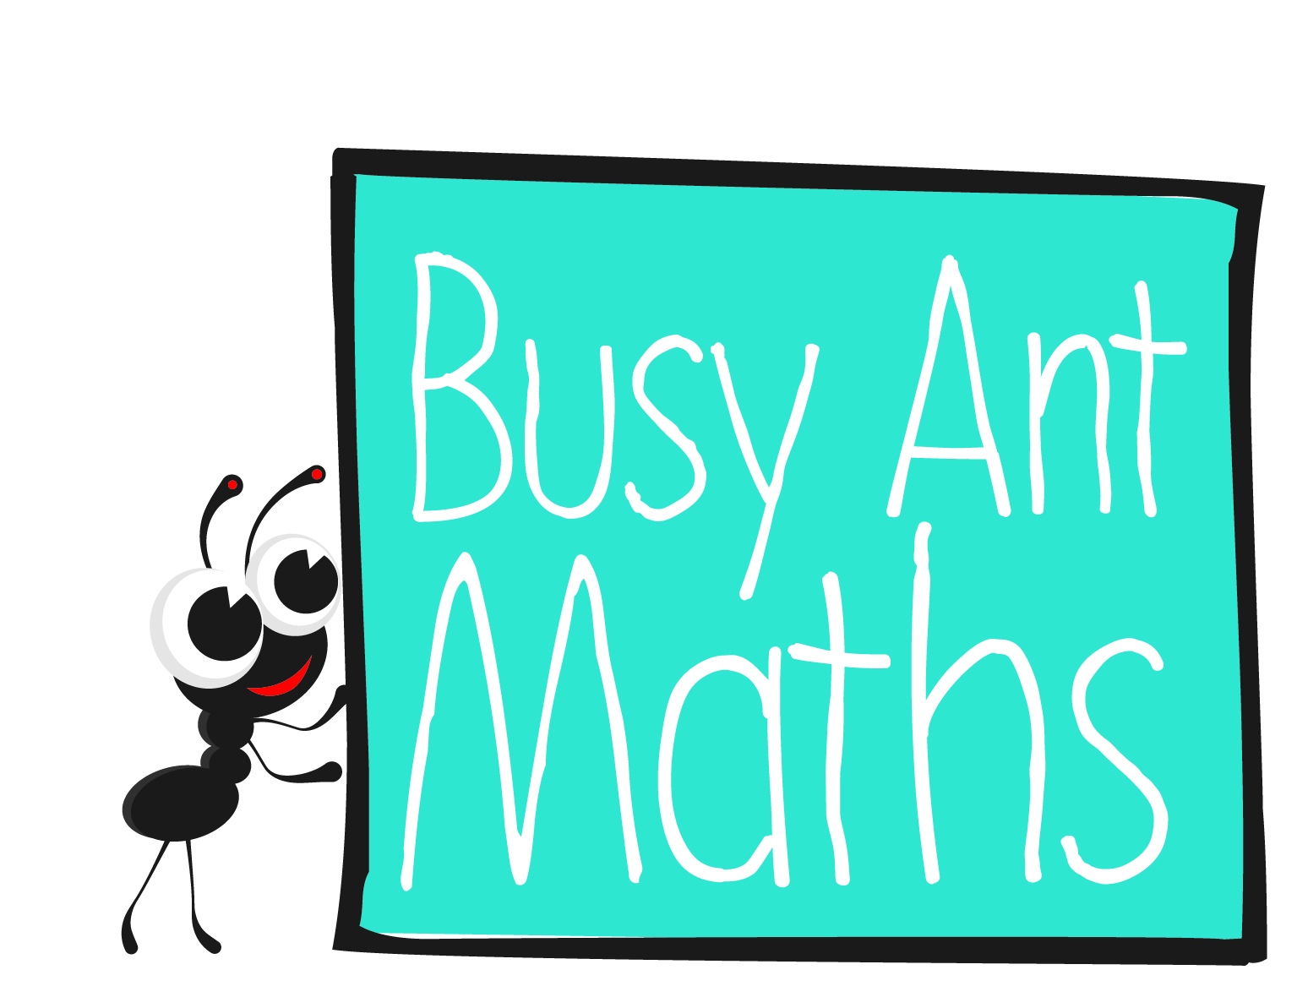
Primary 3
Maths
Newsletter 3
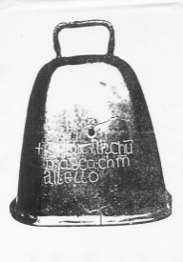
Date: ______________________ Name: ______________________
MATHS TOPICS
These are the maths topics your child will be working on during the next three weeks:
- Multiplication and division, including number and place value
- Position and direction

KEY MATHEMATICAL IDEAS
During these three weeks your child will be learning to:
- count in steps of 2, recognise multiples of 2 and divide by 2 for numbers up to 50
- count in steps of 5, recognise multiples of 5 and divide by 5 for numbers up to 50
- find the position of a square on a grid of squares.

TIPS FOR GOOD HOMEWORK HABITS
Turn off the TV and other devices when your child is doing homework.
Multiplication and division
HERE’S THE MATHS
Your child is learning to multiply and divide by 2 (using numbers up to 20), including using the symbols × and ÷ to record their work, e.g. 4 × 2 = 8, 8 ÷ 2 = 4.

Involve your child in examples of multiplying and dividing by 2 in everyday life.
For example:
- I need to buy 3 bananas for 1 person. How many bananas do I need to buy for
2 people?
- There are 8 toy cars and 2 of us. How many cars can we have each if we share them equally?
2 | 3 | 9 | 2 | 1
6 | 4 | 2 | 2 | 3
2 | 2 | 6 | 5 | 8
3 | 10 | 2 | 4 | 2
4 | 2 | 7 | 2 | 2
ACTIVITY
You will need:
- pencil and paper
- small cards with 2, 4, 6, 8, 10, 12, 14, 16, 18 and 20 written on them
- 20 small counters or coins

What to do
- Shuffle the 10 number cards and place them face down in front of you.
- Take turns to pick up the top card and two counters. Place the counters over two numbers on the grid that multiply together to give the answer shown on the card.
- Keep the card and leave the counters in place if you agree that the counters are placed correctly. Put the card to the bottom of the pile and remove the counters if the counters are not placed correctly.
QUESTIONS TO ASK
What real-life example can you think of
for that multiplication/
division fact?
What is X multiplied/divided by 2?

Multiplication and division
HERE’S THE MATHS
Your child is learning to multiply and divide by 5 (using numbers up to 50), including using the symbols × and ÷ to record their work, e.g. 8 × 5 = 40, 40 ÷ 5 = 8.

Involve your child in examples of multiplying and dividing by 5 in everyday life.
For example:
- I need to buy 4 tomatoes for 1 person. How many tomatoes do I need to buy for
5 people?
- There are 10 slices of bread and 5 of us. How many slices of bread can we have each if we share them equally?
ACTIVITY
You will need:
- pencil and paper
- small cards with 5, 10, 15, 20, 25, 30, 35, 40, 45 and 50 written on them
- 20 small counters or coins

5 | 3 | 9 | 5 | 10 | 1
10 | 1 | 5 | 10 | 5 | 4
5 | 5 | 10 | 5 | 8 | 10
3 | 5 | 5 | 4 | 2 | 5
6 | 10 | 7 | 5 | 10 | 2

What to do
- Shuffle the 10 number cards and place them face down in front of you.
- Take turns to pick up the top card and two counters. Place the counters over two numbers on the grid that multiply together to give the answer shown on the card.
- Keep the card and leave the counters in place if you agree that the counters are placed correctly. Put the card to the bottom of the pile and remove the counters if the counters are not placed correctly.
QUESTIONS TO ASK
What real-life example can you think of for that multiplication/division fact?
What is X multiplied/divided by 5?

How do you write the signs for multiplication and division?
How do you write the signs for multiplication and division?

