Measurement (mass)
HERE’S THE MATHS
Your child has been ordering objects from lightest to heaviest and weighing objects to find out their mass in kilograms and/or grams.
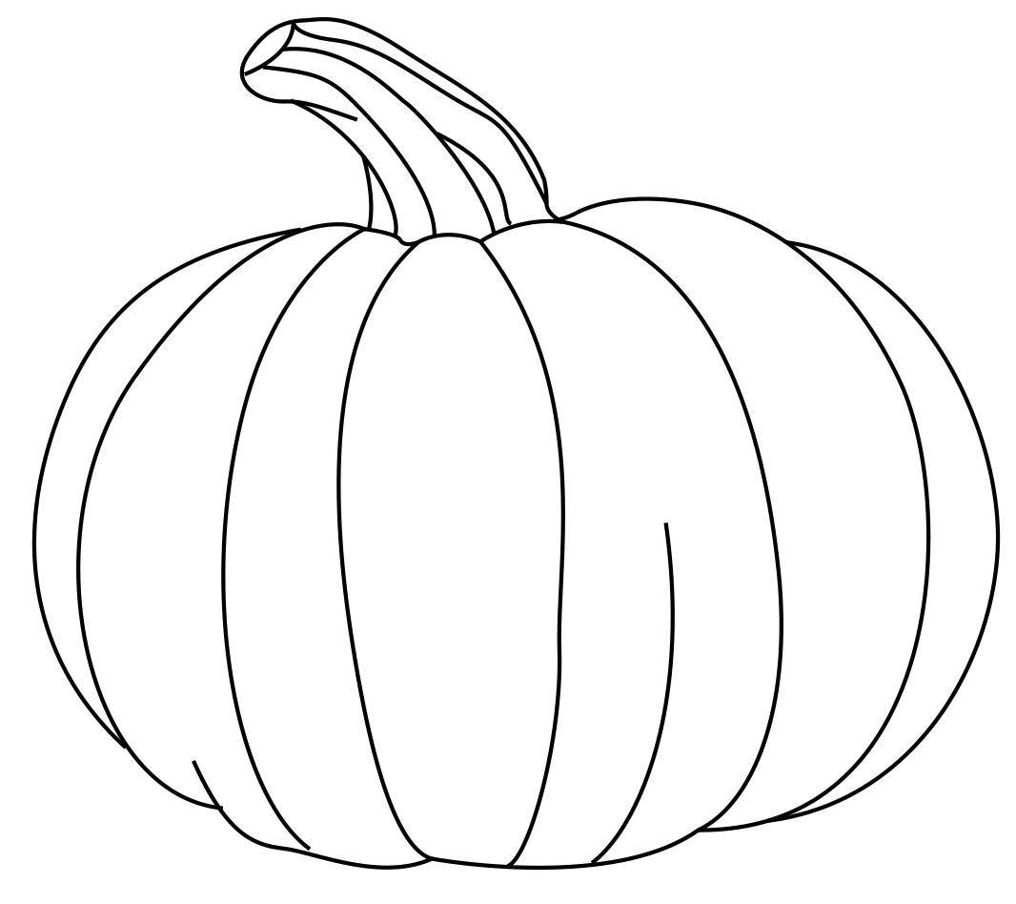
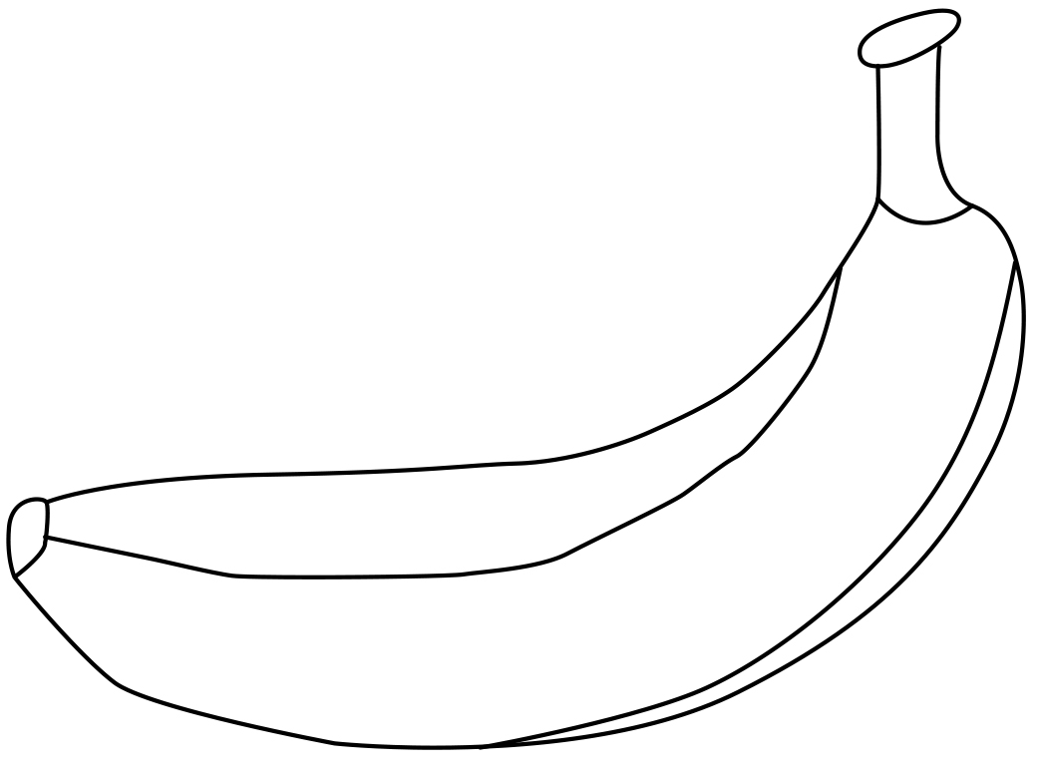
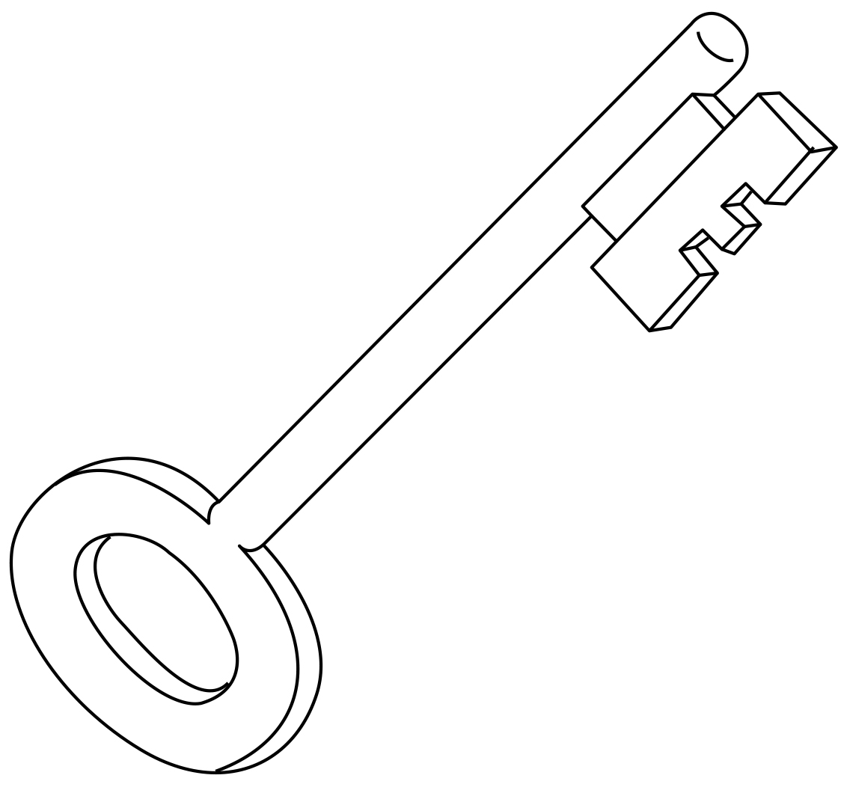
Lightest Heaviest

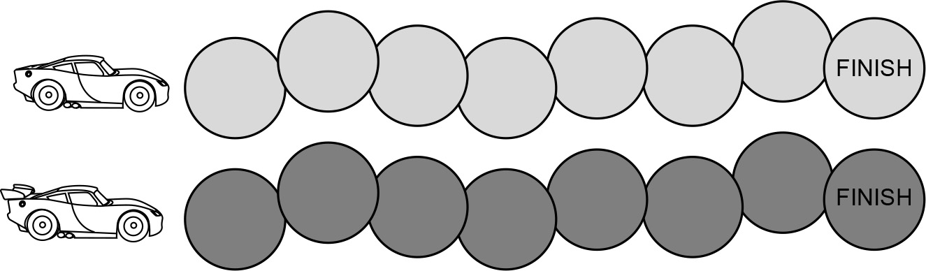
ACTIVITY
MATHS TOPICS
These are the maths topics your child will be working on during the next three weeks:
- Multiplication and division
- Measurement (mass)

KEY MATHEMATICAL IDEAS
During these three weeks your child will be learning to:
- count on and back in steps of 2, 5 and 10
- multiply and divide by 5 and 10
- compare and order objects according to their mass.

TIPS FOR GOOD HOMEWORK HABITS
Don’t get your child to do too much in one sitting, so they don’t get bored or overwhelmed.

What to do
You will need:
- 2 small counters
- 20 everyday objects of different weights (up to approximately 1·5 kg)
- kitchen scales
- Put a counter on each racing car.
- Player 1 takes two objects and decides whether
the second object is lighter or heavier than the first. They check their answer using scales and move their counter one space if correct.
- Player 2 takes the second object from Player 1 and picks a new object. Player 2 decides whether the new object is lighter or heavier than the other object, checks their answer and moves their counter one space if correct.
- Continue playing until someone wins by reaching the finish line.
Variation
- Change the task to working out whether the object is lighter or heavier than 1 kg.
QUESTIONS TO ASK
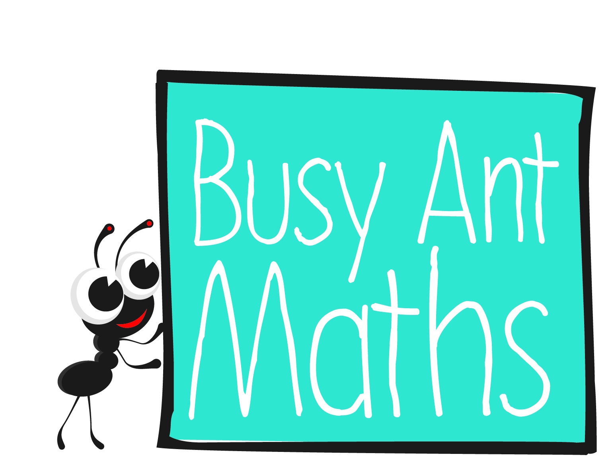
Primary 3
Maths
Newsletter 6
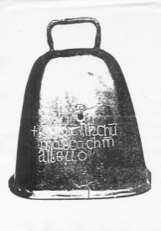
Which object is lighter/heavier?
Which 2 objects do you think might weigh the same as this object?
Order these 5 objects from lightest to heaviest.
Which objects
do you think will be lighter/heavier than X?
Date: ______________________ Name: ______________________

Multiplication and division
HERE’S THE MATHS
Your child has been learning to count on and back in steps of 2, 5 and 10 from various starting numbers.
16 18 20 22 24 26 28 30 steps of 2
85 80 75 70 65 60 55 50 steps of 5
23 33 43 53 63 73 83 93 steps of 10
ACTIVITY
1 | 2 | 3 | 4 | 5 | 6 | 7 | 8 | 9 | 10
11 | 12 | 13 | 14 | 15 | 16 | 17 | 18 | 19 | 20
21 | 22 | 23 | 24 | 25 | 26 | 27 | 28 | 29 | 30
31 | 32 | 33 | 34 | 35 | 36 | 37 | 38 | 39 | 40
41 | 42 | 43 | 44 | 45 | 46 | 47 | 48 | 49 | 50
51 | 52 | 53 | 54 | 55 | 56 | 57 | 58 | 59 | 60
61 | 62 | 63 | 64 | 65 | 66 | 67 | 68 | 69 | 70
71 | 72 | 73 | 74 | 75 | 76 | 77 | 78 | 79 | 80
81 | 82 | 83 | 84 | 85 | 86 | 87 | 88 | 89 | 90
91 | 92 | 93 | 94 | 95 | 96 | 97 | 98 | 99 | 100

You will need:
- 2 small counters

What to do
- One player puts their counter on 3 and is working towards 100. The other player
puts their counter on 98 and is working towards 0.
- Players take turns to choose steps of 2, 5 or 10 and count on or back a maximum
of 5 steps of that size, moving their counter as they jump.
- In each game, each player must use every step size (2, 5 and 10) at least once.
- The winner is the first player to land exactly on their target number (0 or 100).
Swap starting positions and play again.
QUESTIONS TO ASK
Ask your partner to write down each number as you say it. What pattern do you notice in the sequence of tens and/or ones?
What size step(s) would take you directly from X to Y?
If you start at X and count on/back Y steps of 2/5/10, what number do you end up on?

How many steps of 2/5/10 would it take to get from X to Y?
Multiplication and division
HERE’S THE MATHS
Multiply and divide by 5 (by counting on and back in 5s to help, if needed):
8 × 5 = 40 35 ÷ 5 = 7
5, 10, 15, 20, 25, 30, 35, 40 35, 30, 25, 20, 15, 10, 5

Multiply and divide by 10 (by counting on and back in 10s to help, if needed):
7 × 10 = 70 60 ÷ 10 = 6
10, 20, 30, 40, 50, 60, 70 60, 50, 40, 30, 20, 10
ACTIVITY
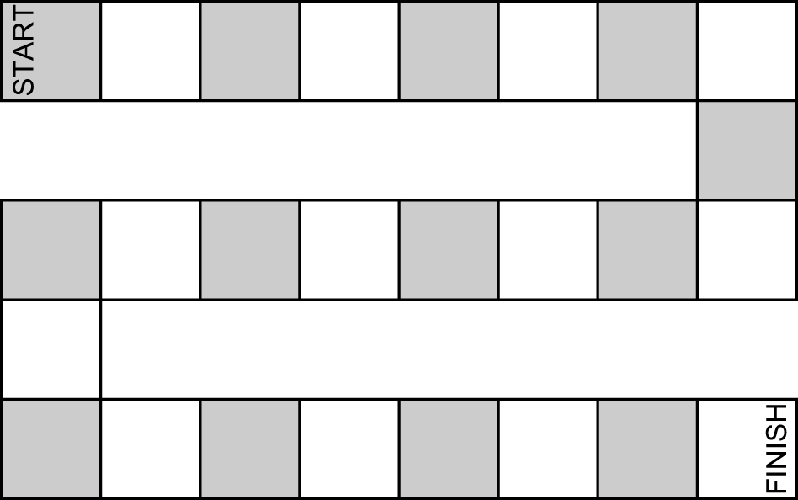
You will need:
- pencil and paper
- 2 counters
- 1–6 dice
- small pieces of paper with multiplication or division questions for 5 (numbers up to 50) or 10 (numbers up to 100) without answers written on them (e.g. 1 × 5 =, 30 ÷ 5 =,
6 × 10 =, 90 ÷ 10 =)

What to do
- On a plain piece of paper, draw a simple zigzag game board with approximately 20–25 numbered squares as shown above.
- Put both counters at the beginning of the board game.
- Shuffle the question cards and put them face down in front of you.
- Take turns to take the top card and work out the answer. For correct answers only, roll the dice and move your counter that number of squares.
- The winner is the first player to reach the finish. Reshuffle the question cards, if needed.
QUESTIONS TO ASK
What do you notice when you multiply/divide a number by 10?
How does the answer differ from
the starting number?
What is X multiplied/divided by 5/10?
How can you make 40 by multiplying by 5 or 10?

