Measurement
HERE’S THE MATHS
Your child has been learning to find out the mass (weight) of objects in kilograms (kg) and grams (g). There are 1000 g in 1 kg so 1000 g = 1 kg.

Doubling a mass is the same as multiplying it by 2: 150 g × 2 = 300 g.
This can be thought of as (100g × 2) + (50 g × 2) = 200 g + 100 g = 300 g.

Halving a mass is the same as dividing it by 2: 150 g ÷ 2 = 75 g
This can be thought of as (100 g ÷ 2 = 50 g) + (50 g ÷ 2 = 25 g) = 50 g + 25 g = 75 g.
ACTIVITY
What to do
You will need:
- kitchen scales
- bowl
- dried pasta, dried beans or rice
- 7 small pieces of paper (with 50 g, 100 g, 150 g, 200 g and 250 g written on one set; ‘halve’ and ‘double’ written on the other set)
- bag or box in which to put the ‘halve’ and ‘double’ pieces of paper
- Shuffle the pieces of paper with weights on them and place them face down in a pile. Put the ‘halve’ and ‘double’ pieces of paper in the bag or box.
- Ask your child to pick up the top piece
of paper and weigh that amount of dried pasta, beans or rice into the bowl.
- Then ask your child to take a piece
of paper from the bag/box and challenge them to work out and then weigh half
or double their original amount of pasta/beans/rice.
Variation
- Follow a recipe, but ask your child to work out and weigh half or double of each ingredient.
QUESTIONS TO ASK
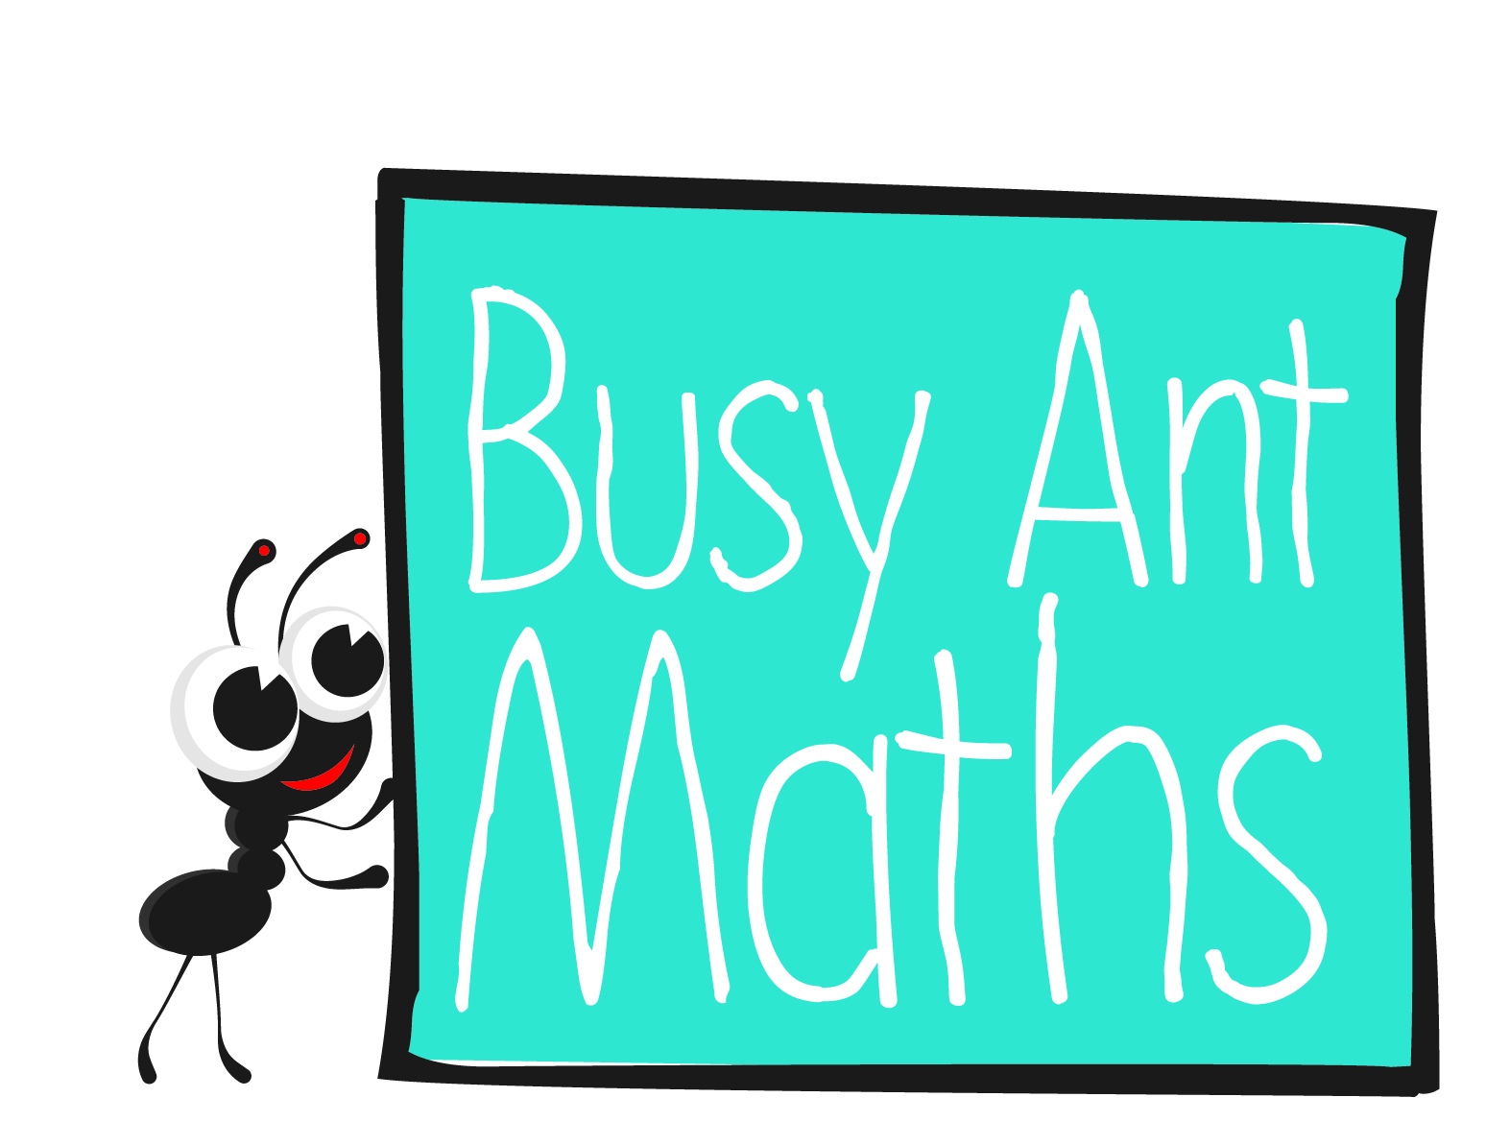
Primary 3
Maths
Newsletter 10
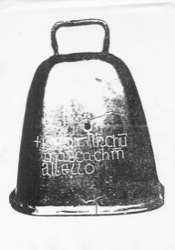
What is half of/double X g?
How much lighter/heavier is X g than Y g?
Look at this recipe and order the ingredients from lightest to heaviest.
Date: ______________________ Name: ______________________
MATHS TOPICS
These are the maths topics your child will be working on during the next three weeks:
- Multiplication and division
- Measurement

KEY MATHEMATICAL IDEAS
During these three weeks your child will be learning to:
- double and halve numbers to 30
- recognise and recall multiplication and division facts for the 2, 5 and
10 times table
- compare mass by halving and doubling.

TIPS FOR GOOD HOMEWORK HABITS
Offer encouragement and praise as your child completes their homework.

How many grams are equivalent to 1 kg?

Multiplication and division
HERE’S THE MATHS
Doubling a number is the same as multiplying it by 2:
6 × 2 = 12.

Halving a number is the same as dividing it by 2:
18 ÷ 2 = 9.

Multiply and divide by 5 (by counting on and back in 5s to help, if needed):
8 × 5 = 40 35 ÷ 5 = 7
5, 10, 15, 20, 25, 30, 35, 40 35, 30, 25, 20, 15, 10, 5
ACTIVITY
You will need:
- small pieces of paper
What to do
- Work together to write a set of calculations (without answers) on small pieces of paper. These could be any combination of × 2, ÷ 2, × 5 or ÷ 5 (up to and including 12 × 2 or 12 × 5 and a maximum of 24 ÷ 2 or 60 ÷ 5).
- Shuffle the question cards and put them face down in front of you.
- Take turns to take the top card and work out the answer. For correct answers only, keep the question card. For incorrect answers, return the question card to the bottom of the pile.
- The winner is the player with the most question cards when they have all been taken.
Variation
- Create a game board and use the question cards, a dice and counters to move around it.
QUESTIONS TO ASK
What is 2 multiplied by X? What is 5 multiplied by X?
Multiplication and division
What is half of X?
What is X divided by 2? What is X divided by 5?
What is double X?
HERE’S THE MATHS
All multiples of 5 end in 0 or 5.
Multiply and divide by 5 (by counting on and back in 5s to
help, if needed):
8 × 5 = 40 35 ÷ 5 = 7
5, 10, 15, 20, 25, 30, 35, 40 35, 30, 25, 20, 15, 10, 5

Multiply and divide by 10 (by counting on and back in
10s to help, if needed):
All multiples of 10 end in 0.
6 × 10 = 60 50 ÷ 10 = 5
10, 20, 30, 40, 50, 60 50, 40, 30, 20, 10

ACTIVITY
What to do
You will need:
- small pieces of paper
- pencil and paper
- Division game: write the numbers 5, 10, 15, 20, 25, 30, 35, 40, 45, 50, 60, 70, 80, 90 and 100 on pieces of paper.
- Shuffle the pieces of paper and place them face down in a pile in front of you.
- Take turns to take the top number and decide whether you can divide it by 5, 10
or both.
- Score a point for each correct division calculation and answer using that number
(e.g. 30 ÷ 10 = 3 and 30 ÷ 5 = 6 scores 2 points).
- The winner is the player with the most points when all of the numbers have been used.
Variation
- Multiplication game: write the numbers 1 to 12 on pieces of paper and the numbers
5 and 10 on two other pieces of paper. Put the 5 and 10 in a box or bag, shuffle the numbers 1 to 12 and spread them out face down in front of you. Take turns to pick
up a number from 1 to 12 and 5 or 10 from the box/bag. Multiply the two numbers together and keep the 1–12 number if correct; otherwise put it back at the bottom
of the pile. Return the 5 or 10 card to the box/bag. The winner is the player with the most number cards at the end of the game.
QUESTIONS TO ASK
Count on in 5s/10s from 0.
What is X divided by 5? What is X divided by 10?
Which number do you multiply/divide by X
to give Y?

