Properties of shapes
HERE’S THE MATHS
Triangles have 3 straight sides.

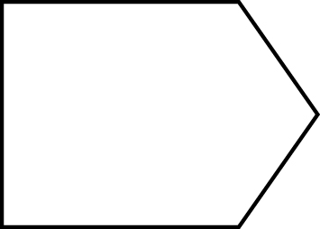
Pentagons have 5 straight sides.

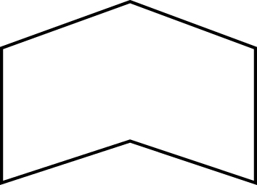
Hexagons have 6 straight sides.

Octagons have 8 straight sides.

The sides in a shape do not all have to be the same length.

ACTIVITY
What to do
You will need:
- pencil and paper
- ruler
- scissors
- timer (optional)
- Draw and then cut out a range of different shapes with
3, 5, 6 and 8 sides.
- Challenge your child to sort the shapes into four groups: triangles, pentagons, hexagons and octagons. Help them to write a label for each group.
Variations
- A timer could be used to create an extra challenge. Each time your child completes the task, challenge them to beat their previous best time.
- Ask your child to find all of one shape – triangles, pentagons, hexagons or octagons.
- Ask your child to make their own shapes to add to each group.
QUESTIONS TO ASK
Which 4-sided shapes can you name?
What is that shape called? How do you know?
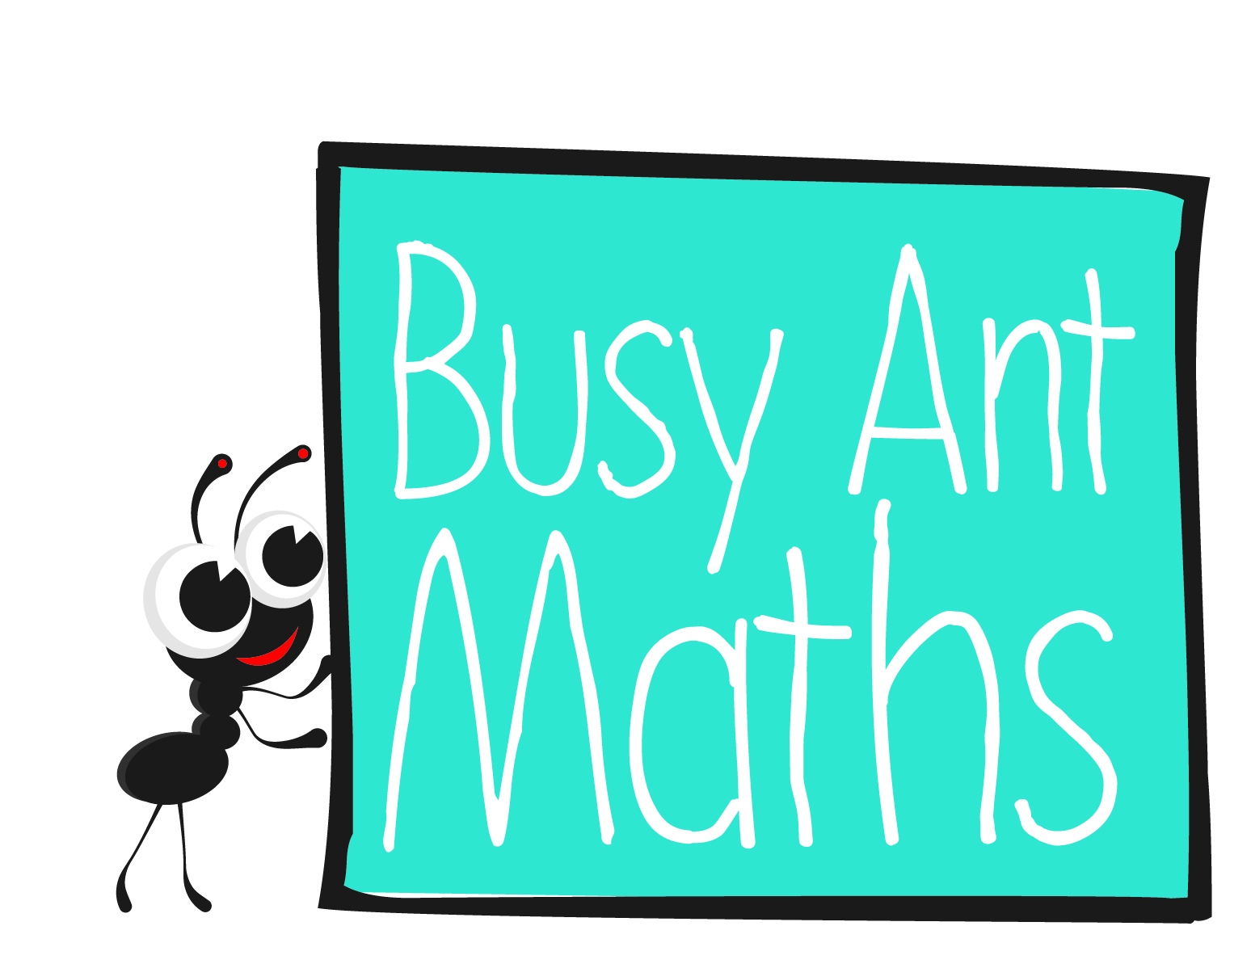
Primary 3
Maths
Newsletter 1
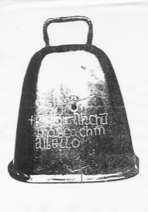
Which shapes have a line of symmetry and which do not?
How many sides/vertices does
a triangle/pentagon/
hexagon/octagon have?
Date: ______________________ Name: ______________________

MATHS TOPICS
These are the maths topics your child will be working on during the next three weeks:
- Number and place value
- Addition and subtraction
- Properties of shapes

KEY MATHEMATICAL IDEAS
During these three weeks your child will be learning to:
- compare numbers up to 50 and use the greater than (>) and less than (<) signs
- recall and use addition and subtraction facts up to 20
- recognise and name 2-D shapes: triangle, pentagon, hexagon and octagon.

TIPS FOR GOOD HOMEWORK HABITS
Plan a homework timetable and agree a time when your child will do their homework.

Number and place value
HERE’S THE MATHS
< means ‘less than’ > means ‘greater than’ = means ‘equals’ or ‘is equal to’

The wider part of < and > belongs next to the larger number and the narrow point belongs next to the smaller number, e.g. 26 < 42 (26 is less than 42) and 42 > 26 (42 is greater than 26).
ACTIVITY
Tens digit Ones digit
You will need:
- pencil
- paper clip
- paper

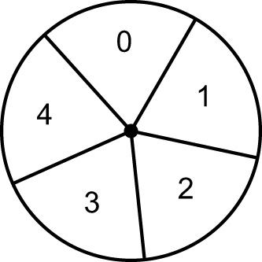
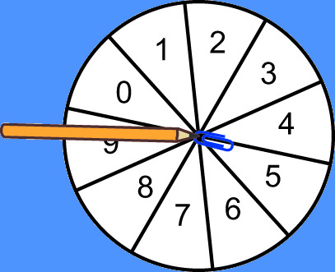
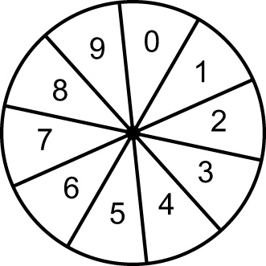

What to do
- Use the paper clip and pencil as shown in the picture above to create a spinner.
- Take turns to create a 2-digit number by first spinning on the tens digit circle and then the ones digit circle. Say the number and write it on a piece of paper. Draw a box to the right of it. Repeat to make a second 2-digit number, say it and write it to the right of the box, e.g. 36 47.
- Write the correct less than or greater than sign (< or >) in the box in between the two numbers.
- Score a point for every correct comparison. The winner is the player with the most points after a chosen number of turns or a set amount of time.
Variation
- Look for 2-digit numbers up to 50 in everyday life and compare them.
QUESTIONS TO ASK
If the two numbers have the same number of tens, how do you know which number is less/greater than the other?
How do you know which sign to use in between the two numbers?
How many tens/ones are there in that
2-digit number?
Addition and subtraction
HERE’S THE MATHS
An addition and subtraction fact family is a group of four related facts made using the same three numbers. This fact family is made using the numbers 2, 10 and 12:

10 + 2 = 12 2 + 10 = 12 12 − 10 = 2 12 − 2 = 10
ACTIVITY
You will need:
- pencil and paper
13 | 1 | 10 | 5 | 15 | 20 | 3
4 | 14 | 19 | 17 | 0 | 12 | 9
18 | 7 | 2 | 11 | 8 | 6 | 16

What to do
- Take turns to pick two numbers from the grid above.
- Agree whether to add or subtract the two numbers (if adding, the total must be 20 or less) and each write the calculation on your own piece of paper.
- Use the three numbers to create your own fact family by writing the other three related addition and subtraction facts.
Variation
- Write each number 0 to 20 on a small piece of paper and arrange them in groups of three numbers that make fact families. Write +, − and = on other pieces of paper and then time how long it takes to arrange each set of three numbers in all four ways.
QUESTIONS TO ASK
How did you work out the missing number in the fact family?
What do you need
to add to/subtract from X to give Y?

What is X add/plus/take away/subtract Y?
How did you work out the other calculations in the fact family?

