Measurement (time)
HERE’S THE MATHS
This week your child is revising reading and writing times with a.m. and p.m. notation and converting 12-hour clock times to 24-hour clock times and vice versa. They are calculating the duration of events and practising changing times from one unit of time, e.g. minutes, hours, days, weeks, months and years, to another. Try to point out and use different clocks and watches.
ACTIVITY
What to do
You will need:
- pack of playing cards with 10s removed (picture cards represent zero)
MATHS TOPICS
These are the maths topics your child will be working on during the next three weeks:
- Multiplication and division
- Measurement (time)

KEY MATHEMATICAL IDEAS
During these three weeks your child will be learning to:
- identify prime factors by making factor trees
- identify multiples and factors, including finding all factor pairs of a number and common factors of two numbers
- calculate durations of time to solve problems.

TIPS FOR GOOD HOMEWORK HABITS
Show your child how you use maths in daily life and involve them in everyday tasks, e.g. telling the time and using time to plan journeys, appointments, etc.
- First person turns over three cards to give the duration of an event in minutes, e.g. 2, 0, 3 equals 203 minutes.
- Second person converts this to hours and minutes: 3 hours, 23 minutes.
- First person turns over 4 cards and arranges them to give a valid 24-hour time. (If this is not possible, continue to turn select cards until one can be made.)
- Second person works out the finishing time of the event.
- First person checks the calculation.
- Change roles and repeat.
- Continue for 10 minutes.
Variation
- Make the chosen time the finishing time and take away the duration to find the start time.
QUESTIONS TO ASK
How many minutes in 5 hours?
How many hours and minutes in 250 minutes?
How many days (weeks, months)
in 3 years?
How many days until Christmas/your birthday/the end of term?
What are the two possible times for 6:35 in 24-hour time?
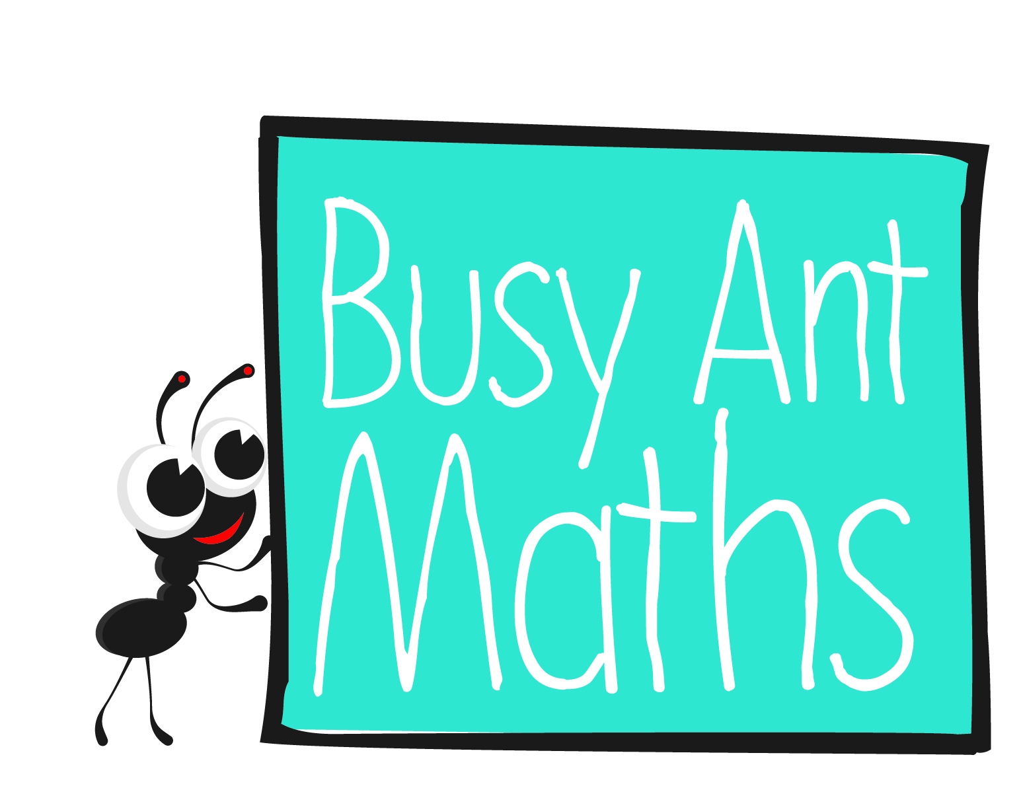
Primary 6
Maths
Unit 4
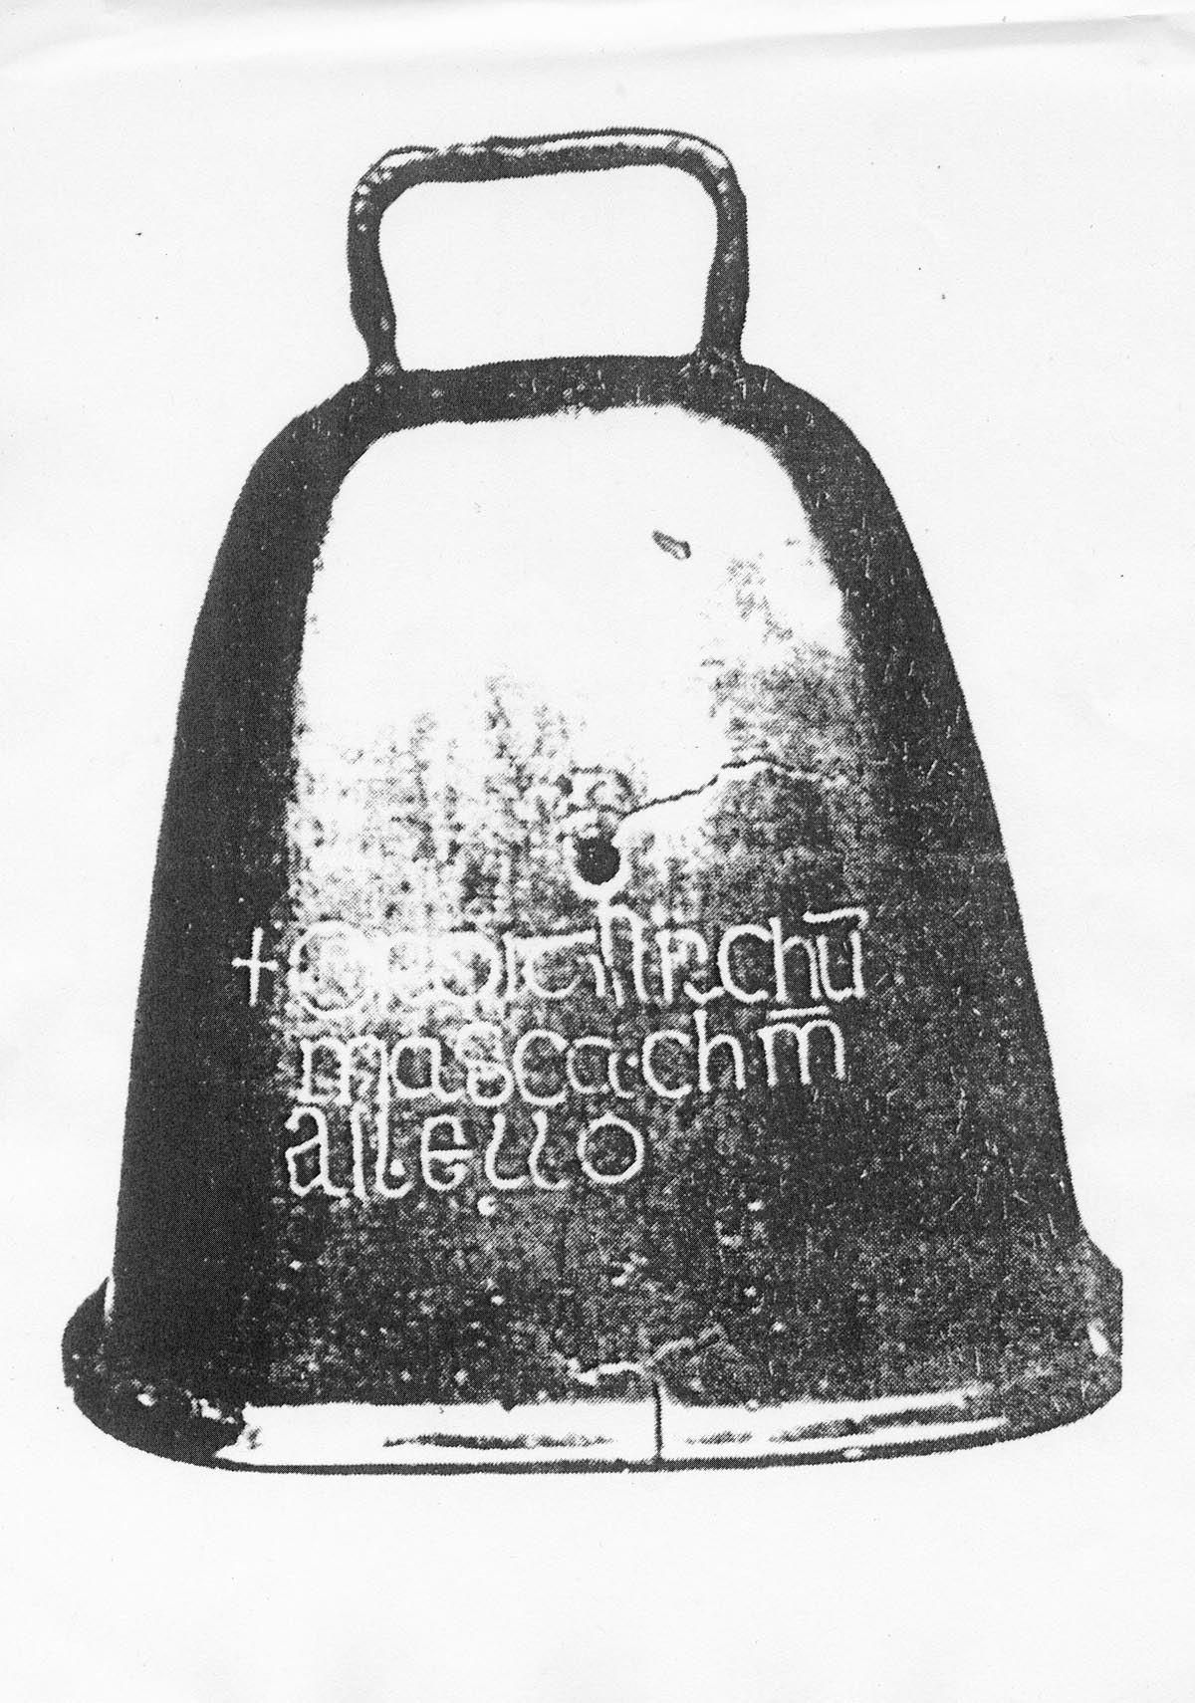
Date: ______________________ Name: ______________________

Multiplication and division
HERE’S THE MATHS
This week’s focus is on multiples and factors. The child finds the prime factors of
a number using a factor tree, e.g. the prime factors of 18 are 2, 3 and 3. Prime factors are prime numbers that are factors of the number. (A prime number is a number that has only 1 and itself as factors.) When the prime factors are multiplied they result in the number, so 18 = 2 × 3 × 3.
ACTIVITY
You will need:
- pencil and paper
1 | 2 | 3 | 4 | 5 | 6 | 7 | 8 | 9 | 10
11 | 12 | 13 | 14 | 15 | 16 | 17 | 18 | 19 | 20
21 | 22 | 23 | 24 | 25 | 26 | 27 | 28 | 29 | 30
31 | 32 | 33 | 34 | 35 | 36 | 37 | 38 | 39 | 40
41 | 42 | 43 | 44 | 45 | 46 | 47 | 48 | 49 | 50
51 | 52 | 53 | 54 | 55 | 56 | 57 | 58 | 59 | 60
61 | 62 | 63 | 64 | 65 | 66 | 67 | 68 | 69 | 70
71 | 72 | 73 | 74 | 75 | 76 | 77 | 78 | 79 | 80
81 | 82 | 83 | 84 | 85 | 86 | 87 | 88 | 89 | 90
91 | 92 | 93 | 94 | 95 | 96 | 97 | 98 | 99 | 100

What to do
- Take turns to choose a number from the number square and draw a factor tree
for the number, continuing until the prime factors have been reached.
- Check the factor tree and then cross out the number.
- If you chose a prime number, write P on the number.
- Continue for 10 minutes.
- Discuss which numbers have interesting factor trees, e.g. 64: 2, 2, 2, 2, 2, 2 and
81: 3, 3, 3, 3.
Variation
- Challenge each other to find the prime factors of 3-digit numbers.
QUESTIONS TO ASK
What is 12²?
Can you explain how to find the factors of 30 using a factor tree?
What are the factors of 28?
Multiplication and division
HERE’S THE MATHS
Your child is learning to identify prime numbers and factors of numbers up to 12 × 12.
A prime number is a number that has only 1 and itself as factors, whereas a composite number can be divided exactly by numbers other than 1 and itself. For example, the factor pairs of 18 are 1 × 18, 2 × 9 and 3 × 6. Each pair multiplies to give the number.
ACTIVITY
What to do
You will need:
- book with about 150 pages
- coin
- Take turns to open the book to a different page (open again if the book is opened to a page that has been used).
- Toss a coin to decide whether to score the left- or right-hand page, heads for left and tails for right. Find all the factor pairs for the number.
- Score 10 points if you have picked a prime number or 3 points for each factor pair
of a composite number. For example, if you open the book at pages 11 and 12, heads gives page 11 which is a prime number and scores 10. Tails gives 12, which has three factor pairs (1 × 12, 2 × 6, 3 × 4) and scores 9.
- Play for 10 minutes.
- Winner has the higher score.
Variation
- Find the factors for two pages (not consecutive ones) and identify common factors.
QUESTIONS TO ASK
What are the first ten prime numbers?
(2, 3, 5, 7, 11, 13, 17, 19, 23, 29)
What is a composite number? Are all even numbers composite?
(2 is prime, all other even numbers are composite)

What are the prime factors of 18?
(2, 3, 3)

What are the factor pairs of 32?
(1 × 32, 2 × 16, 4 × 8)

What are the common factors
of 20 and 30?

