Primary One Curriculum Overview 2017-18
General Information | - Water bottles must have a sport’s cap to lessen spillages within the class.  - Children should wear their coat to school every day, particularly in the Autumn and Spring Terms.  - Please ensure that all homeworks are completed and signed. Use pencil for written answers and no markers to be used!  - All clothing and water bottles must be labelled clearly with your child’s name and class.  - Healthy break- fruit or vegetables only (no raisins), water or milk. One piece/small portion is sufficient.
Religion | Primary One ‘Grow in Love’ Scheme with weekly homework on Thursday.  Please complete ‘At Home’ page, sign and return pupil activity book either on Friday/Monday.  Encourage your child to bless themselves properly and to say their prayers clearly.
Literacy  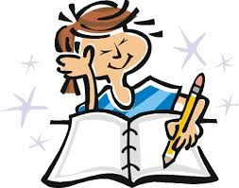  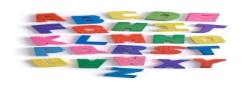 | Collins Literacy and Jolly Phonics/ Linguistic phonics & Cross Curricular ideas to coincide with WAU.  Reading readiness  Children will have lots of opportunities for discussion, role play and shared reading experiences along with oral language activities help to broaden the children’s vocabulary.  Children’s pre-reading skills will be developed through games and activities incorporating: matching/rhyming/direction/ motor skills/concepts of print/language skills/phonics.  Approaches to reading: Guided reading, shared reading- at home/in school, Independent reading.  Children can access books from the classroom Library (enjoy a book together –read to them and/or share the reading-let them tell the story) READ EVERY NIGHT  (For guided reading books (Oxford Reading Tree/Rigby Star/Big Cat Collins reading schemes) Please encourage strategies as noted inside book cover).  Writing  Children experiment with ‘mark-making’ in the Early Years, which progresses to more controlled letter formation.  Nelson Handwriting scheme has been newly purchased and will be a guide throughout the year.  Please ensure that your child uses the correct formation of letters as and when taught, as it can be quite difficult to ‘reverse’ embedded ‘habits’!  Children are exposed to a range of different genres of writing, including recount, poetry, narrative, instructional and play-script.  Phonics  Pupils will learn sounds of letters and be able to use these sounds to write words independently by segmenting and blending to read and write words (decoding skills).  Useful websites for Phonics /High frequency words: www.roythezebra.co.uk, www.phonicsplay.co.uk, www.bbc.co.uk/schools/wordsandpictures/cvc, www.ictgames.co.uk.

Numeracy  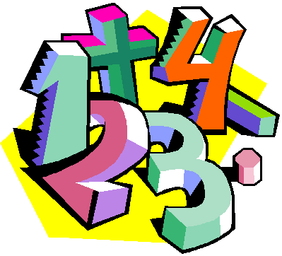 | New ‘Collins – Busy Ant Maths’ scheme.  In Primary One children will:  - Become familiar with numbers 0-10 (extending up to 20).  - Count orally in 1s forwards/backwards to/from 10 (extending up to 20).  - Count in 1s forwards/backwards from a given number within 10 (extending up to 20).  - Recognise, read, and write numbers to 10.  - Understand the terms number ‘before’, ‘after’, ‘between’ within 10 (extending up to 20).  - Order consecutive numbers increasing/decreasing within 10 (extending up to 20).  - Understand the concept of zero as the empty set.  - Understand conservation of number.  - Be able to combine sets up to 10.  - Be able to practically subtract objects from a set up to 10.  - Use everyday language to talk about position and distance  - Be able to recognise and compare 1p,2p, 5p, 10p, 20p, 5p, £1 and £2 coins.  - Be able to order and sequence familiar events.  - Be able to recognise, name and talk about some 2D and 3D shapes.  - Use everyday language to talk about capacity to compare objects and solve problems.  - Use everyday language to talk about weight to compare objects and solve problems.  - Use everyday language to talk about length to compare objects and solve problems.
World Around Us | Topic-based approach to cover Geography, History, Science and Technology  Term 1 ‘Autumn’, Nursery Rhymes and People who help Us  Term 2 All about Me  Bread  Term 3 Minibeasts
Art & Design | Cross curricular links to coincide with WAU and Play based learning. | Music | Cross Curricular links and Music Express Resource used.
PDMU  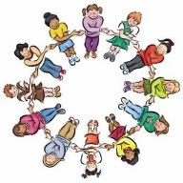 | Living, Learning, Together Year 1 resources. | PE & Fundamental skills  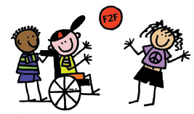 | Attainment areas of ‘Games’, ‘Gymnastics,’ ‘Dance’ and ‘Athletics’ will be delivered.  Pupils will develop their balance, co-ordination and loco-motor skills.  Please ensure that your child wears their PE gear to school on Friday.
Learning Through Play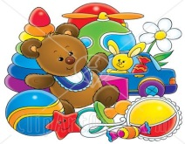 | Based on WAU Topic  Children learn best through play when play is challenging – therefore we have set up challenges in play which are related to the topics.  Play should also build on the children’s own interests and experiences.  Children will have opportunities to report to their class about their play experiences during ‘Play Reporter’ time – which they will then record in the class ‘Play Reporter’ book.

