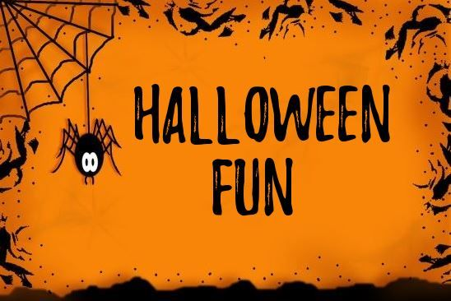
The Friends of St Joseph and St James’s had their first committee meeting last week. It was agreed by the committee that we would aim to raise £1000 and donate this to the school to assist with paying for the PATHS programme. This is an excellent programme focused on emotional well-being which will assist all of our children throughout their lives. Our first fundraising event will take place on Friday the 26th October.
The children can come to school in Hallowe’en Fancy Dress and there will be a Hallowe’en Parade in the morning.
Anto, from ‘Bee Active’, has kindly agreed to DJ and run a ‘dance off’ for each of the classes in the Hallowe’en decorated Parish Hall. There will be a prize for each class’s ‘dance off’ champion.
The children can also enter a Hallowe’en colouring competition. Prizes will be awarded for each of the 3 category winners (P1 and 2, P.3 and 4, P.5, 6 and 7).
Colouring competition £1
Hallowe’en Fun Day £2
The event is voluntary and children do not have to take part. Please send the necessary money into school with your child, to be handed in to their teacher.
Yours sincerely
Friends of St Joseph and St James’s Committee
(Alan Hudson, Helen Hamill, Irena Twohig, Margaret Savage, Martina Grew, Sharon Watters, Therese Farthing)

