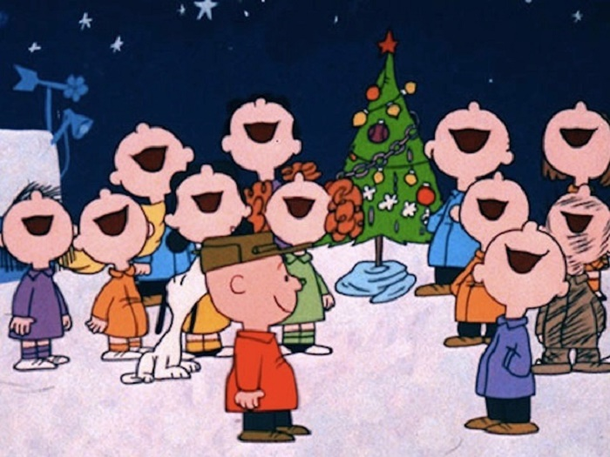

The Pupils of St Joseph and St James’s P.S present their
Christmas Carol Service
In The Parish Hall
Tuesday 18th December at 7pm

‘Friends Of’ Christmas Draw and tea, coffee and delicious mince pies!
Everyone welcome!

