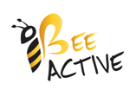

Through your generosity and support we have raised

£1500.00!!!

Thank you so much!

This money will help pay for ‘Bee Active’ for the next year.