Properties of shapes
HERE’S THE MATHS
An angle measures an amount of turn in degrees (°). A whole turn is 360°, a right angle 90° and a straight-line angle 180° (two right angles). Your child is learning to calculate an unknown angle at a point on a straight line and other multiples of 90°, to use a protractor to draw and measure angles and to estimate the size of an angle. Acute (less than 90°), obtuse (between 90°and 180°) and reflex angles (greater than 180°) have been defined.
ACTIVITY
MATHS TOPICS
These are the maths topics your child will be working on during the next three weeks:
- Number and place value
- Addition and subtraction
- Properties of shapes

KEY MATHEMATICAL IDEAS
During these three weeks your child will be learning to:
- read, write, order and compare numbers up to 1 000 000 and determine the value of each digit
- add and subtract decimals to decimal places using the formal written method
- identify angles at a point on a straight line and other multiples of 90°.

TIPS FOR GOOD HOMEWORK HABITS
Talk to your child about maths and use a wide range of vocabulary, e.g. in this unit the names of different types of angles: acute, obtuse and reflex.
What to do
- One person draws a straight line.
You will need:
- 1–6 dice
- pencil, paper and ruler
- Roll the dice and multiply the score by 10 to give an acute angle, e.g. a roll of 4 is an angle of 40°.
- Sketch and label the angle on the line. Try to sketch the angle approximately the correct size.
- Roll the dice again and repeat to give a second angle.
- Calculate the missing angle to make the straight line.
- Second person checks the calculation.
- Change roles and repeat.
- Continue for 10 minutes.
Variation
- Roll the dice three times to give three angles and work out the missing angle
for a complete turn.
QUESTIONS TO ASK
How many degrees in a whole turn? (Two whole turns?)
What is an acute angle? Obtuse angle? Reflex angle?
Explain what a protractor is and
how to use it.
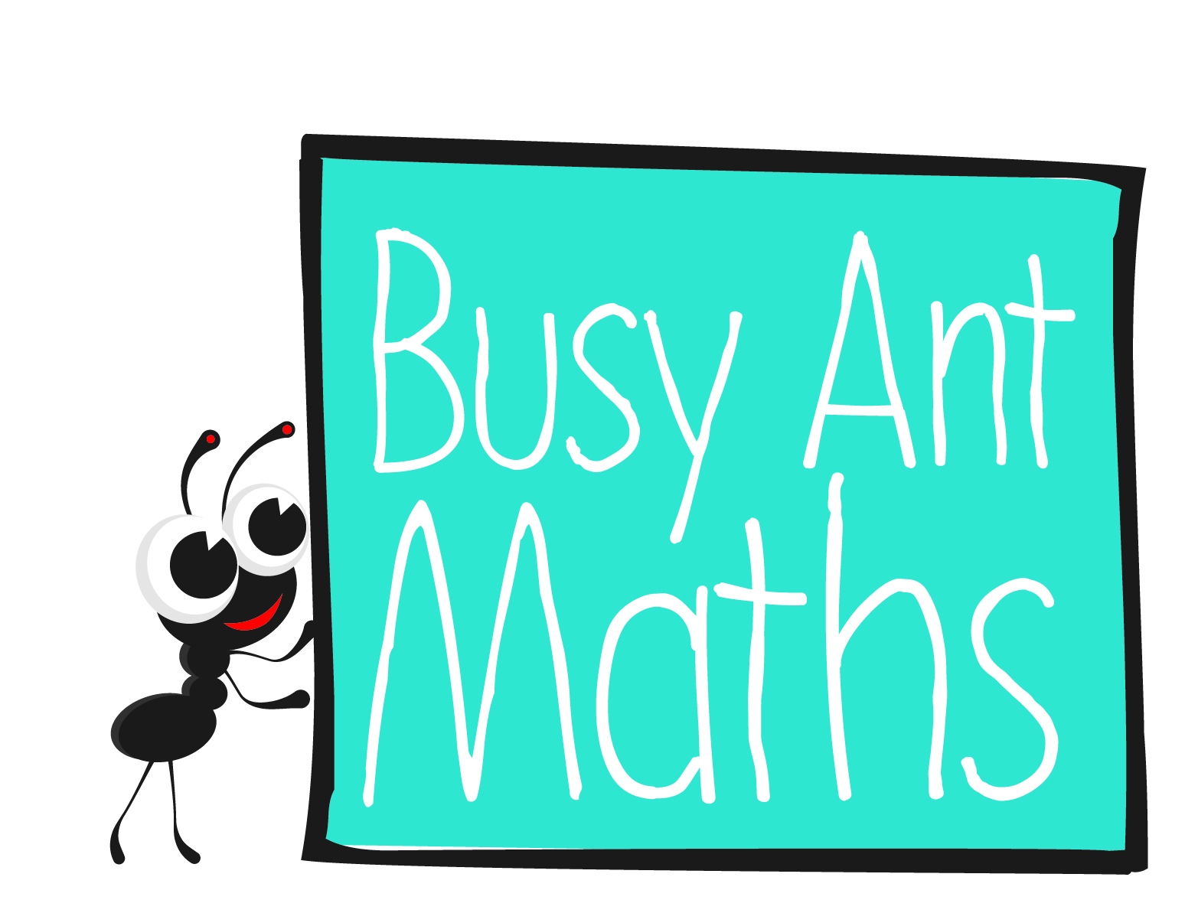
Primary 6
Maths
Newsletter 5
Insert
school logo
here
How many right angles
in a whole turn?
(Two whole turns?)
Date: ______________________ Name: ______________________

Number and place value
HERE’S THE MATHS
In order to add, subtract, multiply and divide successfully, your child needs to be able to recognise, count, read, write, compare and order numbers. It is also extremely important that they recognise the place value of each of the digits in numbers up to 1 000 000.
ACTIVITY
What to do
You will need:
- pack of playing cards with the 10s removed (picture cards represent zero)
- Take half the pack of cards each and both lay out six cards to make a 6-digit number.
- Read the number to each other.
- Score the numbers according to the following rules:
- If your number is even, score 5.
- If your number is exactly divisible by 5, score 5.
- If your number has an odd number of millions, score 5.
- The larger of the two numbers scores a bonus of 10.
- Record the score.
- Return the cards to the pack, shuffle them and repeat with a new number.
- Continue for 10 minutes.
- The winner is the person with the higher score.
Variation
- Make up new rules for scoring.
QUESTIONS TO ASK
Round 555 555 to the nearest 10 (100, 1000).
What is 5 − 10?
What is 1000 000 minus 1?
Addition and subtraction
HERE’S THE MATHS
The focus this week is on subtraction. Your child is learning to choose an appropriate method to subtract whole numbers. This may be a mental method, using a number
line or jottings, or the formal written method. They estimate and use rounding to check their answers. They are also learning to subtract decimal numbers with up to two decimal places.
ACTIVITY
You will need:
- pencil and paper
.
− .
__________
__________
What to do
- Use the digits 1–9 in the 2-place decimal subtraction above.
- Both try to make up a subtraction calculation that has an answer as close as
possible to 3.
- Each number can only be used once.
- After a few minutes, compare answers and discuss strategies.
Variation
- Change the target answer.
QUESTIONS TO ASK

The difference in two temperatures is 8°. Give some possible examples of the two temperatures where one is positive
and one negative.
What is 12 506 − 9?
What is 76 321 − 600?
What is 34 687 − 5000?
What is 23 560 − 80?
When are negative numbers used in everyday maths?

