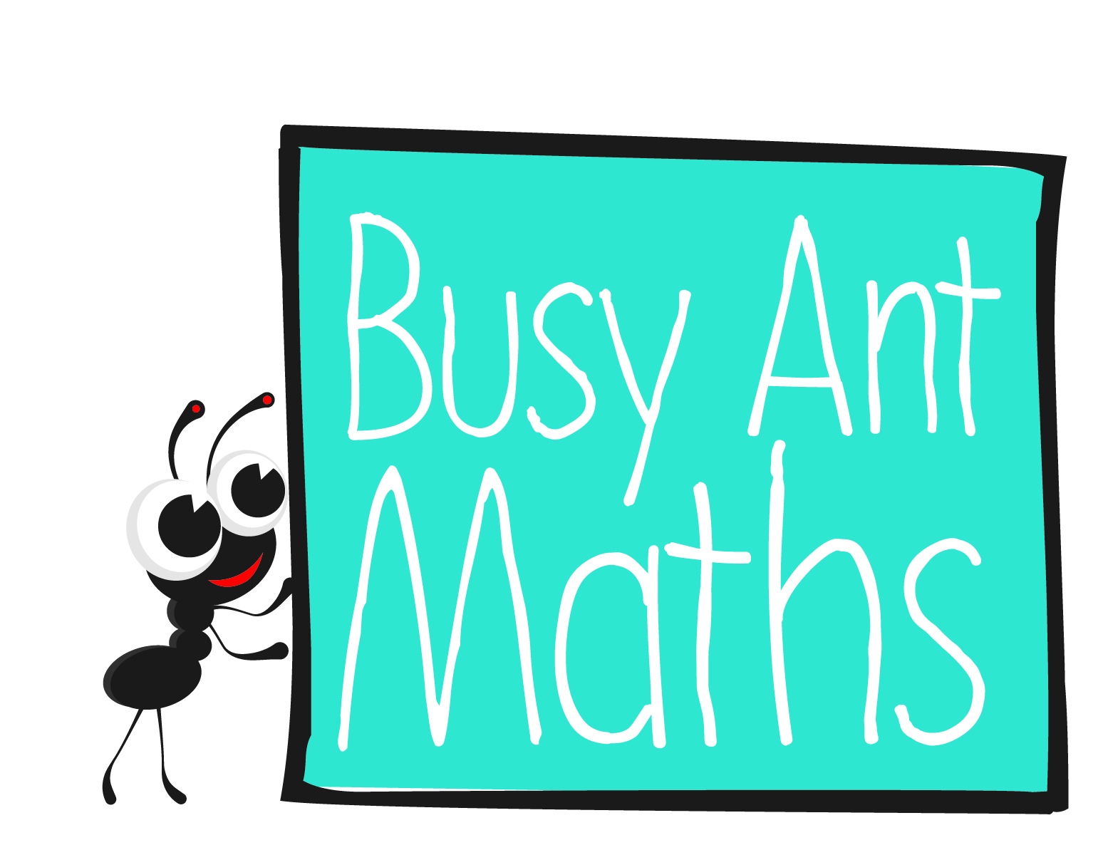
Measurement (length)
HERE’S THE MATHS
Your child is carrying out practical measurement of lengths this week, gaining confidence in using the metric units of length and converting from one unit to another. They know the imperial unit, the inch, and its rough metric equivalent in centimetres:
1 inch ≈ 2·5 cm.
ACTIVITY
MATHS TOPICS
These are the maths topics your child will be working on during the next three weeks:
- Multiplication and division
- Fractions
- Measurement (length)

KEY MATHEMATICAL IDEAS
During these three weeks your child will be learning to:
- use the formal written method of short division to calculate HTO ÷ O, expressing the remainder as a number, a fraction or a decimal
- identify thousandths and relate them to tenths and hundredths
- know the imperial unit ‘inch’ and the rough metric equivalent in centimetres.

TIPS FOR GOOD HOMEWORK HABITS
Always take a break before your child gets bored or overwhelmed.
What to do
Useful to know:
- 1 inch ≈ 2.5 cm
- One person turns over a card and converts this number
of inches to centimetres, e.g. Queen,
12 inches = 30 cm.
- Find something that you estimate is this length.
- The other person uses the ruler or tape measure to check that it is reasonably close in length – agree an acceptable error margin.
You will need:
- cm ruler or tape measure
- pencil and rubber
- pack of cards, Jack represents 11, Queen 12 and King 13
- Change roles and repeat.
- Continue for 10 minutes.
Variation
- Use the cards to estimate lengths in metres
(you would probably need to do this outside).
QUESTIONS TO ASK
Change 207 cm to metres.
What is 2340 m in kilometres?
Primary 6
Maths
Newsletter 6
How do you change centimetres to inches?
Change 1·6 m to centimetres.
Use your finger and thumb to show me the approximate size of 1 inch.
Date: ______________________ Name: ______________________
Insert
school logo
here

Multiplication and division
HERE’S THE MATHS
The focus this week is on division. Your child is learning to use a variety of strategies
to divide, including the formal written method of short division to calculate HTO ÷ O. Until this year, the division calculations that your child met divided exactly without a remainder. Now, they are learning to express the remainder as a number, a fraction
or a decimal and also to appreciate that sometimes the answer to a division problem needs rounding up and at other times it needs rounding down. For a question such as how many full packets there are, round down. If it asks how many cars are required to take everyone, round up – the final car will be part full.
ACTIVITY
What to do
You will need:
- set of cards from 1–9 (e.g. from a red suit of cards)
- set of cards from 2–12 (e.g. from a black suit of cards)
- calculator (optional)
- Each person turns over 3 red cards and writes the six possible 3-digit numbers.
- Turn over a black card. This will be the divisor (the number you divide by).
- Divide each number and note down the remainder.
- Add the remainders.
- You may like to check the division calculations on a calculator.
- The winner has the smaller number.
Variation
- Begin as previously, but this time, predict the remainder. Work out the calculation and if you are correct, score a point. (At this stage, your child should be able to predict remainders when dividing by 2, 5 and 10. They will probably need to guess when dividing by other numbers, though you may know some rules.)
QUESTIONS TO ASK
Give another example
of when you need
to round up the answer to a division problem.
What is $\frac{13}{1000}$ as a decimal?
How do you find the answer to $\frac{2}{3}$ – $\frac{1}{6}$ ?
50 people want to hire rowing boats. A maximum of 6 people can go in each boat. How many boats will be needed?
What is the largest possible remainder when you are dividing by 4?
Fractions
Give another example of when you need to round down the answer to a division problem.
Muffins are sold in packs of 6. A baker makes 50. How full packets are there?
HERE’S THE MATHS
This week your child will be introduced to thousandths – decimals with three decimal places. They are learning that 0·4, $\frac{4}{10}$ , is the same as 0·40, $\frac{40}{100}$ and the same as
0·400, $\frac{400}{1000}$ .
ACTIVITY
What to do
You will need:
- pack of playing cards with the 10s removed (picture cards represent zero)
- Turn over three cards, e.g. 3, 7 and Jack.
- Make all the possible thousandths from these numbers, i.e. $\frac{37}{1000}$ , $\frac{73}{1000}$ , $\frac{307}{1000}$ , $\frac{307}{1000}$ , $\frac{730}{1000}$ ,$\frac{730}{1000}$.
- Convert them into decimal form and order them, i.e. 0·037, 0·073, 0·307, 0·370, 0·703, 0·730.
- Repeat with new cards.
- Continue for 10 minutes.
Variation
- Have three cards each and make the largest decimal number. The person with the larger number scores a point. Repeat 10 times. The person with the higher score
is the winner.
QUESTIONS TO ASK
What is $\frac{1}{3}$ + $\frac{1}{4}$ ?
What is 0·789 as a fraction?
How do you write $\frac{1}{1000}$ as a decimal?

