Statistics
HERE’S THE MATHS
Your child is learning to use information from line graphs to solve problems. Line graphs plot continuous data so you can predict intermediate values. Straight-line graphs are often used to convert currencies. Your child is learning to complete, read and use data in a table, including timetables using 24-hour notation. You could look at real bus, train or ferry timetables together.
ACTIVITY
MATHS TOPICS
These are the maths topics your child will be working on during the next three weeks:
- Decimals
- Addition and subtraction
- Statistics

KEY MATHEMATICAL IDEAS
During these three weeks your child will be learning to:
- read, write, order and compare numbers with up to 3 decimal places
- add and subtract decimals with a different number of decimal places
- use information presented in a line graph to solve problems.

TIPS FOR GOOD HOMEWORK HABITS
Be positive about maths even if you didn’t like it at school. Let your child explain to you the different strategies and methods that they are learning. Avoid teaching your child methods you used at school as it may confuse them.
What to do
- Discuss the likely temperature in a classroom and factors that might affect it.
- Draw a line graph to show the temperature in a school classroom during the winter.
- Use the data to make up three questions each to ask each other, e.g. what time is the heating turned on in the morning?
QUESTIONS TO ASK
What does it mean if a line graph follows a horizontal straight line? (whatever is being measured on the y-axis does not change)
What is the difference between discrete and continuous data? (Discrete data can only have certain values, e.g. number of people, while continuous data can take any value, e.g. a person’s height.)
What is the vertical axis called? And the horizontal axis?
(y-axis, x-axis)
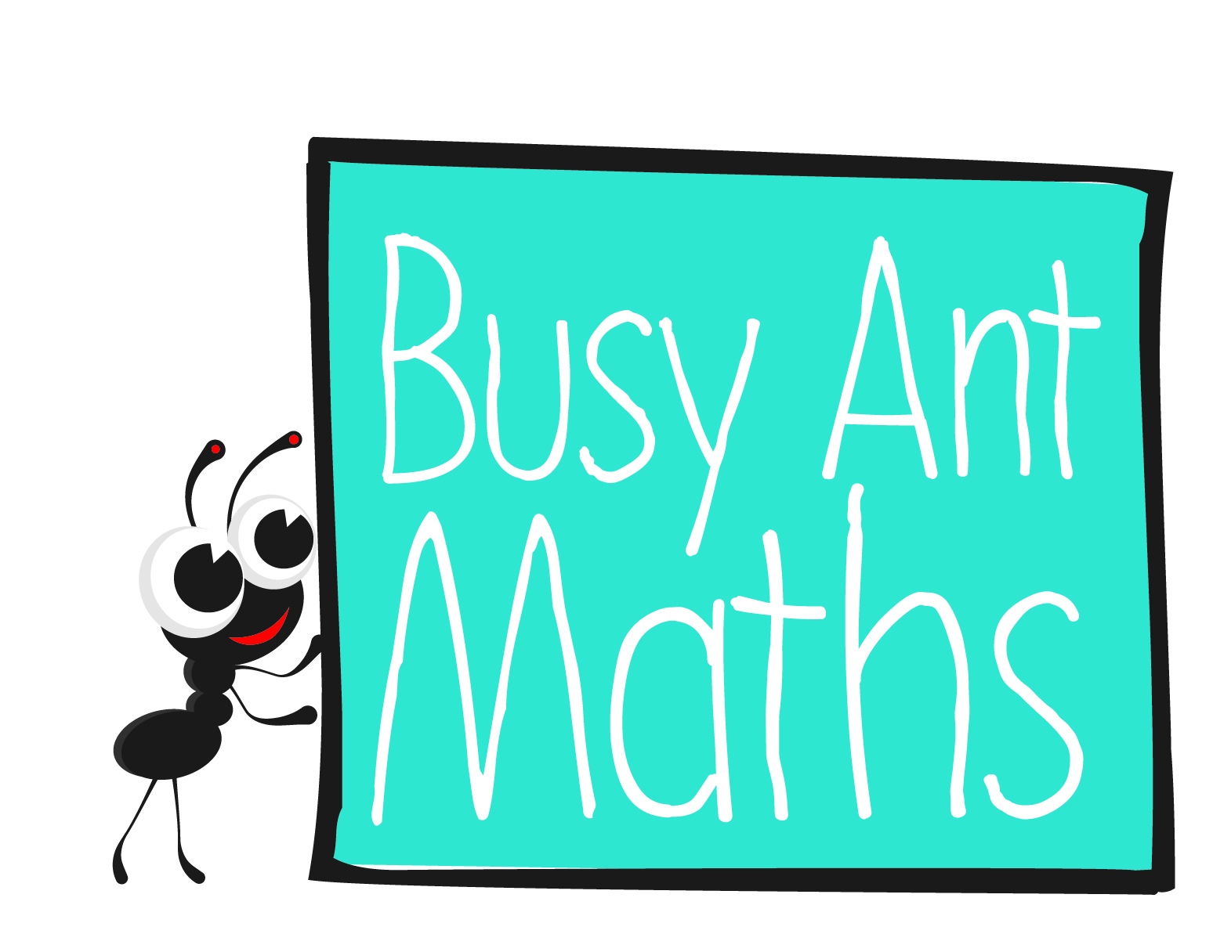
Primary 6
Maths
Newsletter 7
Insert
school logo
here
Date: ______________________ Name: ______________________

Decimals
HERE’S THE MATHS
This focus this week is on understanding and handling (reading, writing, ordering, ordering and rounding) decimals with 3 decimal places. Measurement of length
(metres to kilometres), mass (grams to kilograms) and capacity (millilitres to litres) involves practical use of decimals with up to 3 decimal places. A common misconception at this stage is to think that 0·499 is bigger than 0·5. This is resolved through a secure understanding of place value.
ACTIVITY
0·3 | 0·3 | 0·3 | 0·3 | 0·3
0·7 | 0·7 | 0·7 | 0·7 | 0·7
1·4 | 1·4 | 1·4 | 1·4 | 1·4
2·9 | 2·9 | 2·9 | 2·9 | 2·9
What to do
You will need:
- pack of playing cards with the 10s removed (picture cards represent zero)
- pencil and rubber
- Take turns to complete the 3-place decimals by turning over the cards.
- Order the row from the smallest to largest decimal number.
- Change roles and complete the next row.
- Complete the grid.
- Rub out the grid so that it can be used again.
Variation
- In addition to ordering the decimals, round them to one decimal place.
QUESTIONS TO ASK
What is 23·38 rounded to one decimal place?
What is the total of 3·7 + 11 + 1·28?
What is the value of 4 in 2·374?
Which is bigger, 0·6 or 0·589?
Express $\frac{7}{1000}$. as a decimal.
Addition and subtraction
Round 3·499 to one decimal place and round it to the nearest whole number. What do you notice?
HERE’S THE MATHS
The focus this week is on adding and subtracting decimals with a different number
of decimal places. When using formal written methods, your child needs to set out the calculation so that digits of the same place value are correctly aligned underneath one another. This becomes second nature once their understanding of place value is firmly embedded.
ACTIVITY
What to do
You will need:
- pencil and paper
- Choose 4 digits and use them to write a whole number, a number with 1 decimal place, a number with 2 decimal places and a number with 3 decimal places.
- Challenge one another to make numbers which, when added, give the smallest
(or largest) possible total.
- Compare answers.
- Repeat with new digits.
- Continue for 10 minutes.
Variation
- Set a new challenge to get as close as possible to a particular whole number,
e.g. 5000.
QUESTIONS TO ASK
What has to be added to 0·72 to make 1?
What is 1 − 0·43?
What is the value of 9 in 2·439?

