Measurement
(volume and capacity)
HERE’S THE MATHS
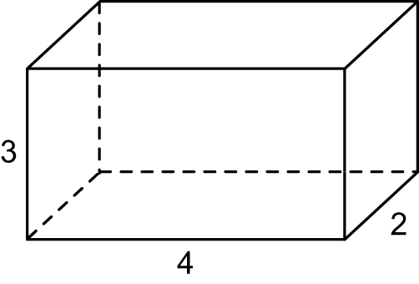
This week your child will be introduced to calculating the volume of cuboids using
1 cm³ cubes. They use cubes (and diagrams of cubes) to count number of cubes
in each layer. They are beginning to establish an understanding that volume equals length × width × height.
MATHS TOPICS
These are the maths topics your child will be working on during the next three weeks:
- Multiplication and division
- Fractions
- Measurement (volume and capacity)

KEY MATHEMATICAL IDEAS
During these three weeks your child will be learning to:
- multiply and divide whole numbers and those involving decimals by 10, 100 and 1000
- recognise mixed numbers and improper fractions and convert from one form to the other.
- calculate the volume of cuboids using 1 cm³ cubes.

TIPS FOR GOOD HOMEWORK HABITS
If your child is struggling, don’t give them the answer in order to finish the homework. Instead, talk through the task together and help them to arrive
at the solution themselves.

1 layer of 3 × 4 cubes = 12 cm³
2 layers of cubes = 24 cm³
ACTIVITY
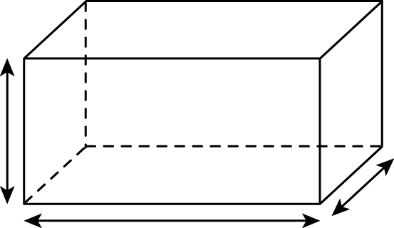
You will need:
- pencil and paper
- two 1–6 dice

What to do
- Each person rolls their dice three times to give dimensions of a cuboid.
- Each person sketches the cuboid and calculates the volume.
- The person with the cuboid that has the greater volume scores a point.
- The winner is the first person to reach 5 points.
Variation
- Use 1–9 cards to increase the number of possible cuboids.
QUESTIONS TO ASK
Change 4070 ml to litres.
How many glasses
of lemonade (250 ml) can be poured from 10 litres?
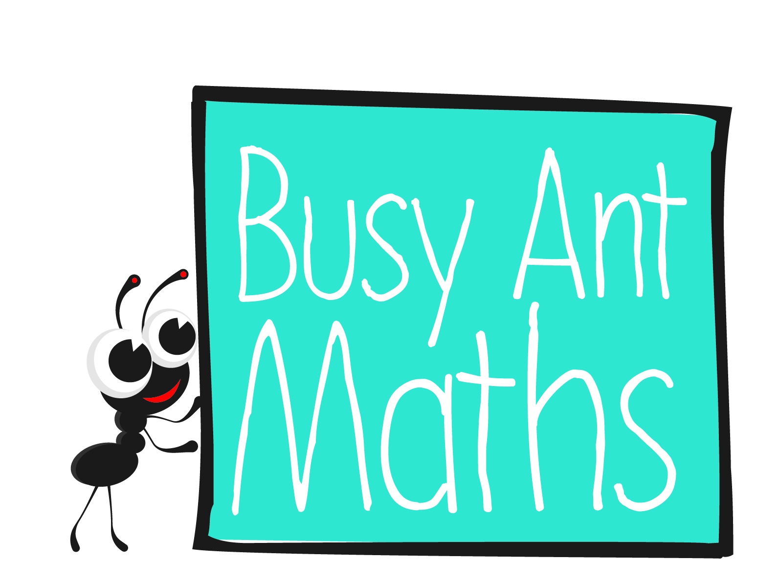
Primary 6
Maths
Newsletter 10
Insert
school logo
here
1 litre = 1 $\frac{3}{4}$ pints. Approximately how many pints are there in 5 litres?
How many 1 cm³ cubes are required to make a cuboid 5 cm × 3 cm × 4 cm?
Change 5·25l
to millilitres.
Date: ______________________ Name: ______________________

Multiplication and division
HERE’S THE MATHS
Your child is consolidating their ability to multiply and divide whole numbers and those involving decimals by 10, 100 and 1000. They can recall the multiplication facts up to 12 x 12 and extend this to multiplication tables that are 10 times or 100 times greater, i.e. 20x, 30x, 40x etc. and 200x, 300x, 400x etc. They can look at a calculation and choose the most efficient method to work it out.
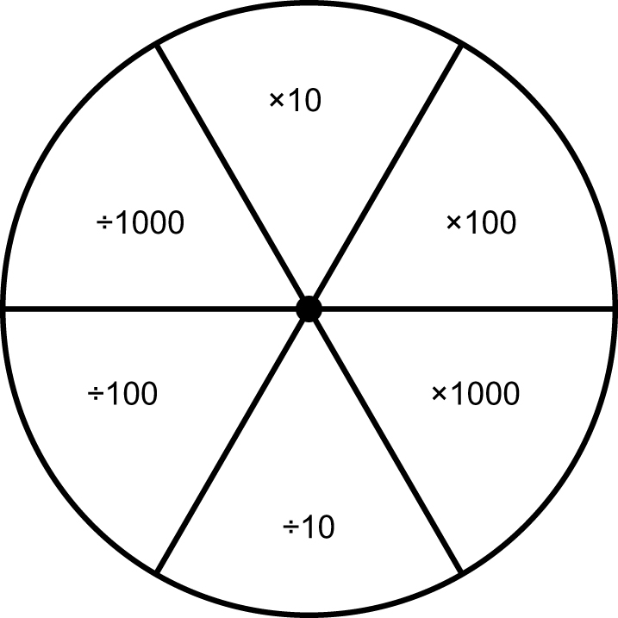
ACTIVITY
You will need:
- 1 coin: heads means multiply and tails means divide
- 1–6 dice
- pencil and paper clip – for the spinner

How to use the spinner
- hold the paper clip in the centre of the spinner using the pencil and gently flick the paperclip with your finger to make it spin

What to do
- Roll the dice.
- Take it in turns to spin the spinner and carry out the operation.
- Write down your score.
- Repeat and add your score to your total.
- The winner has the higher score.
- (The scores may differ hugely because in a single round, one person could score 6000 and the other 0·006).
Variation
What is an improper fraction?
What is a mixed number?
Can you change 3 $\frac{1}{3}$
to an improper fraction?
Can you change $\frac{18}{4}$ to a mixed number and simplify?
What is $\frac{3}{4}$× 3?
What is $\frac{21}{4}$ × 5?
- Roll the dice twice to give a 2-digit starting number.
QUESTIONS TO ASK
Use factors to multiply 19 × 24.
Multiply 25 × 48 mentally. Explain your method.
Divide 34 000 by 100.

Fractions
HERE’S THE MATHS
Your child is learning to recognise mixed numbers and improper fractions and to convert from one form to the other, e.g.2 $\frac{2}{5}$.= $\frac{12}{5}$. They are introduced to multiplication of mixed numbers and improper fractions. They practise simplifying fractions. A fraction is in its simplest form when the numerator and denominator cannot be any smaller whole numbers.
ACTIVITY
What to do
You will need:
- 1–6 dice
- First person rolls the dice to give a numerator.
- Roll the dice again to give a denominator. (Roll again if you roll a 1.)
- Write down the proper or improper fraction.
- Change an improper fraction to a mixed number and simplify the fraction if possible.
- Score as follows:
– 2 points for a fraction equal to less than a half
– 5 points for a fraction greater than $\frac{1}{2}$ but less than 1
– 10 points for a number greater than 1 but less than 2
– 15 points for a number greater than 2.
- Second person has a turn.
- Continue for 10 minutes.
- Winner is the person with the higher score.
Variation
- Roll the dice twice to give a 2-digit numerator and produce only improper fractions. Decide on a new scoring system.
QUESTIONS TO ASK

