Geometry – position
and direction
HERE’S THE MATHS
Your child is learning to reflect a shape using coordinates in the first quadrant. They reflect shapes in different orientations and understand that the shape has not changed but appears as it would in a mirror.
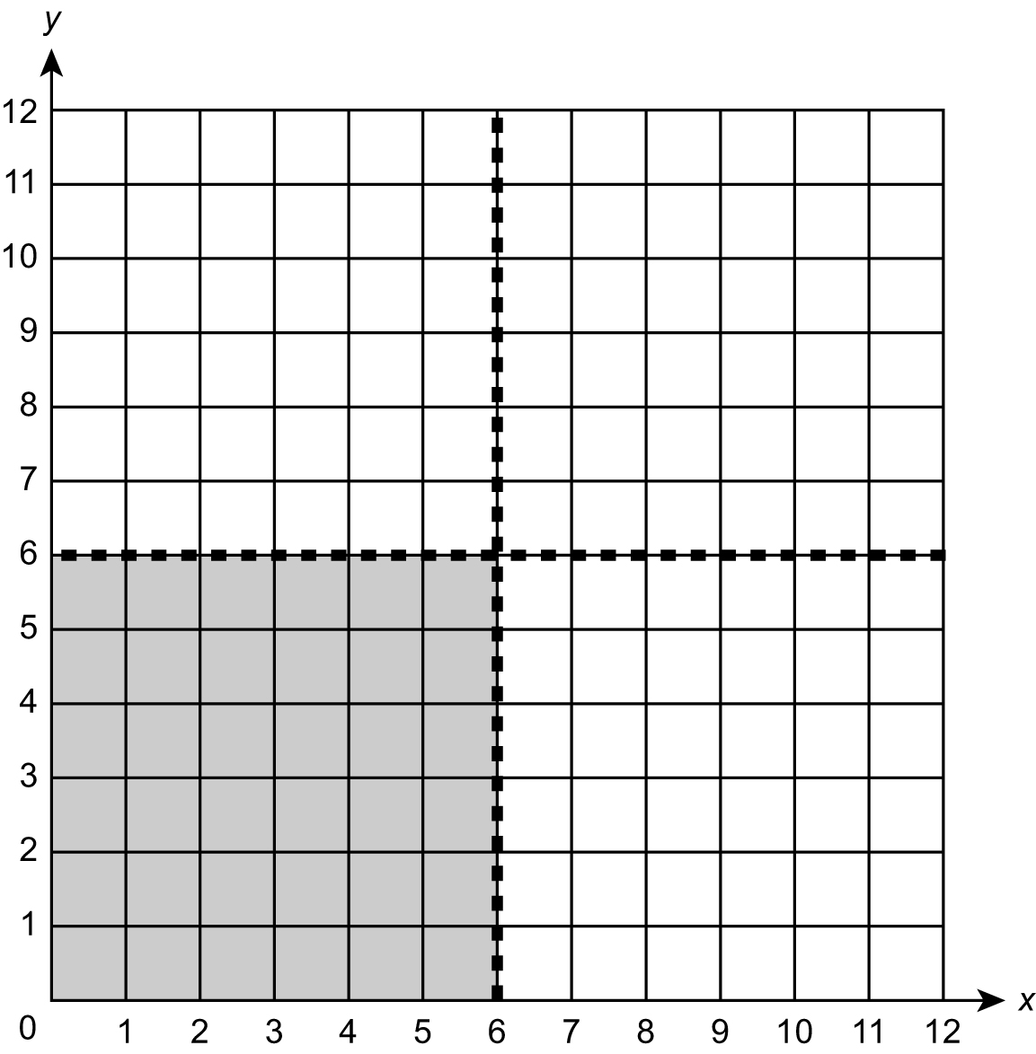
ACTIVITY
MATHS TOPICS
These are the maths topics your child will be working on during the next three weeks:
- Addition and subtraction (including money)
- Percentages (including fractions and decimals)
- Geometry – position and direction

KEY MATHEMATICAL IDEAS
During these three weeks your child will be learning to:
- add and subtract whole numbers and decimals mentally
- understand equivalence between percentages, decimals and fractions and solve problems involving them
- identify, describe and represent the position of a shape following a reflection.

TIPS FOR GOOD HOMEWORK HABITS
Find out what homework needs to be done as soon as possible and consider offering small treats, such as a trip to the park, to encourage your child to complete their homework promptly.
You will need:
- pencil, ruler and rubber

Note
The grid is divided into 4 quadrants by two lines of symmetry.
What to do
- One person draws a simple shape within the shaded grey square.
- The second person reflects the shape in the x = 6 mirror line and writes down the coordinates of the new image.
- The first person reflects the shape in the y = 6 mirror line.
- Rub out the shape and images so that the other person can draw a new shape.
QUESTIONS TO ASK
What word do we use to describe the four sections of the coordinate grid? (quadrants)
Which coordinate is plotted first?
(x-coordinate)
What is the reflected shape/image called?

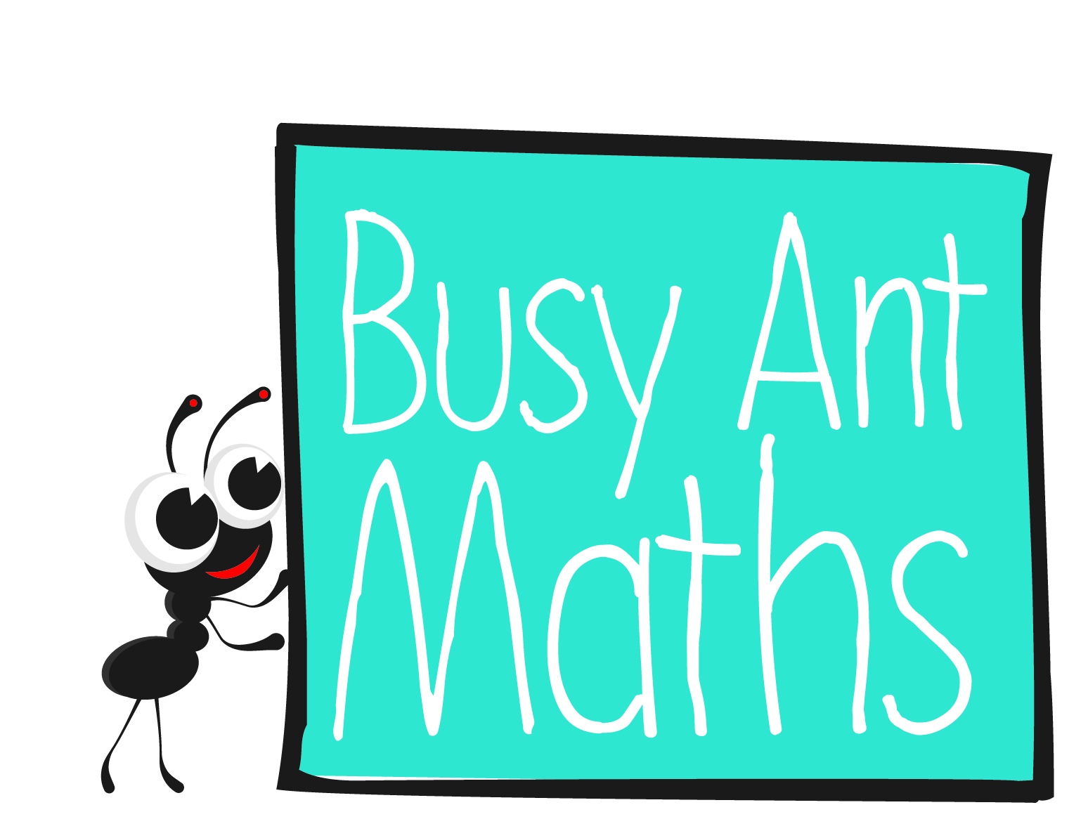
Primary 6
Maths
Newsletter 11
Insert
school logo
here
Date: ______________________ Name: ______________________

Addition and subtraction
HERE’S THE MATHS
Your child is consolidating addition and subtraction calculations including decimal numbers and with whole numbers that have more than 4 digits, using an appropriate mental or formal written method.
ACTIVITY
6, 1  £8·67 | 6, 2  £9·09 | 6, 3  £6·54 | 6, 4  £7·61 | 6, 5  £8·47 | 6, 6  £9·31
5, 1  £11·32 | 5, 2  £10·58 | 5, 3  £11·74 | 5, 4  £12·86 | 5, 5  £11·09 | 5, 6  £12·32
4, 1  £14·87 | 4, 2  £13·02 | 4, 3  £14·59 | 4, 4  £13·41 | 4, 5  £13·57 | 4, 6  £14·88
3, 1  £15·75 | 3, 2  £16·07 | 3, 3  £15·11 | 3, 4  £16·72 | 3, 5  £16·98 | 3, 6  £15·62
2, 1  £17·95 | 2, 2  £18·62 | 2, 3  £16·97 | 2, 4  £17·83 | 2, 5  £17·08 | 2, 6  £16·47
1, 1  £18·91 | 1, 2  £19·01 | 1, 3  £18·74 | 1, 4  £18·62 | 1, 5  £19·74 | 1, 6  £18·45

What to do
You will need:
- 1–6 dice
- pencil and rubber
- Take turns to roll the dice twice to give the coordinate to select a number.
- Take the amount away from £20.
- Write your initials in the square when the calculation has been done. If those coordinates come up again, miss a go.
- Play for a set time or until the grid is completed.
- The winner is the person with the greater number of squares.
QUESTIONS TO ASK
The answer is 0·002 – what is the question?
The answer
is 1000 000 – what is the question?
The answer
is 60,000 –
what is the question?

The answer is 3.9 – what is the question?
The answer is 6·57 – what is the question?

Percentages (including fractions and decimals)
HERE’S THE MATHS
The focus this week is on handling percentages. Your child is learning the percentage and decimal equivalents of fractions and how to solve problems involving percentages. They calculate percentages of numbers and amounts. To find 70% of a quantity, first find 10% ($\frac{1}{10}$) and then multiply the answer by 7.
ACTIVITY
SALE REDUCTION | 1  5% | 2  10% | 3  20% | 4  25% | 5  40% | 6  50%

You will need:
- 1–6 dice
- pencil and paper

ITEM | 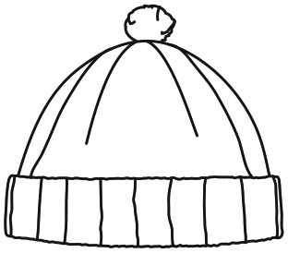  Beanie hat  £20 | 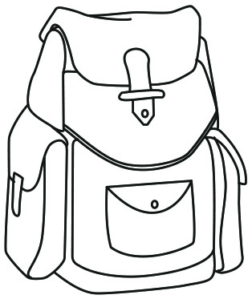  Rucksack  £80 | 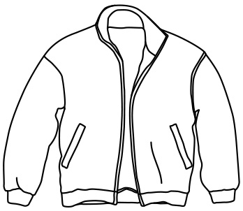  Fleece jacket  £60 | 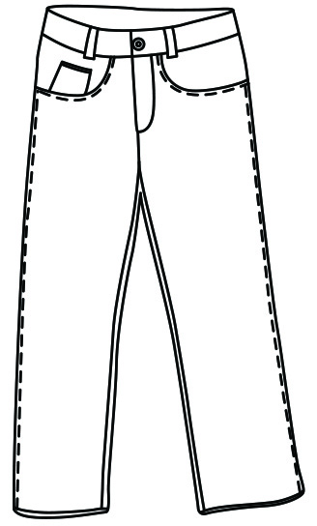  Jeans  £40 | 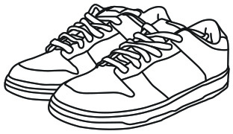  Trainers  £100 | 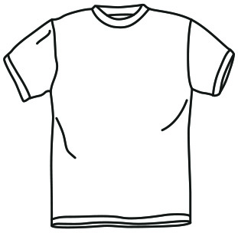  T-shirt  £30

What to do
- You each have £200 and have to try to buy one of every item.
- Take turns to roll the dice to see the sale discount offered.
- Decide what to buy, calculate the cost and take the amount away from £200.
- If you don’t have enough money to buy the items you still need, you miss that go.
- The winner is the first person to have bought one of each item.
Variation
- Make a new grid of items to buy and use reductions of 10%, 25%, 30%, 50%
and 75%.
QUESTIONS TO ASK
The answer is 100%
– what is the question?
The answer is 65% – what is the question?
The answer is 5% – what is the question?

The answer is 0·4 – what is the question?
The answer is $\frac{32}{100}$
– what is the question?

