Statistics
HERE’S THE MATHS
Your child is learning to use information presented in a line graph to solve problems. They determine the value of each interval on a scale and use this to estimate the values of readings between divisions. They are beginning to appreciate how the choice of scale can affect the impact of a graph.
ACTIVITY
MATHS TOPICS
These are the maths topics your child will be working on during the next three weeks:
- Multiplication and division (including money)
- Statistics

KEY MATHEMATICAL IDEAS
During these three weeks your child will be learning to:
- use all four operations to solve problems involving money using decimal notation, including scaling
- use the formal written method of short division to calculate ThHTO ÷ O and to express the remainder as a decimal, a fraction or to round the answer as appropriate
- use information presented in a line graph to solve problems.

TIPS FOR GOOD HOMEWORK HABITS
Reflect on the variety of maths tasks that you have practised together throughout the year. Try to decide which strategies have helped you to understand maths
most easily.
What to do
- One person draws a line graph to show trends that they think would best fit the data for:
You will need:
- pencil and rubber
- annual sales of ice cream
- average monthly temperature
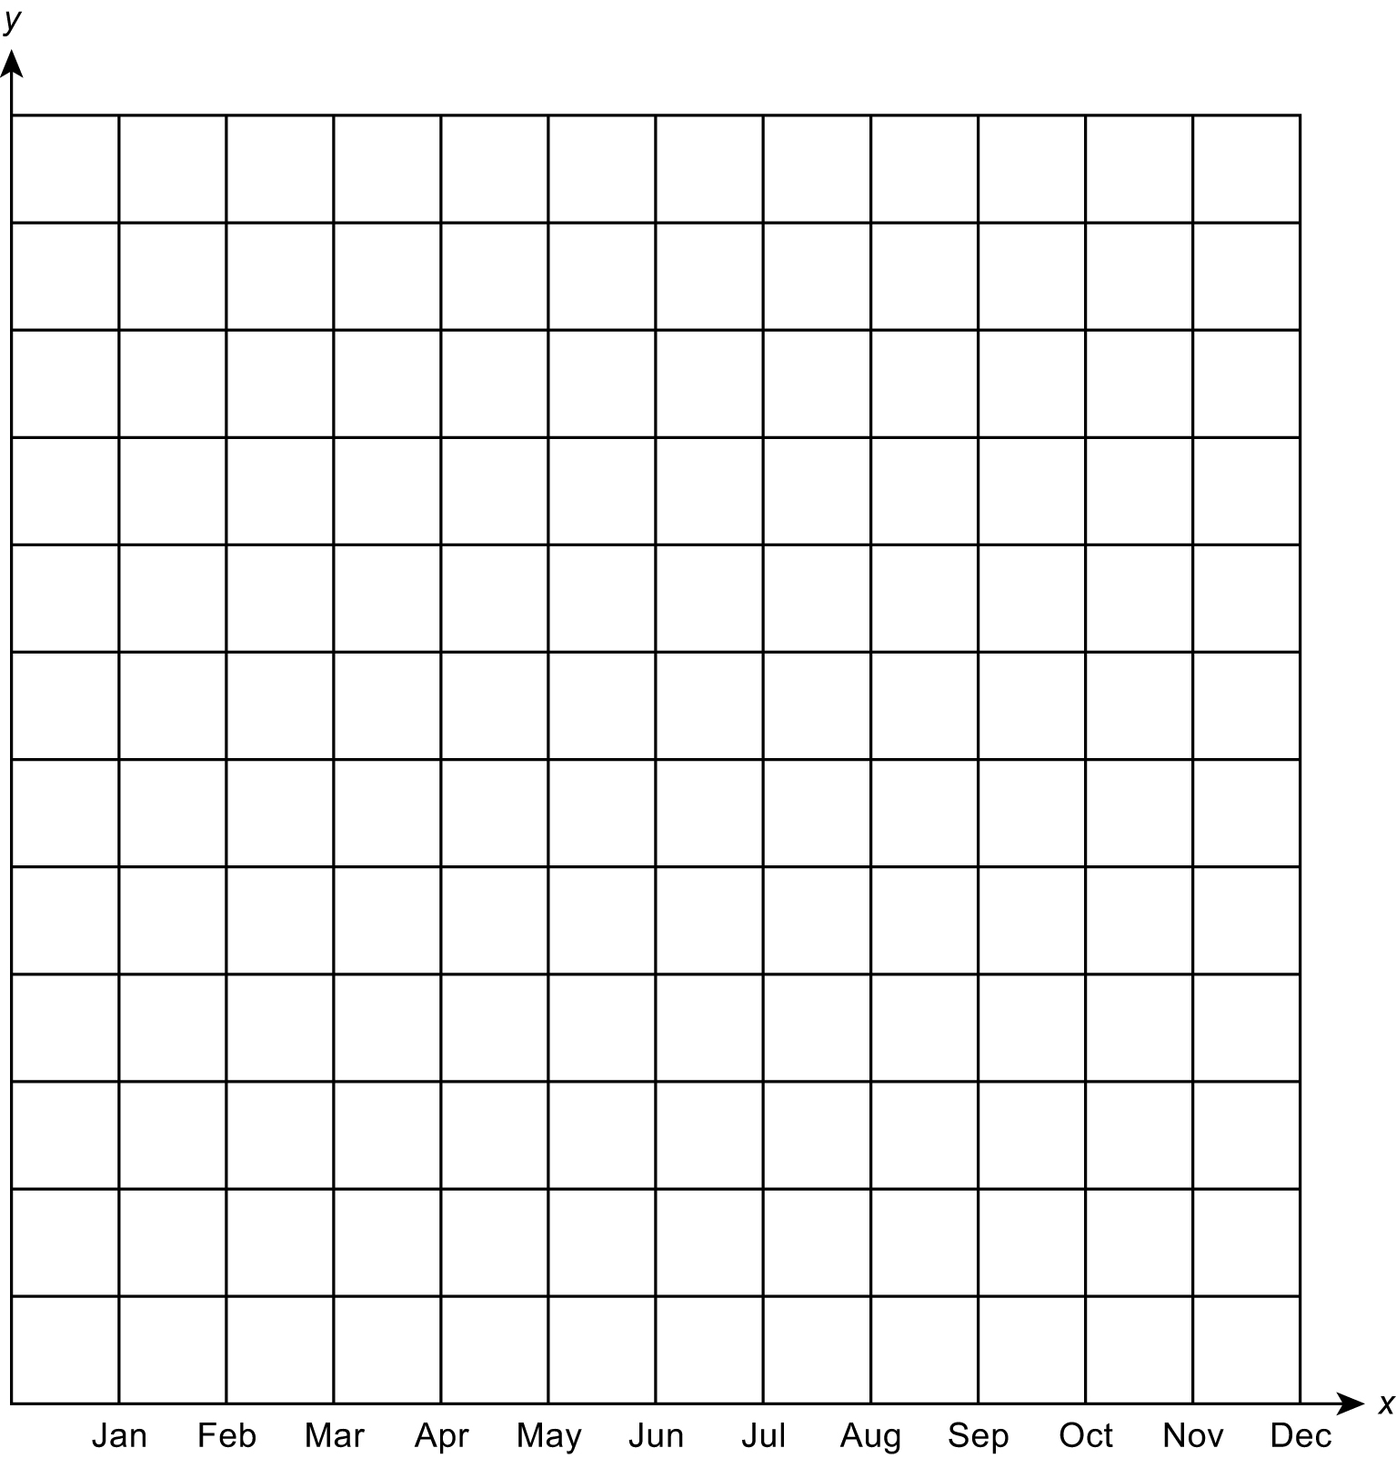
- sales of school uniform
- your own ideas.
- The second person interprets the shape of the line graph that has been drawn.
- The creator of the graph explains whether the interpretation matches their intention.
- Rub out the line graph and repeat, swapping roles.
Variation
- Use alternative scales on the x-axis, e.g. 24 hours.

QUESTIONS TO ASK
Why is a scale of 0, 7, 14 not a good choice?
Why is it important to give a graph a title? And to label the axes?
How do you decide on the scales to use on the x- and
y-axes?
When is a line graph an appropriate choice?

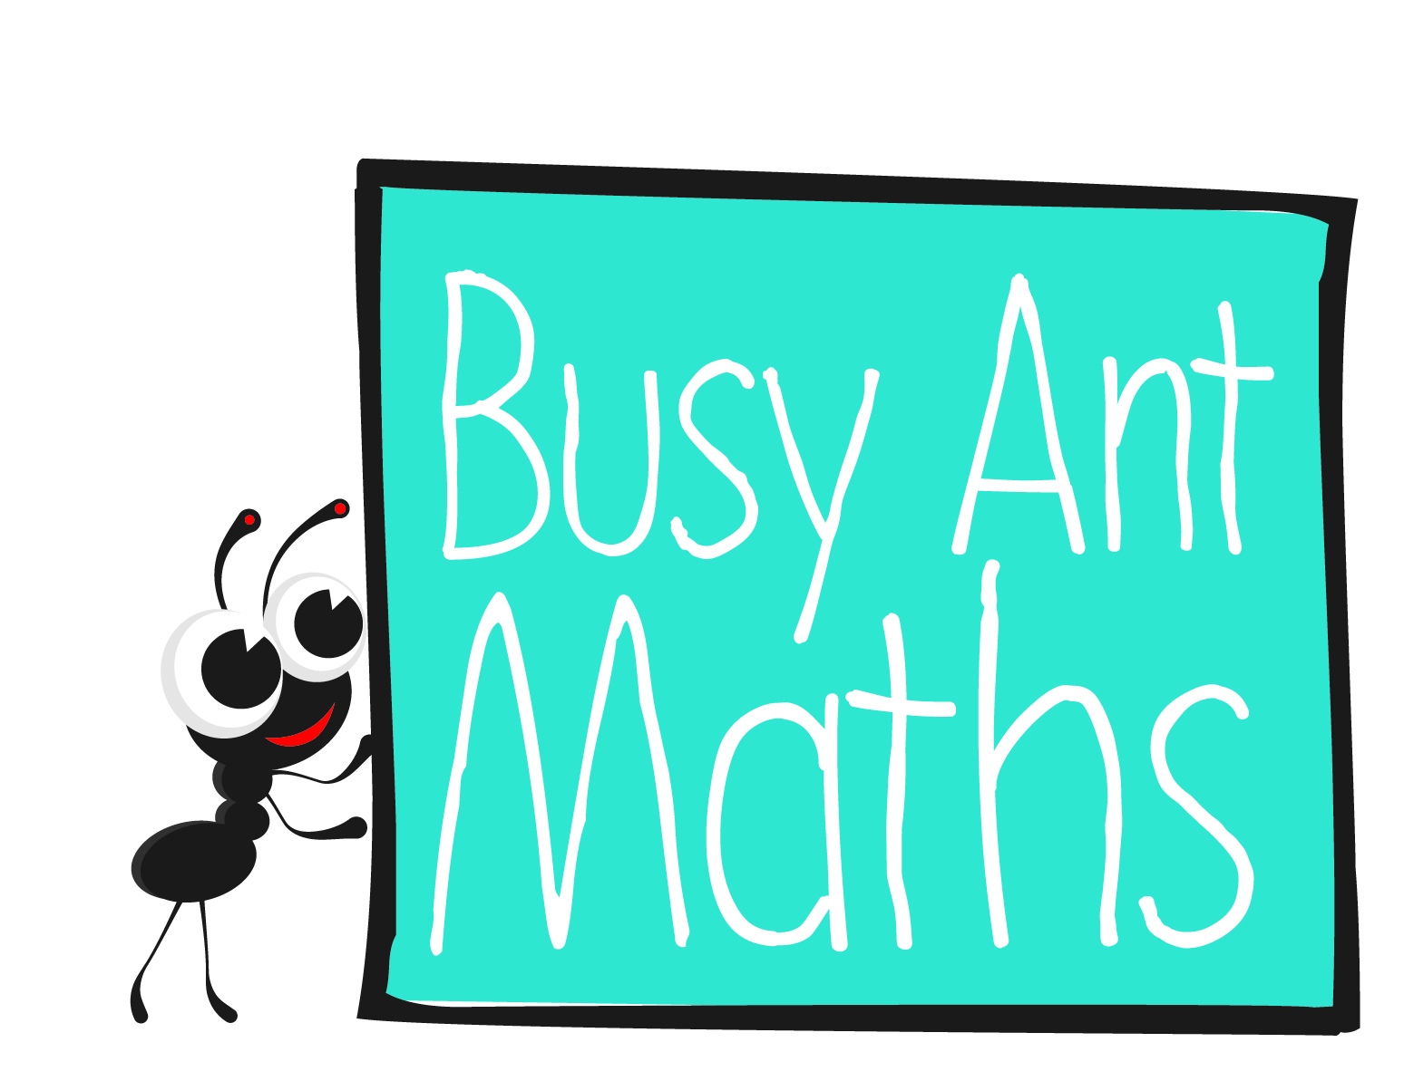
Primary 6
Maths
Newsletter 12
Insert
school logo
here
Date: ______________________ Name: ______________________
Multiplication and division (including money)
HERE’S THE MATHS
Your child is learning to use all four operations to solve problems, involving money problems and decimal notation.
ACTIVITY
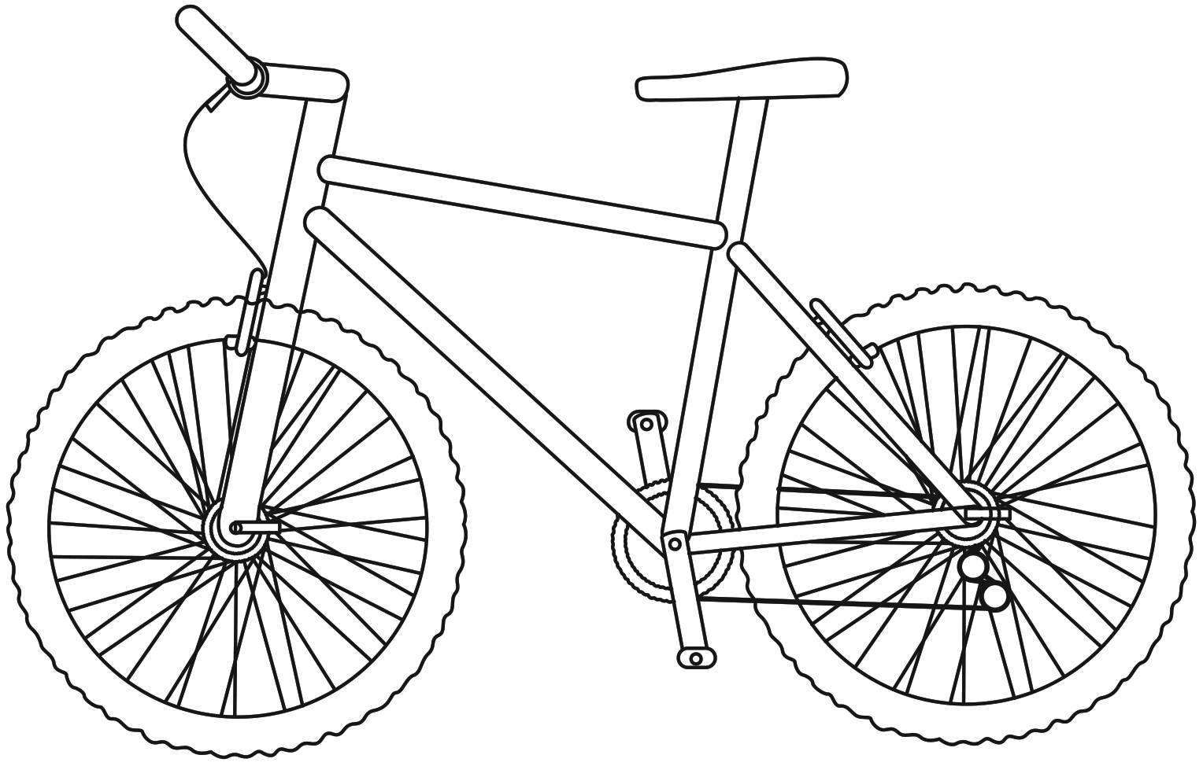 £345  Mountain bike | 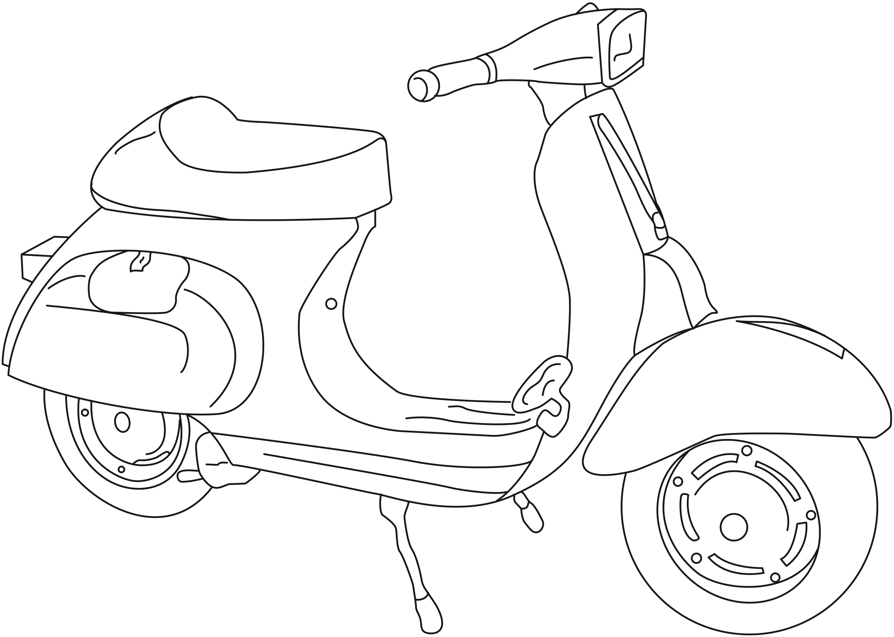 £167  Scooter | 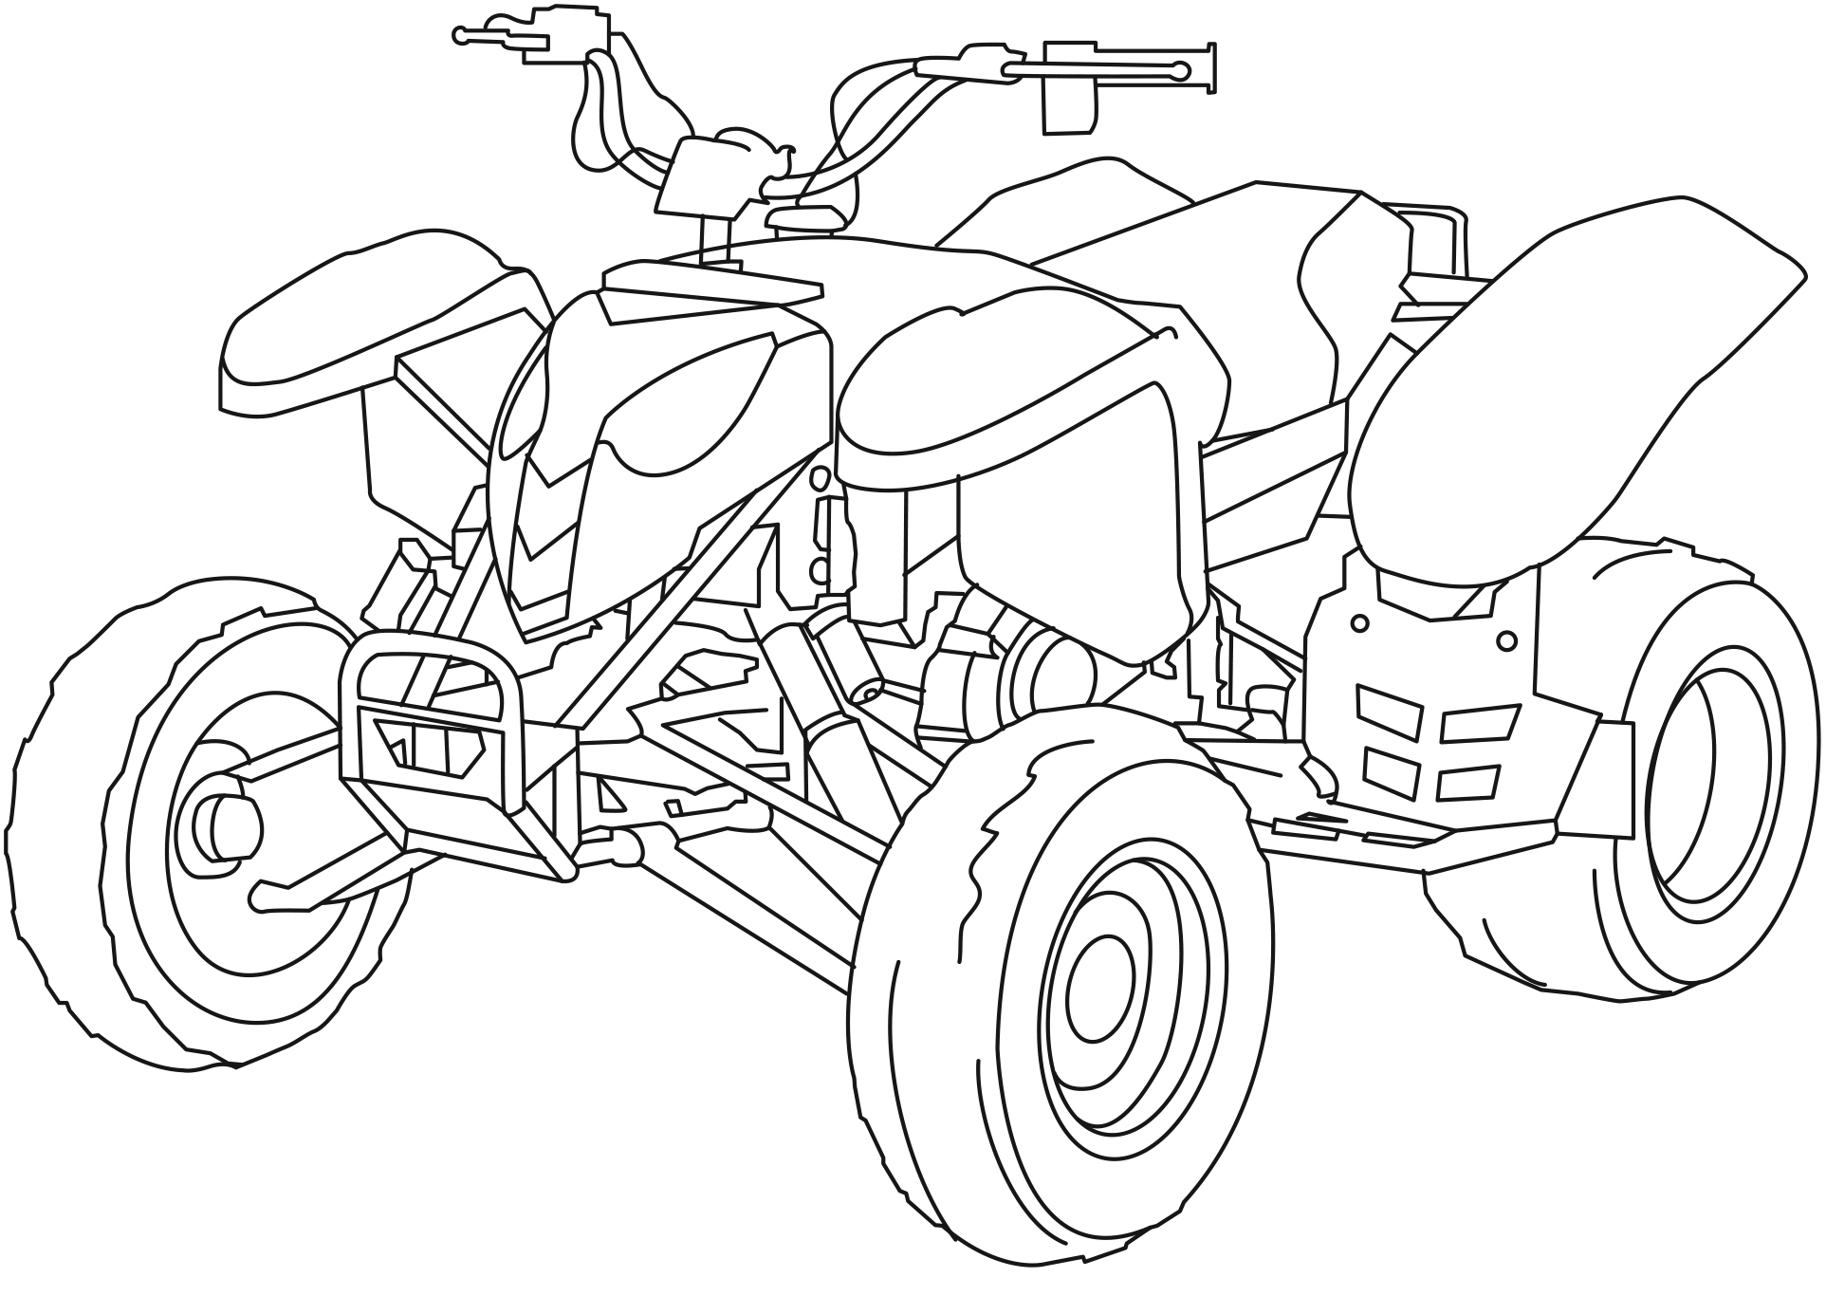 £429  Quad bike
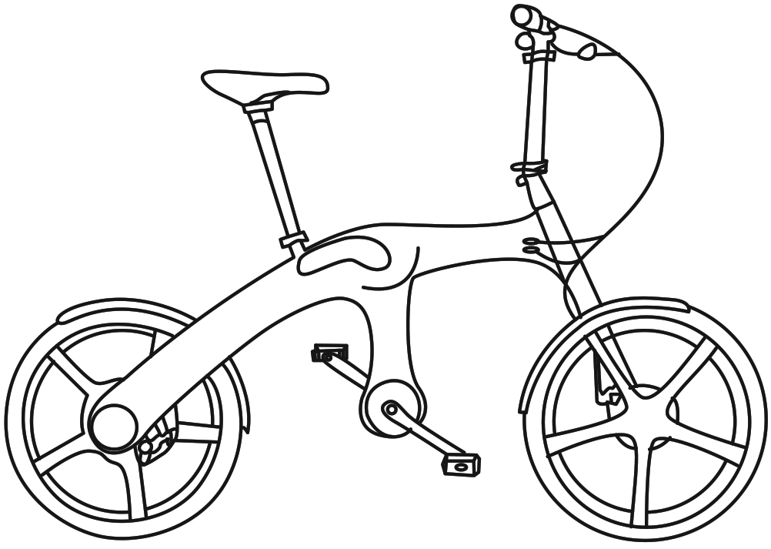 £505  Folding bike | 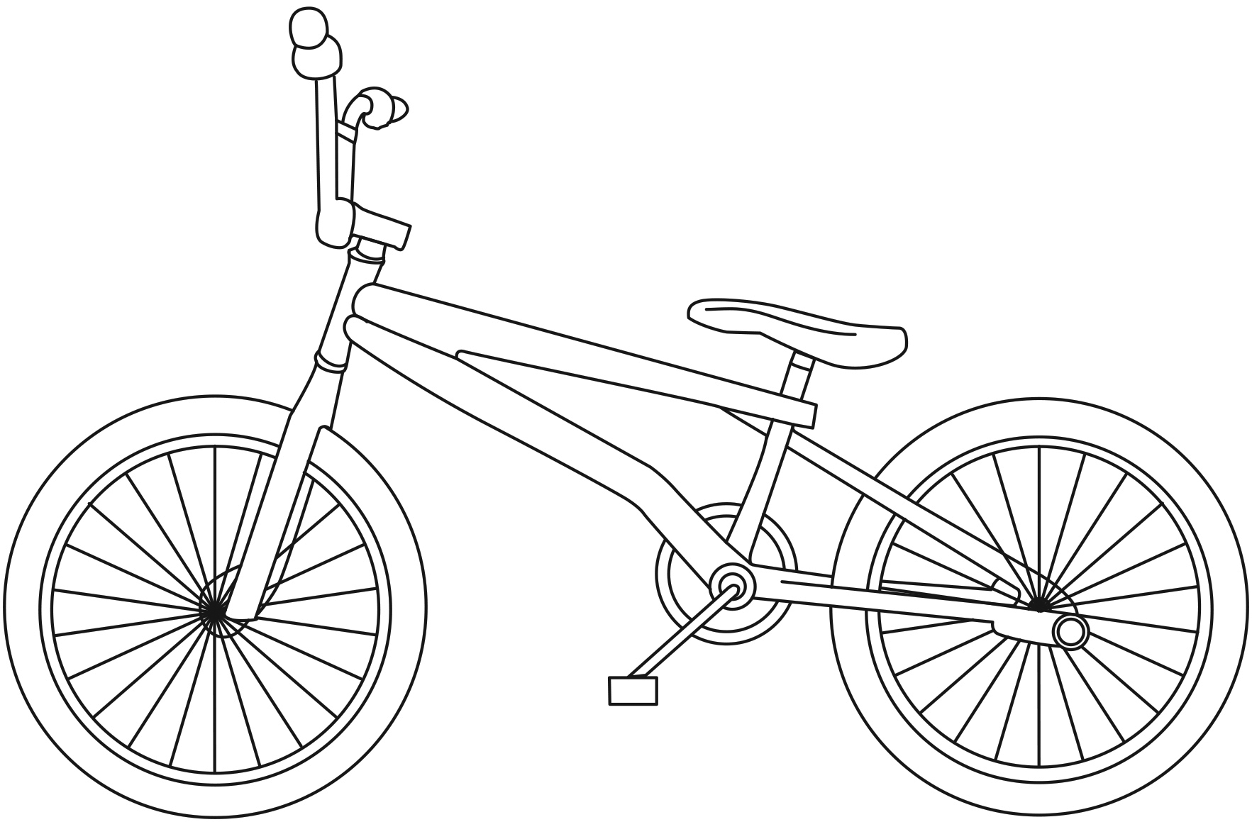 £148  BMX bike | 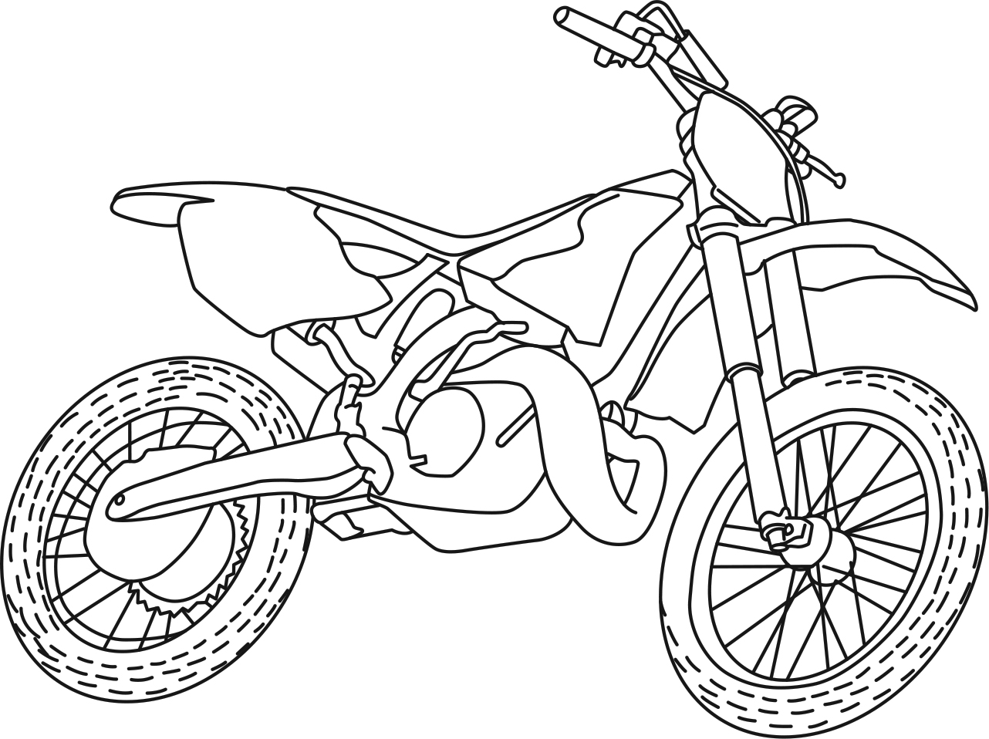 £299  Dirt bike
What to do
You will need:
- pencil and paper
- calculator
- Use the information above to write two problems for each other to solve.
- Try to use two or more different operations in each one, using all four operations (addition, subtraction, multiplication and division) at least once. For example, how much change will there be from £1000 if you buy 3 dirt bikes (multiplication and subtraction)?
A generous grandmother bought quad bikes for her two grandsons. She had planned to spend £1000 so she shared the change between the two boys. How much did each boy receive (multiplication, subtraction and division)?
- Discuss your questions, looking at the operations involved and the strategies used, and check the answers with a calculator.
QUESTIONS TO ASK
What is £98.70 ÷ 10?
Estimate the answer to 137 × 78 by rounding.
Count backwards in 60s from 480 to zero.
Multiplication and division
HERE’S THE MATHS
The focus this week is on using all four operations to solve problems including money and to express the remainder as a decimal, a fraction or to round the answer as appropriate. A decimal answer is usually required for money calculations. A fraction
is appropriate when objects such as pizzas or bars of chocolate are being shared. Rounding is necessary for questions such as how many full coaches are there (round down) or how many coaches are required to take everyone (round up – the final coach will be part-full).
ACTIVITY
A  Choose one | 5643 | 3033 | 1257 | 2345  You will need:  - pencil and paper
 | 1089 | 6541 | 4201 | 8733

B  Choose one | ÷ 4 | ÷ 5 | ÷ 2
What to do
- Choose one number from A to divide and a divisor from B.
- Calculate the answer and express the remainder as a fraction and a decimal.
- Work together to turn the calculations into three different problems where:
- the remainder is best expressed as a fraction
- the remainder is best expressed as a decimal.
- Repeat with new number choices.
Variation
- Work together to turn the calculations into problems where the remainder has to be rounded up or down.
QUESTIONS TO ASK
What happens to a number when you divide by 10 (100)?
A theatre has made £4000 ticket sales. A ticket costs £20. How many tickets were sold?
Jumbo sweet packets contain 250 sweets. You have 3200 sweets. How many full packets?
Cruise ships carry 500 passengers. How many ships will be needed for 2300 people?
What is
1089 ÷ 10 (100)?

