Measurement (mass)

HERE’S THE MATHS
Your child is learning to calculate and convert between standard units of mass:
1 tonne (t) = 1000 kg; 1 kg = 1000 g) to solve problems, using decimal notation
up to three decimal places: 100 g = 0·1 kg, 10 g = 0·01 kg, 1 g = 0·001 kg.

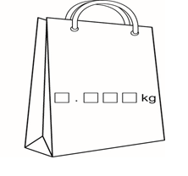
ACTIVITY

You will need:
- 1–9 digit cards from a pack of playing cards
- pencil, paper and rubber
- coin

What to do
- The first person turns over cards to make the mass of two different shopping bags
in kilograms with three decimal places.
- Round each mass to the nearest 100 g and find the total.
- The second person has a turn.
- Toss the coin to score: heads means the person with the bag with the greater mass scores a point, and, tails, the person with the smaller mass.
- The winner is the first person to score 5 points.

Variation
- Instead of rounding the mass, each person keeps a running total of the exact mass
of their bags and the first person to reach 20 kg is the winner.

QUESTIONS TO ASK
What is 6378 g
in kilograms?
What is 7500 kg in tonnes?
What is 1 g in kilograms?

Can you convert
1·009 tonnes to kilograms?
Can you convert
0·075 kg to grams?

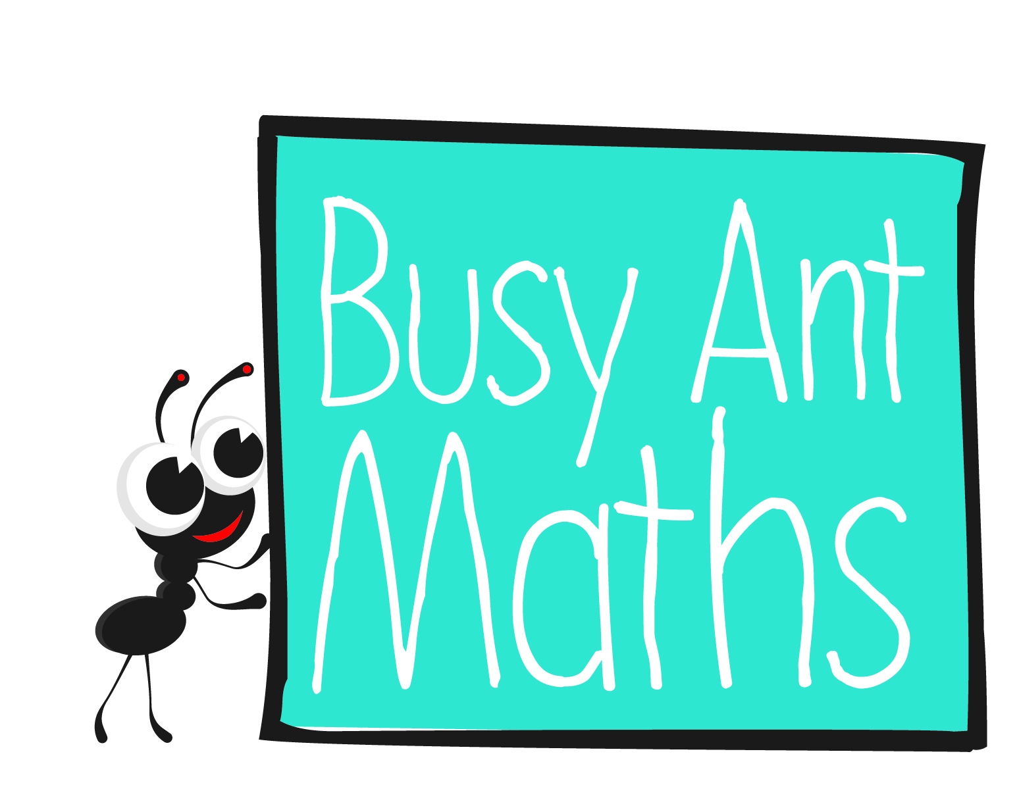
Primary 7
Insert
school logo
here
Maths
Newsletter 6
Date: ______________________ Name: ______________________
MATHS TOPICS
These are the maths topics your child will be working on during the next three weeks:
- Multiplication and division, including decimals
- Measurement (mass)

KEY MATHEMATICAL IDEAS
During these three weeks your child will be learning to:
- multiply multi-digit numbers (up to ThHTO) by a 2-digit number using an appropriate method, including the formal written method of long multiplication
- use mental methods to multiply decimals to tenths or to hundredths by
whole numbers
- calculate and convert between standard units of mass to solve problems,
using decimal notation up to three decimal places.

TIPS FOR GOOD HOMEWORK HABITS
Take a break before your child gets bored or overwhelmed.

Multiplication and division

HERE’S THE MATHS
Your child is learning to multiply multi-digit numbers (up to ThHTO) by a 2-digit number using an appropriate method, including the formal written method of long multiplication. The importance of estimation the answer continues to be emphasised.

ACTIVITY

Grid method  457 x 36 400 50 7  30 12 000 1500 210  6 2400 300 42  13 710 + 2742 = 16 452 | Formal written method  4 5 7  × 3 6  1 3¹ 7² 1 0  2 7³ 4⁴ 2  1 6 4 5 2  ¹
What to do
You will need:
- 1–9 cards
- One person chooses three cards to make a 3-digit number and two cards for a 2-digit number.
- Write out the multiplication carefully and execute it as show in the example above.
- Second person checks the answer with calculator.
- Change roles and repeat.
- Score 1 point for each odd number in the answer and 2 points for each even number in the answer.
- Continue for 10 minutes.
- The winner is the person with the higher score.

Variation
- Choose four cards to make a 4-digit number and multiply by TO as before.

QUESTIONS TO ASK
How can you calculate
39 × 25 mentally? (4 × 25 = 100 so 39 × 25 = 975)
Estimate 326 × 69. (300 × 70 = 21 000)
In a HTO × TO calculation, when you multiply by the tens figure, why do you put a 0 in the ones column? (Because you are multiplying by a multiple of ten, not a single digit.)
Multiplication and division
What is the ones digit in the answer to 489 × 67? (3, because 9 × 7 = 63)

HERE’S THE MATHS
Your child is practising the multiplication of decimals to tenths or to hundredths by whole numbers, using an appropriate method, including the formal written method. They may choose a mental method, the grid method, partitioning, the expanded written method or the formal written method.

ACTIVITY
What is 65·38 × 6?  Estimate 70 × 6 = 420 | 6 5 3 8  × 6  3 9 2 2 8  ³ ² ⁴ | 65·38 × 6 is equivalent to  6538 × 6 ÷ 100.  This equals 39 228 ÷ 100 which is 392.28  65·38 × 6 = 392·28

1  6.37 | 2  17.62 | 3  23.78 | 4  30.29 | 5  41.06 | 6  8.42 | 7  13.94 | 8  27.47 | 9  36.59
What to do
- Shuffle the cards and turn one over to choose the calculation.
You will need:
- 1–9 digit cards from a pack of playing cards
- calculator (or use mobile phone)
- Turn a second card over to decide what to multiply by.
(If 1 is selected, turn another card).
- Both complete the calculation.
- Compare strategies.
- Continue for 10 minutes.

Variation
- Take turns to complete calculations and award a point to the person with the higher score.

QUESTIONS TO ASK
Can you estimate the answer to 4.6 × 7? (35)
What is 0.07 × 6 (0.42)
What is 0.8 × 3? (2.4)

What is the cost of 4 boxes of biscuits costing £1.59 a box? (£6.36)
Can you estimate the answer to £7.07 × 7? (£49)

