Properties of shapes
Insert
school logo
here

HERE’S THE MATHS
Your child is learning to identify and name vertically opposite angles and to know that they are equal. They have previously learned other angle facts that are important to be able to recall in order to calculate missing angles. The facts are:
- The angles in a triangle add up to 180°.
- The angles in a straight line add up to 180°.
- The angles in a complete turn add up to 360°.
They are learning to identify and name angles where they meet at a point and find missing angles.
MATHS TOPICS
These are the maths topics your child will be working on during the next three weeks:
- Addition, subtraction, multiplication and division
- Algebra
- Properties of shapes

KEY MATHEMATICAL IDEAS
During these three weeks your child will be learning to:
- use negative numbers in context and calculate intervals across zero.
- generate and describe linear number sequences
- identify and name angles where they meet at a point, finding missing angles
and expressing relationships algebraically.

TIPS FOR GOOD HOMEWORK HABITS
Homework gives you the opportunity to become involved in your child’s learning.
Try to show them how their learning is useful in everyday life.

ACTIVITY
Angle x | 1  100° | 2  105° | 3  110° | 4  115° | 5  120° | 6  125° | 7  130° | 8  135° | 9  140° | 10  145°
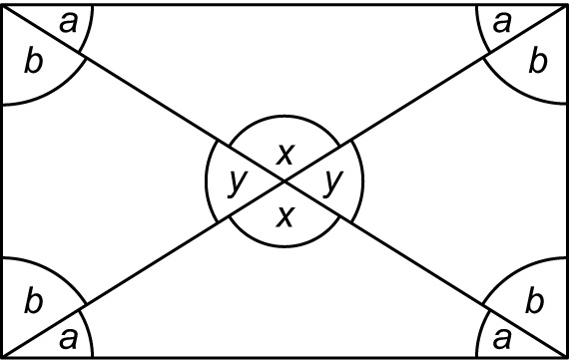
You will need:
- pack of playing cards with the picture
cards removed

What to do
- Turn over a card. This determines the value of angle x.
- Both work out the values of y, a and b.
- Compare answers.
- Repeat.
- Continue for 10 minutes.

Variation
- Start with a selection of ten values for angle a, from 15° to 40°, and calculate the angles.

QUESTIONS TO ASK
What do the angles in a straight line add up to?
What do the angles in a triangle add up to?
Describe vertically opposite angles.

What size are the other angles
in a triangle if one angle is 30°? (30° and 120° or 75° and 75°)

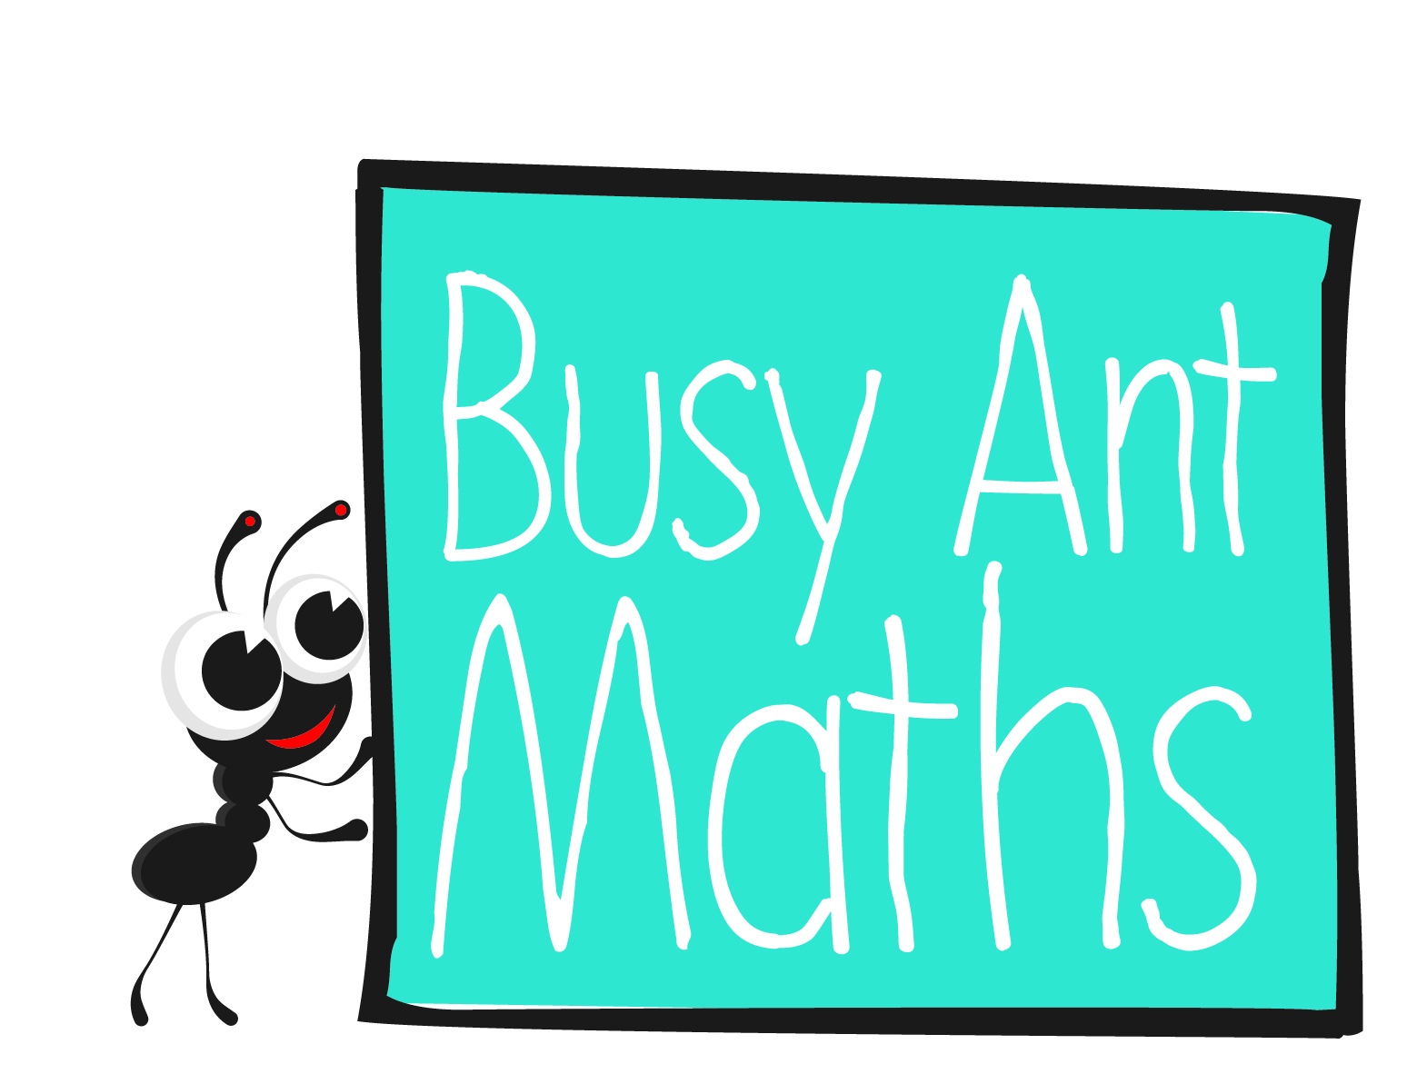
Primary 7
Maths
Newsletter 5
Date: ______________________ Name: ______________________
Addition, subtraction, multiplication and division

HERE’S THE MATHS
Your child is learning to use negative numbers in contexts, such as temperature and money, and calculate across zero. A number line may help them. Positive numbers are written to the right of zero and negative numbers to the left.

ACTIVITY

Balance in the bank | 1  £12.45 | 2  £24.12 | 3  £20.98 | 4  £15.78 | 5  £21.39 | 6  £17.52 | 7  £16.05 | 8  £19.31 | 9  £22.22
Spending | 1  £25.16 | 2  £36.11 | 3  £27.83 | 4  £31.45 | 5  £39.93 | 6  £28.01 | 7  £30.87 | 8  £37.24 | 9  £33.55

What to do
- Player 1 turns over two cards; the first gives the balance in the bank and the second the spending.
You will need:
- 1–9 digit cards from a pack of playing cards
- calculator
- Work out the negative bank balance using an appropriate method.
- Player 2 uses the calculator to check the subtraction.
- Swap roles.
- Repeat 5 times.

Variation
- To make this easier, use amounts that are multiples of 10p.

QUESTIONS TO ASK
The temperature at midnight is
4° C. By 5:00 a.m. it has dropped by 8° C. What is the temperature at 5.00 a.m.? (−4° C).
What is the difference between −9 and 4? (13)
What is 20 − 29? (−9)
Algebra
What is −16 + 23? (7)
The difference between the highest and lowest temperature is 26° C. If the highest temperature is 18° C, what is the lowest temperature? (−8° C)

HERE’S THE MATHS
Your child is learning to generate and describe linear number sequences. The numbers in sequences are called ‘terms’. To find the next term in a sequence, find the difference between the terms. Knowing the first term in a sequence and the difference between the terms allows a formula to be written for the general term, usually known as the ‘n^{th} term’. Here are examples:
Sequence is 4, 7, 10 . . . The difference is 3, first term is 4, i.e. (3 × 1) + 1 so n^{th} term is 3n + 1.
Sequence is 2, 7, 12 . . . The difference is 5, first term is 2, i.e. (5 × 1) − 3 so n^{th} term is 5n − 3.

ACTIVITY
What to do
You will need:
- 1–6 dice (second 1–6 dice for variation)
- One person rolls the dice to decide the starting number, e.g. 3.
- Roll the dice again to decide the difference between terms, e.g. 5.
- Write the first five terms and calculate the 10th term (e.g. 3, 8, 13, 18, 23 and 48).
- This is your score.
- The other person takes a turn.
- Play for 10 minutes.
- The winner is the person with the higher score.
Variation
- Use the total of two dice to find the difference to give an extended range
of sequences.

QUESTIONS TO ASK
What is the next number in the following sequences? What is the 10th term?
What is the n^{th} term?
2, 5, 8 . . .
6, 10, 14 . . .
4, 14, 24 . . .
5, 11, 17 . . .
How do you find the next number in number sequences?

