Measurement (time)

HERE’S THE MATHS
Your child is learning to calculate speed. Speed is a measure of how fast something is moving. It is the distance travelled per unit of time and measured using compound units, e.g. miles per hour or metres per minute.

ACTIVITY
MATHS TOPICS
These are the maths topics your child will be working on during the next three weeks:
- Multiplication and division
- Fractions (including decimals and percentages)
- Measurement (time)

KEY MATHEMATICAL IDEAS
During these three weeks your child will be learning to:
- identify common factors, common multiples and prime numbers
- solve problems involving the calculation of percentages and the use
of percentages for comparison
- calculate speed using compound units, for example, miles per hour.

TIPS FOR GOOD HOMEWORK HABITS
Show your child how you use maths in daily life and involve them in everyday tasks, e.g. following speed limits using the speedometer and calculating times to plan journeys based on likely average speeds.
Dice roll | 1 | 2 | 3 | 4 | 5 | 6
Speed | 25 mph | 50 mph | 75 mph | 100 mph | 125 mph | Broken down!  Stationary

What to do
- Play with a partner.
You will need:
- 1–6 dice
- Take turns to roll the dice to determine a speed and toss the coin to see how long you travel at that speed, e.g. 2 and tails means travelling at 50 mph for 2 hours, so a distance of 100 miles.
Coin
Heads = 1 hour
Tails = 2 hours
- Keep a note of the distance each person has travelled.
- The winner is the first person to travel 400 miles or more.

Variation
- Use 20 km/hour, 40 km/hour, 60 km/hour, 80 km/hour and 100 km/hour as the distance and times of $\frac{1}{2}$ hour and 2$\frac{1}{2}$ hours.

QUESTIONS TO ASK
A cyclist rides 10 miles in 30 minutes –
what is his average speed in miles per hour? (20 miles per hour)
A plane has an average speed of 500 mph – how long will it take to fly 2500 miles? (5 hours)
If the average speed of a car is 50 miles an hour, how far does it travel in 3 hours? (150 miles)

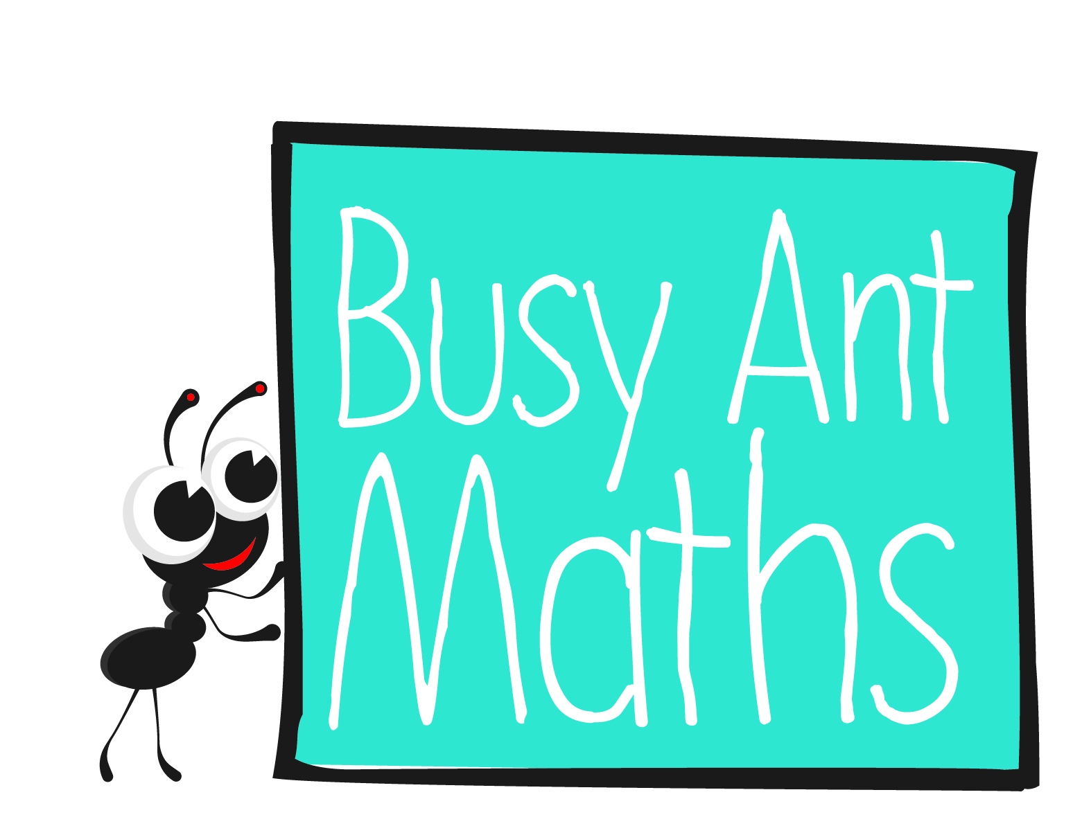
Year 6
Insert
school logo
here
If a bus travels at an average speed of 24 mph, how far will it travel in 15 minutes? (6 miles)
Maths
Newsletter 4
Date: ______________________ Name: ______________________

Multiplication and division

HERE’S THE MATHS
Your child is practising identifying common factors, common multiples and prime numbers. For example, the common factors of 12 and 28 are 1, 2 and 4. A common multiple of 8, 5 and 20 is 40. he first ten prime numbers are 2, 3, 5, 7, 11, 13, 17, 19,
23 and 29. The factors of 20 can be arranged in pairs each making 20: 1 × 20, 2 × 10 and 4 × 5. The prime factors are prime numbers that make the number when multiplied together: 2 × 2 × 5.

ACTIVITY
You will need:
- pencil and paper
27 | 32 | 44 | 54 | 62 | 77 | 82 | 90
24 | 34 | 46 | 55 | 63 | 75 | 88 | 93
21 | 33 | 42 | 51 | 66 | 78 | 84 | 95
25 | 36 | 48 | 56 | 64 | 72 | 85 | 98
28 | 35 | 45 | 52 | 60 | 70 | 80 | 96
22 | 38 | 49 | 58 | 65 | 76 | 86 | 99

What to do
- Take turns to choose two numbers from different columns and write down all the factors.
- Circle the common factors.
- Score one point for each common factor.
- Continue for 10 minutes.
- The winner has the higher score.

Variation
- Find the prime factors of the numbers. Circle any common factors.

QUESTIONS TO ASK
How can you be sure that you have found the prime factors of a number?
What are the common factors of 30 and 20? (1, 2, 5 and 10)
How can you be sure that you have found all the factors of a number?
Fractions (including decimals and percentages)
What are the first ten prime numbers?
Tell me four multiples of 21.

HERE’S THE MATHS
Your child is learning to solve problems involving the calculation of percentages and the use of percentages for comparison. They should know that 1% is $\frac{1}{100}$, 10% is $\frac{1}{10}$,
25% is $\frac{1}{4}$, 50% is $\frac{1}{2}$, and 75% is $\frac{3}{4}$. To calculate 35% of an amount they can calculate 10%, multiply that by 3 and add half of 10%. Another way would be to find the value
of 1% and multiply that by 35.

ACTIVITY
You will need:
- 0–9 digit cards from a pack of playing cards (use Jacks to represent zero)
- pencil and paper

Player 1 | Player 2
  % of   0 0 |   % of   0 0
What to do
- Player 1 shuffles the cards and turns over four cards to fill the spaces.
- Calculate the percentage, using an appropriate method.
- Player 2 has a turn.
- The player with the larger number scores a point.
- Repeat with new cards.
- The winner is the first person to reach 5 points.

Variation
- To make it easier, find 1-digit percentages of a 3-digit number using:
 % of    0

QUESTIONS TO ASK
What percentage is 30 of 150? (20%)
Which is bigger? 25% of 300 or 40% of 200? (40% of 200 = 80 whereas 25% of 300 is 75)
How would you find 15% of 340? What is the answer? (51)
How would you find 35% of 280? What is the answer? (98)
What is 1% of 570? (5·7)

