Measurement (length)
MATHS TOPICS
These are the maths topics your child will be working on during the next three weeks:
- Addition and subtraction
- Decimals
- Measurement (length)

KEY MATHEMATICAL IDEAS
During these three weeks your child will be learning to:
- add and subtract large numbers using formal written methods
- multiply decimals by whole numbers including in practical contexts
- convert between units of length to solve problems using decimal notation.

TIPS FOR GOOD HOMEWORK HABITS
Turn off the TV and computer. Choose a quiet place, preferably sitting at a table, where your child can work comfortably without disturbance.
HERE’S THE MATHS
Your child is learning to convert between units of length to solve problems using decimal notation.

Remember: 1 km = 1 000 m; 1 m = 100 cm; 1 cm = 10 mm. Your child needs practice estimating lengths and actually measuring lengths.
ACTIVITY
What to do
You will need:
- tape measure
- Look at a car and take turns to complete the table with estimates of the lengths.
 | Estimate | Actual measurement | Change of units
Length of car
Diameter of steering wheel
Height of car door
Width of number plate
Height of number plate
Length of windscreen wiper
Own choice

- Take turns to measure the lengths accurately.
- In the final column, change the units, those in metres to centimetres and those in centimetres to millimetres.
- Each person writes two problems using these measurements for their partner to solve.
Variation
- Make estimates and measurements in another setting, e.g. objects in the lounge.
QUESTIONS TO ASK
How many centimetres in 5 metres?
How many metres in 3 km?

How many millimetres are there in a kilometre? (1 km = 1 000 000 mm)
Change 3 cm into millimetres.

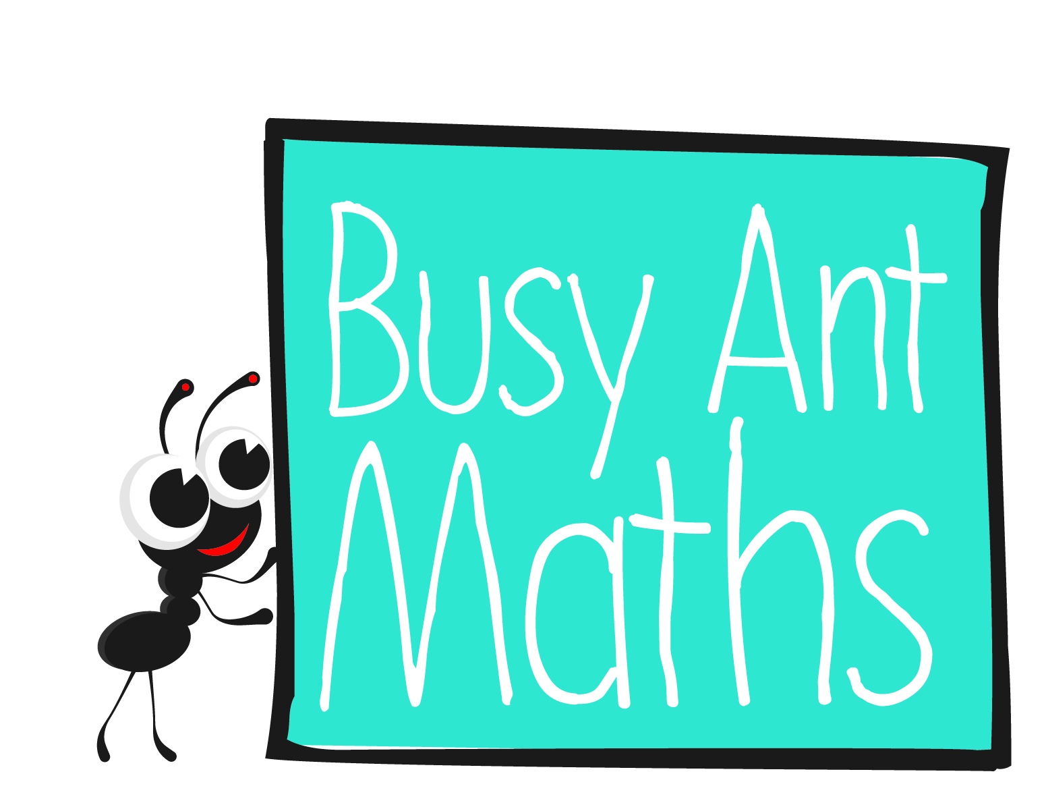
Primary 7
Maths
Newsletter 3
Insert
school logo
here
Date: ______________________ Name: ______________________
Addition and subtraction
HERE’S THE MATHS
Your child is practising and consolidating addition and subtraction of large numbers using formal written methods. It is important to set out the calculation clearly so that
the columns are lined up properly and so carrying figures are not missed. Estimating answers before working out calculations is a good way to check that answers are
of the correct magnitude.
ACTIVITY
A | B | C | D | E | F | G | H | I | J | K | L | M | N | O | P | Q | R | S | T | U | V | W | X | Y | Z
1 | 2 | 3 | 4 | 5 | 6 | 7 | 8 | 9 | 1 | 2 | 3 | 4 | 5 | 6 | 7 | 8 | 9 | 1 | 2 | 3 | 4 | 5 | 6 | 7 | 8

What to do
- Use this table to generate multi-digit numbers from words, e.g. CARPET = 319 752.
You will need:
- pencil and paper
- Each choose a seven-letter word and a six-letter word and write numbers from them.
- Subtract the 6-digit number from the 7-digit one.
- Check each other’s answers.
- Repeat with new words.
- Continue for 10 minutes.
Variation
- To simplify, use six-letter and five-letter words.
QUESTIONS TO ASK
When carrying out formal addition and subtraction, it is important to estimate.
Estimate the answers to these calculations.
541 098 + 460 231 (1 000 000)
345 150 – 123 189 (230 000)
142 987 + 653 761 (790 000)
675 987.34 + 321 659.65 (1 000 000)
761 324.67 – 524 987.32 (240 000)
Tell me a number that comes between 6.74 and 6.75.
What is the 6 worth in 23.46?
(6 thousandths)

Tell me the 0.4 times table.
What is 4.3 × 6?

What is 9 × 0.2?

Decimals
HERE’S THE MATHS
Your child is learning to multiply decimals by whole numbers, starting with simple cases, such as 0.4 x 2 = 0.8, and in practical contexts such as measures and money. The digits move one place to the left. Children need to remember that amounts of money are always written with 2 decimal places, e.g. £0.30 not £0.3. They are also learning about thousandths.
ACTIVITY
You will need:
- collection of 10p and 20p coins worth 90p in a bag or box (at least six coins) (use pieces of paper with the amounts written on them if you do not have change)
- two 1–6 dice
What to do
- Take turns to roll one dice and take out that number of coins, e.g. a roll of 3 could be 30p
(3 × 10p), 40p (20p + (2 × 10p)), 60p (3 × 20p), etc.
- Change the value to a decimal, e.g. 60p becomes £0.60.
- Roll both dice and add the two values, e.g. 3 and 5, sum is 8.
- Multiply the value of the chosen coins by the dice total, e.g. 8 × £0.60 = £4.80.
- Record the total.
- Play for 10 minutes. The winner is the person with the larger sum of money.
Variation
- Increase the number of 10p and 20p coins (to at least 12 coins) and roll both dice
to decide the number to choose so that the calculations involve bigger numbers.
QUESTIONS TO ASK

