Position and direction
MATHS TOPICS
These are the maths topics your child will be working on during the next three weeks:
- Multiplication and division
- Fractions
- Position and direction

KEY MATHEMATICAL IDEAS
During these three weeks your child will be learning to:
- practise multiplication and division calculations, including with large numbers
- use common factors to simplify fractions and use common multiples to express fractions in the same denominator
- use coordinates to describe the positions of shapes in all four quadrants.

TIPS FOR GOOD HOMEWORK HABITS
Help your child to read any instructions and discuss the homework before they start, ensuring that they fully understand the task.
HERE’S THE MATHS
Your child is learning to use coordinates to describe the position of shapes in all four quadrants. Numbers to the right of zero and up from zero are positive; numbers to the left of zero and down from zero are negative.
ACTIVITY
What to do
- Take turns to roll the two dice and toss the coins to determine a set of coordinates, e.g. 3 and 2p heads, 5 and 1p tails gives (3, −5)
- Colour that coordinate in. It does not count if thrown again.
- Play for 10 turns each and then add up the scores.
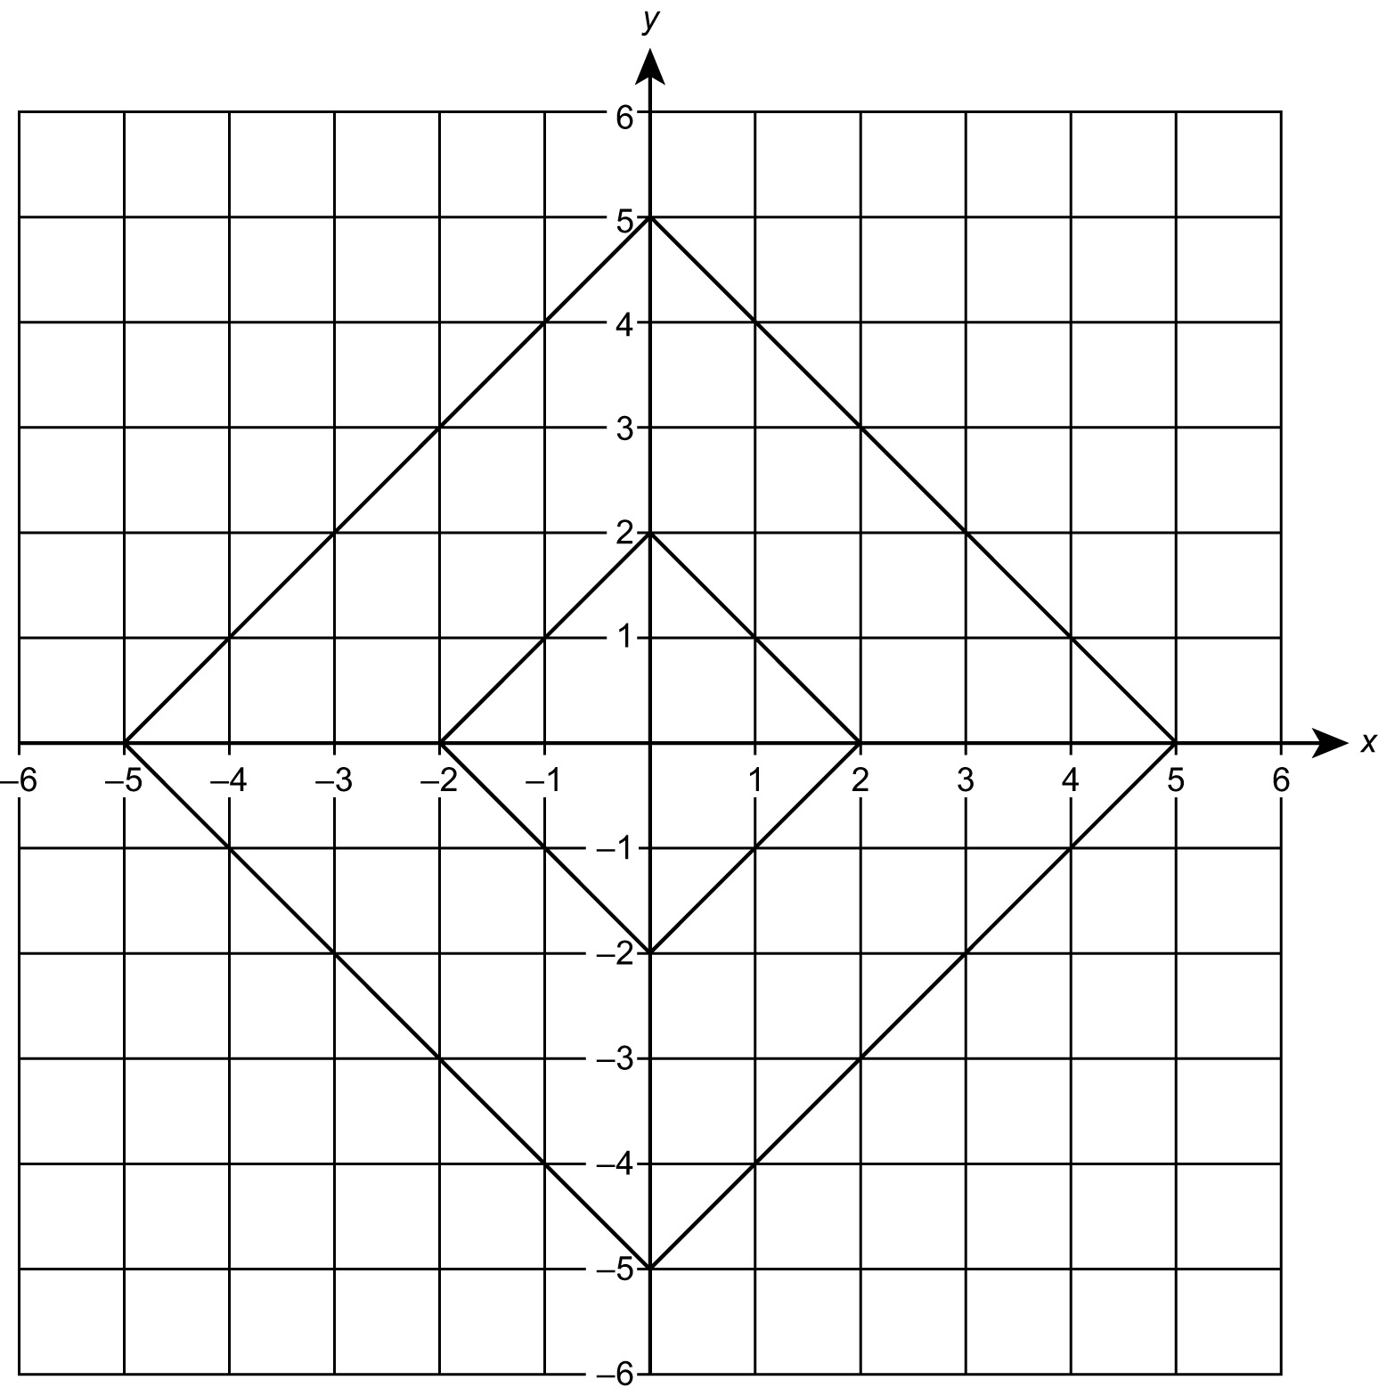
- Scoring system: 0 for outside the outer square, 1 on the line of the outer square, 2 inside the outer square, 3 on the line of the inner square, 4 inside the inner square.
- Player with the higher score wins.
You will need:
- two 1–6 dice
- two different coins,
e.g. 2p for the x- and 1p for the y- coordinates – heads positive, tails negative
- two coloured pencils

QUESTIONS TO ASK
What are the new coordinates of (1, 3) when reflected in the y-axis? (−1, 3)
What are the new coordinates
of (1, 3) when reflected in the
x-axis? (1, −3)
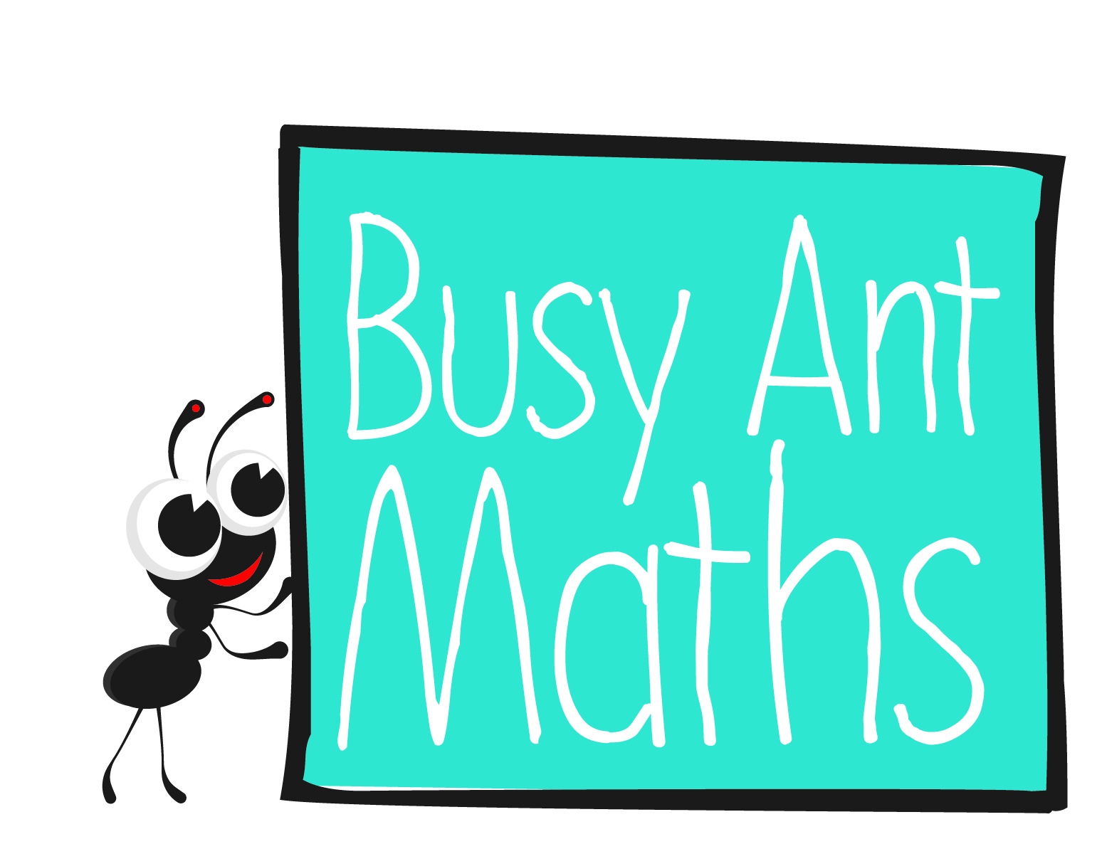
Primary 7
Maths
Newsletter 2
Insert
school logo
here
Date: ______________________ Name: ______________________
Multiplication and division
HERE’S THE MATHS
Your child is practising multiplication calculations, including with large numbers,
e.g. ThHTO × O and TO × TO. They are learning to scrutinise a calculation to determine the best method to solve it. They can perform mental calculations, using jottings as appropriate, or a formal written method. They are encouraged to estimate and check answers.
ACTIVITY
What to do
You will need:
- pencil and paper
- Ask your child to look at these calculations and possible answers and use their mathematical knowledge of multiplication to choose and explain the correct one.
34 × 57? A 2130 B 1938 C 1875 D 8978
- One explanation (of many possible) is as follows. The ones digit in the correct answer must be 8 because 4 × 7 is 28, therefore it cannot be A or C. An estimate of the answer is 30 × 60 which is 1800, which means D is too big and so the correct answer is B.
- Now use a formal written method to see if 1938 is actually correct.
- Each try carrying out a similar type of analysis of one of the following calculations.
67 × 58? A 1207 B 3764 C 1273 D 3886
83 × 26? A 2158 B 3158 C 2150 D 7158
- Write similar questions for each other to try.
- Listen to one another’s reasoning carefully.
Variation
- Write calculations and possible answers for each other for calculations of the type ThHTO × O.
QUESTIONS TO ASK
If 6 × 7 = 42, tell me two more multiplication calculations that you know. (60 × 7, 6 × 70, 60 × 70, etc.)
What is the ones digit in the answer to 37 × 17? (9)

Estimate the answer to 3139 × 4?
(12 000 or 12 400) Do you think the exact answer will be greater or smaller than your estimate? (Greater) Why? (Because to estimate, you will round down to 3000 or 3100)
Put these fractions in order without finding a LCM: $\frac{3}{7}$, $\frac{3}{4}$, $\frac{3}{11}$. Explain your thinking. (Quarters are bigger than sevenths because the whole has been divided into fewer parts.)
Estimate the answer to 37 × 28? (1200) Do you think the exact answer will be greater or smaller than your estimate? (Smaller) Why? (Because to estimate, you will round up to 40 x 30)
Simplify $\frac{9}{27}$ ($\frac{9}{36}$, $\frac{9}{18}$, $\frac{9}{90}$, $\frac{9}{45}$) Answers $\frac{1}{3}$,( $\frac{1}{4}$, $\frac{1}{2}$, $\frac{1}{10}$, $\frac{1}{5}$)

Express 2 in quarters, eighths and sixteenths. ($\frac{8}{4}$, $\frac{16}{8}$, $\frac{32}{16}$)
Fractions
HERE’S THE MATHS
Your child is using common factors to simplify fractions and common multiples to express fractions in the same denominator. The lowest common multiple (LCM) is the smallest number required to add fractions with different denominators, e.g. to calculate
$\frac{2}{3}$ + $\frac{1}{4}$, the LCM is 12 because 12 is the first common multiple of 3 and 4, so $\frac{2}{3}$ + $\frac{1}{4}$ = $\frac{8}{12}$ +
$\frac{3}{12}$ = $\frac{11}{12}$. Simplifying fractions is changing them by dividing the numerator and denominator by a common factor, e.g. $\frac{15}{30}$ = $\frac{3}{6}$ = $\frac{1}{2}$. $\frac{1}{2}$ is this fraction in its simplest form.
ACTIVITY
You will need:
- pencil and paper
- coin
What to do
Numerator | 1 | 2 | 3 | Denominator | 4 | 5 | 6

- Each person makes up two fractions by selecting different numerators and denominators, e.g. $\frac{2}{5}$ and $\frac{3}{4}$.
- Add the fractions by finding the LCM, e.g. $\frac{2}{5}$ + $\frac{3}{4}$ = $\frac{8}{20}$ + $\frac{15}{20}$ = $\frac{23}{20}$= 1 $\frac{3}{20}$.
- Compare your fractions.
- Toss the coin – for heads, the larger fraction scores a point, for tails, the smaller fraction scores a point. You may need to find a new LCM to find out the winner.
- Play for a set time or until one person reaches a score of 5 points.
Variations
- For a simpler version use these figures:
Numerator | 1 | 2 | Denominator | 3 | 4 | 5

- For a more complex version, use a greater variety of numerators and denominators.
QUESTIONS TO ASK
What is the lowest LCM required to add $\frac{1}{7}$ and $\frac{1}{4}$? (28)
What is the lowest LCM required to add $\frac{1}{10}$ and $\frac{1}{5}$? (10)

