Properties of shapes
MATHS TOPICS
These are the maths topics your child will be working on during the next three weeks:
- Number and place value
- Addition and subtraction
- Properties of shapes

KEY MATHEMATICAL IDEAS
During these three weeks your child will be learning to:
- read, write, order and compare numbers to 10 000 000 and round any number
to a required degree of accuracy
- add and subtract mentally, including with large numbers and decimals
- recognise, describe and build simple 3-D shapes, including making nets.

TIPS FOR GOOD HOMEWORK HABITS
Plan a homework timetable and agree a time when your child will do their homework.

HERE’S THE MATHS
Your child is learning to recognise, describe and build simple 3-D shapes, including making nets. A net is a 2-D pattern of faces that you can cut and fold to make a model of a solid shape. Small tabs are often added in order to glue the shapes together.

cuboid square-based pyramid
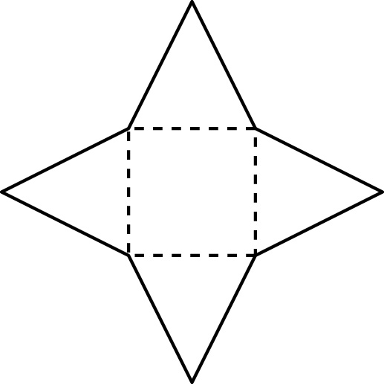
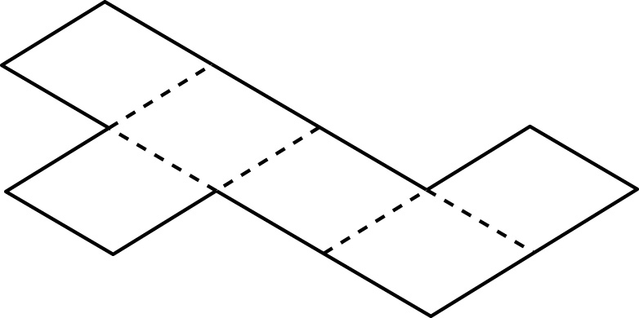

ACTIVITY
What to do
You will need:
- 2 small square shapes to use to draw around, e.g. block of square sticky notes
- pencil and paper
- timer (or phone with timer)
- Set the timer to 5 minutes.
- Each person draws as many different nets for a cube as possible.
- When the time is up, swap papers and check each other’s nets.
- The winner is the person with the greater number of correct nets.
- If you cannot be certain of a particular net, cut it out and try it! There are 11 different nets in total.
Variation
- Draw two different nets for a cube. Put dice dots on the faces so that opposite sides add up to seven as on a real dice. Cut and fold the nets to check they are correct.
QUESTIONS TO ASK
Describe the net of a square-based pyramid. (4 triangles joined by a side to a central square)
Which 3-D shape has a net with two triangular
and three rectangular faces? (triangular prism)
The net of a 3-D shape is made
up of six 2-D shapes. What could it be? (cube, cuboid, pentagonal pyramid)
Which 3-D shapes have nets composed of triangles only? (tetrahedron, octagon, icosahedron)
Can you explain the meaning of ‘net’?
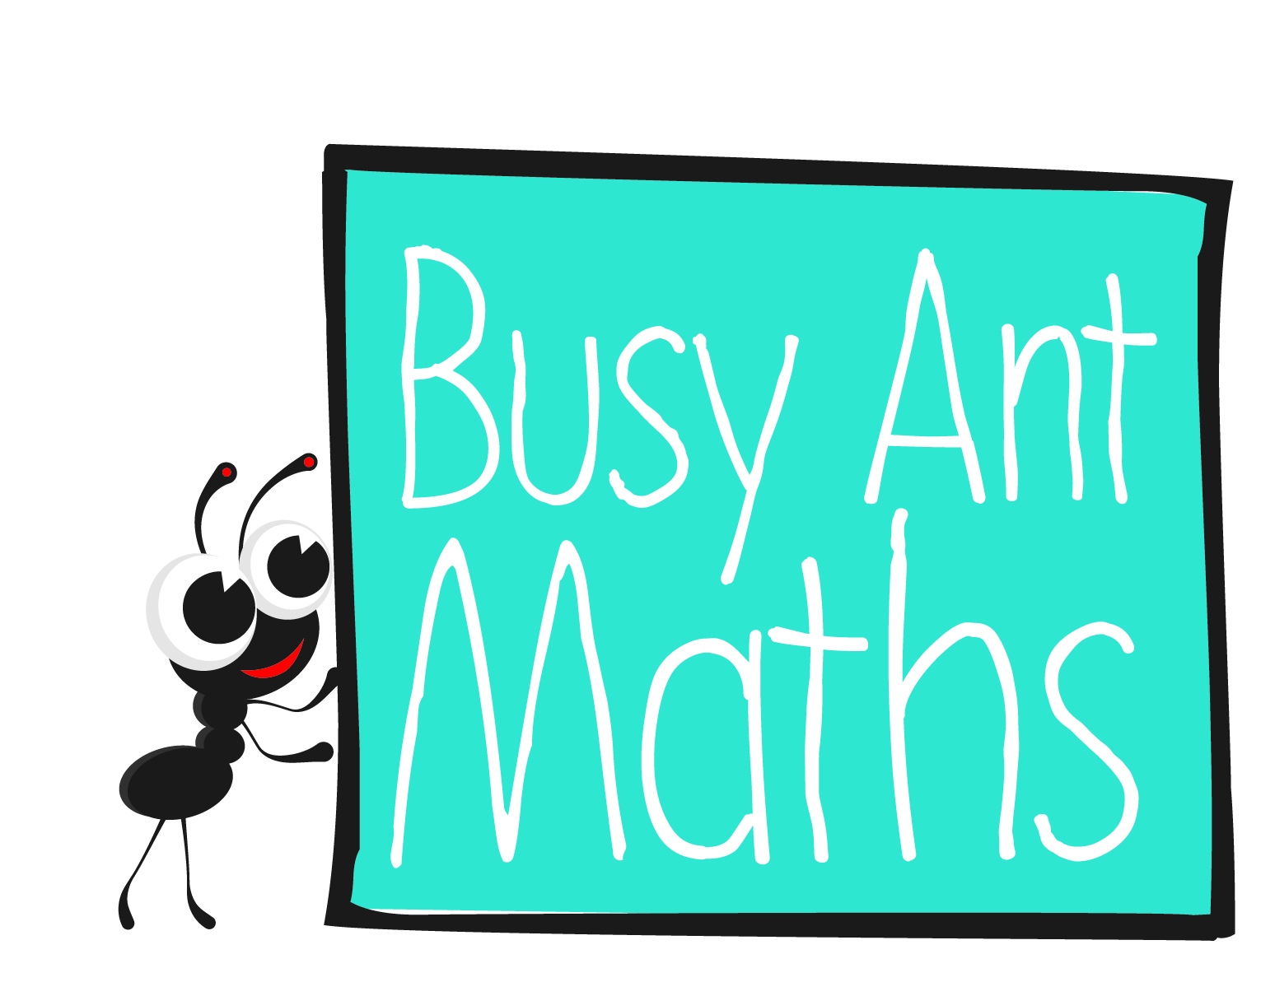
Primary 7
Maths
Newsletter 1
Insert
school logo
here
Date: ______________________ Name: ______________________
Number and place value
HERE’S THE MATHS
Your child is learning to read, write, order and compare numbers to 10 000 000.
They are also consolidating their understanding of rounding numbers to a required degree of accuracy. The rule for rounding to the nearest 10 (100, 1000, 10 000 and
so on) is that 5 (50, 500, 5000 and so on) or greater is rounded up and 4 or fewer
(49, 499, 4999 and so on) is rounded down.
ACTIVITY
What to do
You will need:
- 2 sets of 0–9 digit cards from
a pack of playing cards (use Jacks to represent zero)
- Each person has a set of 0–9 cards.
- Lay out 7 cards.
- Use the cards to make the largest 7-digit number possible.
- Read your numbers to one another.
- The person with the larger number scores a point.
- Shuffle the cards and repeat.
- The winner is the first person to reach a score of 5.
Variation
- Play the same game but make the smallest number.
QUESTIONS TO ASK
What is the 2 worth in these numbers:
1 256 789? (two hundred thousand:
200 000)
1 567 234? (two hundred: 200)
1 426 000? (twenty thousand: 20 000)
How is zero used as a placeholder? (Zeros keep the digits in the correct places.)

What happens to digits when you divide by 1000? (The digits move one place to the right.)

Which digits change when you add
1 to 999 999? Why?
(All of them, because adding one more to each nine changes the value to 10.)

Addition and subtraction
HERE’S THE MATHS
Your child is practising mental subtraction, including with large numbers and decimals. Subtracting from a 7-digit number involves a secure understanding of place value. It can be helpful to write the number to be subtracted in the correct position beneath 1 000 000 to ‘see’ the answer.
ACTIVITY
50 | 4000 | 100 | 200 000 | 20 | 15 000
2 | 18 000 | 900 000 | 9000 | 9 | 600
2000 | 300 | 70 | 600 000 | 11 000 | 400 000
100 000 | 500 000 | 4 | 80 | 7000 | 3000
40 | 6 | 8000 | 7 | 1 | 700 000
14 000 | 10 000 | 16 000 | 12 000 | 300 000 | 90

What to do
- Take turns to choose a number on the grid.
You will need:
- calculator
- buttons or counters in two colours
- The first person subtracts their chosen number from
1 000 000.
- Use a number line or jottings if necessary.
- The second person checks the calculation, mentally. If they disagree, use a calculator to check.
- If the answer is correct, cover the number; if it’s incorrect, leave it uncovered.
- Swap roles. Each time subtract from a million.
- Play for 10 minutes or until the grid is complete.
- The winner has the greater number of counters.
Variation
- Include a row of decimal numbers, e.g.
0.6 | 0.04 | 0.2 | 0.9 | 0.03 | 0.009

QUESTIONS TO ASK
What is 67.5 − 37.8?
What is four less than four million?
How many zeros does a million have?

What has been subtracted from 5 612 345 to leave 4 712 345?
What is 246 246 −
570 (5 700, 57 000)?

