Statistics
HERE’S THE MATHS
Your child is learning to interpret pie charts and use them to solve problems. A pie chart is a circular chart divided into sectors. Each sector shows the relative size of each value. A key explains what each sector represents. When the total number is known, the exact numbers for each sector can be calculated. Pie charts are useful for comparison.
ACTIVITY
MATHS TOPICS
These are the maths topics your child will be working on during the next three weeks:
- Fractions
- Ratio and proportion
- Statistics

KEY MATHEMATICAL IDEAS
During these three weeks your child will be learning to:
- add and subtract fractions with different denominators and mixed numbers, using the concept of equivalent fractions
- recognise and solve proportion problems
- interpret pie charts and use them to solve problems.

TIPS FOR GOOD HOMEWORK HABITS
Be positive about maths even if you didn’t like it at school. Let your child explain
to you the different strategies and methods that they are learning. Avoid teaching your child methods you used at school as it may confuse them.
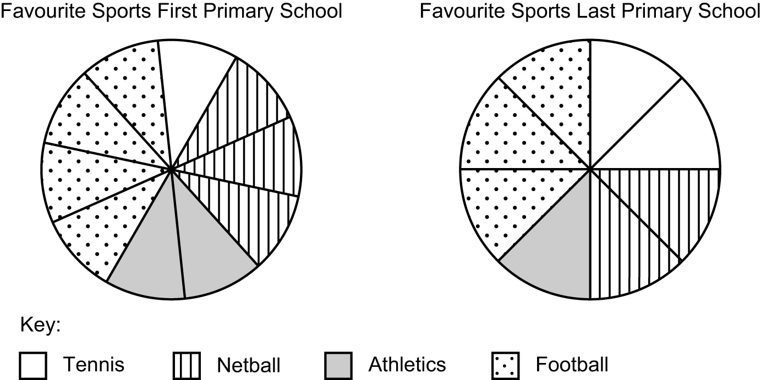
You will need:
- 4 pieces of paper, marked 80, 120, 200, 320
- pencil and paper

What to do
- Choose one of the papers without looking. This number represents the number
of pupils in the school.
- Use this number to find out how many pupils prefer each of the sports.
- One person calculates the numbers for First Primary School and one for Last Primary School and then writes three questions for the other person to answer.
- Repeat with a different starting number.
Variation
- Try larger starting numbers but make sure they are divisible by both 8 and 10.
QUESTIONS TO ASK
What is a pie chart?
If a pie chart is divided into 20 sectors, what percentage is each sector worth? (5%)
If a pie chart is divided into 12 sectors, what fraction do 2 sectors represent? ($\frac{1}{6}$)
If a pie chart is divided into 8 sectors, what is the angle at the centre of each sector? (45°)
Why is a key necessary for a pie chart? (to explain what each segment represents)
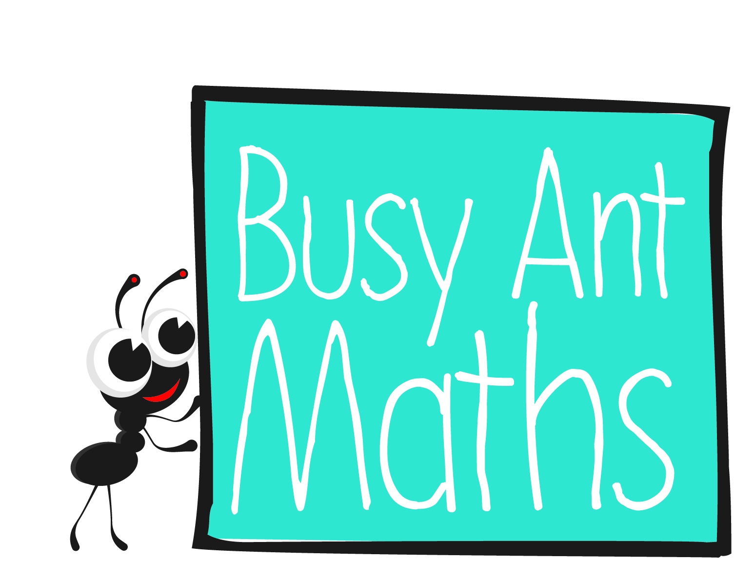
Primary 7
Maths
Newsletter 7
Insert
school logo
here
Date: ______________________ Name: ______________________
Fractions
HERE’S THE MATHS
Your child is practising adding and subtracting fractions with different denominators and mixed numbers, using the concept of equivalent fractions. In order to add or subtract fractions, they needs to be changed to an equivalent fraction with the same denominator,
e.g. $\frac{1}{3}$ + $\frac{3}{8}$= $\frac{8}{24}$ + $\frac{9}{24}$ = $\frac{17}{24}$. Answers are best expressed in their simplest form,
e.g. an answer of $\frac{6}{8}$ should be simplified to $\frac{3}{4}$ .
ACTIVITY
1  $$\frac{1}{4}$$ | 2  $$\frac{4}{5}$$ | 3  $$\frac{3}{8}$$ | 4  $$\frac{7}{8}$$
5  $$\frac{1}{8}$$ | 6  $$\frac{3}{5}$$ | 7  $$\frac{1}{2}$$ | 8  $$\frac{5}{8}$$
9  $$\frac{1}{5}$$ | 10  $$\frac{3}{4}$$ | 11  $$\frac{2}{5}$$ | 12  $$\frac{3}{2}$$
What to do
You will need:
- pack of playing cards with the Kings removed (Jack represents 11, Queen 12)
- One person shuffles the cards, and turns over 3 cards. In the table above, they find the fraction represented by the cards. They add the fractions by finding a common denominator and simplifying the answer if possible.
- The second person checks the addition.
- Change roles. Repeat twice more.
- Keep a note of all 6 answers.
- Race one another to put the fractions in increasing order.
QUESTIONS TO ASK
Simplify $\frac{9}{45}$ . ($\frac{1}{5}$)
Change $\frac{14}{4}$ to a mixed number in its simplest form. ($\frac{31}{2}$)
What is an improper fraction? (fraction with the numerator bigger than the denominator)

Ratio and proportion
HERE’S THE MATHS
Your child is learning to recognise and solve proportion problems. Proportion compares a part to the whole and is expressed as a fraction, decimal or percentage, e.g. in a ball pool, $\frac{1}{4}$ (or 25%) of the balls are red. This can be expressed as ‘1 in 4 balls is red’ or
‘1 in every 4 balls is red’.
ACTIVITY
Fleeces made in a factory
1  4000 | 2  320 | 3  480 | 4  560 | 5  160 | 6  800
7  5600 | 8  8000 | 9  1600 | 10  720 | 11  2400 | 12  640

Dice roll | 1 | 2 | 3 | 4 | 5 | 6
Proportion of blue fleeces | 1 in every 8 | 1 in every 4 | 3 in every 8 | 1 in every 2 | 5 in every 8 | 7 in every 8
What to do
You will need:
- pencil and paper
- pack of playing cards with the Kings removed (Jack represents 11, Queen 12)
- 1–6 dice
- The challenge is to buy as many blue fleeces as possible.
- Take turns to turn over a card to decide
on the number of fleeces in production.
- Roll the dice to find out the proportion
of blue fleeces being made.
- Each person keeps a running total of their blue fleeces.
- Declare the winner after 10 minutes.
QUESTIONS TO ASK
In the manufacture of sweets, the proportions
of flavours are as follows: 4 in every 10 sweets are orange, 3 in every 10 sweets are lemon,
2 in every 10 sweets are strawberry and
1 in every 10 sweets is lime. …
… How many of each flavour are there if there are 50, 300 (600, 7000, etc.) sweets?

