Measurement
(perimeter and area)
HERE’S THE MATHS
Your child is learning to use a formula to calculate the area of triangles.
Area = $\frac{1}{2}$ bh, where b = base of the triangle and h = height.
ACTIVITY

Base | 1  4 cm | 2  7 cm | 3  10 cm | 4  6 cm | 5  9 cm | 6  12 cm
Height | 1  5 cm | 2  8 cm | 3  11 cm | 4  3 cm | 5  13 cm | 6  2 cm

What to do
You will need:
- 1–6 dice
- pencil and paper
- Take turns to roll the dice to choose the length
of the base and roll again to decide the height.
- Calculate the area of the triangle in cm² using
the formula, A = $\frac{1}{2}$ bh
- Score as follows:
Area ≤ (less than or equal to) 10 cm²  scores 2 points | Area > (greater than) 10 cm² ≤  25 cm²  scores 4 points | Area > 25 cm² ≤  60 cm²  scores 6 points | Area > 60 cm² ≤  78 cm²  scores 8 points
- Play for 10 minutes.
- The person with the higher score is the winner.
QUESTIONS TO ASK
How do you find the area of a triangle?
If the area of a triangle is 12 cm², what are the possible lengths of the base? (factors of 24)
What is the area of a triangle of base length
10 cm and height 8 cm?
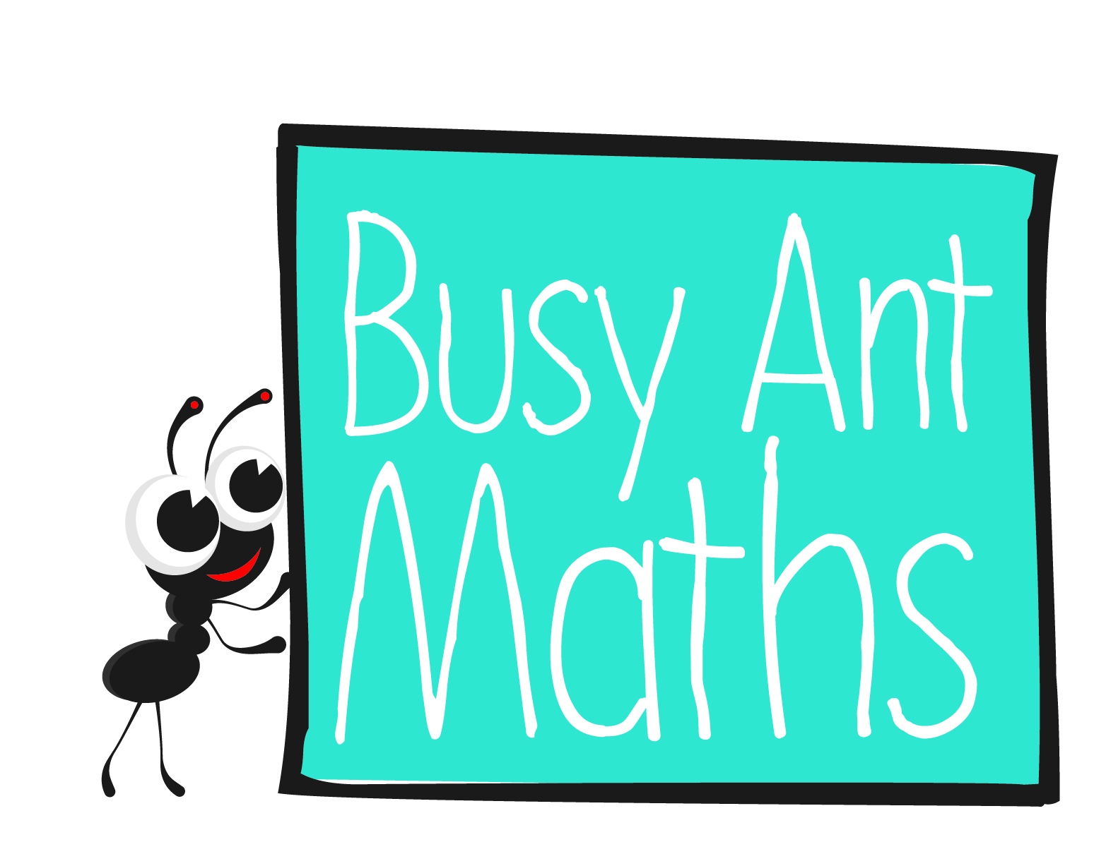
Primary 7
Maths
Newsletter 8
Insert
school logo
here
Date: ______________________ Name: ______________________

MATHS TOPICS
These are the maths topics your child will be working on during the next three weeks:
- Multiplication and division, including decimals
- Measurement (perimeter and area)

KEY MATHEMATICAL IDEAS
During these three weeks your child will be learning to:
- divide numbers up to 4 digits by a 2-digit whole number using an appropriate method, including the formal method for long division
- divide numbers with up to 2 decimal places by 1-digit whole numbers, using
a method of choice
- use a formula to calculate the area of triangles.

TIPS FOR GOOD HOMEWORK HABITS
When your child has finished their homework, discuss with them what they have learnt and whether they found it easy or hard.

Multiplication and division
HERE’S THE MATHS
Your child is learning to carry out calculations of the type HTO ÷ TO and ThHTO ÷ TO, using the expanded and formal written method. Both methods require your child to have good recall of their multiplication tables, place value and subtraction using the formal written method. It also helps if they can set out their calculations as neatly as possible.
ACTIVITY
Example – Expanded written method | Example – Formal written method
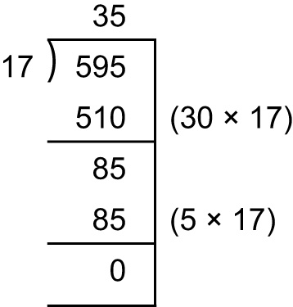 | 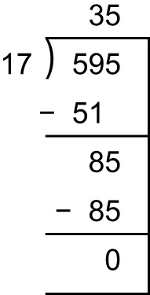
What to do
You will need:
- 0–9 digit cards from a pack of playing cards (use Jack to represent zero)
- Begin by working out the 17 times table together up to × 10 and writing it down for reference. (This step involves calculations that will not be used but means that your child will be able to find the required multiple of 17 instantly.)
- Turn over 3 cards to make a 3-digit number. Estimate the answer when divided by 17.
- Both do the calculation using your choice of method. Compare answers.
Long multiplication sometimes fazes children so work together for a while if you think it would improve your child’s confidence.
- If your child is confident, the first person to find the answer can score a point.
- Repeat with new numbers.
- Continue for 10 minutes. If scoring, the winner has the higher score.
QUESTIONS TO ASK
Multiplication and division
Estimate the answer to
2574 ÷ 17 (about 150)
Estimate the answer to 434 ÷ 36 (more than 10 – about 12, actual answer 12 r 2)
Estimate how many 19s there are in 84. (4 r 8)
HERE’S THE MATHS
Your child is practising division of numbers with up to 2 decimal places by 1-digit whole numbers, using a method of choice. They are encouraged to look at each calculation to see whether it can be done mentally (with jottings) or whether a formal written method
is required.
ACTIVITY
  ·  
What to do
You will need:
- 0–9 digit cards from a pack
of playing cards (use Jack
to represent zero)
- calculator (or use mobile phone)
- Turn over 4 cards and make a number with 2 decimal places.
- Turn over another card to be the divisor (turn again if it is zero or 1).
- Look at the calculation and discuss which method you think most appropriate to use with these numbers.
- Both carry out the calculation and check that your answers are the same.
- Rearrange the cards to give a different number and repeat.
- Continue for 10 minutes. Use new cards if you run out of arrangements.
Variation
- Extend to include multiplying by 11 and 12 – use the Jack to represent 11
and the Queen 12.
QUESTIONS TO ASK
Say the 1·1 times table up to 13·2.
Say the 0·11 times table up to 1·32.
What will the hundredths figure be in the answer to 29·84 × 9? (6)
What is 0·25 × 12? (3)
What is 0·75 × 8? (6)

- Ask more questions liked these and ask your child to make up questions to ask you.

