Properties of shapes
HERE’S THE MATHS
Your child is learning to draw and name parts of circles and understand that the diameter is twice the radius. The circumference is the distance around the edge
of a circle. They are learning to draw 2-D shapes accurately and use conventional markings for lines and angles.
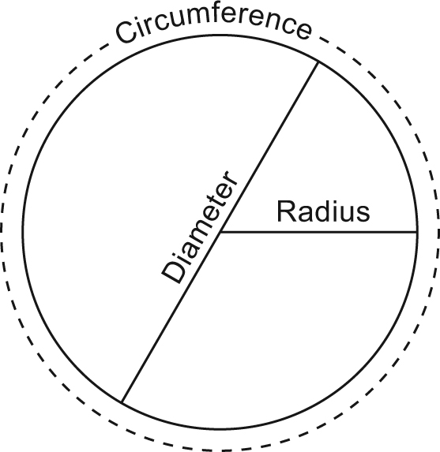
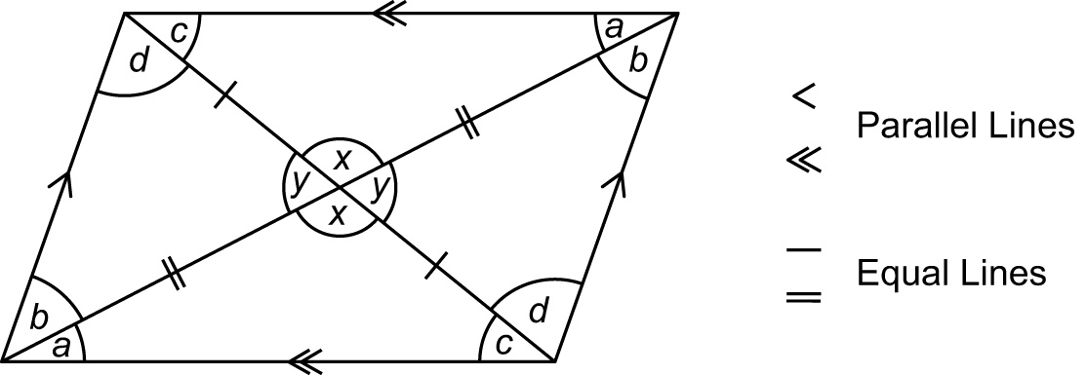

ACTIVITY
What to do
You will need:
- sharp pencil and paper
- compasses (or a circular shape to draw around)
- Each draw a circle and inside it carefully draw a triangle with the vertices touching the circumference of the circle.
- Measure the length of each side of the triangle and calculate its perimeter.
- Find the midpoint of each side and join them to make a new triangle.
- Measure the perimeter of the new triangle.
- Discuss how this perimeter is related to the perimeter of the first triangle. (Perimeter of smaller triangle is half the first.)
Variation
- Use a different starting shape, e.g. a trapezium.
QUESTIONS TO ASK
What is the diameter of a circle?
How are equal lines and angles marked in geometric diagrams?
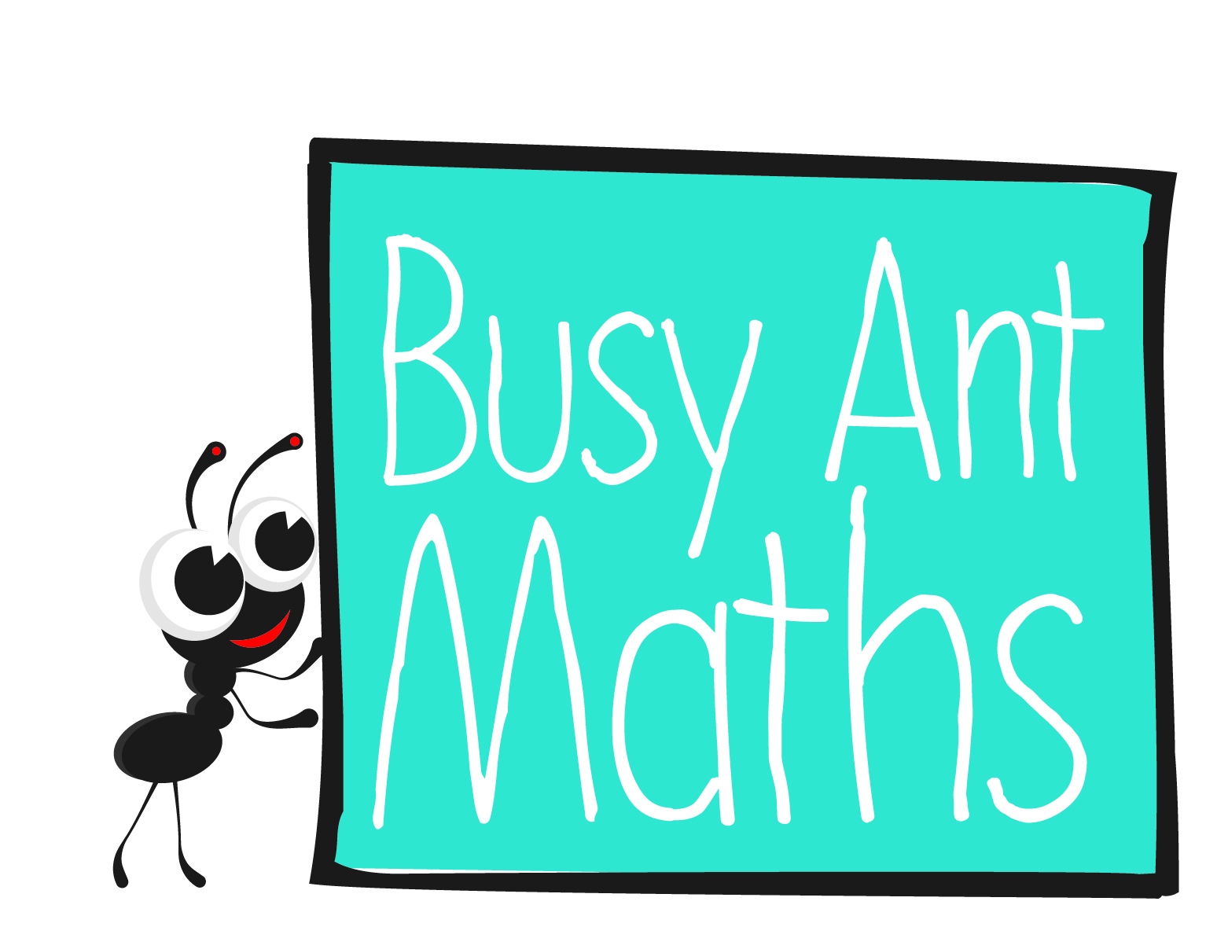
Primary 7
Maths
Newsletter 9
Insert
school logo
here
What is the circumference of a circle?
Date: ______________________ Name: ______________________

MATHS TOPICS
These are the maths topics your child will be working on during the next three weeks:
- Addition, subtraction, multiplication and division
- Algebra
- Properties of shapes

KEY MATHEMATICAL IDEAS
During these three weeks your child will be learning to:
- use knowledge of the order of operations to carry out calculations involving
the four operations
- use simple formulae
- illustrate and name parts of circles and know that the diameter is twice the
radius, and draw 2-D shapes accurately, using conventional markings for lines and angles.

TIPS FOR GOOD HOMEWORK HABITS
Talk to your child about maths and use a wide range of vocabulary, e.g. in this unit, the vocabulary of the circle – radius, circumference, diameter and compasses.

How are the radius and diameter of a circle related?
Using the rule, d = 2r, what is the radius
of a circle with a diameter of 6 cm (10 cm,
16 cm)? (3 cm, 5 cm, 8 cm)

Addition, subtraction, multiplication and division
HERE’S THE MATHS
Your child is learning to use knowledge of the order of operations to carry out calculations involving the four operations. The mnemonic for the order of operations
is BODMAS.
B Brackets O Orders (e.g. 3²) DM Division and Multiplication
AS Addition and Subtraction
Using the BODMAS rules, some possible arrangements for 2, 3 and 6 are:
(2 × 3) + 6 = 12, (2 × 3) – 6 = 0, (6 ÷ 3) + 2 = 4, (6 ÷ 2) + 3 = 6.
ACTIVITY
1  4 8 3 | 2  10 5 2 | 3  7 28 2 | 4  100 25 4 | 5  60 15 3² | 6  51 3 17
What to do
You will need:
- pencil and paper
- 1–6 dice
- timer (or phone with timer)
- Roll the dice to decide the numbers to work with from the boxes above.
- Set the timer for 2 minutes and each try to make as many different answers as possible using the BODMAS rules.
- Check each other’s answers.
- Repeat. (Roll again if you roll a number you have already had.)
- The person with the greater number of answers scores a point.
- Play for 10 minutes or until a player reaches 5.
QUESTIONS TO ASK
Algebra
5 ? (6 ? 2) = 40 (5 ? 6) ? 2 = 32 (5 ? 6) ? 2 = 22 5 ? (6 ? 2) = 20
What signs are needed to make each calculation correct?
4 ? (9 ? 3) = 10 (4 ? 9) ? 3 = 33 (4 ? 9) ? 3 = 12 4 ? (9 ? 3) = 1
What signs are needed to make each calculation correct?
HERE’S THE MATHS
Your child is learning to use simple formulae and to express missing number problems algebraically. They are introduced to the formula for a straight line, y = mx + c. x and y are the values on the x- and y-axes, m describes the gradient of the line and c is where the line crosses the y-axis. Practise substituting formulae will give your child confidence handling equations.
ACTIVITY

1 | 2 | 3 | 4 | 5 | 6
y = x + 4 | y = 2x + 1 | y = 3x + 2 | y = x − 2 | y = 4x − 2 | y = 8 − x
What to do
- One person rolls both dice, e.g. 3 and 4. Let the sum
of the numbers be x.
You will need:
- pencil and paper
- two 1–6 dice
- Substitute this value for x in the equations for the two numbers rolled. In this case, y = 3 × 7 + 2 = 23 and
y = 7 − 2 = 5.
- The score for the turn is 23 + 5 = 28.
- The second person has a turn.
- Play for 10 minutes or until a score of 100 is reached.
Variation
- Write new formulae of your own.
QUESTIONS TO ASK
Multiply out the brackets in
3(a + 2b). (3a + 6b)
Simplify 3a + 2b + 4a − b. (7a + b)
What are the possible values of a and b if a + b = 5? (a 1, b 4;
a 2, b 3; a 3, b 2; a 4, b 1)
In the equation, 2a = 4b + 4,
what is a when b = 3 (6, 8, 13)?
(8, 14, 18, 28)

