Measurement
(volume and capacity)
HERE’S THE MATHS
Your child is learning to calculate and compare volume of cubes and cuboids in cm³, using the rule V = lbh, and to find missing lengths, e.g. V = 80 cm³, height = 8 cm and breadth = 2 cm. To find the length, use L = V ÷ (bh) = 80 ÷ (8 × 2) = 80 ÷ 16 = 5 cm.
ACTIVITY
Length =  cm Width =  cm Height =  cm
You will need:
- 1–9 digit cards from a pack of playing cards
What to do
- The first person turns over three cards to give the dimensions in centimetres of a cuboid.
- Calculate the volume in cm³.
- The second person has a turn.
- Sketch the cuboids, showing a stack one on top of each other and keeping a record of the increasing height.
- The person who places the cuboid that makes the tower reach or exceed a height
of 50 cm is the winner.
Variation
- Each person builds their own tower. Use the cards to give a volume as before but allow the dimensions to be changed and the cuboids to be stacked with the longest side as the height.
QUESTIONS TO ASK
A cuboid has a volume of 90 cm³ and one side is 3 cm. What lengths could the other sides have? (6 cm and 5 cm or 3 cm and 10 cm)
What is the length of the side in a cube
with volume 27 cm³
(64 cm³, 125 cm³)?
(3 cm, 4 cm, 5 cm)
What is the volume of a cuboid with dimensions of 3 cm, 5 cm and 7 cm? (105 cm³)
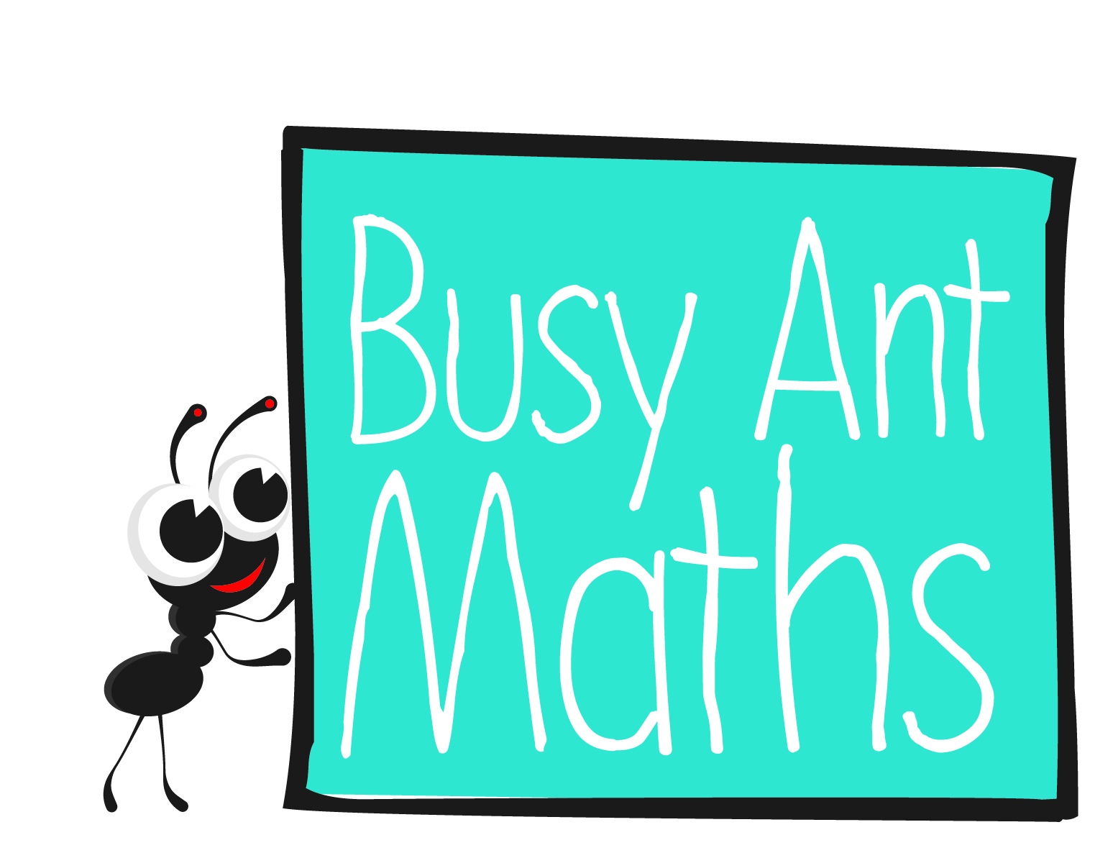
Primary 7
Maths
Newsletter 10
Insert
school logo
here
Date: ______________________ Name: ______________________

MATHS TOPICS
These are the maths topics your child will be working on during the next three weeks:
- Multiplication and division (including decimals)
- Fractions
- Measurement (volume and capacity)

KEY MATHEMATICAL IDEAS
During these three weeks your child will be learning to:
- use mental methods to divide numbers with up to two decimal places
by 1-digit numbers
- multiply simple pairs of fractions, writing the answer in its simplest form
- calculate and compare volume of cubes and cuboids in cm³, using the rule
V = lbh (Volume = length × breadth × height), and find missing lengths.

TIPS FOR GOOD HOMEWORK HABITS
If your child is struggling, don’t give them the answer in order to finish the homework. Instead, talk through the task together and help them to arrive
at the solution themselves.

How many 2 cm cubes can be fitted into a 4 cm cube? (8)

Multiplication and division (including decimals)
HERE’S THE MATHS
The focus this week is on multiplication of decimal numbers with up to two decimal places by a 2-digit whole number. Your child will practise a number of different methods: grid multiplication, the expanded written method and the formal written method. As their understanding of the process deepens, they are encouraged to use the formal written method, but always to check first whether a written method is necessary.
ACTIVITY
What to do
You will need:
- 0–9 digit cards from
a pack of playing cards (use Jack to represent zero)
- calculator (or use mobile phone)
- One person turns over 3 cards to make a number with two decimal places:  ·  .
- Turn over another card to multiply by (choose another card if it is 0 or 1).
- Carry out the multiplication.
- The second person checks using the calculator.
- The first person rounds their number to the nearest whole number and records this as a score.
- Swap roles.
- Both keep a running total of the scores.
- The winner has the higher score at the end of 10 minutes.
Variation
- Use 4 cards to make numbers of the type   ·  
QUESTIONS TO ASK
Multiply £2.56 × 4. (£10.24)
What is 0·09 × 7? (0·63)
What is 8 times 5·9? (47·2)

Fractions
Can you estimate the answer
to 41·87 × 51? (2000)
Can you estimate the answer to 38·45 × 48? (2000)
HERE’S THE MATHS
Your child is learning to multiply simple pairs of fractions, writing the answer in its simplest form. To multiply fractions, multiply the numerators of the fractions to find the new numerator and multiply the denominators of the fractions to find the new denominator. To remember the method, it can help to carry out the simplest possible calculation, i.e. $\frac{1}{2}$ × $\frac{1}{2}$ because this is easy to visualise as $\frac{1}{4}$. To reduce or simplify
a fraction, you need to find the common factors of the numerator and denominator,
e.g. $\frac{9}{15}$: the common factor of 9 and 15 is 3 so it can be simplified to $\frac{3}{5}$.
ACTIVITY
What to do
You will need:
- two 1–6 dice
- Take turns to generate fractions to multiply.
- Roll the dice to make a proper fraction (if they are the same, re-roll one dice), e.g. 4 and 3 gives $\frac{3}{4}$.
- Roll them again to give a second fraction, e.g. 5 and 2 gives $\frac{2}{5}$.
- Multiply the pair of fractions, e.g. $\frac{3}{4}$ × $\frac{2}{5}$ = $\frac{6}{20}$.
- Simplify the answer: $\frac{6}{20}$ = $\frac{3}{10}$.
- Put the answer on a number line from 0 to 1.
- The largest and the smallest fractions are the winning ones. If you have one each,
it’s a draw!
Variation
- Use digit cards 1–9 to increase the range of possible fractions.

QUESTIONS TO ASK
What is $\frac{6}{10}$ × $\frac{2}{3}$ in its simplest form? ($\frac{2}{5}$)
Calculate $\frac{1}{2}$ × $\frac{3}{5}$. ($\frac{3}{10}$)
What is $\frac{1}{4}$ of $\frac{1}{2}$? ($\frac{1}{8}$)

