Geometry – position
and direction
HERE’S THE MATHS
Your child is consolidating the use of coordinates to describe the positions of shapes in all four quadrants. Numbers to the right of zero and up from zero are positive; numbers to the left of zero and down from zero are negative. Conventionally, coordinates are identified by capital letters, e.g. A (3, 3), and the reflected coordinates are named as
A| and A||.
ACTIVITY
MATHS TOPICS
These are the maths topics your child will be working on during the next three weeks:
- Addition, subtraction, multiplication and division
- Ratio and proportion
- Geometry – position and direction

KEY MATHEMATICAL IDEAS
During these three weeks your child will be learning to:
- use knowledge of the order of operations to carry out calculations involving the four operations
- understand and use ratio to solve problems
- use coordinates to describe the position of shapes in all four quadrants, predict missing coordinates and reflect shapes.

TIPS FOR GOOD HOMEWORK HABITS
Find out what homework needs to be done as soon as possible and consider offering small treats to encourage your child to complete their homework promptly.
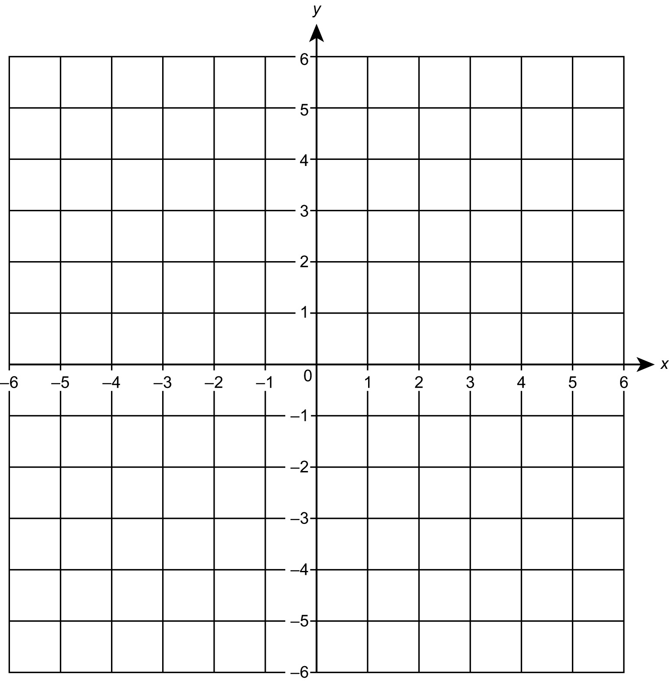
You will need:
- 1–6 dice
- pencil, ruler and rubber

What to do
- Roll the dice twice to give a coordinate in the first quadrant.
- Repeat twice more and plot the coordinates to give a triangle.
- Use a ruler to draw the triangle sides.
- Reflect in the x- and y-axes to give two new triangles.
- Work out the coordinates for these triangles.
- Rub out and repeat.
QUESTIONS TO ASK
What do the coordinates (2, 1) become when reflected in the x-axis? (2, −1)
How do you number the axes to show four quadrants?

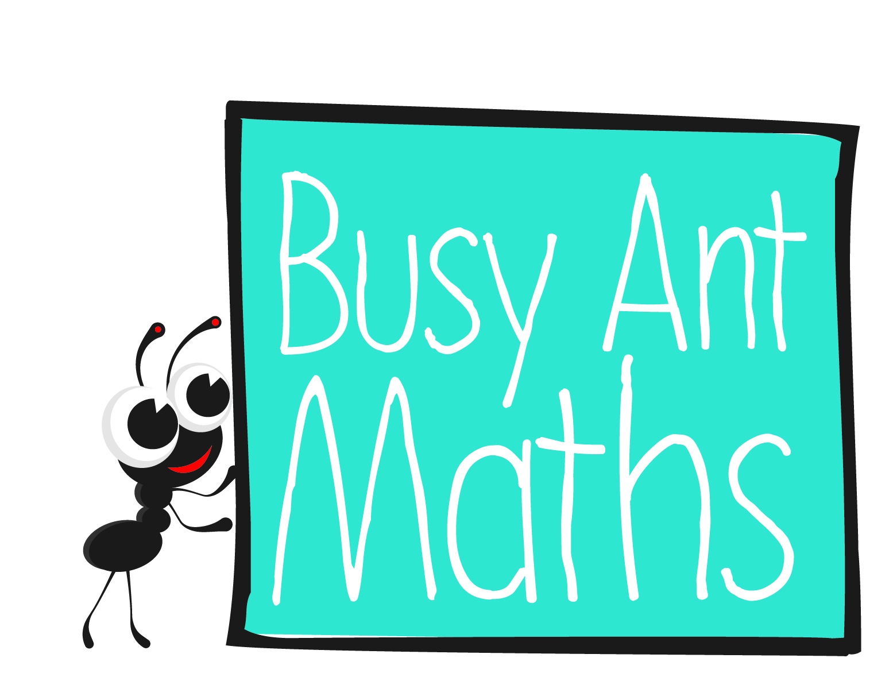
Primary 7
Maths
Newsletter 11
Insert
school logo
here
Date: ______________________ Name: ______________________

Addition, subtraction, multiplication and division
HERE’S THE MATHS
Your child is consolidating their knowledge of the order of operations to carry out calculations involving the four operations. The mnemonic for the order of operations
is BODMAS.
B Brackets O Orders (e.g. 3²) DM Division and Multiplication
AS Addition and Subtraction
ACTIVITY
What to do
You will need:
- 1–9 digit cards
- pencils and paper
- Turn over 2 cards to give a 2-digit target number,
e.g. 2 and 8 gives a target of 28.
- Select 4 cards, e.g. 3, 7, 8, 5.
- Each person tries to find a calculation using any operation, following the BODMAS rule to reach the target.
- If either player makes a calculation that reaches the target exactly they score 2 points, e.g. (7 × 8) ÷ (5 − 3) = 28.
- If not, the person closer to the target after an agreed time scores 1 point.
- Play for 10 minutes. The person with the higher score is the winner.
Variation
- As before, but the digits can be put together to make 2-digit numbers.
QUESTIONS TO ASK
What is the order in 2³? What does 2³ equal? (3 or cubed; 2³ = 2 × 2 × 2 = 8)
What is BODMAS?
Ratio and proportion
3 × 5 − 4 = 3 3 × 5 − 4 = 11
Where should the brackets be placed
to make these equations correct?
(3 × (5 – 4) = 3 (3 × 5) – 4 = 11)
When using positive whole numbers, which operations will give you bigger (smaller) number answers? (x and +) (− and ÷)
HERE’S THE MATHS
Your child is learning to understand and use ratio to solve problems. For example,
if 7 apples cost £3.50, what will 4 apples cost? First, work out the cost of one apple using division £3.50 ÷ 7 = £0.50, then multiply by the number of apples required:
£0.50 × 4 = £2.00.
ACTIVITY

1  £3.20 | 2  £4.88 | 3  £4.00 | 4  £5.68 | 5  £7.20 | 6  £8.00
7  £16.32 | 8  £2.48 | 9  £8.56 | 10  £6.40 | 11  £8.88 | 12  £9.60
What to do
- First person tosses the coin to decide if the amount represents 4 items or 8 items.
You will need:
- 2–12 digit cards from a pack of playing cards with the aces and Kings removed (Jack represents 11 and Queen 12)
- coin – heads is 4 items and tails is 8 items
- calculator (or use mobile phone)
- Turn over a card to decide the cost of items.
- Calculate the cost of a single item.
- Turn over a second card to decide how many items you would like to buy.
- Calculate the cost.
- Second person checks (using a calculator if they like).
- Swap roles.
- Continue for 10 minutes.
Variation
- Introduce a target spend of £20. The first person to spend £20 is the winner.
QUESTIONS TO ASK
The ratio of pink, purple and white coloured beads in a necklace is: 1: 2: 3. How many purple beads will there be if there are:
60 white ones? 5 pink ones? 120 beads in total?
The ratio of ham, cheese and tuna sandwiches is:
5: 2: 3. How many cheese sandwiches if there are:
12 tuna ones? 100 sandwiches in total? 25 ham ones?

