Statistics

HERE’S THE MATHS
Your child is learning to find the mean of a set of numbers from data. To calculate the mean, first find the total and then divide by how many values there are in the data set, e.g. the mean netball score of a team scoring 4 goals, 9 goals and 8 goals is 7 goals
($\frac{21}{3}$ = 7). When talking about goal average or average temperature, this is actually describing the mathematical mean.

ACTIVITY
What to do
You will need:
- 1–9 digit cards from a pack of playing cards
- coin
- pencil and paper
- Turn over a card to give a tens digit.
- Toss the coin – heads means zero in the ones column, tails means five, so an 8 and heads would give 80.
- Repeat this 4 more times.
- Look at the five 2-digit numbers and both estimate the mean.
- Calculate the actual mean of the numbers.
- Score 10 points if you predicted the exact mean, 7 points if you were within +/− 2
of the mean and 5 points if you were within +/− 5 of the mean.
- Play for 10 minutes. The winner has the higher score.

Variation
- Use two cards to give the hundreds and tens digits and the coin as before to decide the ones digit.

QUESTIONS TO ASK
What is the mean of 1·7, 2·3, 1·8 and 2·6? (2·1)
What is the mean
of 60, 80, 90 and 50? (70)
How do you find the mean of a set of numbers?

The mean of three numbers is 2.6. Suggest possible values for the numbers.
The mean of four numbers is 12. Suggest possible values for the numbers.

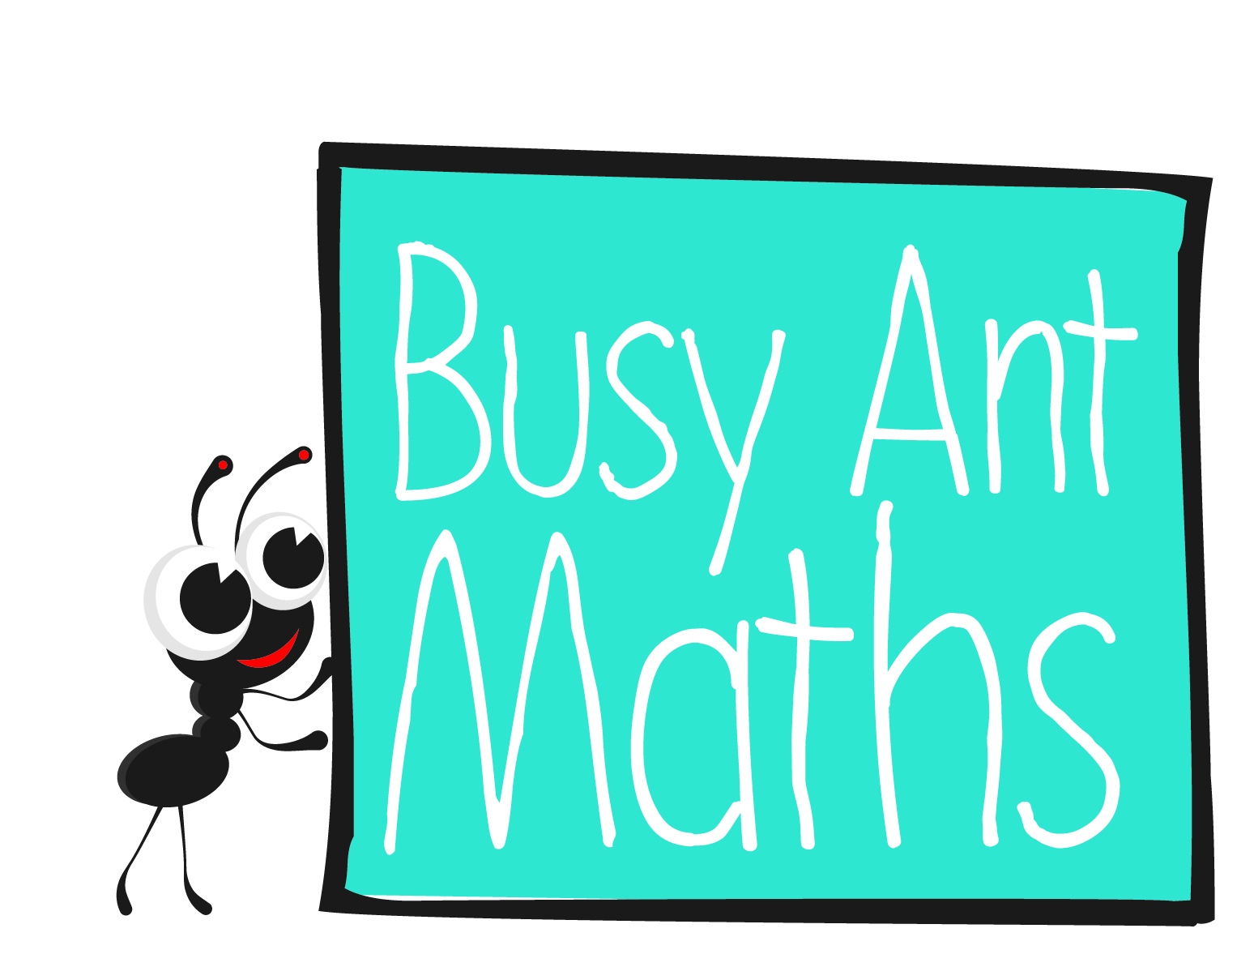
Primary 7
Insert
school logo
here
Maths
Newsletter 12
Date: ______________________ Name: ______________________
MATHS TOPICS
These are the maths topics your child will be working on during the next three weeks:
- Multiplication and division
- Fractions, including decimals and percentages
- Statistics

KEY MATHEMATICAL IDEAS
During these three weeks your child will be learning to:
- identify common factors and common multiples
- use division to convert fractions to decimals
- calculate and interpret the mean as an average of a set of data.

TIPS FOR GOOD HOMEWORK HABITS
Reflect on the variety of maths tasks that you have practised together throughout the year. Try to decide which strategies have helped you to understand maths
most easily.

Multiplication and division

HERE’S THE MATHS
Your child is strengthening their ability to identify common factors and common multiples. They are able to identify factors of large numbers using tests of divisibility. They know divisibility rules for 2, 3, 4, 5, 6, 8, 9, 10 and 25. Here are the less
well-known tests. A number is divisible by:

3 if the sum of its digits is divisible by 3
4 if the tens and units digits are divisible by 4
6 if it is even and is also divisible by 3
8 if half of it is divisible by 4 or its last three digits are divisible by 8
9 if the sum of its digits is divisible by 9

ACTIVITY
What to do
You will need:
- 0–9 digit cards from a pack of playing cards (use Jack to represent zero)
- pencil and paper
- timer (or use mobile phone)
- Turn over 4 cards to make a 4-digit number.
- Each write down as many factors that you can find in
30 seconds (or an agreed time). The factors do not necessarily have to be ones that you know a test for, e.g. 2715 is divisible by 5 and 3, so 15 will also be
a factor.
- Score 2 points for every different factor that you find.
- Check each other’s answers.
- Continue for 10 minutes.
- The person with the higher score is the winner.

Variations
- To make this easier, use 3 cards to make a 3-digit number.
- To make this more challenging, use 5 cards to make a 5-digit number.

QUESTIONS TO ASK
Fractions, including decimals and percentages
Tell me three 3-digit numbers that are divisible by 3 and 4. Will they be divisible by 12?
Is 424 divisible by 8? (Yes)
When is the next leap year? Leap years are divisible by 4. (2016)

HERE’S THE MATHS
Your child is learning to use division to convert fractions to decimals. The numerator is divided by the denominator. Your child already knows some equivalences, e.g. $\frac{1}{2}$ = 0.5, $\frac{1}{4}$ = 0.25. Some fractions do not ever divide exactly, e.g. $\frac{1}{3}$, which carries on as 0·3 for as long as you keep dividing. We write $\frac{1}{3}$ = 0.3 and we say ‘a third equals nought point
three recurring’.

ACTIVITY
What to do
You will need:
- pencil and paper
- 1–9 digit cards from a pack of playing cards
- calculator (or use mobile phone)
- Each person turns over the cards two at a time to make 5 different proper fractions, simplifying them where possible.
- Change them into decimals by dividing the numerator by the denominator (round to 2 decimal places where necessary).
- Check using a calculator.
- Mark the approximate positions of the decimals on a 0–1 number line.
- The winner is the person with the decimal closest to 1.
Variation
- Use the cards to make five different 2-place decimals and write four fractions that are equivalent to each decimal.

QUESTIONS TO ASK
Which is bigger 80% or $\frac{3}{4}$? (80%)
Which is bigger 39% or $\frac{2}{5}$? ($\frac{2}{5}$)
What is $\frac{1}{8}$ as a decimal? (0.125)

What is left of a pizza
if $\frac{1}{8}$, 25% and 0.375
is eaten? ($\frac{1}{4}$)
In the activity which fraction is the closest possible to 1? ($\frac{8}{9}$)
Did anyone pick it in your game?
Is 666 exactly divisible by 18? How do you know?

