Properties of shapes
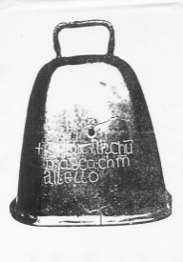
MATHS TOPICS
These are the maths topics your child will be working on during the next three weeks:
- Number and place value
- Addition and subtraction
- Properties of shapes

KEY MATHEMATICAL IDEAS
During these three weeks your child will be learning to:
- count, read and write numbers to 20
- understand addition as counting on and subtraction as taking away
- recognise and name 2-D shapes (rectangles, squares, circles and triangles).

TIPS FOR GOOD HOMEWORK HABITS
Plan a homework timetable and agree a time when your child will do their homework.
HERE’S THE MATHS
Your child has been learning to recognise and name some 2-D shapes: circles, triangles, rectangles and squares. They have been taught that squares are special types of rectangles because all four sides are the same length. They are learning that:
- circles have 1 curved side and no corners
- triangles have 3 straight sides and 3 corners
- rectangles and squares have 4 straight sides and 4 corners.

ACTIVITY
What to do
You will need:
- pencil and paper
- 4 different colouring pencils
- Help your child to draw circles, triangles, squares and rectangles on a piece of paper. Ideally, find items to draw around (e.g. coin, cheese triangle, dice, small box) to make accurate shapes.
- Choose a colour for each shape and take turns to challenge each other to colour a specific shape. Score a point for each shape coloured correctly.
- At the end of the game, ask your child to count and write how many of each shape there are.
Variation
- When drawing the shapes, arrange them to make a picture.
QUESTIONS TO ASK
What is different about
a circle compared to a triangle? (Vary the shapes being compared.)
How do you know that it is a circle/triangle/
rectangle/square?
What makes
a square a special rectangle?

What is this shape? (Point to shapes in everyday life.)
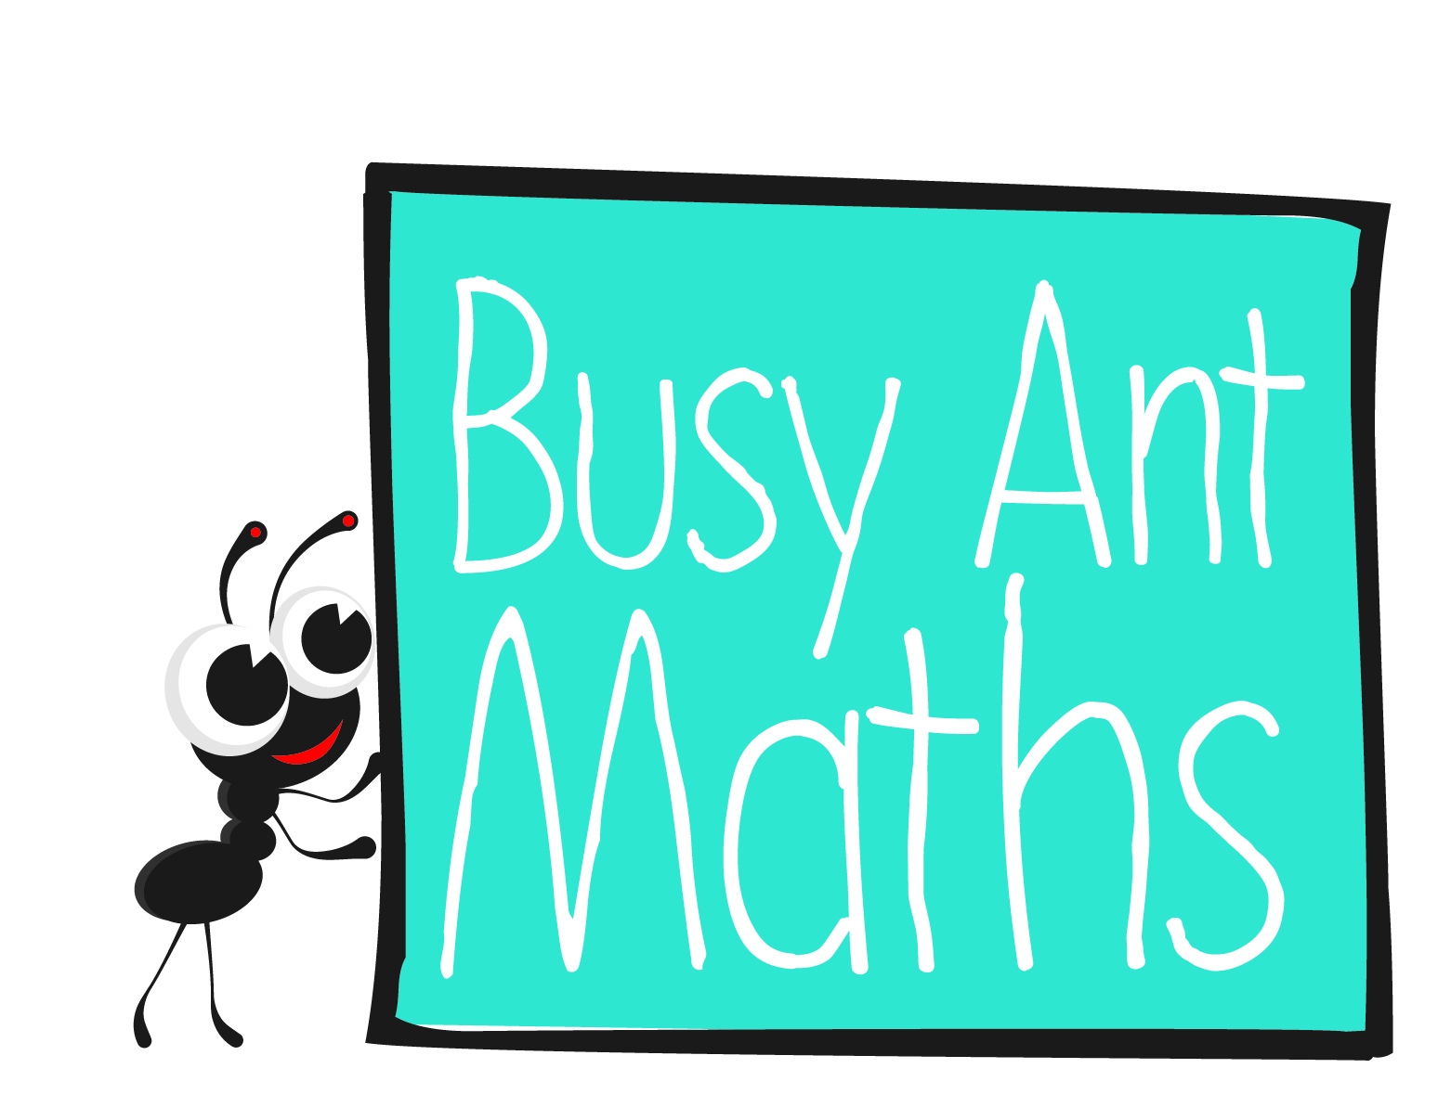
Primary 2
Maths
Newsletter 1
Date: ______________________ Name: ______________________

Number and place value
HERE’S THE MATHS
It is very important for your child to become as confident as possible with numbers to 20. This includes:
- counting forwards and backwards
- reading and writing (numerals such as 0, 1, 2 rather than words)
- knowing one more and one less
- ordering (first, second, third, etc.).
ACTIVITY
What to do
You will need:
- pencil and paper
- 20 small, everyday objects (e.g. building bricks, toy cars)
- Write the numbers 1 to 20, in order, across a piece of paper.
- Ask your child to secretly choose one of the numbers. Then ask your child some questions (the answer to which must be yes or no) to work out the secret number. For example:
Is it less/more than 10?
Is it between 10 and 20?
Does it have a 4 in it?
- When the number has been guessed correctly, swap roles.
Variations
- For an easier game, use numbers up to 10.
- For a harder game, use a 5-question limit and/or write the numbers 1 to 20 muddled up on the piece of paper.
QUESTIONS TO ASK
How is that number written?
How did you decide what question to
ask next?
What is the total?
Put your objects in a line. Which object is in the first/second/third etc. position?
How can you make the number 5 using two groups of objects? How many ways can you find?
Show me that number of objects.
What number is one less/more than your number?

How can you write that number fact using numbers and symbols?
Addition and subtraction
HERE’S THE MATHS
In order to be able to add and subtract numbers confidently, your child needs to understand addition as counting on and subtraction as taking away. It is important that they practise these concepts using numbers up to 5 and record addition and subtraction facts using the symbols +, − and =. For example: 1 + 3 = 4.

Start with 1 object and 3 objects. Count on from 1 by adding on 3 (one at a time): ‘two, three, four’.
5 − 2 = 3.

Start with 5 objects and take 2 away, leaving 3 objects to be counted.
ACTIVITY
What to do
You will need:
- pencil and paper
- 5 or more small, everyday objects (e.g. building bricks, toy cars)
- For addition practice, give your child one group
of objects (between 0 and 5) and ask how many objects there would need to be in a second group to make a total (choose a number between
1 and 5).
- For subtraction practice, give your child one group of objects (between 1 and 5) and ask how many objects they need to take away to leave a given number (choose a number
between 0 and 5).
- For both activities, ask your child to write the number fact using numbers
and symbols. They score 1 point for using the objects correctly and a bonus point
for writing the number fact correctly.
QUESTIONS TO ASK
How many are left?
How did you know how many objects to add/take away?

