Measurement (mass)
HERE’S THE MATHS
Your child has been learning to compare the weights of up to three objects using the words ‘heavy’, ‘heavier’ and ‘heaviest’, and ‘light’, ‘lighter’ and ‘lightest’.
The pencil is lighter than the book.
The book is heavier than the pencil.
The pencil is light but the feather is lighter.
The chair is heavy but the dining table is heavier.
There is a book, a feather and a pencil. The pencil is heavier than the feather but the pencil is lighter than the book. The feather is the lightest and the book is the heaviest.
MATHS TOPICS
These are the maths topics your child will be working on during the next three weeks:
- Multiplication and division, including number and place value
- Multiplication and division
- Measurement (mass)

KEY MATHEMATICAL IDEAS
During these three weeks your child will be learning to:
- count in multiples of 2 (up to 30), multiples of 5 (up to 50) and multiples
of 10 (up to 100)
- recognise multiples of 2, 5 and 10
- count sets of 2, 5 and 10 and share objects into equal groups
- use the words ‘heavy’, ‘heavier’ and ‘heaviest’, ‘light’, ‘lighter’ and ‘lightest’ correctly; compare the weight of two objects.

TIPS FOR GOOD HOMEWORK HABITS
Don’t get your child to do too much work in one sitting, otherwise they may get bored or overwhelmed.
ACTIVITY
What to do
You will need:
- a collection of toys and everyday household objects of varying weights
- Take turns to choose two objects and challenge the other player to make up a sentence about the two objects using either ‘lighter’ or ‘heavier’ in their description.
- It is worth choosing objects where the weight difference is obvious when the objects are held (for smaller items) or where your child will recognise that one object weighs more than the other, for example a chair and a dining table.
Variations
- Take turns to challenge each other to find an object that is lighter or heavier than
a chosen object.
- Take turns to choose three objects for the other person and challenge them to arrange the objects in order from lightest to heaviest or heaviest to lightest.
QUESTIONS TO ASK
Which object is lighter/heavier?
How can you tell?
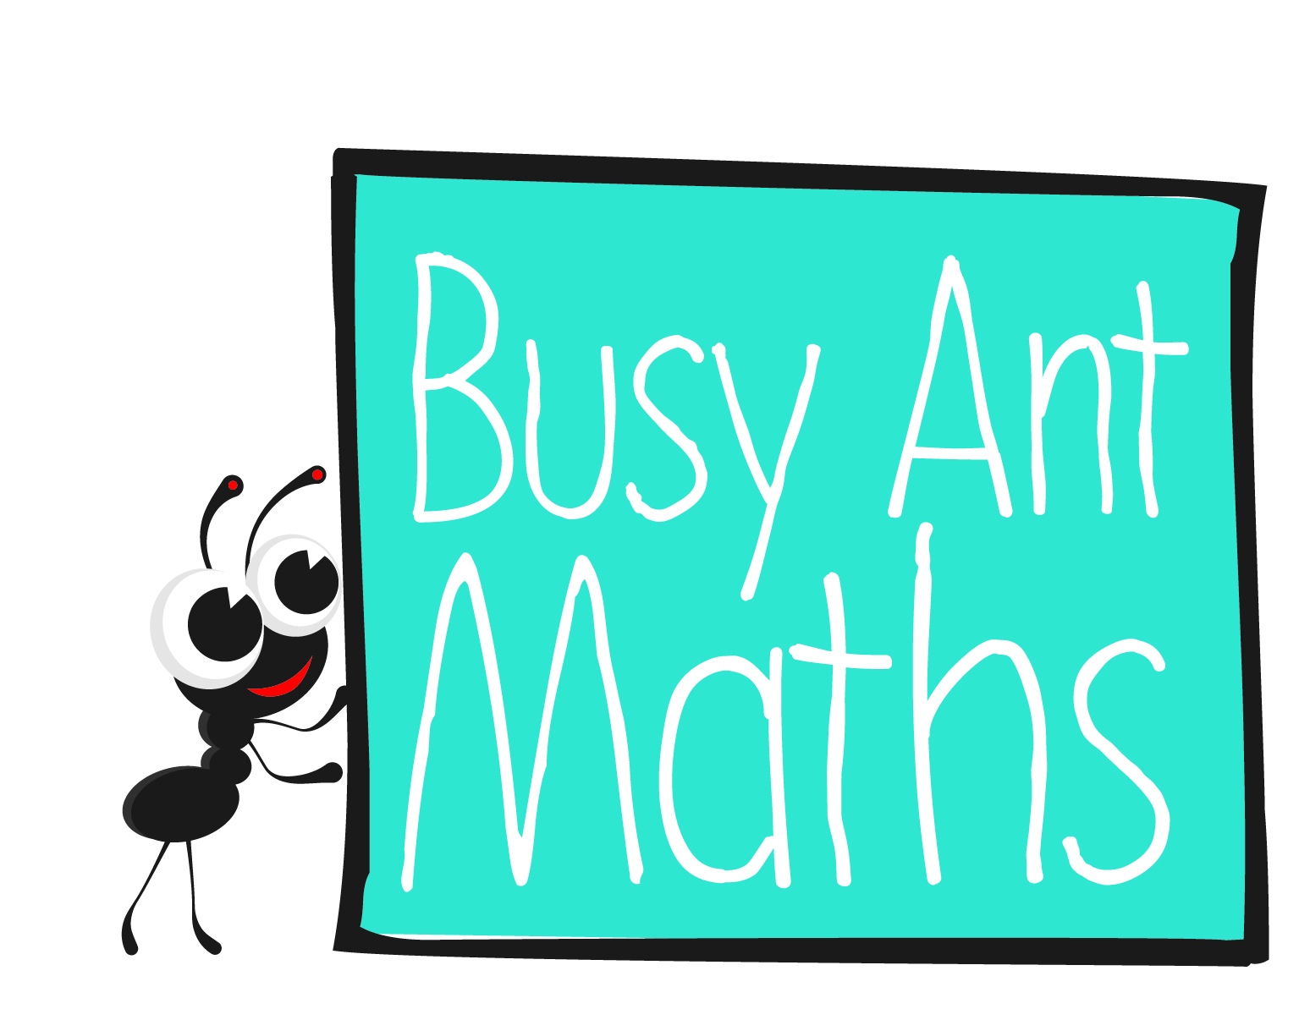
Primary 2
Maths
Newsletter 6
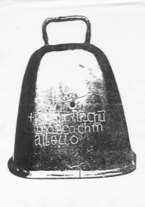
Which objects are lighter/heavier than X?
How can you find out the weight of an object?
Which object is the lightest/heaviest?
Date: ______________________ Name: ______________________

Multiplication and division, including number and
place value
HERE’S THE MATHS
Useful to know:
- Multiples of 2 end in 0, 2, 4, 6 or 8.
- Multiples of 5 end in 0 or 5.
- Multiples of 10 end in 0.
- Numbers ending in 0 are multiples of 2, 5 and 10.
Your child has been learning to recognise multiples of 2 (up to 20), multiples of 5 (up to 50) and multiples of 10 (up to 100).
- 6 is a multiple of 2 (2 × 3 = 6).
- 15 is a multiple of 5 (5 × 3 = 15).
- 40 is a multiple of 10 (10 × 4 = 40),
2 (2 × 20 = 40) and 5 (5 × 8 = 40).

ACTIVITY
What to do
You will need:
- 15 small pieces of paper (the numbers 1 to 5 written on one set and the numbers 0 to 9 written on the other set)
- Separately shuffle the two sets of cards and place them face down with the 1 to 5 set on the left and the
0 to 9 set on the right.
- Take turns to turn over the top card on each pile
to create a two-digit number. Score a point for each correctly identified multiple (2, 5 and/or 10) or for correctly identifying that the number isn’t a multiple
of 2, 5 or 10.
- Put the used cards in two separate piles. After 5 turns, reshuffle the 1–5 cards and put them face down to the left of the 0–9 cards. Continue playing for another 5 turns.
- The winner is the player with the most points after 10 turns.
QUESTIONS TO ASK
Which multiple of 2/5/10 comes next? How do you know?
What numbers
do multiples of 2/5/10 end in?
Multiplication and division
Is 8 a multiple of 2? How do you know?
HERE’S THE MATHS
Your child is counting sets of 2, 5 and 10 to learn about multiplication and sharing objects equally to learn about division.

3 sets of 2 dots make 6
4 sets of 5 dots make 20

ACTIVITY
What to do
You will need:
- 15 small pieces of paper (2, 5 and 10 written on one set and 0 to 10 written on the other set and one piece with ‘sets of’ written on it)
- pencil and paper
- Separately shuffle the two sets of cards and place them face down in two piles with the ‘sets of’ label in between the two piles.
- Take turns to turn over the top card on each pile and read out the question, for example ‘7 sets of 2’.
- Encourage your child to draw the question using circles (one circle per set) and dots (2, 5 or 10 per circle) if they need help to visualise the question.
- Score a point for each correctly answered question. Put the used cards in two separate piles.
- After every 3 turns, reshuffle the 2, 5 and 10 cards and put them face down again.
- The winner is the player with the most points after 11 turns, when all of the set number cards have been used once.
Variation
- Continue playing for an agreed amount of time, reshuffling and reusing both sets
of cards as needed.
QUESTIONS TO ASK
How do you know which numbers are multiples
of 2, 5 and 10?

How many sets of 2/5/10 make X?
6 sets of 5 make 30. What are 5/7 sets of 5?

