Properties of shapes
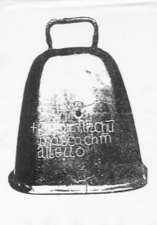
HERE’S THE MATHS
2-D shapes are flat.

circle triangle square rectangle
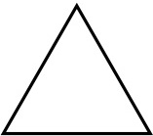

MATHS TOPICS
These are the maths topics your child will be working on during the next three weeks:
- Number and place value
- Addition and subtraction, including measurement (money)
- Properties of shapes

KEY MATHEMATICAL IDEAS
During these three weeks your child will be learning to:
- know odds and even
- order numbers to 20
- solve money problems
- recognise and name 3-D shapes.

TIPS FOR GOOD HOMEWORK HABITS
Help your child with reading any instructions to make sure they understand the
task that has been set.

3-D shapes have depth.

sphere cube cuboid cylinder cone pyramid

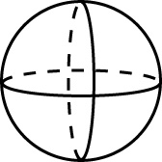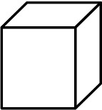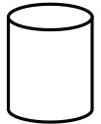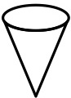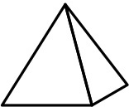
Your child has been learning to recognise and name these 2-D and 3-D shapes as well as recognise the difference between 2-D and 3-D shapes.
ACTIVITY
What to do
You will need:
- 2-D and 3-D shape cards made by cutting out the shapes on this page (without names)
- 10 cards with a shape name (circle, triangle, square, rectangle, sphere, cube, cuboid, cylinder, cone, pyramid) written on each one
- Play 2-D and 3-D shape Pelmanism by shuffling the shape cards and shape name cards separately. Spread the cards out face down in two separate groups.
- Take turns to turn over a shape card followed by a shape name card. If the shape and the shape name match, the player keeps the cards. If not, they turn them back over.
- The winner is the player with the most cards when all of the cards have been taken.

QUESTIONS TO ASK
How are 2-D and 3-D shapes different?
What is the name of this shape?
Is this a 2-D or
a 3-D shape?
How do you know?

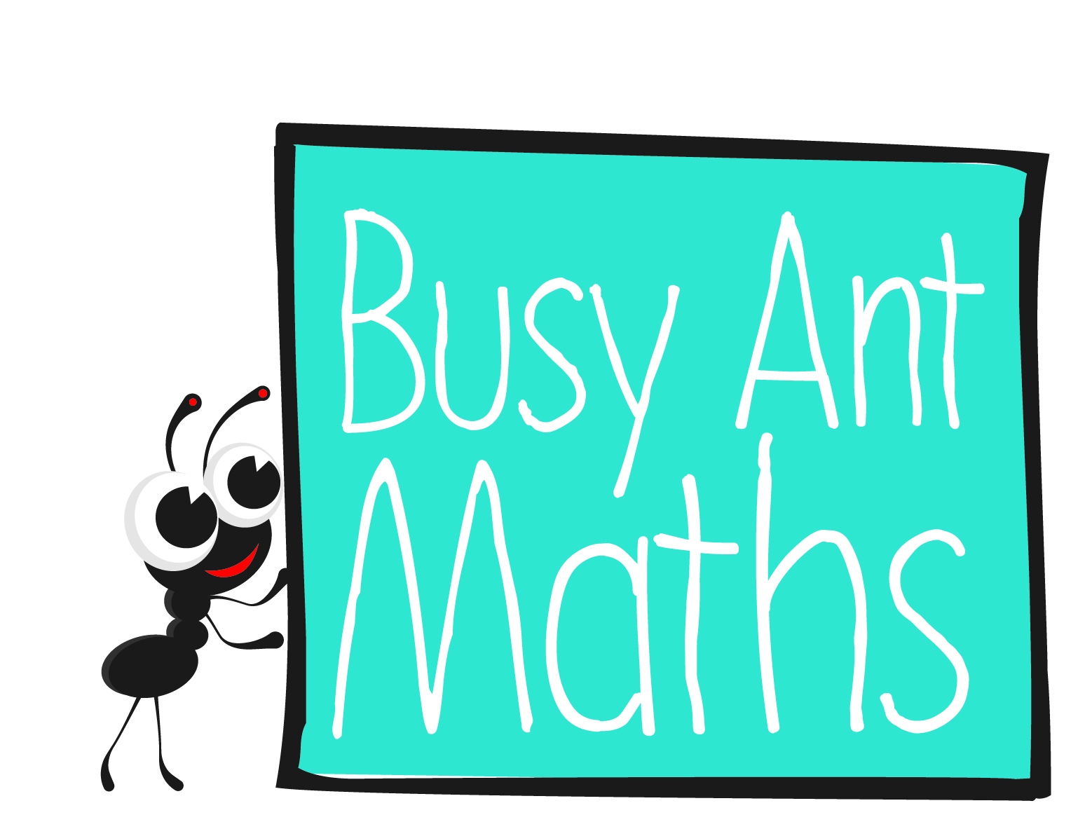
Primary 2
Maths
Newsletter 5
Date: ______________________ Name: ______________________

Number and place value
HERE’S THE MATHS
Your child has been learning which numbers up to 20 are odd and which numbers are even.
- Odd numbers: 1, 3, 5, 7, 9, 11, 13, 15, 17, 19
- Even numbers: 0, 2, 4, 6, 8, 10, 12, 14, 16, 18, 20
Numbers can be sorted into size order. Start with the smallest number first.
- 11, 7, 16 becomes 7, 11, 16
- 4, 13, 0 becomes 0, 4, 13
ACTIVITY
What to do
You will need:
- pencil and paper
- 2 counters
- 21 small pieces of paper (with the numbers 0 to 20 written on them)
- On a plain piece of paper, draw a simple zigzag game board with 20 numbered squares with ‘Start’ written on square number 0 and ‘Finish’ written on square number 20.
- Put both counters at the beginning of the game board.
- Shuffle the 21 pieces of paper and put them face down in front of you.
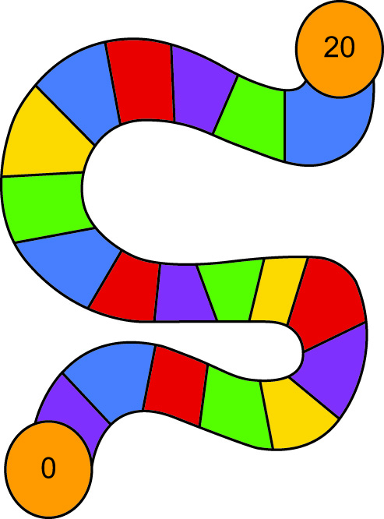
- Take turns to take the top three pieces of paper and arrange
the numbers into the correct order. (Reshuffle the number cards
as needed.)
- If your answer is correct, move forward onto the next even number
on the board. If your answer is incorrect move backward onto the
previous odd number on the board.
- Put the used number cards on a separate pile.
- The winner is the first player to reach the finish.
Variation
- Roll a 1–6 dice to move around the board. If you roll an even number, move forward to the next even number. If you roll an odd number, move backward to the previous odd number.
QUESTIONS TO ASK
Which is the next even number?
Say the even/odd numbers up to 20 in the correct order.
Which number is the smallest/largest?

Addition and subtraction, including measurement (money)
HERE’S THE MATHS
Your child has been learning to solve money problems by adding and subtracting amounts up to 20p.
- Amir has 15p. He buys a ball that costs 9p. How much does Amir have left?
- Lucy has 7p. Her mum gives her 8p more. How much does Lucy have altogether?

The child can find the total cost of two items and give the correct money or work out the change to be given from 20p.
ACTIVITY
What to do
You will need:
- assorted coins or drawings of individual coins
- small toys each labelled with a price up to 10p
- Create a toy shop where you are the shopkeeper and your child is the customer.
- Invite your child to choose two items to buy and then identify coins that make the correct amount
to pay for the item.
Variation
- Swap roles so that you are the customer and your child is the shopkeeper. This time, pay for your chosen items using a 20p coin. Your child must work out how much change they need to give you and identify coins they could use to give the change.

QUESTIONS TO ASK
How much change will I get from 20p?
How much money will I have left?
What coins could you use to pay for those items?
How much do those items cost altogether?

