Measurement (money)
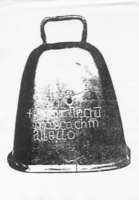
HERE’S THE MATHS
Your child has been learning to recognise 1p, 2p, 5p and 10p. They can make the same amount of money using different combinations of coins.
For example:
6p = 5p + 1p OR 6p = 2p + 2p + 2p OR 6p = 2p + 2p + 1p + 1p
10p = 5p + 5p OR 10p = 5p + 2p + 2p + 1p OR 10p = 5p + 2p + 1p + 1p + 1p

They can find the total cost of two items and give the correct money or work out the change to be given from 10p.
ACTIVITY
MATHS TOPICS
These are the maths topics your child will be working on during the next three weeks:
- Addition and subtraction
- Fractions
- Measurement (money)

KEY MATHEMATICAL IDEAS
During these three weeks your child will be learning to:
- recall addition and subtraction facts using numbers to 15
- recognise and find half of objects, shapes, quantities and lengths; know that two halves make a whole
- use coins to show different ways of making the same value.

TIPS FOR GOOD HOMEWORK HABITS
Before your child starts on their homework, discuss the task with them to ensure that they fully understand what they are required to do.
What to do
You will need:
- assorted coins or drawings of individual coins
- small toys each labelled with a price up to 5p
- Create a toy shop where you are the shopkeeper and your child is the customer.
- Invite your child to choose an item to buy and then identify coins that make the correct amount to pay for the item.
Variations
- Extend the activity by asking your child to choose two items to buy so that they must work out the total cost and pay using the correct amount.
- Swap roles so that you are the customer and your child is the shopkeeper.
This time, pay for your chosen item(s) using a single coin (up to 10p). Your child
must work out how much change they need to give you and identify coins they could use to give the change.
QUESTIONS TO ASK
What coins could you use to replace the 5p/10p coin?
What coins could you use instead?
What coins could you use to pay for that item/those items?
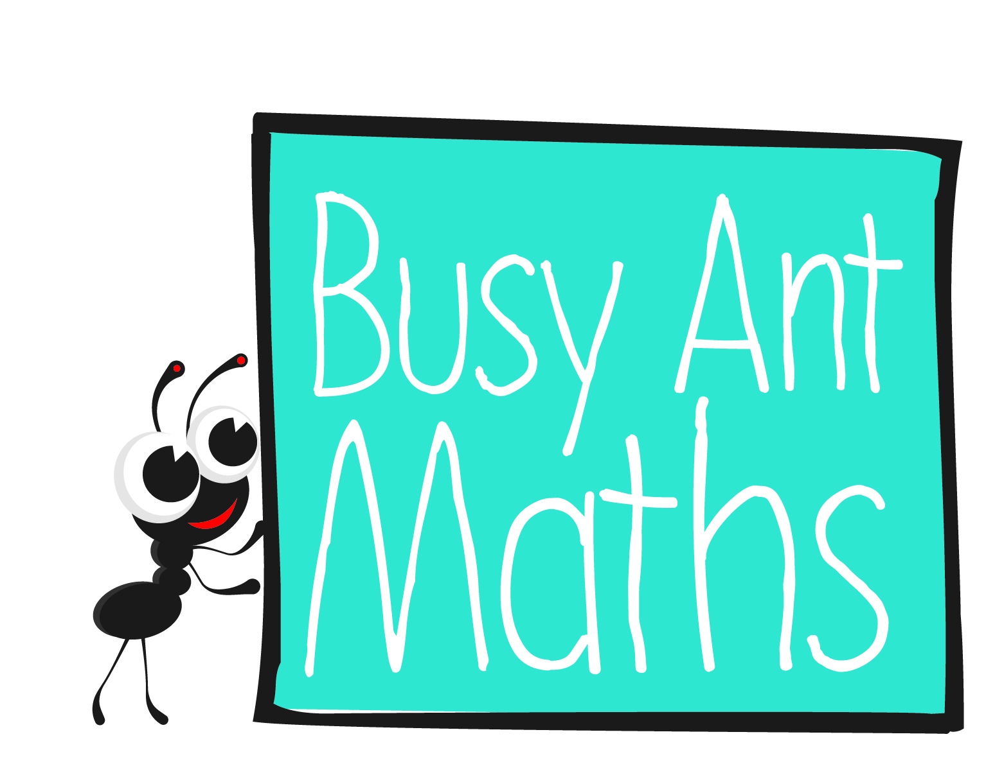
Primary 2
Maths
Newsletter 4
How much change should I get if I pay with a 10p coin?
What is the total price of those items?
Date: ______________________ Name: ______________________

Addition and subtraction
HERE’S THE MATHS
It is very important for your child to become as confident as possible with adding and subtracting numbers to 15. This week, your child is learning to:
- use these symbols to write addition and subtraction facts: + − =
- add two numbers where the total is 15 or less (e.g. 2 + 11 = 13)
- subtract two numbers where the largest number is 15 or less (e.g. 14 − 6 = 8).
ACTIVITY
What to do
You will need:
- 0 to 15 number cards (16 small pieces of paper each one with
a number written on it)
- pencil and paper
- For addition, put the cards 6 to 15 in one shuffled pile and the cards 0 to 5 in a second shuffled pile.
- Take turns to turn over the top card from both piles and add the two numbers together. (Reject the card from the 6 to 15 pile, put it to the bottom of the pile and turn over the next one if the total would be greater than 15.)
- Write the addition fact using the symbols + and =.
- Score a point for a correct answer and a bonus point for writing the addition
fact correctly.
- Continue playing for a chosen number of turns or a fixed amount of time. The winner is the player with the most points at the end of the game.
Variation
- For subtraction, put the cards 11 to 15 in one pile and the cards 0 to 10 in a second pile. One person turns over the top card from each pile and subtracts the smaller number from the larger number. Write the subtraction fact using the symbols − and =.
2

3
QUESTIONS TO ASK
What is 13 subtract/take away 6?
What is 9 add 5?
Fractions
How can you write that calculation?
How did you work out the answer?
HERE’S THE MATHS
Splitting something (a number, a shape, an object) in half means that you must end up with two equal-size shapes, numbers or objects in place of the original single object.
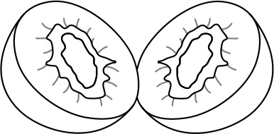
For example: 3 is half of 6 (3 + 3 = 6)

ACTIVITY
What to do
You will need:
- pencil and paper
- 2 counters
- 10 small pieces of paper (with each of the following questions written on 2 pieces of paper ‘half of 2?’, ‘half of 4?’, ‘half of 6?’, ‘half of 8?’ and ‘half of 10?’)
- colouring pencils and scissors (optional)
- On a plain piece of paper, draw a simple zigzag game board with approximately 20–25 numbered squares (as shown below).
- Shuffle the 10 question cards and place them face down.
- Put both counters at the beginning of the game board.
- Take turns to pick up the top card and work out the ‘half of’ question. If the question is answered correctly, the player moves their counter that number of squares along the board. If the answer is answered incorrectly the player does not move their counter.
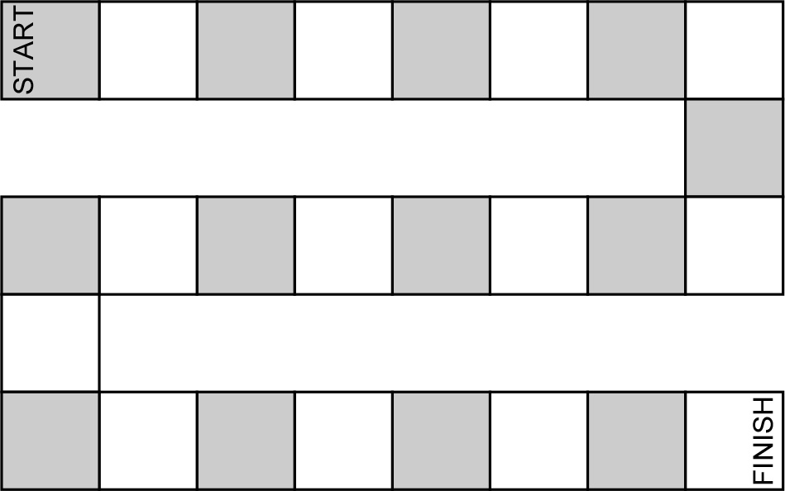
- The winner is the first player to reach the finish. Reshuffle the question cards if you need to go through them again.
Variations
- Draw some simple (symmetrical) shapes (such as circles, squares, rectangles, triangles, etc.) on a piece of paper. Ask your child to colour them in and then, with close supervision, cut each shape in half using scissors. Stick the shape halves down next to each other on a piece of paper.
QUESTIONS TO ASK
How can you check that your answer is half of the number you started with?
How did you work it out?
What is half of 2/4/6/8/10?

