Position and direction
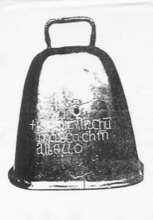
HERE’S THE MATHS
A person will face different directions after different turns.
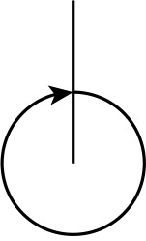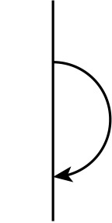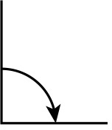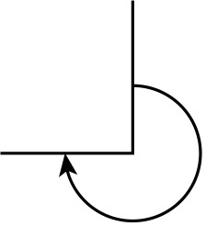
MATHS TOPICS
These are the maths topics your child will be working on during the next three weeks:
- Number and place value
- Multiplication and division
- Position and direction

KEY MATHEMATICAL IDEAS
During these three weeks your child will be learning to:
- count on and back in 2s and 5s up to 20; count on and back in 10s up to 100
- count sets of 2, 5 and 10
- describe movements and positions of objects; make and recognise whole, half, quarter and three-quarter turns.

TIPS FOR GOOD HOMEWORK HABITS
Turn off the TV while your child is doing homework.
full turn half turn quarter turn three-quarter turn

ACTIVITY
What to do
- Ask your child to stand in a particular location. Either give an instruction to make
a certain turn and ask what they can see or give an instruction to turn to face a particular object and ask how far they turned.
Variation
- You stand in a particular location. Either ask your child to give you an instruction so that you face a particular object of your choice or ask your child to tell you what you will see after a turn of your choice.

QUESTIONS TO ASK

What do you see if you make a whole/half/ quarter/three-quarter turn to the right?
How far do you have to turn to see X?
Turn until you see X. How far have you turned?
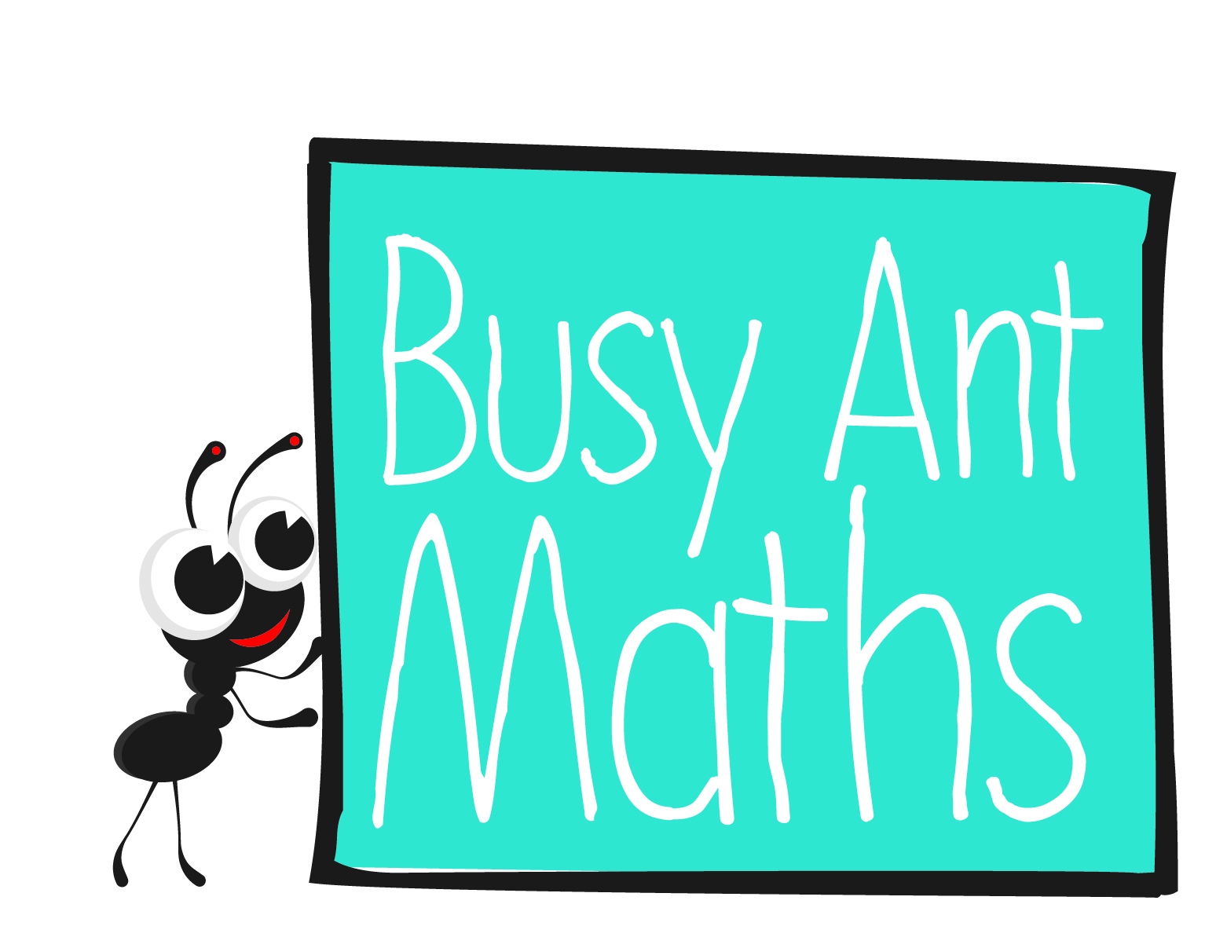
Primary 2
Maths
Newsletter 3
What turn do I need
to make to see X?
Date: ______________________ Name: ______________________

Number and place value
HERE’S THE MATHS
Your child has been counting on and back in 2s, 5s and 10s as well as learning about multiples.
Useful to know:
- Multiples of 2 end in 0, 2, 4, 6 or 8.
- Multiples of 5 end in 0 or 5.
- Multiples of 10 end in 0.
- Numbers ending in 0 are multiples of 2, 5 and 10.
- 6 is a multiple of 2 because 2 can be multiplied by another whole number to give 6 (2 × 3 = 6).
- 7 is not a multiple of 2 because 2 cannot be multiplied by another whole number to give 7.
- 15 is a multiple of 5 (5 × 3 = 15). 18 is not
a multiple of 5.
- 40 is a multiple of 10 (10 × 4 = 40). 25 is not
a multiple of 10.
ACTIVITY
What to do
You will need:
- 0 to 20 number cards (21 small pieces of paper each one with a number written on it)
- 2 label cards (‘multiple’ and ‘not a multiple’)
- timer (or phone with timer) – optional
- Decide whether to play the game using multiples
of 2 or 5. Discuss how to identify multiples.
- Shuffle the number cards and put them in a pile face down. The two label cards should be face up with space next to each one.
- Take turns to pick up a card and identify whether or not it is a multiple of your chosen number.
- Place the card alongside the correct label.
- When all of the cards have been sorted, choose whether to sort the cards by counting up to 20 or back from 20. Challenge your child to sort the multiples into the correct order as quickly as possible, using a timer if wanted.
QUESTIONS TO ASK
Which multiple of 2/5/10 comes next?
How do you know?
What numbers do multiples of 2/5/10 end in?
Multiplication and division
Is 8 a multiple of 2? How do you know?
HERE’S THE MATHS
Having learnt to count on and back in 2s, 5s and 10s, your child is now counting sets
of 2, 5 and 10 as a way of beginning to learn about multiplication.
3 sets of 2 dots make 6
4 sets of 5 dots make 20
ACTIVITY
What to do
You will need:
- A4 paper cut into 30 pieces (6 x 5 arrangement) as follows:
- 10 pieces each with 2 dots on
- 5 pieces each with 5 dots on
- 10 pieces each with 10 dots on
- 5 blank pieces
- Shuffle the pieces of paper with 2 dots and the blank pieces, then put them face down and spread them out.
- Take turns to choose a number of pieces of paper (between 5 and 10) for the other person to turn over, e.g. count out 6 pieces of paper.
- The person who turns over the pieces of paper then has to say how many sets of 2 they can see and say, for example, ‘4 sets of 2 equals 8’. If the answer is correct, the person scores a point.
- Play the game for a chosen number of turns or a certain amount of time, such as 5 minutes.
- The winner is the player with the most points at the end of the game.
QUESTIONS TO ASK
What numbers can multiples of 2/5/10 end in?
How many dots are there on X pieces of paper?
How many sets of 2/5/10 make X?

