Measurement
(length and height)
MATHS TOPICS
These are the maths topics your child will be working on during the next three weeks:
- Addition and subtraction
- Measurement (length and height)

KEY MATHEMATICAL IDEAS
During these three weeks your child will be learning to:
- recall addition and subtraction facts using numbers to 10
- add numbers in any order, find the difference between two numbers and solve addition and subtraction problems
- compare and measure lengths and heights.

TIPS FOR GOOD HOMEWORK HABITS
Choose a quiet place to work, preferably sitting at a table, where your child can work comfortably without being disturbed.
HERE’S THE MATHS
Your child is learning to use language to compare two measurements:
- longer/longest and shorter/shortest for length
- taller/tallest and shorter/shortest for height.
Your child is also measuring objects using his/her own body, for example: hand span, foot length, fingertip to elbow (cubit), stride. Encourage your child to choose a sensible unit of measurement depending on the size of the object they want to measure.
ACTIVITY
What to do
You will need:
- pencil and paper
- Choose one type of measurement, e.g. hand span, and ask your child to measure the height or length of 6 different objects using that form of measurement.
- Help them to write their measurements on a piece of paper, for example:
- The table is 7 hand spans high.
- When they have all 6 measurements, challenge your child to make up as many sentences as possible to compare different pairs of measurements and comment
on the sizes, for example:
- The table is taller than the stool. / The stool is shorter than the table.
- The toy garage is longer than the toy truck. / The toy truck is shorter than the toy garage.
- The table is the tallest object. / The toy truck is the shortest object.
Variation
- Ask your child to use a different form of measurement. If your child shows an interest in using a ruler to measure objects, encourage them to do so and help them to write down the measurements using centimetres.
QUESTIONS TO ASK
What is shorter/longer/taller than X?
How did you measure that object?
Where did you measure
from and to?
Which is the shortest/longest/tallest object? How do you know?
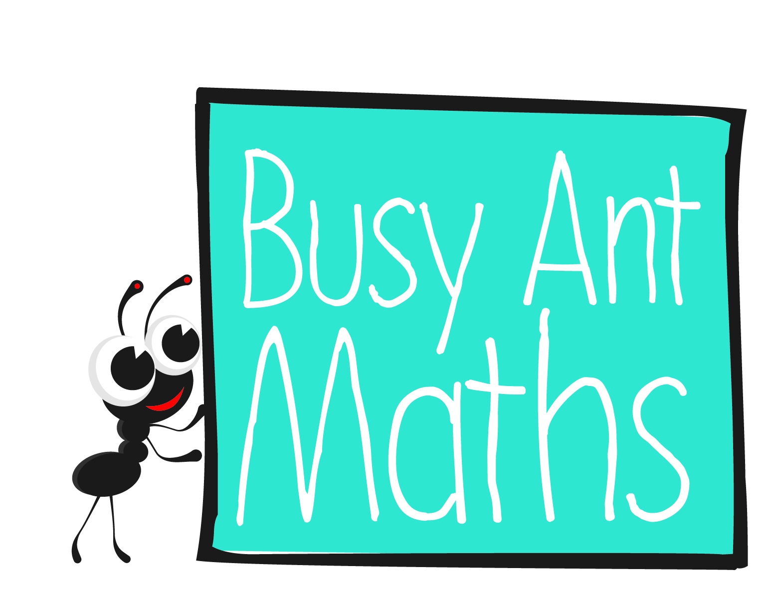
Primary 2
Maths
Newsletter 2
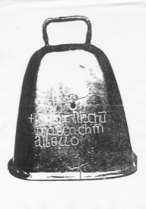
Date: ______________________ Name: ______________________

Addition and subtraction
HERE’S THE MATHS
It is very important for your child to become as confident as possible with adding and subtracting numbers to 10. This week, your child is learning to:
- use the symbols +, − and = to write addition and subtraction facts
- add two numbers where the total is 10 or less (e.g. 6 + 3 = 9)
- subtract two numbers where the largest number is 10 or less (e.g. 8 − 2 = 6)
- add doubles (0 + 0 = 0, 1 + 1 = 2, 2 + 2 = 4, 3 + 3 = 6, 4 + 4 = 8, 5 + 5 =10).
ACTIVITY
What to do
You will need:
- number cards 0 to 10 (11 small pieces of paper each one with a number written on it)
- pencil and paper
- Decide whether to play an addition game, subtraction game or both.
- Lay out the cards face up and ask your child to pick one card.
- If you are playing an addition game, you choose another card showing a number that can be added to your child’s number to make a total less than 10. If you are playing a subtraction game, you choose any other card and put the cards
in the correct order for a subtraction sum.
- Challenge your child to make an addition or subtraction calculation, write it down and work out the answer.
- Repeat the activity as many times as you like, returning the cards after each turn.
Variation
- Use two lots of number cards numbered 0 to 5 and pick a card. Challenge your child to find the same number, then write and work out the double number calculation.
QUESTIONS TO ASK
What is double 0/1/2/3/4/5?
How did you work out
the answer?

What is 7 subtract/take
away 2?
What is 4 add 5?
How did you work out the answer?
How can you write that calculation?
How can you write that calculation?
What is 4 add 5?
Addition and subtraction
HERE’S THE MATHS
Solving addition and subtraction problems in real life is a very important part of your child's learning. If needed, help your child to work out whether they are being asked to add two numbers together or take one away from the other by acting out the problem.

There were 7 strawberries in a bowl.
Katie gave 3 of them to her friend.
How many were left?

Place 7 building blocks, or similar, in front of your child, ask them to give away 3 of them and then ask how many they have left. Explain that they have taken away or subtracted 3 from 7.
ACTIVITY
What to do
You will need:
- a variety of everyday objects in different locations
- Set your child addition and subtraction problems based on everyday objects around you. Use the question ‘How many X altogether?’ for addition and ‘How many Y were left?’ for subtraction.
- For example:
- There were 4 cars queuing at the traffic lights. Another 2 cars arrived. How
many cars are there altogether?
- There were 6 children playing on the roundabout. 5 children got off. How many children were left?
Variation
- Ask your child to set problems for you to solve. Remind them to use the question ‘How many X altogether?’ for addition and ‘How many Y were left?’ for subtraction.
QUESTIONS TO ASK
What is 7 subtract/take away 2?
How do you know whether to add or subtract?

