Properties of shapes

HERE’S THE MATHS

Your child has been learning about repeating patterns involving 2-D and 3-D shapes. The repeat might happen after two or three shapes.

For two shapes, the shapes will alternate:

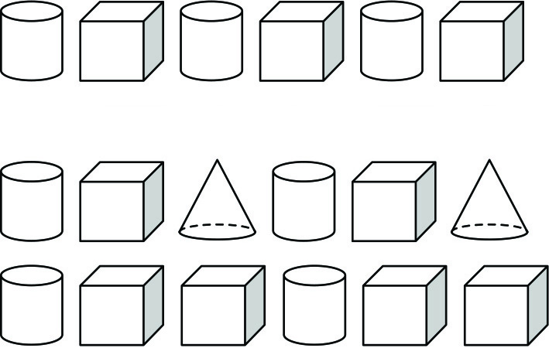

MATHS TOPICS

These are the maths topics your child will be working on during the next three weeks:

* Addition and subtraction
* Properties of shapes

KEY MATHEMATICAL IDEAS

During these three weeks your child will be learning to:

* recall addition and subtraction facts to 20, with increasing confidence and accuracy
* write related addition and subtraction facts
* make repeating patterns using 2-D and 3-D shapes.

TIPS FOR GOOD HOMEWORK HABITS

Once your child has completed their homework, congratulate them on something they did really well, for example: if they sat down and got on with their work really sensibly; they kept going even though they found parts of it really challenging; they asked for help when they needed it; they followed the instructions carefully.

For three shapes there are different possibilities:

ACTIVITY

What to do

You will need:

* cylinders (e.g. cans of food), cuboids (e.g. food boxes), cubes (e.g. food boxes, dice), spheres (e.g. balls)
* Challenge your child to create as many repeating patterns using the household 3-D shapes as possible.

Variation

* Cut out some paper circles, triangles, squares and rectangles and use them to create repeating 2-D shape patterns.

QUESTIONS TO ASK

How many shapes do there need to be for someone to be able to identify the repeating pattern?

What is the repeating pattern?

What shape comes next?

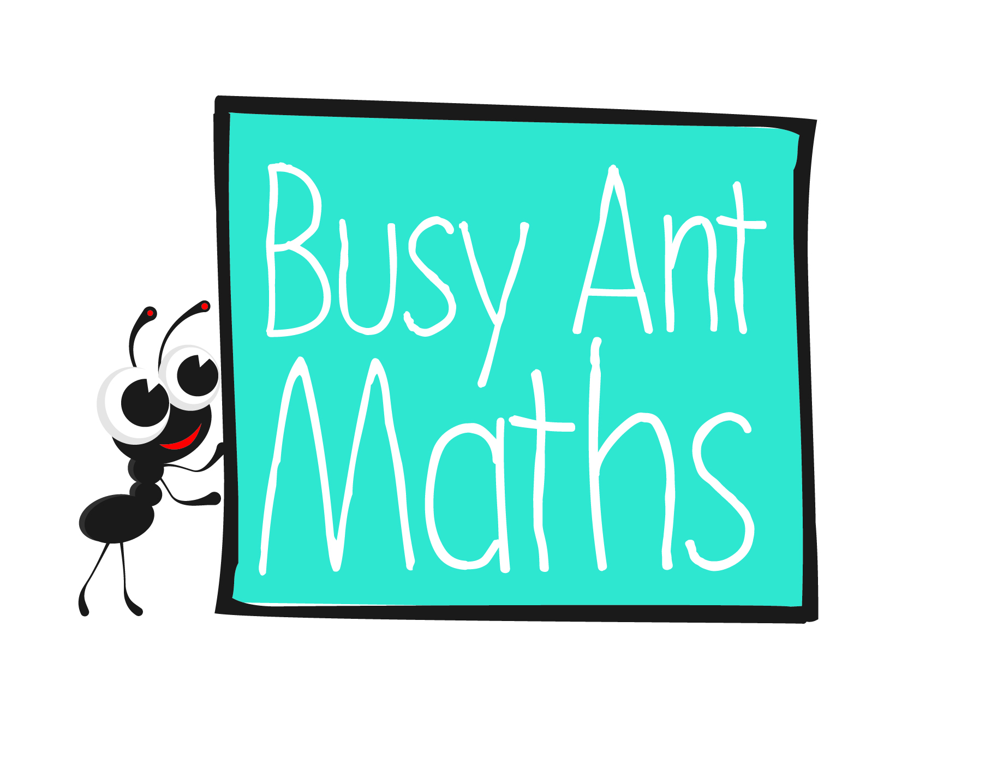Primary 2  
Maths  
Newsletter 11

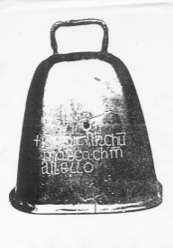

How many shapes are there in the repeating pattern?

Date: ______________________ Name: ______________________

Addition and subtraction

HERE’S THE MATHS

Your child should know that addition can be done in any order. It is better to start with the larger number and add on the smaller number by counting on. This is because there is less to count on. So, think of 4 + 13 as 13 + 4.

Counting back is used to subtract a smaller number from a larger number. A number line or track can be used for support, if needed.



ACTIVITY

What to do

You will need:

* 1–6 dice
* pencil and paper
* Both draw six empty boxes as per the pyramid layout shown below.
* 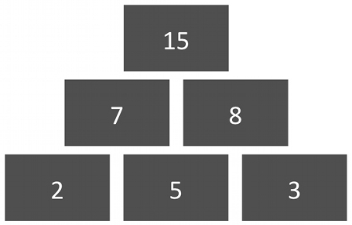Roll the dice and write the number in the middle of the bottom three boxes.
* Roll the dice twice more and write the numbers in the other two of the bottom three boxes.
* Both work individually to solve the pyramid. In the bottom row, add the left-hand and middle numbers together and write the answer in the left-hand box in the middle row. Repeat for the middle and right-hand numbers, writing the answer in the right-hand box in the middle row. Then add the two numbers in the middle row and write the answer in the top box.
* Compare your answers and score a point if your calculations are correct.
* Repeat for more pyramids.

QUESTIONS TO ASK

What do you need to add to X to make Y?

What's the largest total   
you can have at the top   
of the pyramid?

What is X add/plus/subtract/

take away Y?

Addition and subtraction

HERE’S THE MATHS

Related addition and subtraction facts use the same three numbers. For example:

12 + 4 = 16 4 + 12 = 16 16 − 12 = 4 16 − 4 = 12

ACTIVITY

What to do

You will need:

* pencil and paper
* Show this 5 by 5 grid to your child and ask them to circle as many groups of three numbers as possible where the two smaller numbers add together to give the largest number.

|  |  |  |  |  |
| --- | --- | --- | --- | --- |
| 10 | 5 | 15 | 8 | 18 |
| 6 | 8 | 3 | 5 | 7 |
| 16 | 2 | 18 | 4 | 20 |
| 9 | 4 | 2 | 9 | 11 |
| 7 | 13 | 20 | 11 | 9 |

* For each set of three numbers they should then write four related addition and subtraction facts.

Variation

* Create your own 5 by 5 grid that includes groups of three numbers that will make related addition and subtraction facts.

QUESTIONS TO ASK

What is X add/plus/subtract/  
take away Y?

Where does the largest number appear in the addition/subtraction facts?

How did you work out the related addition and subtraction facts?