Measurement
HERE’S THE MATHS
Your child has been learning to estimate and then measure the length/width/height of objects using a ruler. Estimating measurements is a useful skill – it can help children to identify when their actual measurement might have gone wrong and needs rechecking.

The ruler must be correctly positioned with 0 lined up with the start of the object, not 1.
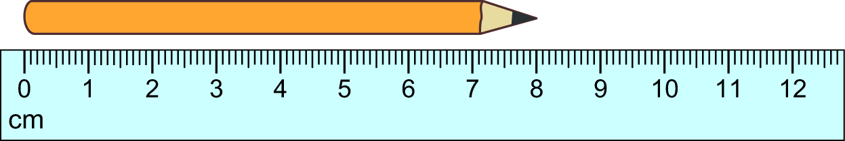

MATHS TOPICS
These are the maths topics your child will be working on during the next three weeks:
- Multiplication and division, including number and place value
- Measurement

KEY MATHEMATICAL IDEAS
During these three weeks your child will be learning to:
- use arrays to count in 2s, 5s and 10s
- solve problems involving sharing
- estimate and compare lengths.

TIPS FOR GOOD HOMEWORK HABITS
Always offer encouragement and praise as your child completes their homework.

Once the ruler is lined up, the length/width/height of the object can be found by looking where the other end of the object is against the ruler.
ACTIVITY
What to do
You will need:
- 30 cm ruler
- assorted everyday objects
- Pick a room in the house and find 5 objects with
a length, width or height of less than 30 cm.
- Write down the names of the objects in a list,
one underneath the other, and ask your child to estimate the length, width or height of each one (in cm).
- Write the estimates to the right of the objects.
- Measure each of the objects and write down the actual measurements to the right
of the estimated measurements.
- Talk about how close your child’s estimates were and think of ways to help them improve their estimates next time. This could be finding familiar objects that are approximately 10 cm, 20 cm and 30 cm long so that your child becomes familiar
with what those lengths look like.
QUESTIONS TO ASK
How do you measure an object using the ruler?
What is the difference between your estimate and the actual measurement?
Did you over- or under-estimate the width/length/height?

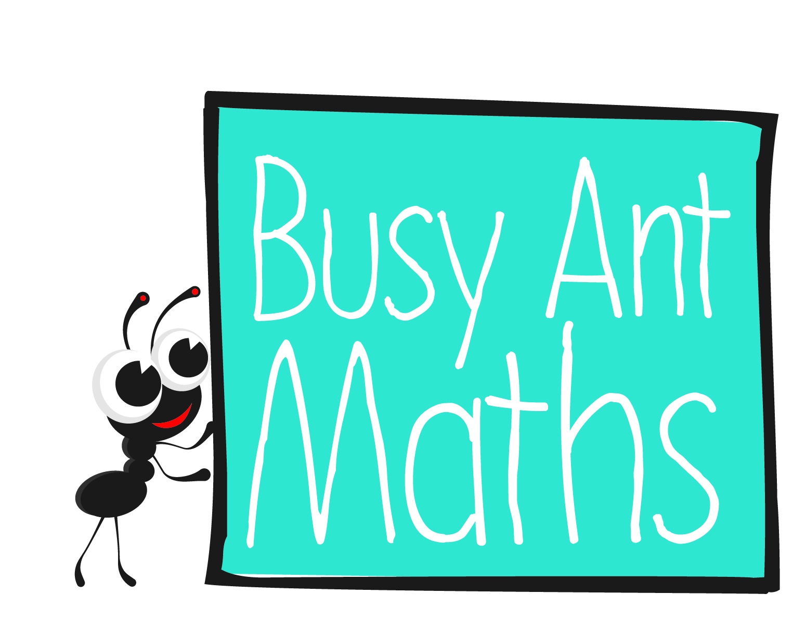
Primary 2
Maths
Newsletter 10
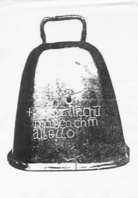
Date: ______________________ Name: ______________________
4

1
Multiplication and division
HERE’S THE MATHS
Your child has been learning about arrays as a way to represent counting in 2s, 5s
and 10s.

2 × 5 = 10 6 × 2 = 12 3 × 10 = 30
2 rows of 5 6 rows of 2 3 rows of 10

ACTIVITY
What to do
You will need:
- 30 small items as close to identical as possible (e.g. coins, buttons, dried beans or small building bricks)
- 13 small pieces of paper (with 10, 12, 14, 15, 16, 18, 20, 22, 24, 25, 26, 28, 30 written on them)
- small bag or box to hide the pieces of paper

- Put the pieces of paper in the small bag or box to hide them.
- Take turns to pick one of the pieces of paper out of the bag/box.
- Use the small objects to create an array to represent that total number.

QUESTIONS TO ASK
Is 2, 5 or 10 a multiple
of the number on your piece of paper?
How do you know?
In how many ways
can you show 10
as an array?
How can using arrays make it quicker
to count objects?

Multiplication and division
HERE’S THE MATHS
Your child has been sharing objects into equal groups and using this skill to solve problems involving sharing.

12
shared between shared between

2

is . is 6.

ACTIVITY
- Both write the numbers 2, 3, 4, 5 and 10 on pieces of paper in front of you.
You will need:
- pencil and paper
- 13 small pieces of paper (with 2, 4, 5, 6, 8, 9, 10, 12, 14, 15, 16, 18, 20 written on them)
- 20 small objects, such as coins, buttons, building bricks, dried beans (optional)
- Shuffle the number cards and place them face down in a pile in between you.
- The numbers on the individual cards are the number of objects to be shared. The numbers written on your piece of paper are the number of groups to share the objects into.
- Take turns to turn over the top card to reveal a number of objects. The player who turns over the card must then choose a group size to share the objects between.
- Say a sentence out loud: ‘X shared between Y is Z’.
- Cross the number of groups off your list if your sentence is correct.
- The player who is first to cross off all of the groups on their piece of paper, or has the most crossed off when all cards have been turned over, is the winner.
QUESTIONS TO ASK
What is X shared between Y groups?
How can you check that you have correctly shared the objects into equal-sized groups?
If I share X equally between Y groups, how many will there be in each group?
3
2

