Position and direction
HERE’S THE MATHS
Your child has been using the terms ‘around’, ‘near to’, ‘close to’ and ‘far from’ to position objects, such as:
- The square is near to the triangle.
- The circle is far from the square.
- The circle is around the rectangle.
- The cylinder is close to the cube.
MATHS TOPICS
These are the maths topics your child will be working on during the next three weeks:
- Number and place value
- Addition and subtraction
- Position and direction

KEY MATHEMATICAL IDEAS
During these three weeks your child will be learning to:
- recognise place value in numbers to up 40
- solve addition problems involving numbers to up 20
- use the terms ‘around’, ‘near to’, ‘close to’ and ‘far from’ to position objects.

TIPS FOR GOOD HOMEWORK HABITS
Don’t let homework become a chore. Make it a special time that both you and
your child look forward to. Offer lots of praise and support – and most importantly, have fun!
ACTIVITY
What to do
You will need:
- a collection of approximately 10 small everyday objects such as toys
- small table, rug or other defined area on which to place objects
- Take turns to give each other instructions for where to put each of the objects. Use the position terms ‘around’, ‘near to’, ‘close to’ and ‘far from’ as well as any others that are useful. Write any extra position terms on this sheet.
- Check that the other person has followed your instruction correctly even if it isn’t exactly where you would have placed the object!
Variation
- Look at an everyday arrangement of items
(e.g. a table laid for dinner, items around the edge of the bath, toys on the floor)
and challenge your child to use the position terms to describe where objects
are in relation to each other.
QUESTIONS TO ASK
What is around/near to/close to/far from X?
Put X around/near to/close to/far from X.
Where is X?
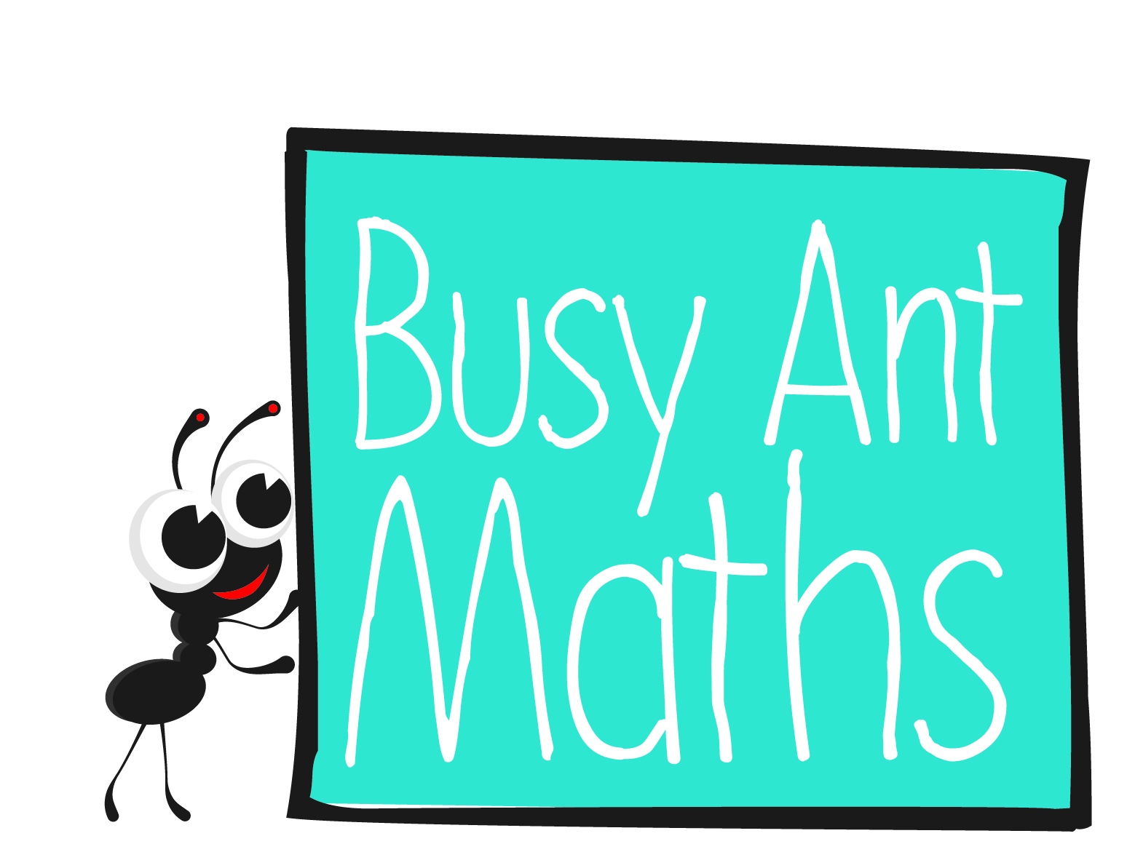
Primary 2
Maths
Newsletter 9
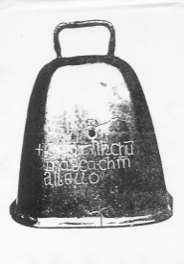
Move all of the objects so that they are as
close to/far from each other as possible.
Date: ______________________ Name: ______________________

Number and place value
HERE’S THE MATHS
Your child has been learning that 2-digit numbers are made up of tens and ones.
- The number 16 is made up of one ten (10) and six ones (6).
- The number 29 is made up of two tens (20) and nine ones (9).
ACTIVITY
You will need:
- 16 small pieces of paper
- pencil and paper
What to do
- Make one set of six cards with 1 ten, 2 tens and 3 tens written on individual pieces of paper, two of each. Make a second set of 10 cards with 0 ones, 1 one, 2 ones, 3 ones, up to 9 ones, written on individual pieces of paper.
- Shuffle each set of cards separately and place them face down in front of you.
- Take turns to turn over the top card from each pile and say the number that is made when the tens and ones are put together. Also write the number on a piece of paper for the other person to see. Score a point if you say and write the correct number.
- Put the used cards on separate discard piles. Reshuffle the tens cards when they have all been used so you can continue playing.
- The winner is the player with the most points after 10 turns.
Variation
- Look out for 2-digit numbers in everyday life (e.g. house numbers, the last two digits of telephone numbers stored in your mobile phone) and challenge your child to tell you how many tens and ones are need to make each 2-digit number.
QUESTIONS TO ASK
How many tens/ones are in that number?
Write the following numbers and then rewrite them in order from smallest to largest. 3 tens and 1 one,
1 ten and 6 ones,
2 tens and 3 ones.
Addition and subtraction
What number is one less/more than X?
How would you write that number using digits?
HERE’S THE MATHS
Your child has been learning number doubles for numbers up to 10 and using them
to help solve other addition problems.

1 + 1 = 2 2 + 2 = 4 3 + 3 = 6 4 + 4 = 8
9 + 9 = 18 10 + 10 = 20

If you know that 6 + 6 = 12 then it is simple to adjust one or both numbers to work out that 5 + 6 = 11, 5 + 7 = 12 and 6 + 7 = 13.
ACTIVITY
What to do
You will need:
- 21 number cards (numbered 0 to 20)
- Shuffle and spread out the number cards face up in front of you.
- Take turns to challenge the other player to make a total (any number from 1 to 20) using any two cards. If the cards make the correct total, the player keeps the cards. If the cards do not make the correct total, put them back on the table.
- The winner is the player with the most cards when all of the cards have been used.
Variation
- Challenge each other to make a given total using three cards. Use a timer to time how long it takes. Replace the cards after each turn and encourage your child to improve on their time with each turn.
QUESTIONS TO ASK
What do you have to add to X to make Y?
What double makes X?
(A double is two of the same number added together, e.g. 6 + 6 = 12.)
What near double could you use to make 13?
(A near double is an addition where the two numbers are nearly, but not quite the same,
e.g. 7 + 6 = 13.)
How else could you make the total X?

