Measurement
(volume and capacity)
HERE’S THE MATHS
Your child has been comparing the capacity of containers, for example:
- A cup holds less than a saucepan.
- A saucepan holds more than a cup.

Your child has been learning to compare and order containers according to their capacity. It is important that they can choose a suitable non-standard measure
(such as a spoon or cup) and use it consistently (full, not part or half full) to compare the capacities of different containers.
MATHS TOPICS
These are the maths topics your child will be working on during the next three weeks:
- Number and place value
- Fractions
- Measurement (volume and capacity)

KEY MATHEMATICAL IDEAS
During these three weeks your child will be learning to:
- compare and order numbers to 20; write the numbers 0–20 in words
- recognise and find one quarter of an object, shape or quantity, understanding that it is one of four equal parts
- compare and order containers based on their capacities.

TIPS FOR GOOD HOMEWORK HABITS
Once your child has finished their homework, discuss with them what they have learnt and whether it was easy or hard.
ACTIVITY
You will need:
- a range of kitchen containers such as spoons, cups, bowls, jugs, saucepans, buckets
- kitchen sink
What to do
- Give your child a range of containers and encourage them to choose the smallest one to use as a measuring device for the larger containers.
- Work with them to test how many cups full of water, for example, it takes to fill each of the containers.
As they work through the containers, make notes on paper and begin to place the containers in size order.
Variation
- Challenge your child to organise the containers into two groups: one where they think the containers will hold less than 1 litre and the other where they think the containers will hold more than 1 litre. Give your child a litre jug or container to test their predictions by pouring 1 litre of water into each of the containers.
QUESTIONS TO ASK
Which container holds the least/most water?
Which container has the smallest/largest capacity?

How many spoons of water does the cup hold?
How many cups of water does the saucepan hold?
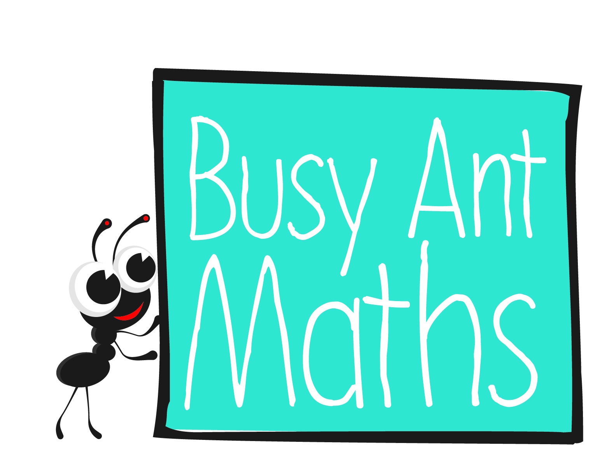
Primary 2
Maths
Newsletter 8
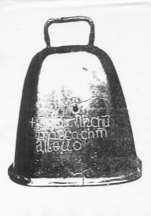
Date: ______________________ Name: ______________________

Number and place value
HERE’S THE MATHS
Your child has been learning to compare numbers using the phrases ‘less than’ and ‘more than’, for example:
8 is less than 12 14 is 1 less than 15 9 is more than 5 but less than 10
6 is more than 3 19 is 1 more than 18 11 is more than 10 but less than 15

They have also been ordering numbers.
17, 3, 13 in order gives 3, 13, 17
12, 19, 15 in order gives 12, 15, 19
ACTIVITY
What to do
You will need:
- 21 small pieces
of paper (3 × 7 arrangement)
- pencil
- Write each of the numbers 0 to 20 on small pieces
of paper. Shuffle them and spread them out, face down in front of you.
- Take turns to turn over two cards and compare the two numbers using descriptions like the ones shown above.
- For each turn, a maximum of 3 points may be scored (1 point for each of 3 correct comparison sentences).
- After each turn, replace the number cards and move all of the cards around to shuffle them.
- Set a time limit on the game or play for a chosen number of turns. The winner is the player with the most points at the end of the game.
Variation
- Take turns to reveal three cards and put them in order from smallest to largest.
Score 1 point for correctly ordered numbers.
QUESTIONS TO ASK
Which is the smaller/smallest/bigger/biggest number?
Which numbers are more than X but less than Y?
What is 1 less/more than X?

Fractions
HERE’S THE MATHS
One quarter ( $\frac{1}{4}$) is one of four equal parts. The word equal is very important!

One quarter of 8 is 2

2 + 2 + 2 + 2 = 8

Something has only been split into quarters if all four parts are exactly the same size.
ACTIVITY
What to do
You will need:
- ribbon, string or paper
- ruler
- pen or pencil
- scissors (close supervision needed)
- Prepare lengths of ribbon, string or paper that are
4 cm, 8 cm, 12 cm, 16 cm and 20 cm long.
- Ask your child to measure one piece using the ruler and work out one quarter of the length. Encourage them to check that they have calculated one quarter correctly by adding together their answer
4 times – the answer should be the original length.
- Your child should then measure one quarter of the length and make a mark. They should then measure another quarter from that mark and repeat for a third time.
- Ask your child to check that the final quarter is the same length as the other 3 measured quarters. They should check their calculation and measuring if not!
- Once the ribbon, string or paper is marked into quarters your child should cut along the marks.
- Line the pieces up next to each other to show that there are four equal quarters.
- Repeat with other lengths.
QUESTIONS TO ASK
What is one quarter of X (where X is a multiple of 4 up to 20: 4, 8, 12, 16, 20)?
How many quarters are there in 2/3/4 etc. whole ones?
How can you check whether or not you’ve correctly worked out one quarter?

