Measurement (time)

HERE’S THE MATHS

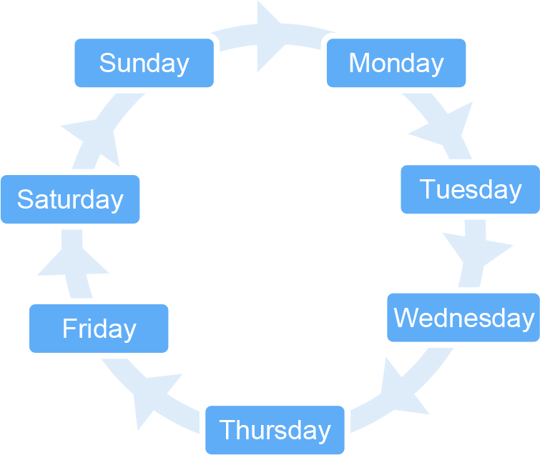Your child has been learning to order the days of the week, months of the year and seasons of the year. They have been taught that the days, months and seasons can be laid out in a circle to show that, for example, Monday follows Sunday, January follows December and spring follows winter.

MATHS TOPICS

These are the maths topics your child will be working on during the next three weeks:

* Addition and subtraction
* Measurement (time)

KEY MATHEMATICAL IDEAS

During these three weeks your child will be learning to:

* add and subtract numbers to 10, including adding doubles and finding pairs   
  of numbers that total 10
* identify related addition and subtraction facts
* add and subtract numbers to 15 and solve missing number problems using   
  a number track
* order days of the week, months of the year and seasons of the year.

TIPS FOR GOOD HOMEWORK HABITS

If your child is struggling with a task, don’t give them the answer in order to get the homework finished. Instead, talk through the task with your child and help them to arrive at the solution themselves.

ACTIVITY

What to do

You will need:

* 23 small pieces of paper
* timer (or phone with timer) – optional
* Create three sets of cards by writing the relevant words on pieces of paper: one set for days of the week, one set for months of the year and one set for seasons of the year.
* Choose one set to play the game. Shuffle the cards and hold them, spread out, for your child   
  to pick one card.
* Your child places that card down in front of them and must then arrange the rest of the set in a circle to show the order of the days/months/seasons.

QUESTIONS TO ASK

Which days of the week do you go   
to school?

What do you do   
on Saturdays?

When do we celebrate Christmas/Eid/Diwali/Yom Kippur/Wesak/Vaisakhi?

What is the weather usually like in X?

Which day/month/

season comes before/after X?

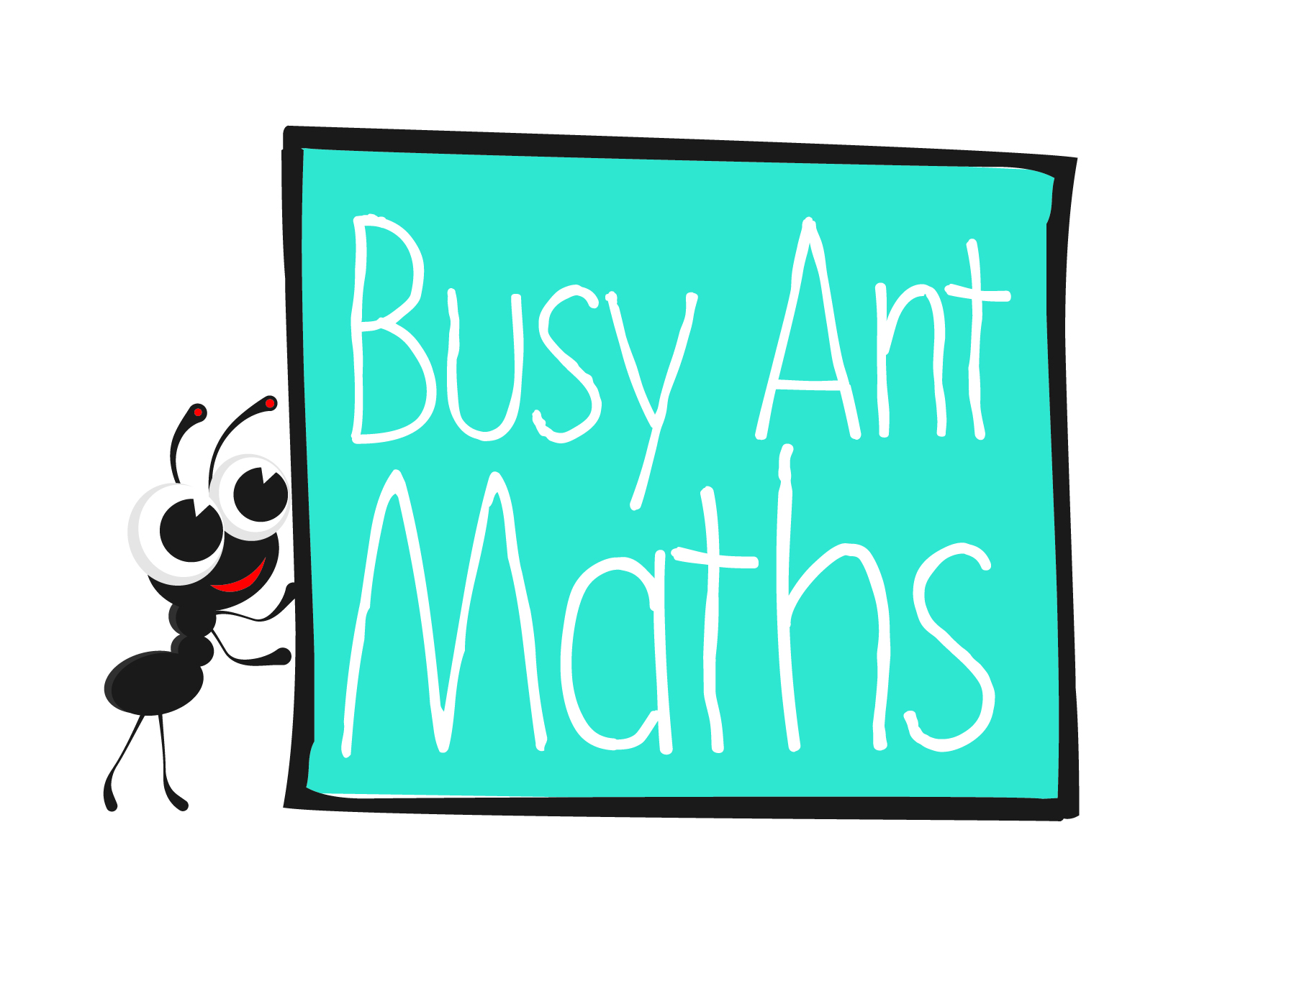Primary 2  
Maths  
Newsletter 7

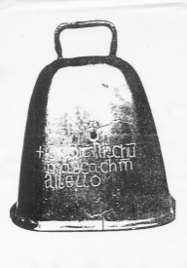

Date: ______________________ Name: ______________________

Addition and subtraction

HERE’S THE MATHS

Your child has been working with addition and subtraction involving numbers up to 10, such as: 6 + 3 = 9 2 + 5 = 7 8 − 3 = 5 6 − 4 = 2

This includes pairs of numbers that add up to make 10 and addition doubles up to a total of 10, such as:

1 + 9 = 10 2 + 8 = 10 3 + 7 = 10 4 + 6 = 10 etc.

1 + 1 = 2 2 + 2 = 4 3 + 3 = 6 4 + 4 = 8 etc.

Your child has also been introduced to the idea of related addition and subtraction facts where the same three numbers make an addition fact and can be rearranged to make subtraction facts. 7 + 2 = 9 or 2 + 7 = 9 9 − 7 = 2 or 9 − 2 = 7

ACTIVITY

What to do

You will need:

* 22 small pieces of paper with the numbers 0 to 10 written twice
* 6 small pieces of paper with the symbols +, −, = written twice
* Shuffle the 22 numbers and place them face down. Keep a set of +, − and = each next to you.
* Take turns to turn over and take the top number from the pile.
* Keep the numbers face up in front of you in a line. When you see that you can make a complete addition/subtraction fact, call out ‘equals’, for example, 6, 4, 2.
* Make an addition/subtraction fact in front of you using the numbers and symbols:   
  6 – 4 = 2. Read the fact aloud, then rearrange the numbers to make a related addition/subtraction fact (using the other symbol to the first calculation),   
  e.g. 4 + 2 = 6.
* Score a point if both facts are correct. Put the cards aside so they aren’t reused.
* Make as many addition and subtraction facts during the game as possible.
* The winner is the player with the most points when all of the pieces of paper have been taken.

QUESTIONS TO ASK

How can you rearrange that addition/subtraction fact to make another subtraction/addition fact?

What do you need to take away from X to make Y?

What do you need to add to X to make Y?

Addition and subtraction

HERE’S THE MATHS

Your child has been adding and subtracting numbers up to 15 and using the symbols +, − and =. For example, 10 + 1 = 11 4 + 9 = 13 14 − 7 = 7 15 − 9 = 6

They can use a number track to count on or back.



They can also solve missing number problems by counting on or back on a number track. 6 + ⬜ = 10 7 + ⬜ = 12 13 − ⬜ = 6 11 − ⬜ = 4

ACTIVITY

What to do

You will need:

* pencil and paper
* 2 counters
* 20 small pieces of paper
* 1–6 dice
* On a piece of paper, draw a simple zigzag game board with 20–25 numbered squares (as shown below).
* 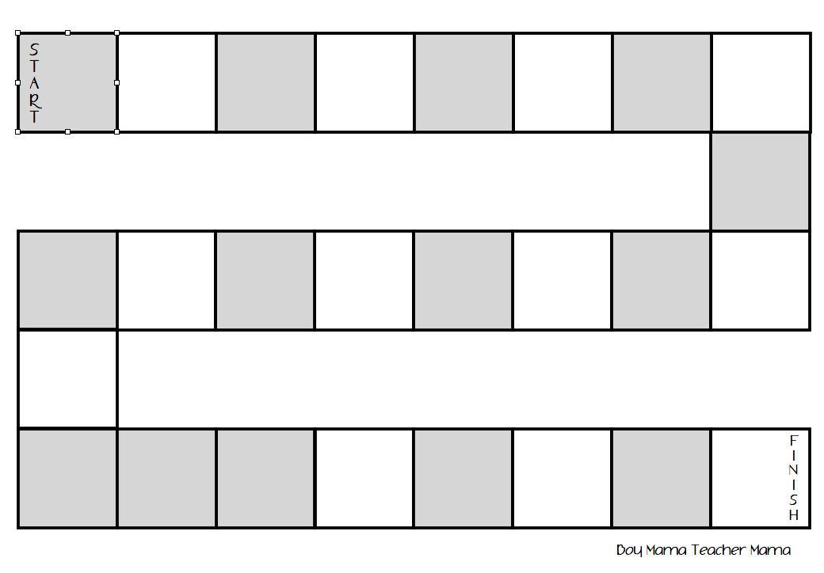Write 10 addition questions (answers up to 15) and 10 subtraction questions (largest number 15) on the small pieces of paper. Draw a blank box for the answer: 7 + 4 = ⬜ / 14 − 5 = ⬜
* Shuffle the 20 question cards and place them face down next to the game board.
* Put both counters at the beginning of the board.
* Take turns to pick up the top card and work out the answer (use the number track on this page, if needed). If the answer is correct, the player rolls the dice and moves their counter that number of squares along the board. If the answer is incorrect, the player does not roll the dice.
* The winner is the first player to reach the finish. Reshuffle the question cards if needed.

QUESTIONS TO ASK

What do you need to add to X to make Y?

What is X take away/subtract Y?

How can you (use the number track to) work out the missing number?