Measurement (time)

HERE’S THE MATHS

Your child has been learning about what they can do in one minute and one hour so that they understand how long both periods of time are. There are:

* 60 seconds in one minute
* 60 minutes in one hour.

ACTIVITY

MATHS TOPICS

These are the maths topics your child will be working on during the next three weeks:

* Multiplication and division
* Fractions
* Measurement (time)

KEY MATHEMATICAL IDEAS

During these three weeks your child will be learning to:

* work out doubles, halves and quarters of numbers
* recognise and find halves and quarters of objects and shapes
* find out how many things they can do in one minute.

TIPS FOR GOOD HOMEWORK HABITS

Encourage your child to ask questions if they don’t understand the task or want   
to know more.

What to do

You will need:

* clock (with a seconds hand), watch or timer
* pencil and paper
* Challenge your child to estimate how many of a particular activity they think they’ll be able to complete in one minute. Then time them while they complete one minute of the given activity. Compare their estimate with the actual result.
* Activities could include:
* writing their name
* star jumps
* touching their heads, shoulders, knees and toes in order
* drawing a tree
* jumps on a trampoline
* swings on a swing
* walking from one end of the room to the other.

Variation

* Explore what can be done in one hour by setting a timer at the beginning   
  of a family activity.

QUESTIONS TO ASK

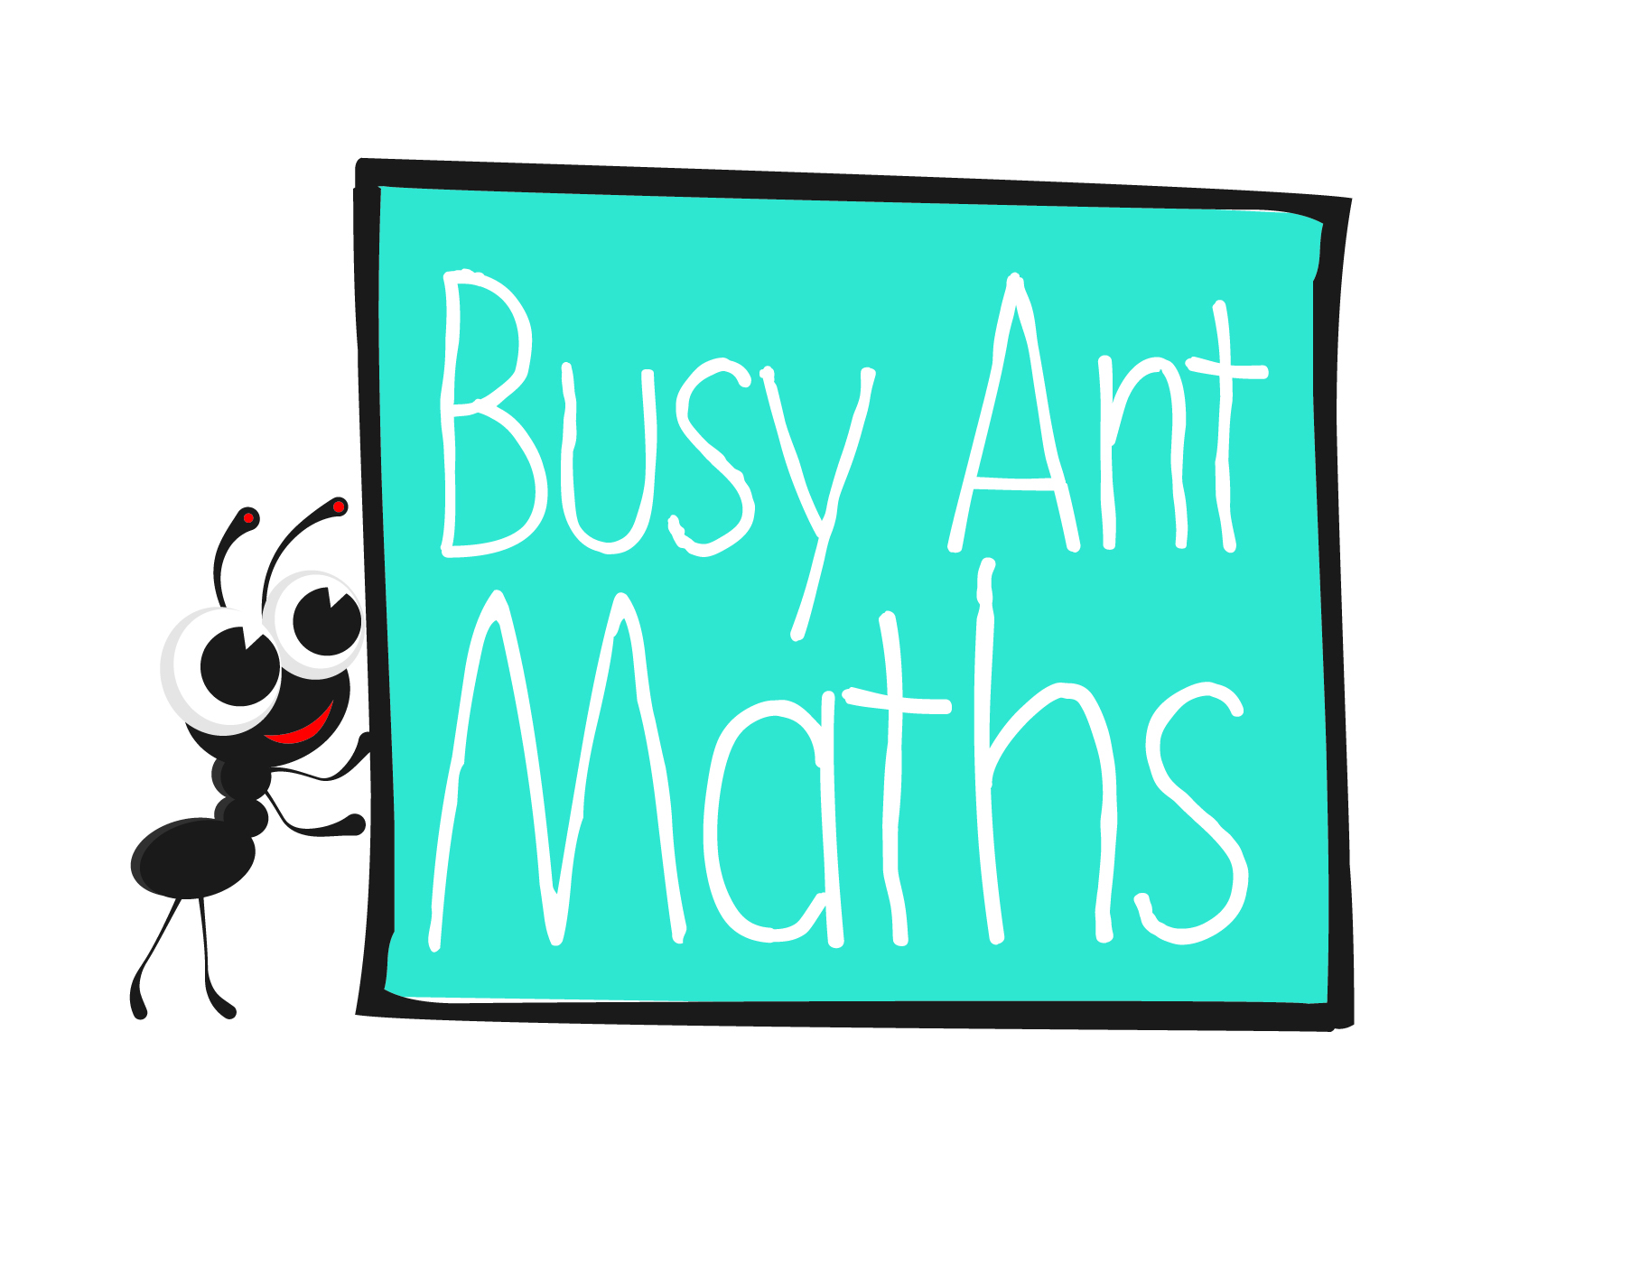Primary 2

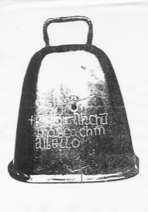

Did you complete more or less in one minute than you thought you would?

How many minutes are there in one hour?

How many seconds are there in one minute?

What other activities could you complete many times in one minute?

Maths  
Newsletter 12

Date: ______________________ Name: ______________________

Multiplication and division

HERE’S THE MATHS

Your child has been learning to work out double, half and quarter of numbers.

To double: Add the same number to itself.

Double 5 is 10.

To halve: Share the number into two **equal** groups.

One half of 6 is 3.

To quarter: Share the number into four **equal** groups.

One quarter of 8 is 2.

ACTIVITY

You will need:

* 1–6 dice
* 2 counters
* pencil and paper
* 27 small pieces of paper (with these words/numbers written on them: ‘double’ followed by the numbers 1 to 10, ‘half’ followed by even numbers 2 to 20, ‘quarter’ followed by 4, 8, 12, 16, 20, 24 and 28)

What to do

* On a plain piece of paper, draw a simple zigzag game board with 20–25 numbered squares as shown below.
* Shuffle the 27 question cards and place them face down.
* Put both counters at the beginning of the game board.
* 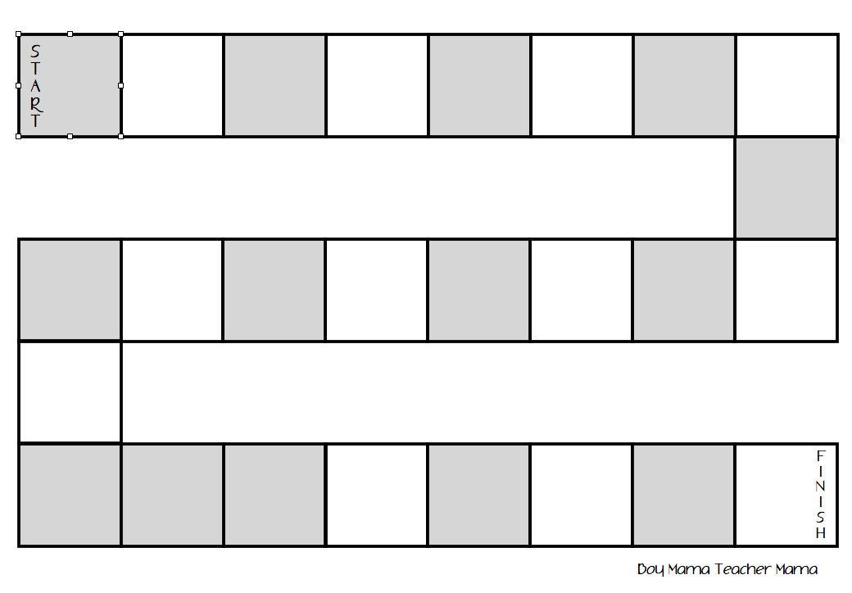Take turns to pick up the top card and work out the answer to the question. If the question is answered correctly, the player rolls the dice and moves their counter that number of squares along the board. If the answer is answered incorrectly, the player does not roll the dice or move their counter.
* The winner is the first player to reach the finish.   
  Reshuffle the question cards if more are needed.

QUESTIONS TO ASK

How can you use finding one half to also work out one quarter? (Work out half and then work out half of the answer.)

What can you draw to help you work out the answer?

What is double/  
one half of/  
one quarter of X?

Fractions

HERE’S THE MATHS

Your child has been learning about halves and quarters of different shapes.

Y1 Newsletters 12d.jpg1 whole

Y1 Newsletters 12e.jpg2 halves

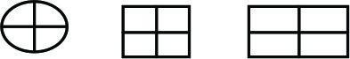

4 quarters

ACTIVITY

What to do

You will need:

* pencil and paper
* colouring pencils or crayons
* circular object to draw around so that 4 circles will fit onto a piece of paper
* ruler or other straight edge to draw along
* 2 pieces of paper (with written on one of them and written on the other one)
* small bag or box to hide the two fraction cards
* Each draw 4 circles on your paper and then divide them into halves and quarters as shown here. Turn them into flowers with a stem and leaves or a lollipop on a stick if you would like to!
* Check that your child recognises the and fraction symbols and can relate them to the circle quarters and halves.
* Take turns to draw a fraction card out of the bag and colour one quarter or one half of a circle.
* The winner is the first player to completely colour all four flowers.

Variation

* Play again using squares or rectangles divided into halves and quarters.

QUESTIONS TO ASK

How do you write that fraction symbol?

How many quarters/halves make one whole?

How do you say that fraction   
in words?