Measurement (time)
HERE’S THE MATHS
At this stage, your child is learning to tell the time using an analogue clock, as shown here, rather than a digital clock.
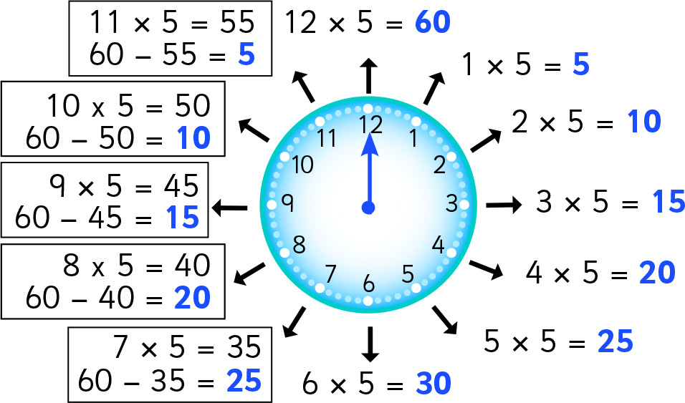

MATHS TOPICS
These are the maths topics your child will be working on during the next three weeks:
- Multiplication and division
- Fractions
- Measurement (time)

KEY MATHEMATICAL IDEAS
During these three weeks your child will be learning to:
- recognise multiples of 2, 5 and 10
- recognise and find fractions of a set of objects
- tell the time to five minutes.

TIPS FOR GOOD HOMEWORK HABITS
Encourage your child to ask questions if they don’t understand a task in their homework or want to know more.

Any time up to and including half past is described as being ‘past’ the hour. Any time after half past is described as being ‘to’ the next hour.
ACTIVITY
What to do
You will need:
- watch or clock with a timer
- analogue watch or clock
- Set a timer on your watch or clock to go off at various five-minute intervals during the day. Ask your child to use an analogue watch or clock to tell you what the time is when the timer goes off.
Variation
- Include ‘o’clock’, ‘half’, ‘quarter past’ and ‘quarter to’ times to reinforce previous learning.
QUESTIONS TO ASK
How do you know whether you need to say ‘past’ an hour or ‘to’ an hour?
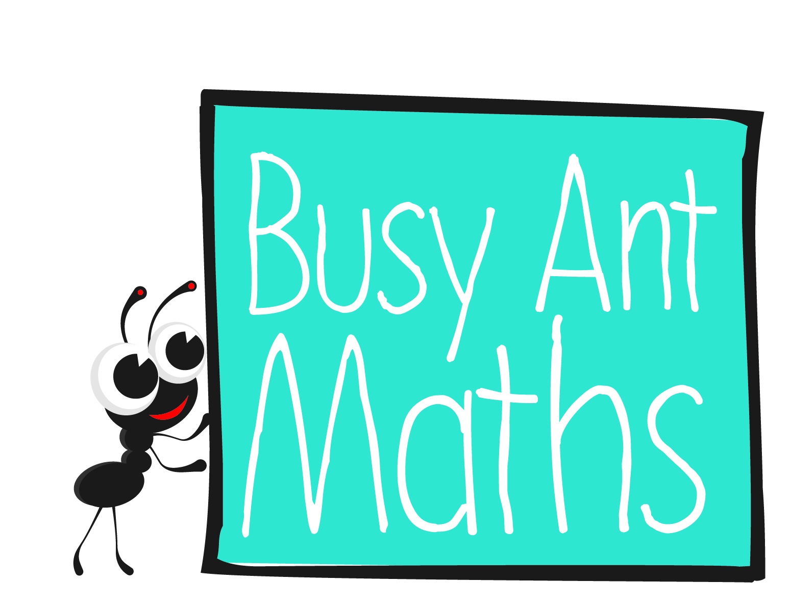
Primary 3
Maths
Newsletter 12
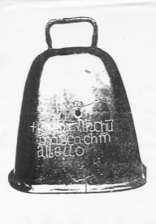
Where does the big hand point when it is 5/10/20/25 past the hour?
How do you know which hour number is needed?
Where does the big hand point when
it is 5/10/20/25 to the hour?
Date: ______________________ Name: ______________________

Multiplication and division
HERE’S THE MATHS
- Multiples of 2 have an even number of ones, so the number must end in 0, 2, 4, 6
or 8, e.g. 12, 36, 58, 70, 84.
- Multiples of 5 have 0 or 5 ones, e.g. 15, 40, 75.
- Multiples of 10 must have 0 ones, e.g. 20, 50, 80.
So, numbers ending in 0 are multiples of 2, 5 and 10.
ACTIVITY
What to do
You will need:
- 20 small pieces of paper (0 to 9 written on 10 pieces for the ones set and 1 to 9 plus a blank piece for the
tens set)
- pencil and paper
(per person)
- timer (or phone with timer)
- Write four headings on your piece of paper: ‘multiples of 2’, ‘multiples of 5’, ‘multiples of 10’ and ‘not a multiple of 2, 5 or 10’.
- Shuffle the two sets of pieces of paper and put them face down in front of you.
- Take turns to reveal the top card on each pile and put them side by side away from the pile to show a 2-digit number (or 1-digit if the blank card has been turned over for the tens). Repeat until one 1-digit and nine 2-digit numbers have been created.
- Set a timer for 30 seconds and write each of the
10 numbers under at least one of the headings.
- Swap pieces of paper and check each other’s working, giving 1 point for every correctly placed number. The winner is the player with the most points.
Variation
- Increase the time allowed to 45 seconds or 1 minute if needed.
- Subtract 1 point for every incorrectly placed number.
QUESTIONS TO ASK
How many ones can a multiple of 2/5/10 have?
Tell me five multiples of 2/5/10 that are less than 100.
How do you know whether that number is a multiple of 2/5/10 or not?
Fractions
How many ones are there in numbers that aren’t a multiple of 2, 5 or 10?
HERE’S THE MATHS
$\frac{1}{4}$ of 8 = 2 $\frac{1}{3}$ of 15 = 5 $\frac{1}{2}$ of 10 = 5 $\frac{3}{4}$ of 12 = 8

ACTIVITY
What to do
You will need:
- 24 very similar small objects such as buttons or dried beans
- 8 small pieces of paper ($\frac{1}{2}$ of 6,
$\frac{1}{2}$ of 18, $\frac{1}{4}$ of 16, $\frac{1}{4}$ of 24, $\frac{1}{3}$ of
12, $\frac{1}{3}$ of 21, $\frac{3}{4}$ of 8, $\frac{3}{4}$ of 20
written on them)
- Shuffle the pieces of paper and put them face down in a pile.
- Take turns to turn over the top piece
of paper, count out the total number of objects and then create the fraction shown.
- Keep the piece of paper if you both agree the answer is correct. Return the piece
of paper to the bottom of the pile if the answer is incorrect.
- The winner is the player with the most pieces of paper when there is none left in the pile.
QUESTIONS TO ASK
What is $\frac{1}{2}$, $\frac{1}{4}$, $\frac{1}{3}$ or $\frac{3}{4}$ of X?
What fraction of all of the objects is in this group?
Which numbers can be split into halves/quarters/thirds? (multiples of 2/4/3)
How many buttons/beans would each person have if you shared them equally between 2/3/4 people?

