Statistics

HERE’S THE MATHS

A pictogram uses pictures to represent data. The picture used for a pictogram usually relates to the data that has been collected.

20 children were asked which of these ice-cream flavours is their favourite.

|  |  |
| --- | --- |
| **Flavour** | **Number of children who chose the flavour** |
| Vanilla | https://cdn3.iconfinder.com/data/icons/snack-time/400/snack_time-29-512.pnghttps://cdn3.iconfinder.com/data/icons/snack-time/400/snack_time-29-512.pnghttps://cdn3.iconfinder.com/data/icons/snack-time/400/snack_time-29-512.pnghttps://cdn3.iconfinder.com/data/icons/snack-time/400/snack_time-29-512.pnghttps://cdn3.iconfinder.com/data/icons/snack-time/400/snack_time-29-512.png |
| Chocolate | https://cdn3.iconfinder.com/data/icons/snack-time/400/snack_time-29-512.pnghttps://cdn3.iconfinder.com/data/icons/snack-time/400/snack_time-29-512.pnghttps://cdn3.iconfinder.com/data/icons/snack-time/400/snack_time-29-512.pnghttps://cdn3.iconfinder.com/data/icons/snack-time/400/snack_time-29-512.pnghttps://cdn3.iconfinder.com/data/icons/snack-time/400/snack_time-29-512.pnghttps://cdn3.iconfinder.com/data/icons/snack-time/400/snack_time-29-512.pnghttps://cdn3.iconfinder.com/data/icons/snack-time/400/snack_time-29-512.pnghttps://cdn3.iconfinder.com/data/icons/snack-time/400/snack_time-29-512.png |
| Strawberry | https://cdn3.iconfinder.com/data/icons/snack-time/400/snack_time-29-512.pnghttps://cdn3.iconfinder.com/data/icons/snack-time/400/snack_time-29-512.pnghttps://cdn3.iconfinder.com/data/icons/snack-time/400/snack_time-29-512.pnghttps://cdn3.iconfinder.com/data/icons/snack-time/400/snack_time-29-512.png |
| Mint choc chip | https://cdn3.iconfinder.com/data/icons/snack-time/400/snack_time-29-512.pnghttps://cdn3.iconfinder.com/data/icons/snack-time/400/snack_time-29-512.pnghttps://cdn3.iconfinder.com/data/icons/snack-time/400/snack_time-29-512.png |

ACTIVITY

**What to do**

You will need:

* pencil and paper
* ruler
* Collect data and create a pictogram for the cutlery (forks, knives and spoons) found in your kitchen. You could use fork, knife and spoon symbols.
* Encourage your child to ask and answer questions about their pictogram.

Variation

* Collect information about different topics and create pictograms using different, relevant symbols. For example:
* colours of cars that drive past your house in X minutes or are parked in your road
* types or colours of clothes in a wardrobe
* colours of front doors
* coins in a purse.

QUESTIONS TO ASK

Which X was the least/most popular?

How many children gave the two least/most popular answers?

How many fewer/more children said   
X than Y?

How many children said X?

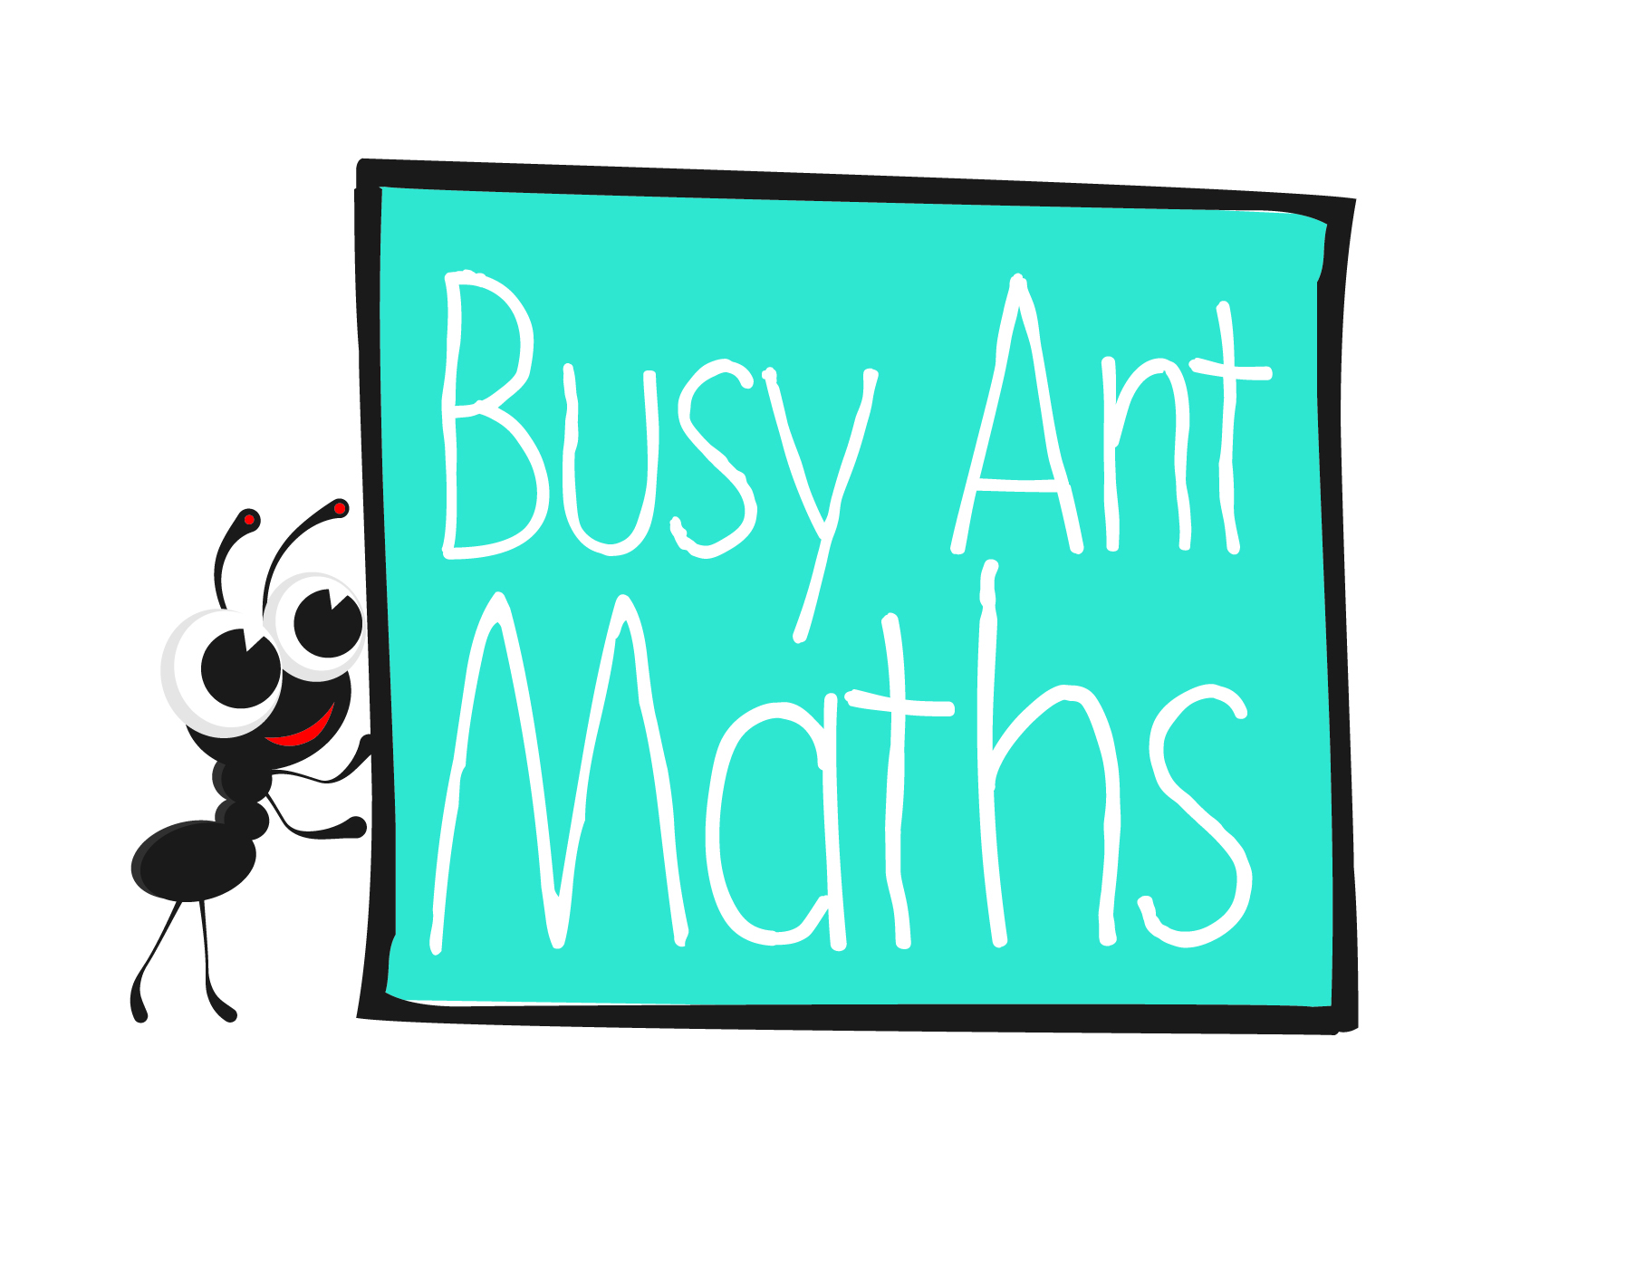  
Maths   
Newsletter 11

Primary 3

I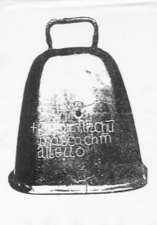nsert   
school logo   
here

Insert   
school logo   
here

Date: ______________________ Name: ______________________

MATHS TOPICS

These are the maths topics your child will be working on during the next three weeks:

* Addition and subtraction
* Statistics

KEY MATHEMATICAL IDEAS

During these three weeks your child will be learning to:

* add and subtract two 2-digit numbers using partitioning
* add and subtract two 2-digit numbers using a written method
* construct a simple pictogram and ask and answer questions from the information collected.

TIPS FOR GOOD HOMEWORK HABITS

Once your child has completed their homework, congratulate them on something they did really well – for example, if they sat down and got on with their work really sensibly; kept going even though they found parts of it really challenging; asked for help when they needed it, or followed the instructions carefully.

Addition and subtraction

HERE’S THE MATHS

Partitioning a 2-digit number means splitting it into tens and ones. Partitioning 58 gives 50 and 8.

Addition using partitioning: 37 + 26 = 30 + 20 + 7 + 6 or 37 + 26 = 37 + 20 + 6

= 50 + 13 = 57 + 6

= 63 = 63

Subtraction using partitioning: 78 – 34 = 78 − 30 − 4

= 48 − 4

= 44

ACTIVITY

**What to do**

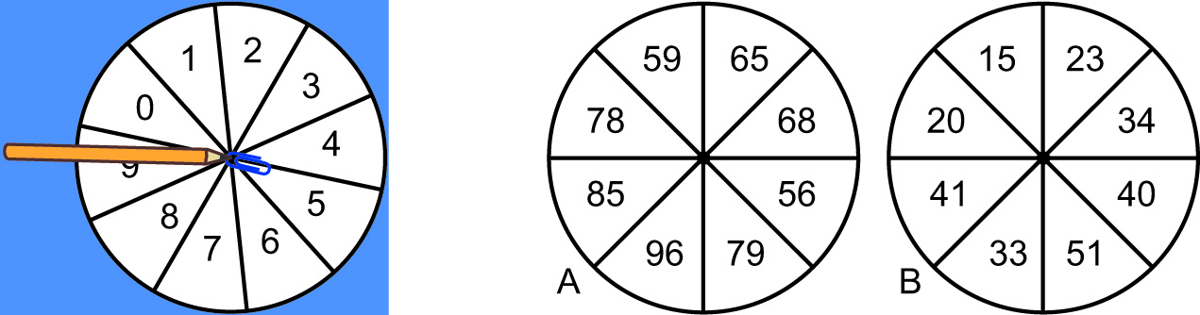

You will need:

* paper clip
* pencil and paper
* Choose whether to play an addition or subtraction game. Copy the relevant pair   
  of spinners onto a piece of paper, making them large enough to use as spinners.   
  Use the paper clip and pencil as shown in the picture above to create a spinner.
* Take turns to use the spinner on both circles to generate two numbers.
* Write down the calculation to add or subtract (A − B) the two numbers using one   
  of the methods shown on this page. Score one point for each correct answer.
* The winner is the player with the most points after 5 minutes.

Variation

* Change the numbers on the spinners but make sure that the biggest number on spinner B is smaller than the smallest number on spinner A.

QUESTIONS TO ASK

What do you get if you partition the number 37?

How did you add those two numbers together?

How did you subtract those two numbers?

What is X add/subtract Y?

Addition and subtraction

HERE’S THE MATHS

Partitioning a 2-digit number means splitting it into tens and ones. Partitioning 58 gives 50 and 8.

Your child has learnt how to add and subtract two 2-digit numbers using written methods:

Addition 37 + 45: 30 + 7 or 37 Subtraction 58 − 13: 58

40 + 5 + 45 − 13

70 + 12 = 82 12 45

70

82

ACTIVITY

You will need:

* 1–6 dice
* pencil and paper (each)

|  |  |  |  |
| --- | --- | --- | --- |
| **Number 1** | | **Number 2** | |
| (tens) | (ones) | (tens) | (ones) |
|  |  |  |  |

**What to do**

* Decide whether to play an addition or subtraction round of the game.
* Take turns to roll the dice four times. Write down the four numbers in the four boxes and decide how to use them to create two 2-digit numbers. (For subtraction, the number of tens in Number 2 must be less than the number of tens in Number 1 and likewise for the number of ones. Take Number 2 away from Number 1.)
* Both use a written method to work out the answer to the question. The person who writes out their workings and gets the correct answer first scores a point.
* The winner is the person with the most points after 5 minutes or 5 calculations.

Variation

* Generate 5 or 10 questions and challenge each other to write workings and work out the answers as quickly as possible.

QUESTIONS TO ASK

What do you get   
if you partition the number 31?

How did you   
add those two numbers together?

What is X add/subtract Y?

How did you subtract those two numbers?