Position and direction
HERE’S THE MATHS
Your child has been learning to follow and write directions involving right-angle turns clockwise and anti-clockwise.

is clockwise is anti-clockwise

For example:
- Go forward 4 squares from Start.
- Make 1 right-angle turn clockwise.
- Go forward 2 squares.
- Make 1 right angle turn clockwise.
- Go forward 3 squares.
- Make 1 right-angle turn anti-clockwise.
- Go forward 2 squares.
- Make 1 right angle turn clockwise.
- Go forward 1 square to arrive at the flag.
Start

ACTIVITY
What to do
- Direct a robot! Take turns to give directions to the other person as if they were a robot.
- Give one direction at a time to move the other person from one position in a room to another position in the same room, to move from one room to another or from one position outside of the house to another position nearby.
Variation
- Plan and write down a set of directions in advance (agree on a stride length). Read them out to your partner and ask them to predict where they will end up if they follow the directions correctly. Check to see whether they guess correctly by reading out the directions again but one at a time so that the other person can carry out each movement.
QUESTIONS TO ASK
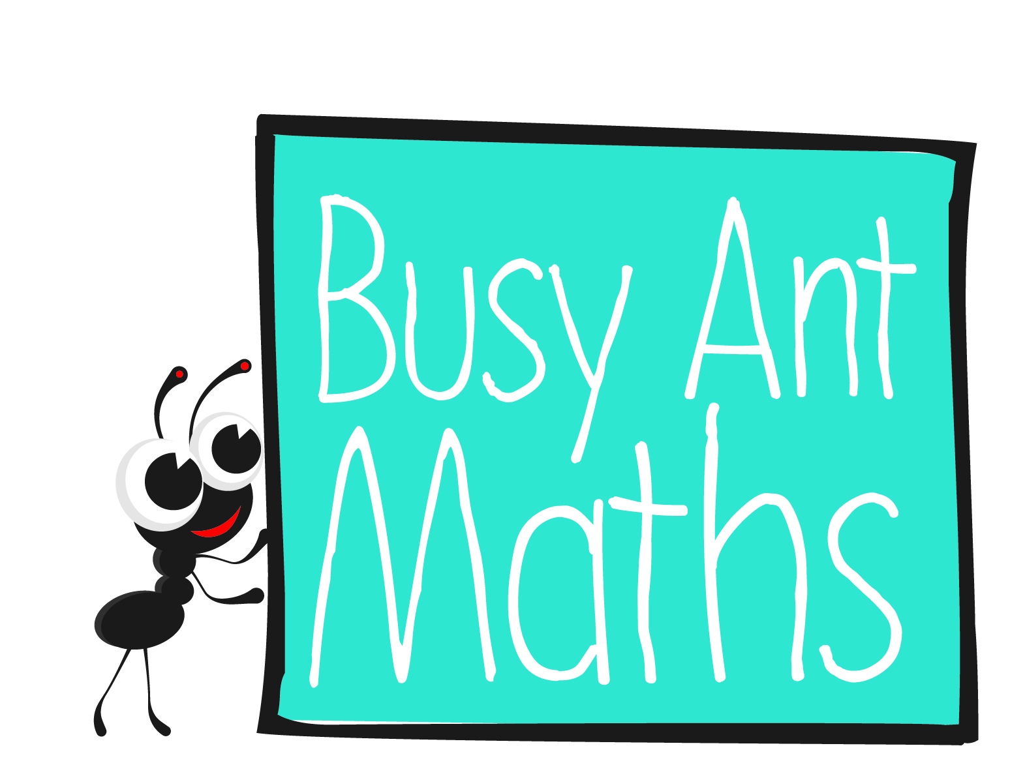
Primary 3
Maths
Newsletter 9
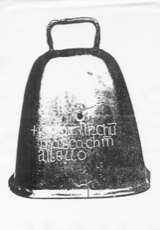
Which direction is clockwise/anti-clockwise?
Where do you think you will end up if you follow the directions?
How many right-angle turns make one whole turn?
What directions are needed
to get from X to Y?
Date: ______________________ Name: ______________________

MATHS TOPICS
These are the maths topics your child will be working on during the next three weeks:
- Number and place value
- Addition and subtraction
- Position and direction

KEY MATHEMATICAL IDEAS
During these three weeks your child will be learning to:
- order numbers to 100 and use the <, > and = signs
- add and subtract two 2-digit numbers
- follow and write directions.

TIPS FOR GOOD HOMEWORK HABITS
Don’t let homework become a chore. Make it a special time that both you and
your child look forward to. Offer lots of praise and support – and most importantly,
have fun!

Number and place value
HERE’S THE MATHS
< means ‘less than’ > means ‘greater than’ = means ‘equals' or 'is equal to’

The wider part of < and > belongs next to the larger number and the narrow point belongs next to the smaller number, e.g. 2 < 4 (two is less than four) and 4 > 2
(four is greater than two).
ACTIVITY
You will need:
- pencil and paper
- timer (or phone with timer)
What to do
- Write 10 random numbers between 0 and 100 on a piece of paper. They should be dotted around the page so that they are not in any particular order. Two of the numbers should
be the same.
- In one minute, both write as many number comparisons using <, > and = as possible.
- Check each other’s answers. The winner is the player with the most correct comparisons.
Variation
- Write the 10 numbers in order from smallest to largest and time how long it takes.
Try to beat the time with 10 different numbers.
QUESTIONS TO ASK
How do you know which number is smaller/larger out of two numbers?
How do you know which symbol to use?

Which is the smallest/largest number?
Which number(s) are less/greater than X?

- Ask more questions like these and ask your child to make up questions to ask you.
Addition and subtraction
HERE’S THE MATHS
Your child has been learning to add and subtract two 2-digit numbers by separating the tens and ones and counting them on or back separately.
12 + 25 = 37 26 − 14 = 12

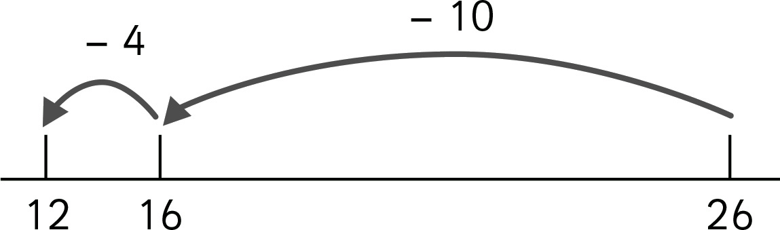
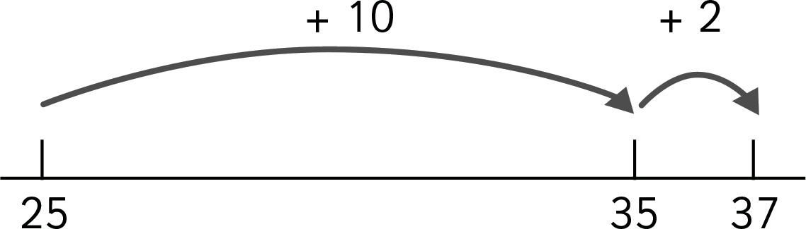

ACTIVITY
What to do
You will need:
- 10 small pieces of paper
(0 to 9 written on them)
- pencil and paper (each)
- Before you begin, decide whether to play an addition or subtraction game and whether the smallest or biggest answer wins.
- Shuffle and spread out the number cards face down in front of you.
- Both players choose four number cards and then arrange them to make two 2-digit numbers that they can then add or subtract, e.g. if a player has 2, 8, 4 and 3, they could make 24 + 38 for their smallest total, 82 + 43 for their biggest total, 42 − 38 for their smallest subtraction answer or 84 − 23 for their biggest subtraction answer.
- Encourage your child to use the methods shown on this page to help them add or subtract.
- The player who makes the smallest/biggest answer wins the round and scores one point.
- Return the number cards to the table, shuffle them and play again. The overall winner is the player with the most points after 5 minutes or 5 rounds.
QUESTIONS TO ASK
How did you work out your smallest/biggest total/answer?
What is X add/subtract Y? How did you work it out?
How else could you arrange the four numbers?
What is the smallest/biggest total/answer you could make using these four numbers?

