Measurement
(volume and capacity)
HERE’S THE MATHS
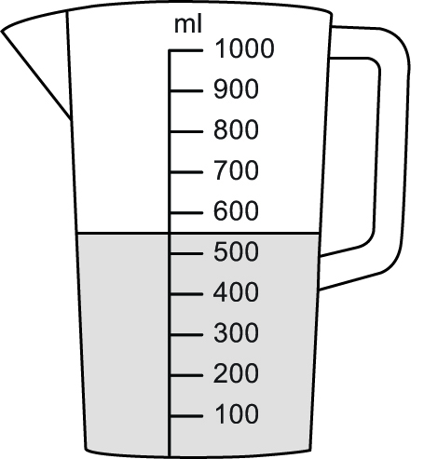
Your child has been reading the scale on measuring jugs
(to the nearest 100 ml). They have also been learning to compare containers and, without measuring, decide whether they hold more or less than 1 litre.
MATHS TOPICS
These are the maths topics your child will be working on during the next three weeks:
- Multiplication and division
- Fractions
- Measurement (volume and capacity)

KEY MATHEMATICAL IDEAS
During these three weeks your child will be learning to:
- recognise odd and even numbers
- find fractions $\frac{1}{4}$, $\frac{1}{3}$,$\frac{1}{2}$,$\frac{2}{4}$,$\frac{2}{3}$ and $\frac{3}{4}$, of an object or number of objects
- read the scale on a measuring jug and compare capacities.

TIPS FOR GOOD HOMEWORK HABITS
Once your child has finished their homework, discuss with them what they have learnt and whether it was easy or hard.
ACTIVITY
What to do
You will need:
- a range of kitchen containers such as spoons, cups, bowls, jugs, saucepans, buckets
- kitchen sink
- measuring jug marked
in millilitres and litres
- pencil and paper
- Give your child a range of containers and a measuring jug.
- Challenge them to organise the containers into two groups: containers they think will hold less than 1 litre and containers they think will hold more than 1 litre.
- Work with them to fill each container in turn and then pour the water into the measuring jug to find out the capacity of each container. As they work through the containers, make notes on paper about the containers and their capacities.
- Ask them to order the containers in capacity order, from smallest to largest.
Variation
- Challenge your child to organise the containers into two groups: one where they think the containers will hold less than 1 litre and the other where they think the containers will hold more than 1 litre. Give your child a litre jug or container to test their predictions by pouring 1 litre of water into each of the containers.
QUESTIONS TO ASK
How many millilitres/litres
of water does the cup/saucepan/bowl/
bucket hold?
How did you read the scale to work out how much water is in the jug?
Which container has the smallest/largest capacity?
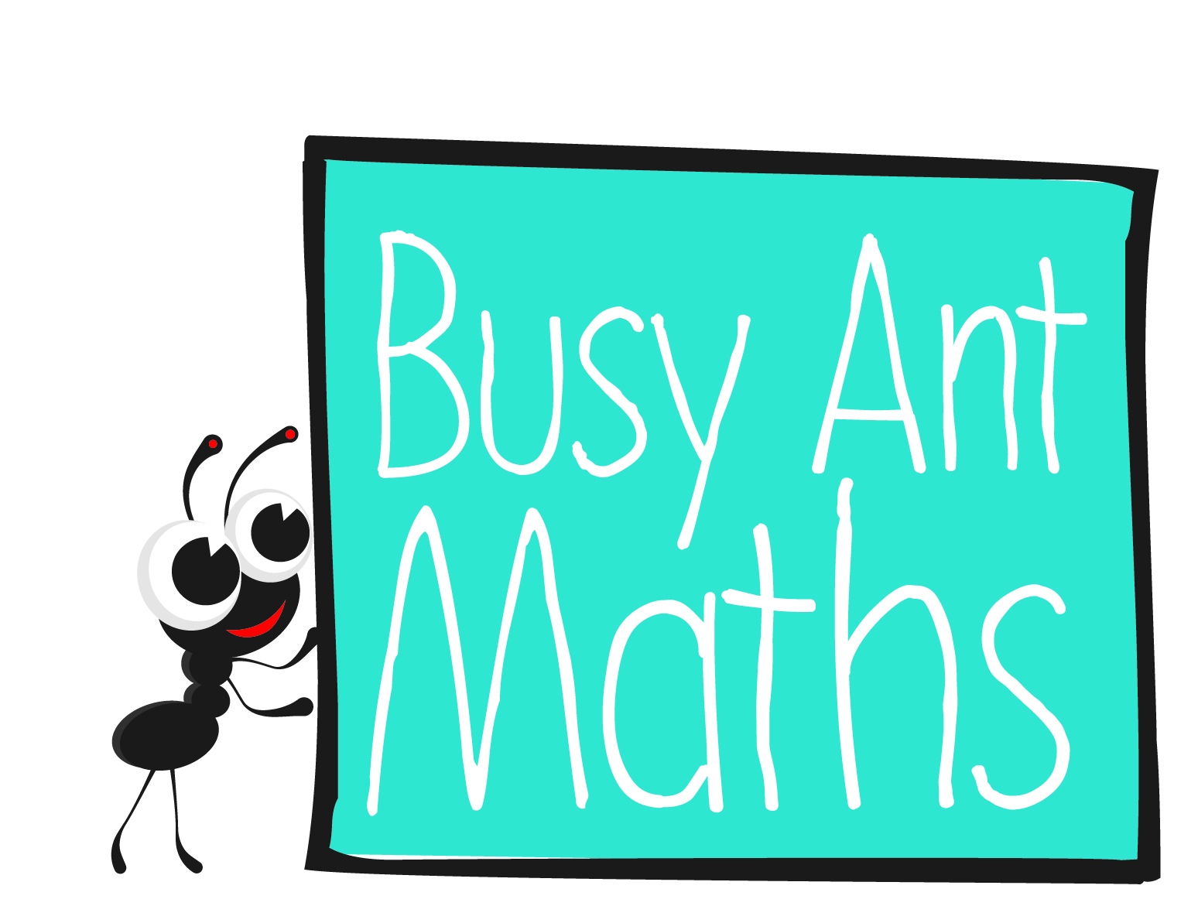
Primary 3
Maths
Newsletter 8
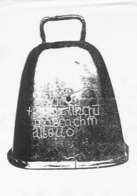
Date: ______________________ Name: ______________________
Multiplication and division
HERE’S THE MATHS
Numbers are either odd or even. Numbers with 1, 3, 5, 7 or 9 ones are odd numbers, e.g. 27, 43, 89. Numbers with 0, 2, 4, 6, or 8 ones are even numbers, e.g. 36, 52, 70.
ACTIVITY
What to do
You will need:
- 20 small pieces of paper (set 1: numbers 0 to 9;
set 2: numbers 1 to 9 and a blank piece of paper)
- timer (or phone with timer)
- Shuffle the two sets of number cards, keeping them separate, and place the two sets face down: 1 to 9 and the blank on the left, 0 to 9 on the right.
- One player starts the timer when the other player turns over the top card from each pile
to create a 1- or 2-digit number (a 1-digit number is created with the blank card).
- The player turning the cards over says whether the number is odd or even.
That player then continues to turn over one card from each pile (until all cards have been turned over) and identifies each number created as odd or even. The player with the timer keeps score of how many correct answers the other player gives, resulting in a maximum score of 10.
- Swap roles. The winner is the player with the most correct answers.
Variation
- Ask your child to correctly identify as many odd and even numbers as possible in a set amount of time, such as 30 seconds or 1 minute. Repeat the task and challenge your child to beat their previous best score.
QUESTIONS TO ASK
If you add together/subtract any two odd/even numbers, what do you notice about
the answer?
If you add together one odd and one even number, what do you notice about the answer?
How many ones can there be in odd/even numbers?

Fractions
HERE’S THE MATHS
$\frac{1}{4}$ of 12 = $\frac{1}{3}$ of 12 = $\frac{1}{2}$ of 12 = $\frac{2}{3}$ of 12 = $\frac{3}{4}$ of 12 =

To work out the answers:
12 ÷ 4 = 3 12 ÷ 3 = 4 12 ÷ 2 = 6 12 ÷ 3 × 2 = 8 12 ÷ 4 × 3 = 9

$\frac{1}{4}$ of = 3 $\frac{1}{3}$ of = 5 $\frac{1}{2}$ of = 9 $\frac{2}{3}$ of = 14 $\frac{3}{4}$ of = 15

To work out the answers:
3 × 4 = 12 5 × 3 = 15 9 × 2 = 18 14 ÷ 2 × 3 = 21 15 ÷ 3 × 4 = 20

ACTIVITY
What to do
You will need:
- pencil and paper
- small pieces of paper on which are written questions similar to those given above (involving numbers 50
or less)
- Shuffle the question cards and put them face down in front of you.
- Take turns to take the top card and work out the answer. Each correct answer scores a point.
- The winner is the first player to score 10. Reshuffle the question cards, if needed.
Variation
- Use cards with $\frac{1}{4}$, $\frac{1}{3}$, $\frac{1}{2}$, $\frac{2}{4}$, $\frac{2}{3}$ and $\frac{3}{4}$ written on them. Take turns to pick one fraction card and a random number between 1 and 50 (not all combinations will work so choose carefully!) and then decide which of the two question types to use. Write the question and the answer.

QUESTIONS TO ASK
$\frac{1}{4}$, $\frac{1}{3}$, $\frac{1}{2}$, $\frac{2}{4}$, $\frac{2}{3}$ and $\frac{3}{4}$ of what number equals X?
What is $\frac{1}{4}$, $\frac{1}{3}$, $\frac{1}{2}$, $\frac{2}{4}$, $\frac{2}{3}$ and $\frac{3}{4}$ of X?

How many quarters are there in one-half/three-quarters?
How do you work out $\frac{1}{4}$, $\frac{1}{3}$, $\frac{1}{2}$, $\frac{2}{4}$, $\frac{2}{3}$ and $\frac{3}{4}$ of an amount?

