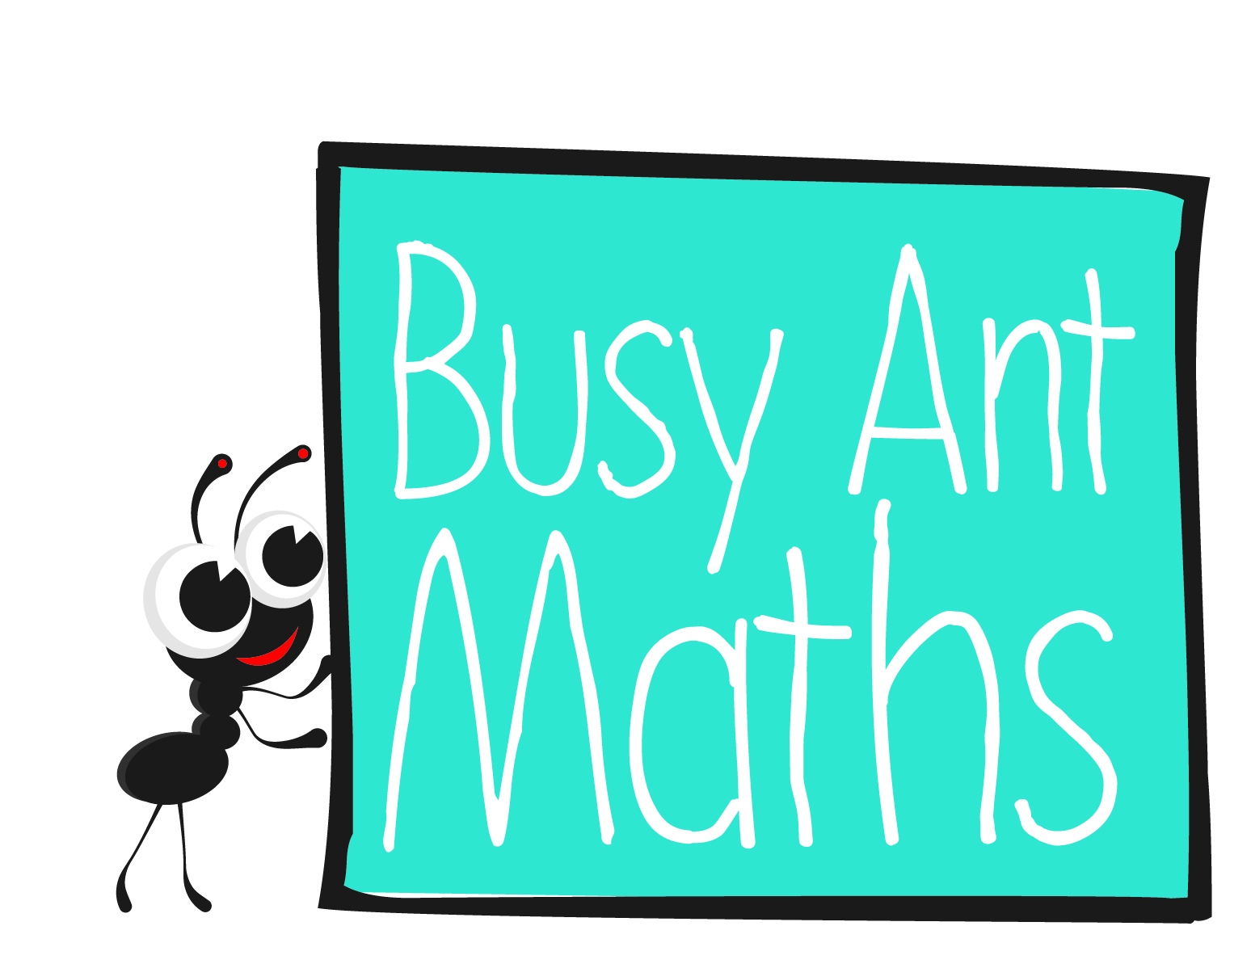
Statistics
HERE’S THE MATHS
A tally chart is used to record how many times different things occur or different answers are given to a question. It is an easy way to collect information. A tally is used to count in fives. Four vertical lines are drawn and then a fifth, horizontal or diagonal, line is drawn through the four lines: IIII represents 5 and IIII IIII represents 10.
20 children were asked which of these ice-cream flavours is their favourite.
Flavour | Tally
Vanilla | IIII | 5 people said vanilla is their favourite flavour.
Chocolate | IIII III | 8 people said chocolate is their favourite flavour.
Strawberry | IIII | 4 people said strawberry is their favourite flavour.
Mint choc chip | III | 3 people said mint choc chip is their favourite flavour.
ACTIVITY
What to do
You will need:
- paper and pencil
- ruler
- Help your child to draw a blank tally chart with two columns headed Cutlery and Tally. The cutlery column should then list fork, knife and spoon.
- Work together to complete the tally chart for the cutlery in your kitchen.
Variations
- Use a tally chart to record:
- colours of cars that drive past your house in X minutes or are parked in your road
- types or colours of clothes in a wardrobe
- colours of front doors
- coins in a purse.
QUESTIONS TO ASK
How many forks/knives/spoons are in our kitchen?
What is the total tally for that group?
What happens when there are already four tally marks and you want to add a fifth tally mark to that group?
How do you make a tally mark?

Primary 3
Maths
Newsletter 7
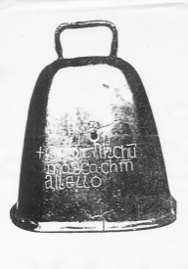
Date: ______________________ Name: ______________________

MATHS TOPICS
These are the maths topics your child will be working on during the next three weeks:
- Addition and subtraction, including money
- Statistics

KEY MATHEMATICAL IDEAS
During these three weeks your child will be learning to:
- find missing numbers in addition and subtraction calculations
- make an amount of money using different combinations of coins
- construct a tally chart to show the number of something in each group.

TIPS FOR GOOD HOMEWORK HABITS
If your child is struggling with a task, don’t give them the answer in order to get the homework finished. Instead, talk through the task with your child and help them to arrive at the solution themselves.

Addition and subtraction
HERE’S THE MATHS
Your child has been learning to use inverse operations to solve missing number addition and subtraction calculations where one number is a multiple of 10.
Addition is the inverse of subtraction. Subtraction is the inverse of addition.
To solve − 30 = 52 use 52 + 30 =
To solve 40 + = 69 use 69 − 40 =
ACTIVITY
What to do
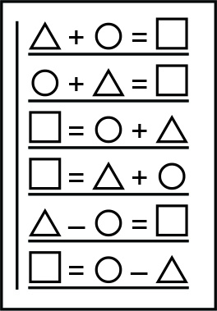
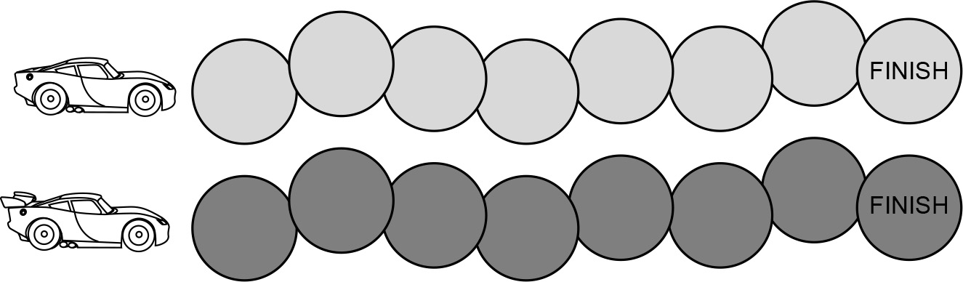

You will need:
- paper and pencil
- 2 small counters
- 9 small pieces of paper (numbers 10, 20, 30, 40, 50, 60, 70, 80 and 90 written on them)
- Shuffle the number cards and put them face down in a pile.
- Take turns to create a question for the other player by following these steps:
- Turn over the top number card to reveal a multiple of 10 (⃝).
- Pick a 2-digit number that is not a multiple of 10 ().
- Choose a question type from the box above.
- Write out the question with for the answer.
- Give the question to the other player. If their answer is correct,
they move their counter one position along the race track.
QUESTIONS TO ASK
How did you write your missing number questions?
How would/did you work out the missing number in this addition/subtraction calculation?
Is the missing number less than or greater than X?
(X is one of the numbers in the question.)

Addition and subtraction (money)
HERE’S THE MATHS
Your child has been learning to make an amount of money using different combinations of coins. 46p can be made in many ways including:

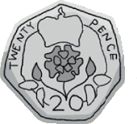
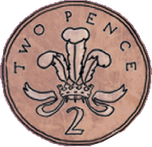
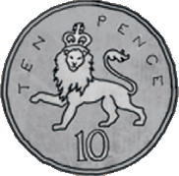

ACTIVITY
What to do
You will need:
- plenty of assorted coins (20p, 10p, 5p, 2p, 1p)
- paper and pencil
- Split the coins into two equal piles, one for each player, and take turns to choose an amount of money between 11p and 49p.
- Both players should then make that amount using their coins and put their hand up or call out ‘money’ when they have finished.
- Check that each other’s coin total is correct and compare how each player has made the amount.
- If both players have used the same coins no one wins a point. If both players have
a correct answer, the first one to finish wins a point. If only one person has the correct amount, they score a point. Write each player’s score on a piece of paper.
- The winner is the first player to score 10 points.
Variations
- Include larger amounts of money and add 50p coins to the set of coins to be used.
- Encourage children to use their skills when out shopping by finding the right money
to pay for an item.
QUESTIONS TO ASK
Which other coins could you have used to replace the Xp coin?
What are the least number of coins you can use to make Xp?
How many ways can you make 5p/10p/20p?

